Topic: Cell Membrane

Cell Membrane

- Introduction:

The cell membrane, also called the plasma membrane, is found in all cells and separates the interior of the cell from the outside environment. The cell membrane consists of a lipid bilayer that is semipermeable. The cell membrane regulates the transport of materials entering and exiting the cell.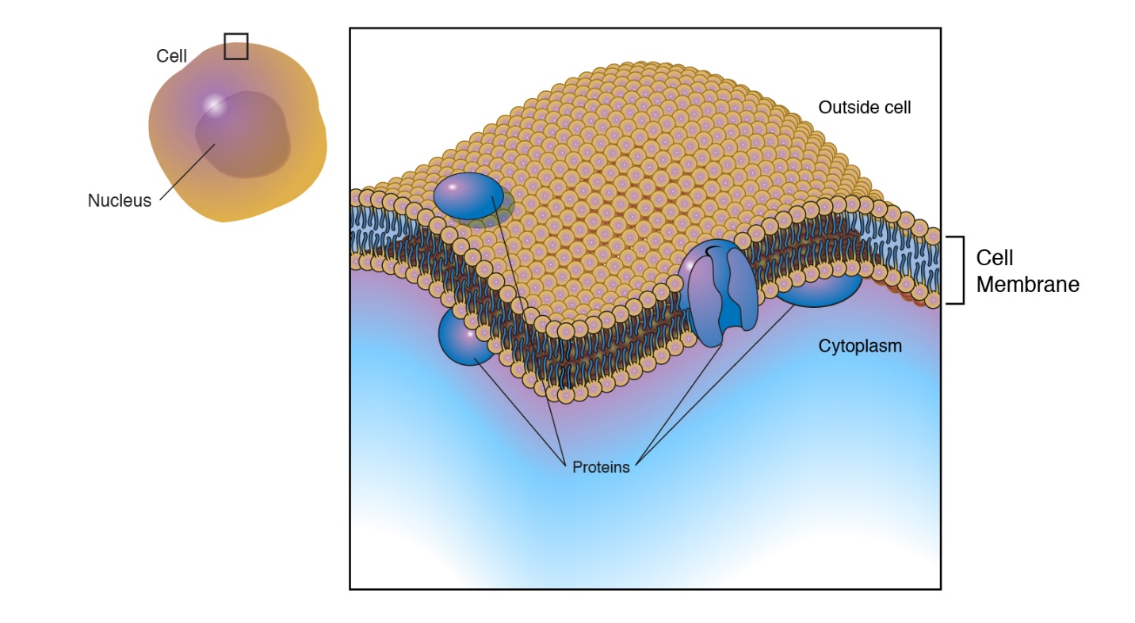
The plasma membrane, or the cell membrane, provides protection for a cell. It also provides a fixed environment inside the cell, and that membrane has several different functions. One is to transport nutrients into the cell and also to transport toxic substances out of the cell. Another is that the membrane of the cell, which would be the plasma membrane, will have proteins on it which interact with other cells. Those proteins can be glycoproteins, meaning there's a sugar and a protein moiety, or they could be lipid proteins, meaning that there's a fat and a protein. And those proteins which stick outside of the plasma membrane will allow for one cell to interact with another cell. The cell membrane also provides some structural support for a cell. And there are different types of plasma membranes in different types of cells, and the plasma membrane has in it in general a lot of cholesterol as its lipid component. That's different from certain other membranes from within the cell. Now, there are different plants and different microbes, such as bacteria and algae, which have different protective mechanisms. In fact, they have a cell wall outside of them, and that cell wall is much tougher and is structurally stronger than a plasma membrane is.

- History of Studies on Plasma Membrane:
The first insights into the chemical nature of the outer boundary layer of a cell were obtained by Ernst Overton of the University of Zürich during the 1890s. Overton knew that nonpolar solutes dissolved more readily in nonpolar solvents than in polar solvents, and that polar solutes had the opposite solubility. He discovered that the more lipid-soluble the solute, the more rapidly it would enter the root hair cells. He concluded that the dissolving power of the outer boundary layer of the cell matched that of a fatty oil.
The first proposal that cellular membranes might contain a lipid bilayer was made in 1925 by two Dutch scientists, E. Gorter and F. Grendel. These researchers extracted the lipid from human red blood cells and measured the amount of surface area the lipid would cover when spread over the surface of water. Since mature mammalian red blood cells lack both nuclei and cytoplasmic organelles, the plasma membrane is the only lipid-containing structure in the cell. Consequently, all of the lipids extracted from the cells can be assumed to have resided in the cells’ plasma membranes. The ratio of the surface area of water covered by the extracted lipid to the surface area calculated for the red blood cells from which the lipid was extracted varied between 1.8 to 1 and 2.2 to 1. Gorter and Grendel speculated that the actual ratio was 2:1 and concluded that the plasma membrane contained a bimolecular layer of lipids, that is, a lipid bilayer.

They also suggested that the polar groups of each molecular layer (or leaflet) were directed outward toward the aqueous environment. This would be the thermodynamically favored arrangement, because the polar head groups of the lipids could interact with surrounding water molecules, just as the hydrophobic fatty acyl chains would be protected from contact with the aqueous environment. Thus, the polar head groups would face the cytoplasm on one edge and the blood plasma on the other. Even though Gorter and Grendel made several experimental errors (which fortuitously canceled one another out), they still arrived at the correct conclusion that membranes contain a lipid bilayer. 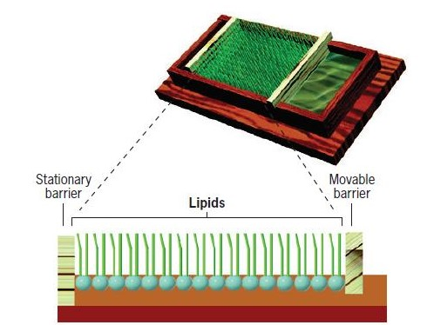
Experiments conducted in the late 1960s led to a new concept of membrane structure, as detailed in the fluid mosaic model proposed in 1972 by S. Jonathan Singer and Garth Nicolson of the University of California, San Diego. In the fluid-mosaic model, which has served as the “central dogma” of membrane biology for more than three decades, the lipid bilayer remains the core of the membrane, but attention is focused on the physical state of the lipid. Unlike previous models, the bilayer of a fluid-mosaic membrane is present in a fluid state, and individual lipid molecules can move laterally within the plane of the membrane.

The structure and arrangement of membrane proteins in the fluid-mosaic model differs from those of previous models in that they occur as a “mosaic” of discontinuous particles that penetrate the lipid sheet. Most importantly, the fluid-mosaic model presents cellular membranes as dynamic structures in which the components are mobile and capable of coming together to engage in various types of transient or semipermanent interactions. In the following sections, we will examine some of the evidence used to formulate and support this dynamic portrait of membrane structure and look at some of the recent data that bring the model up to date. 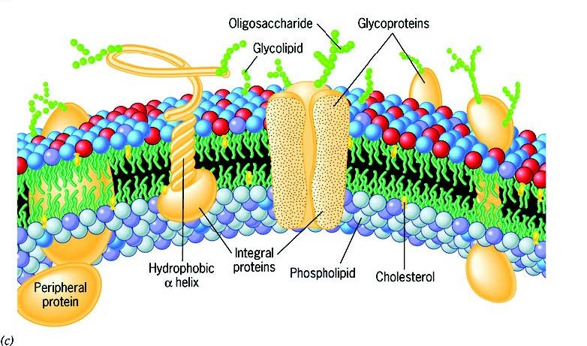

- The Chemical Composition of Membrane:

The principal components of the plasma membrane are lipids (phospholipids and cholesterol), proteins, and carbohydrate groups that are attached to some of the lipids and proteins.
- A phospholipid is a lipid made of glycerol, two fatty acid tails, and a phosphate-linked head group. Biological membranes usually involve two layers of phospholipids with their tails pointing inward, an arrangement called a phospholipid bilayer.
- Cholesterol, another lipid composed of four fused carbon rings, is found alongside phospholipids in the core of the membrane.
- Membrane proteins may extend partway into the plasma membrane, cross the membrane entirely, or be loosely attached to its inside or outside face.
- Carbohydrate groups are present only on the outer surface of the plasma membrane and are attached to proteins, forming glycoproteins, or lipids, forming glycolipids.
The proportions of proteins, lipids, and carbohydrates in the plasma membrane vary between different types of cells. For a typical human cell, however, proteins account for about 50 percent of the composition by mass, lipids (of all types) account for about 40 percent, and the remaining 10 percent comes from carbohydrates.

- Phospholipids:

Phospholipids, arranged in a bilayer, make up the basic fabric of the plasma membrane. They are well-suited for this role because they are amphipathic, meaning that they have both hydrophilic and hydrophobic regions.
The hydrophilic, or “water-loving,” portion of a phospholipid is its head, which contains a negatively charged phosphate group as well as an additional small group (of varying identity, “R” in the diagram at left), which may also or be charged or polar. The hydrophilic heads of phospholipids in a membrane bilayer face outward, contacting the aqueous (watery) fluid both inside and outside the cell. Since water is a polar molecule, it readily forms electrostatic (charge-based) interactions with the phospholipid heads.
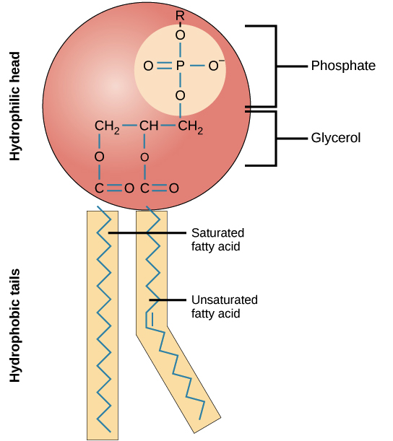
The hydrophobic, or “water-fearing,” part of a phospholipid consists of its long, nonpolar fatty acid tails. The fatty acid tails can easily interact with other nonpolar molecules, but they interact poorly with water. Because of this, it’s more energetically favorable for the phospholipids to tuck their fatty acid tails away in the interior of the membrane, where they are shielded from the surrounding water. The phospholipid bilayer formed by these interactions makes a good barrier between the interior and exterior of the cell, because water and other polar or charged substances cannot easily cross the hydrophobic core of the membrane.

Thanks to their amphipathic nature, phospholipids aren’t just well-suited to form a membrane bilayer. Instead, this is something they’ll do spontaneously under the right conditions! In water or aqueous solution, phospholipids tend to arrange themselves with their hydrophobic tails facing each other and their hydrophilic heads facing out. If the phospholipids have small tails, they may form a micelle (a small, single-layered sphere), while if they have bulkier tails, they may form a liposome (a hollow droplet of bilayer membrane).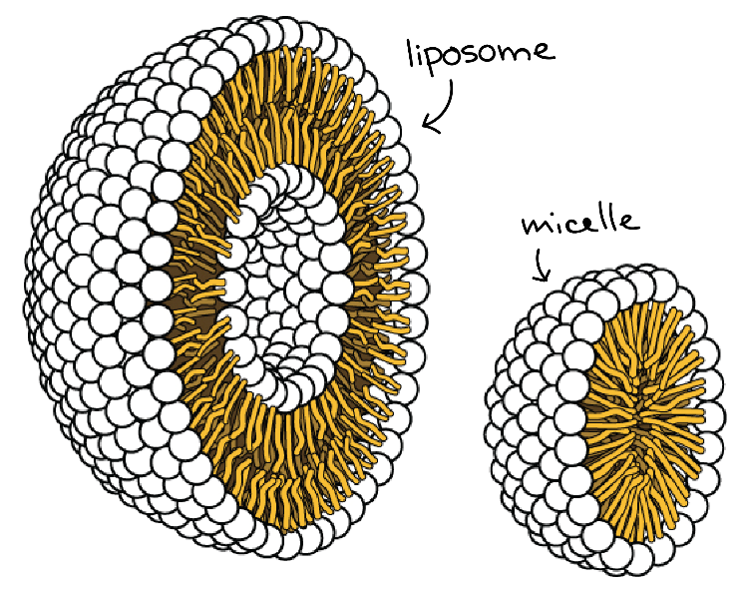

- Proteins:
Proteins are the second major component of plasma membranes. There are two main categories of membrane proteins: integral and peripheral.
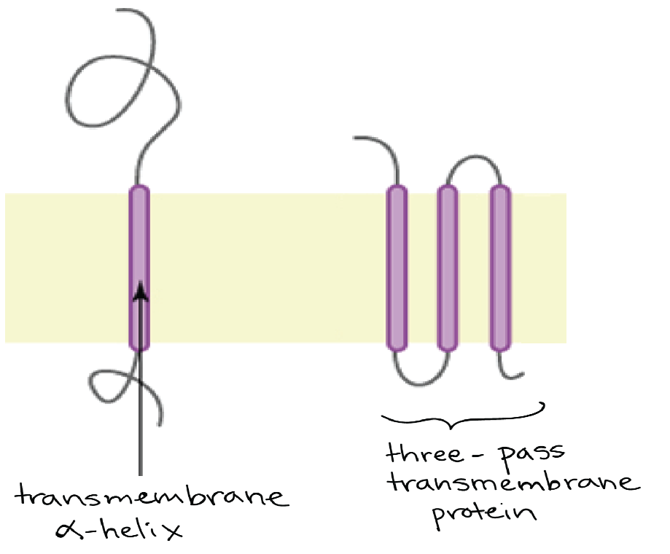
A single-pass transmembrane protein with a single membrane-spanning alpha helix and a three-pass transmembrane protein with three membrane-spanning alpha helices

Integral membrane proteins are, as their name suggests, integrated into the membrane: they have at least one hydrophobic region that anchors them to the hydrophobic core of the phospholipid bilayer. Some stick only partway into the membrane, while others stretch from one side of the membrane to the other and are exposed on either side. Proteins that extend all the way across the membrane are called transmembrane proteins.
- The portions of an integral membrane protein found inside the membrane are hydrophobic, while those that are exposed to the cytoplasm or extracellular fluid tend to be hydrophilic. Transmembrane proteins may cross the membrane just once, or may have as many as twelve different membrane-spanning sections. A typical membrane-spanning segment consists of 20-25 hydrophobic amino acids arranged in an alpha helix, although not all transmembrane proteins fit this model. Some integral membrane proteins form a channel that allows ions or other small molecules to pass. as shown be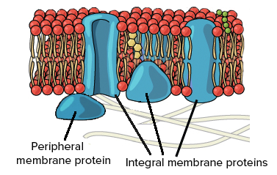
Peripheral membrane proteins are found on the outside and inside surfaces of membranes, attached either to integral proteins or to phospholipids. Unlike integral membrane proteins, peripheral membrane proteins do not stick into the hydrophobic core of the membrane, and they tend to be more loosely attached.

- Carbohydrates:
Carbohydrates are the third major component of plasma membranes. In general, they are found on the outside surface of cells and are bound either to proteins (forming glycoproteins) or to lipids (forming glycolipids). These carbohydrate chains may consist of 2-60 monosaccharide units and can be either straight or branched.
Along with membrane proteins, these carbohydrates form distinctive cellular markers, sort of like molecular ID badges, that allow cells to recognize each other. These markers are very important in the immune system, allowing immune cells to differentiate between body cells, which they shouldn’t attack, and foreign cells or tissues, which they should.

- Water in Cell Membrane:
The cell membrane has a surprising amount of water in it, for something that is supposed to be a mainly lipid-based cellular object. Water is in fact an active structural component of the cell membrane. The water is present in two main forms:
- "Organized" water, i.e. complexed with the hydrophilic heads of the phospholipid molecules
- Bulk water, i.e. chemically normal water which flows through protein channels and pores
So, the membrane is not exactly a rectangular slab of butter as often presented by scientific illustrations. In short, it is probably important to remember that there is plenty of water in the membrane, and that it does useful things. When one takes a sample of purified membrane phospholipid and allows it to form spontaneous liposomes in solution, they will swell and shrink according to the osmotic changes in that solution, demonstrating that water goes in and out of them (Van Zoelen et al, 1978). The lipid bilayer molecules do not fit neatly together but rather are piled somewhat haphazardly, with gaps between them formed by the "kinks" in their hydrophobic tails. Gaps, therefore, appear in the lipid bilayer internal structure, vacancies which readily admit molecules of water and perhaps even a stray ion or two. The water which courses through these channels would certainly not be a normal bulk water flow, but likely some sort of highly organized water, with substantially different solvent properties. Its presence permits lipid-water-protein interactions which strengthen the lipid-protein associations where the protein is hydrophobic. Conversely, the presence of whole nanometer-scale pools of water inside the membrane permits the insertion of polar protein molecules into the non-polar bilayer.
- Functions of Cell Membrane:

- Compartmentalization:
Membranes are continuous, unbroken sheets and, as such, inevitably enclose compartments. The plasma membrane encloses the contents of the entire cell, whereas the nuclear and cytoplasmic membranes enclose diverse intracellular spaces. The various membrane-bounded compartments of a cell possess markedly different contents. Membrane compartmentalization allows specialized activities to proceed without external interference and enables cellular activities to be regulated independently of one another.

- Scaffold for biochemical activities:
Membranes not only enclose compartments but are also a distinct compartment themselves. As long as reactants are present in solution, their relative positions cannot be stabilized and their interactions are dependent on random collisions. Because of their construction, membranes provide the cell with an extensive framework or scaffolding within which components can be ordered for effective interaction.

- Providing a selectively permeable barrier.
Membranes prevent the unrestricted exchange of molecules from one side to the other. At the same time, membranes provide the means of communication between the compartments they separate. The plasma membrane, which encircles cell, can be compared to a moat around a castle: both serve as a general barrier, yet both have gated “bridges” that promote the movement of select elements into and out of the enclosed living space.

- Transporting solutes.
The plasma membrane contains the machinery for physically transporting substances from one side of the membrane to another, often from a region where the solute is present at low concentration into a region where that solute is present at much higher concentration. The membrane’s transport machinery allows a cell to accumulate substances, such as sugars and amino acids, that are necessary to fuel its metabolism and build its macromolecules. The plasma membrane is also able to transport specific ions, thereby establishing ionic gradients across itself. This capability is especially critical for nerve and muscle cells.

- Responding to external stimuli.
The plasma membrane plays a critical role in the response of a cell to external stimuli, a process known as signal transduction. Membranes possess receptors that combine with specific molecules (ligands) or respond to other types of stimuli such as light or mechanical tension. Different types of cells have membranes with different receptors and are, therefore, capable of recognizing and responding to different environmental stimuli. The interaction of a plasma membrane receptor with an external stimulus may cause the membrane to generate a signal that stimulates or inhibits internal activities. For example, signals generated at the plasma membrane may tell a cell to manufacture more glycogen, to prepare for cell division, to move toward a higher concentration of a particular compound, to release calcium from internal stores, or possibly to commit suicide.

- Intercellular interaction.
Situated at the outer edge of every living cell, the plasma membrane of multicellular organisms mediates the interactions between a cell and its neighbors. The plasma membrane allows cells to recognize and signal one another, to adhere when appropriate, and to exchange materials and information. Proteins within the plasma membrane may also facilitate the interaction between extracellular materials and the intracellular cytoskeleton.

- Energy transduction.
Membranes are intimately involved in the processes by which one type of energy is converted to another type (energy transduction). The most fundamental energy transduction occurs during photosynthesis when energy in sunlight is absorbed by membrane-bound pigments, converted into chemical energy, and stored in carbohydrates. Membranes are also involved in the transfer of chemical energy from carbohydrates and fats to ATP. In eukaryotes, the machinery for these energy conversions is contained within membranes of chloroplasts and mitochondria.
- Multiple Choice Questions:
1. The major interaction responsible for stabilizing plasma membrane
(a) hydrophobic interactions
(b) hydrophilic interactions
(c) covalent bonds
(d) ionic bonds

2. In the plasma membrane, the best method to study the properties of integral membrane proteins is
(a) atomic force microscopy
(b) freeze-fracture analysis and electron microscopy
(c) cryo-sectioning and electron microscopy
(d) all of the above

3. In the plasma membrane, Glycolipids are usually situated in
(a) cannot be predicted, it varies according to the cell types
(b) inner leaflet of the plasma membrane
(c) the outer leaflet of the plasma membrane
(d) evenly distributed in both outer and inner leaves of plasma membrane

4. The main role of carbohydrate in cell membrane is
(a) Adhesion
(b) Recognition
(c) Locomotion
(d) Reception

5. The main role of carbohydrate in cell membrane is
(a) Adhesion
(b) Recognition
(c) Locomotion
(d) Reception

6. The major interaction responsible for stabilizing plasma membrane
(a) hydrophobic interactions
(b) hydrophilic interactions
(c) covalent bonds
(d) ionic bonds

7. In the plasma membrane, lipid molecules are arranged in
(a) head parallel
(b) alternate
(c) scattered
(d) series

8. All of the following substances can pass plasma membrane except
(a) O₂
(b) H₂O
(c) CO₂
(d) H⁺

9. The major biochemical molecule responsible for selective uptake of materials across plasma membrane
(a) Carbohydrate
(b) Protein
(c) Lipids
(d) Phospholipids

10. In the plasma membrane, carbohydrates in glycoproteins and glycolipids are oriented
(a) towards outside
(b) towards inside
(c) towards outside and inside
(d) Randomly

