Natural resources , Energy and Environment
1.Gasohol
Gasoline blended with up 20% methanol or ethanol is known as gasohol. This can be used as a fuel in existing internal combustion engines, with little or no adjustment. Individually, methanol or ethanol itself can be used as fuel (instead of gasoline) in suitably designed engine. Methanol is produced by the Destructive distillation of wood, or form synthesis gas manufactured from coal or natural gas. Ethanol is generally manufactured by fermentation of Carbohydrates.
The manufacturing of alcohol can be carried out by fermentation of sugar resulting from hydrolysis of cellulose in wood waste and crop waste.
Brazil is leading country in the manufacture of ethanol for fuel. This country possesses few fossil-fuel resources, but provides optimum conditions for growth of biomass (algae, grass, trees and plants). Most of Brazil’s alcohol is produced by fermentation of sugarcane.
Gasohol has a high octane rating and does not require addition Pb(C₂H₅)₄. It cuts down the exhaust emission, upto 50% for CO and NOx.
USA produced gasohol in some agricultural area. Gasohol is likely to play a useful role in meeting the fuel needs in USA.
2.SOLAR ENERGY
The sun offers an ideal energy source, unlimited in supply in expensive which does not add to the Earth’s total heat burden and does not provide air and water pollution. It is powerful alternative to fossil and nuclear fuels. The necessary technology for harnessing and store solar energy is expensive at present .When it is much cheaper to pump oil from the ground and burn it. But with rising fuel prices and end of petroleum sight, the economic balance is bound to tilt in favour of solar energy. For this reason, there is now considerable activity in the development of solar technology which is likely to cut down costs in engineering improvements and mass production.
The most convenient application of solar energy is in heating buildings and providing hot water which in developed countries like USA, consumes 20-25% of the fuel supply. This is however, the best application for a uniform dispersed energy sources.
Sunlight is collected on plates in the roof and heat transferred to a circulating water system. It has been calculated that an average house in the Central United states can get its energy supply for heating and hot water in December with a collection of 1300 ft², well within average roof area.
Sunlight may be directly converted into electricity through photovoltaic effect. Light is absorbed in a material, with the generation of positive and negative charges which are collected at electrode at either side. The silicon solar cell, developed for the space programme, consist of sandwich of n-type and p-type silicon semiconductors.
A solar photovoltaic cell turns sunlight into usable electricity in three steps
1.Light is absorbed and knocks electrons loose.
2.Loose electrons flow, creating a current.
3.The current is captured and transferred to wires.

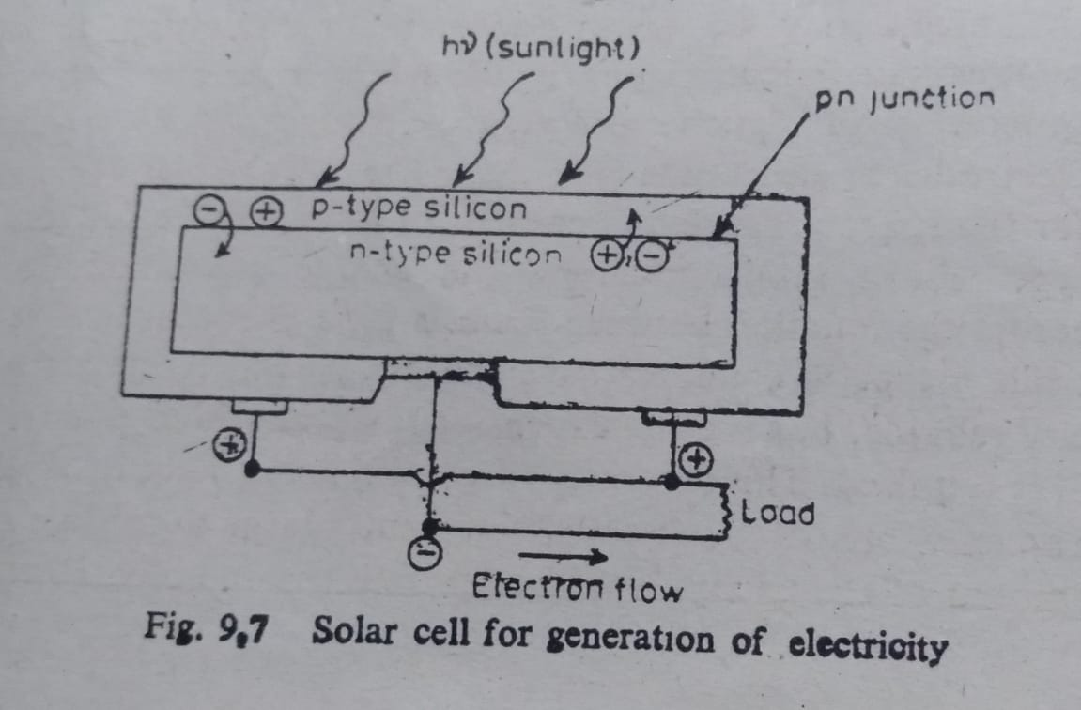3.Nuclear Fission and Nuclear Fusion
The nuclear age dawned and held out promise for the production of abundant energy.U-235 produces per gram, heat energy equivalent 14 barrels of crude oil or 3 tons of coal.
Nuclear power (fision) reactors are based on the fission of U-235 nuclei by thermal neutrons, producing two radioactive fission products, and average of 2.5 neutron and an average energy of 200 MeV per fission.
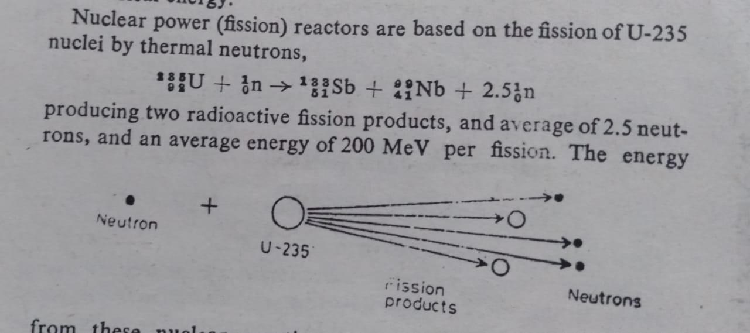

This energy from these nuclear reaction is used to heat water in the reactor and produce steam to drive a steam turbines.
Three reactor types are considered.
1.Light water reactor (LWR)
2.High Temperature Gascooled Reactor (HTGR)
3.Fast Breeder Reactor (FBR)
The HTGR and FBR reactors convert non-fissionable U-238 and TH-232 to fissionable Pu-239 and U-233.
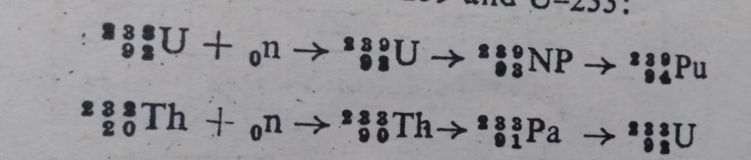
Nuclear fusion is based upon the deuterium-deuterium reaction
And the deuterium-Tritium reaction
4. Coal Conversion
Coal can be transformed to gaseous, liquid or low-suphlur, low-ash solid fuel which is less polluting than coal. The products gases and liquids can be used with distribution system and equipment designed for use with natural gas petroleum industry that reached a peak capacity of 100,000 barrels per day.
A typical coal conversion plant –synthane gasificaton plant-has been developed in the USA with a capacity of 72 tons/day of coal. In synthane gasification plant, steam reacts with coal to produce water gas
C + H₂O CO + H₂
The gaseous products from coal in a synthane gasifier are 10.5% CO, 17.5% H₂, 18.2 % CO₂, 37% H₂O, 15.4% CH₄ and 0.3% H₂S.
Besides these gases, tar, oil, water, ash and S are also produced which must be removed.
The quality of coal is upgraded by hydrogenation process which removes S and ash from coal. Highgrade ash-free coal is produced as SRC (solvent Refined Coal) by suspending coal in a solvent and treating 2% of its weight of H₂ at 1000 psi and 450ºC. SRC is the best anthracite fuel.
Methanol is convenient liquid fuel which can be produced from coal. On a large scale it is produced by the reaction of CO and H₂ at 50 atm and 250 ºC in the presence of copper based catalyst.
Methanol is excellent additive for gasoline. It has a high octane number and improves fuel economy and acceleration time in automobile. It also cuts down the emission of practically all automotive pollutants.

