The Periodic Table
One of the most recognizable tools of chemistry is the periodic table. Once you are familiar with it, the periodic table summarizes a wealth of information about the behavior of elements, organizing them simultaneously in ascending order of atomic number and in groups according to chemical behavior. An experienced chemist can get a rough idea of an element’s properties simply from where that element sits in the periodic table. A number of scientists had devised various schemes for arranging the elements. These attempts to organize the understanding of the elements were not well received, however. One proposal by John Newlands in 1866 would have grouped elements similarly to musical octaves.
H
Li Be B C N O F
Na Ca

This idea was literally laughed at during a scientific meeting where one critic sarcastically asked whether a listing by alphabetical order had been tried, noting, “any arrangement would present occasional coincidences.” Despite the skepticism of the 19th century scientific community, efforts to organize the elements persisted. Numerous observations suggested a regularity, or periodicity (Repetition in properties), in the behavior of the elements known at that time. By 1869, Russian scientist Mendeleev had published his first periodic table and enumerated the periodic law: when properly arranged, the elements display a regular and periodic variation in their chemical properties.
The most significant and impressive feature of Mendeleev’s work was his prediction of the existence of undiscovered elements. He left holes in his proposed table at positions where no known element seemed to fit. Later, when the elements to fill in these holes were identified, the scientific community accepted Mendeleev’s work. The discovery of the periodic law and construction of the periodic table represents one of the most significant creative insights in the history of chemistry. Prior to Mendeleev’s time, chemists had to learn the properties of each element individually. As more and more elements were discovered, that task became increasingly daunting. The periodic table helped the study of chemistry to expand quickly by providing a simple, visual means to organize the elements in terms of their chemical and physical properties.
Periods and Groups
The modern periodic table simultaneously arranges elements in two important ways:
Periods
The horizontal rows of the table, called periods,
Group
The vertical columns, called groups.
There are also names for different regions of the table.
Group A
Elements in the two groups on the left side of the table and the six groups on the right side are collectively referred to as representative elements, or main group elements.
Elements that separate these two parts of the representative groups in the main body of the periodic table are called transition metals. Iron is an example of a transition metal.
The elements that appear below the rest of the periodic table are called lanthanides (named after the element lanthanum, Z = 57) and actinides (named after the element actinium, Z = 89). In addition to these names, several numbering systems have been used to designate groups. Current convention dictates numbering from left to right starting with 1 and proceeding to 18. Thus, for example, the group containing C, Si, Ge, Sn, and Pb is referred to as Group 14.

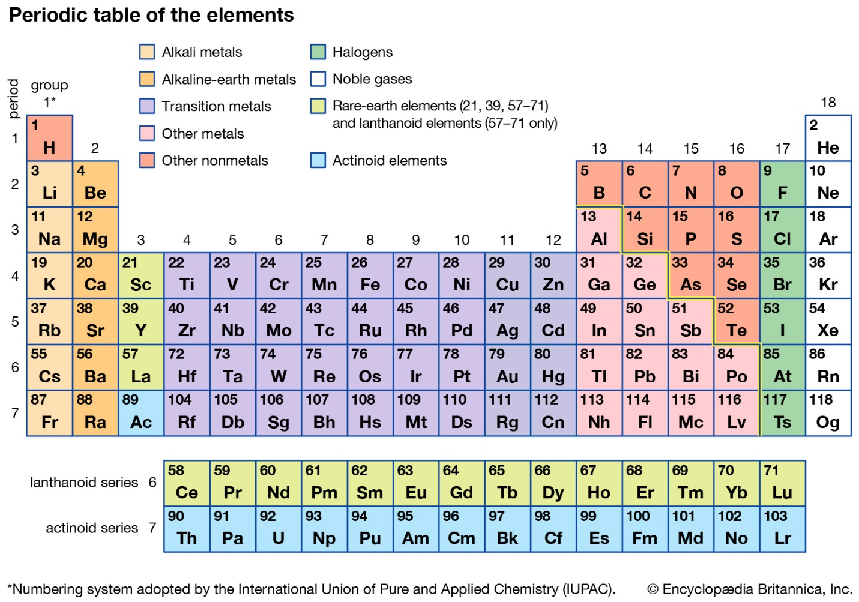
The term “period” is used for the rows because many important properties of the elements vary systematically as we move across a row. The elements in the periodic table are arranged in order of increasing atomic number, moving from left to right across the corresponding row of the periodic table.
Although the properties of the elements can vary widely across a period, each column collects elements that have similar chemical properties.
For Example: Most elements can combine with hydrogen to form compounds. Elements in a group (column) combine with the same number of hydrogen atoms. Fluorine, chlorine, and bromine each combine with one atom of hydrogen, for example, and all fall in the same group. HF. HCl, HBr, HI
These types of chemical similarities were among the evidence that led to the development of the periodic table, so some of the groups predate the general acceptance of the table. These groups of elements were assigned names and those names have remained with them.
Alkali Metals (Group I A)
Thus the elements in the far left-hand column (Li, Na, K, Rb, and Cs) are known collectively as alkali metals.
Alkaline Earth Metals (Group II A)
Similarly, Be, Mg, Ca, Sr, and Ba are called alkaline earth.
Halogens (Group VII A)
F, Cl, Br, and I are referred to as halogens.
Noble Gases (Group VIII A)
He, Ne, Ar, Kr, and Xe were discovered much later than most of the other elements, and they have been named rare gases or noble gases. Other groups are named, but their names are less commonly used and won’t be mentioned here.
Metals, Non-metals and Metalloids
Another way to classify an element is as a metal, nonmetal, or metalloid. Once again, the periodic table conveniently arranges elements so that one can place a given element easily into one of these categories.
Metals are those elements that has ability to lose electrons and are called electropositive.
Most of the elements are metals. Their general location in the periodic table is toward the left and bottom, as seen in the coloring of the periodic table. Metals share a number of similarities in chemical and physical properties. Physically, metals are shiny, malleable (can change from shape to another) and ductile (meaning they can be pulled into wires). They also conduct electricity, so wires are always made from metals. Chemical properties can also be used to distinguish metals. Metallic elements tend to form cations in most of their compounds,
Nonmetals (gain of electorns) occupy the upper right-hand portion of the periodic table. There are fewer nonmetals than metals. But when we consider the relative importance of elements, nonmetals hold their own because of their role in the chemistry of living things. Most of the molecules that make up the human body consist predominantly or exclusively of the nonmetallic elements carbon, hydrogen, oxygen, nitrogen, sulfur, and phosphorus. As our examples so far might lead you to guess, polymers (macromolecules) also consist almost exclusively of nonmetallic elements. In contrast to metals, nonmetals are not shiny, malleable, or ductile nor are they good conductors of electricity. These physical properties provide one means by which we can distinguish metals from nonmetals. Whether an element is a metal or nonmetal may seem simple to determine based on the physical properties cited above. Yet, some elements cannot be classified easily as either metal or nonmetal. The question whether or not a substance conducts electricity, for example, does not always have a simple yes or no answer. Lacking a reliable means of drawing a clean boundary between the two categories, scientists have generally chosen to refer to intermediate cases as metalloids or semimetals. In the periodic table, metalloids are clustered.
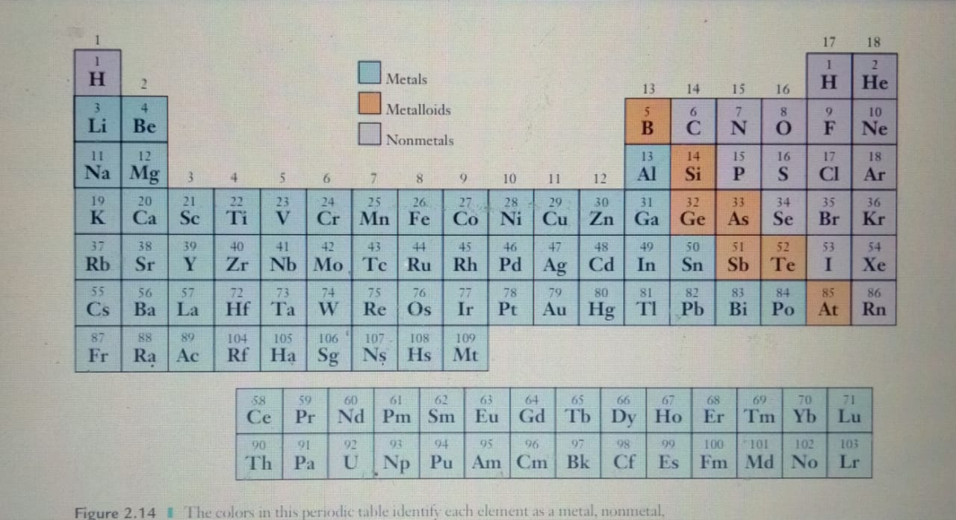

gives us some useful flexibility and also emphasizes that properties change gradually rather than abruptly as one moves across or down the periodic table. All of the polymer molecules we have mentioned are carbon based. Their skeletons consist entirely of carbon atoms. Because elements in the same group of the periodic table have similar chemical behavior, you might be wondering whether similar polymers could be produced based on silicon, which appears right below carbon in Group 14. Silicon-based polymers, known as silicones, do exist, but they differ from carbon polymers in important ways. Covalent bonds can be formed between silicon atoms, but they are not as strong as those between carbon atoms. So chains of silicon atoms become unstable beyond a length of around ten atoms, and silicon analogs of polymers such as polyethylene cannot be produced. Instead of pure silicon, the backbone chains in silicone polymers consist of alternating silicon and oxygen atoms. The Si!O bond is strong enough to allow these chains to grow quite long. Additional atoms or groups of atoms bound to the silicon atoms influence the properties of the polymer. The range of polymers that can be produced is not nearly as diverse as for carbon, but silicone polymers are widely used in applications including greases, caulking materials, water repellents, and surfactants.

