Assignment
Regulation of opening and closing of stomata

Contents
Introduction: 5
What are Stomata? Stomata are specialized epidermal structures that are essential for plant survival and productivity. 5
Diagram1: 5
Structure of Stomata: 6
These structures consist of 6
• TWO guard cells around a pore 6
Function of Stomata 6
Every stoma is a molecular valve that act in following: 6
➢ Gas exchange, mainly of CO₂ and O₂ which is necessary for optimal photosynthesis and restricts H₂O loss by modulating transpiration level. 6
Role of stomata in stress/dihydric conditions: 6
Explanation 6
Positive and negative regulators of stomatal opening: 7
Enzymes involved in Stomatal Action: 7
The Regulatory Role Of Ion Channels Localized In The Guard Cell Membrane In The Opening And Closing Of Stomata: 8
Diagram2: 9
K⁺ ion Balance: 10
Closing of stomata: 12
Protein involved in ABA signaling in stomata: 14
Diagram3: 15
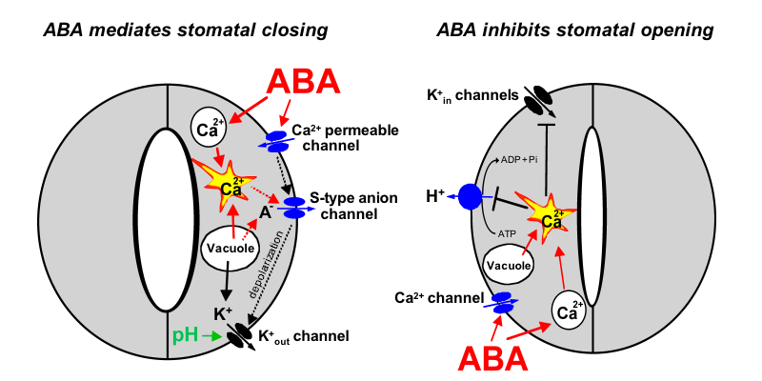 15
Theories: 16
Factors that influence the opening and closing of stomata: 17
Conclusions: 19
References: 19
References 20

Introduction:

What are Stomata? Stomata are specialized epidermal structures that are essential for plant survival and productivity.

Diagram1:

Structure of Stomata:

These structures consist of

TWO guard cells around a pore

Function of Stomata

Every stoma is a molecular valve that act in following:

Gas exchange, mainly of CO₂ and O₂ which is necessary for optimal photosynthesis and restricts H₂O loss by modulating transpiration level.
The genes that are involved in stomatal development were involved in movement of plants from H₂O to land during evolution since stomata facilitated gas exchange while limited desiccations.

Role of stomata in stress/dihydric conditions:
For plants that encounter dihydric conditions, the most essential factor is the ability of stomata to close and thus prevent excess H₂O loss.

- Opening and closing is achieved by swelling and shrinking of the Guard cells which is driven by gas exchange; cytoskeleton recognition and metabolic production.

- Stomatal closure is the earliest plant response to water deficit.

Explanation:

This rapid reaction is regulated by a complex network of signaling pathways, in which the major and the best known player, Abcisic acid (ABA) acts in concert with jasmonates (JA), ethylene, auxins, and cytokinins.
The complexity of response is mainly dependent on the initial threshold of stress and individual plant’s stress history.

Positive and negative regulators of stomatal opening:

Generally, ABA and JA are positive regulators of stomatal closure
while auxins and cytokinins are positive regulators of stomatal opening.
The role of ethylene is ambiguous because it can act as Both Positive and Negative regulator of stomatal opening.

Enzymes involved in Stomatal Action:

A comprehensive review of the genetic and molecular basis reveals that stomatal action is under the control of Phytohormones, particularly when draught condition is considered.

The Regulatory Role of Ion Channels Localized in The Guard Cell Membrane in The Opening and Closing of Stomata:

The guard cell turgor is dynamically adjusted to environmental conditions and hormonal signals in order to facilitate;
- Proper gas exchange
- Prevents excessive water loss
- Mature guard cells don’t have plasmodesmata and for this reason more influx and efflux of solutes occur via ion channels, transporters and pumps that are localized in the Plasma membrane (PM).
- The action of ion channels, transporters and pumps that are essential for stomatal function is well documented and supported by molecular studies involving mutants in the genes encoding the protein.
During the opening of stomata, the H_ ATPase pump mediates the efflux of H_ from the guard cell.
In plants H⁺ ATPase belong to the multi-gene family of the P-type ATPase, with 11 genes in Arabidopsis, which are all expressed in the guard cell.
In the guard cells, the action of H⁺-ATPase activity is positively regulated by
- blue light
- auxins
Diagram2: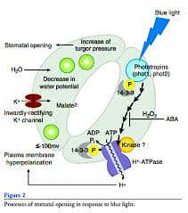

Whereas Ca²⁺ and ABA act as negative regulators. The efflux of H⁺ hyperpolarizes the PM and leads to K⁺ uptake via activation of inward K⁺ rectifying channels, such as KAT1(potassium channels in Arabidopsis thaliana 1), KAT2(potassium channel in Arabidopsis thaliana 2), and AKT1 (Arabidopsis thaliana K transporter 1)
- Another signal that activates the influx of K via K Channels Acidification of apoplast via H extrusion from guard cells

K⁺ ion Balance:
- K+ uptake is balanced by counter ions, mainly, Cl obtained from apoplast, Malate²⁻ that is derived from the starch breakdown or NO3- .
- Ions supplied into guard cells together with water transported via aquaporins generate the turgor that are necessary to keep stomata open and thus water transpires depending upon time of stomatal opening and environmental temperature and humidity.

Diagram showing opening and closing of stomata:

- Closed stomata.
- Opened stomata.
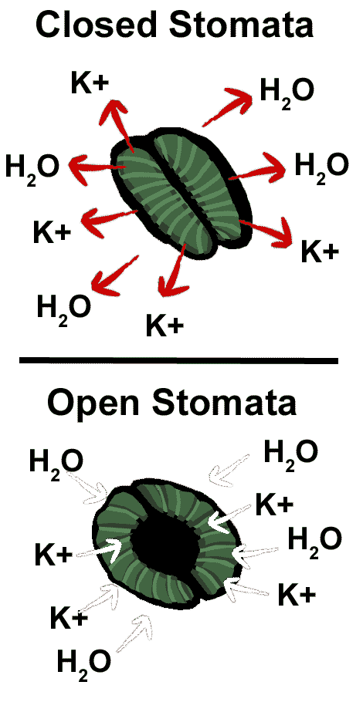

Closing of stomata:

- During Stomatal closure, the inhibition of H⁺ ATPase and the activation of anion channels together result in membrane depolarization. Anion channels such as rapid channels (R-type) and slow channels (S-type) facilitate the efflux of malate²⁻ , Cl⁻, and NO₃⁻.
- The decreased level of malate²⁻ in guard cells is also linked with the gluconeogenic conversion of malate²⁻ into starch.
Membrane depolarization creates a driving force for the efflux of K+ via K+ outwardly recitifying channels.
- Another event that accompanies the closure of stomata is an evaluation of the cytoplasmic Ca2+ -release via channels situated in both the PM and Tonoplast.
Taken together, the efflux of solutes from the guard cells leads to a reduced turgor and stomatal closure.

Abscisic Acid – How The Proper Regulator of Main Regulator of Stomatal Movement Is Achieved in Plants:
Abscisic acid has been postulated as a main regulator of stomatal movement but its proper functioning depends upon biologically active ABA within the plants. ABA is achieved by synchronized processes such as ABA biosynthesis and catabolism. It is synthesized in plastids and cytosol mainly in vascular parenchyma but also in guard cells by cleavage of C₄ carotenoid precursor, followed by two step conversion of intermediate Xanthoxin into ABA via ABA- aldehyde.
- ABA can be deactivated at the C-1 hydroxyl group by different chemical compounds.
Regulation of Stomatal Opening During Diurnal Cycle – The Role of ABA:
The ABA mode of action is linked to diurnal stomatal movements. It has been proposed that this link is based on both the molecular connections between ABA and circadian-lock pathways and on ABA biosynthesis and response to light. Although several studies have been carried out linking the diurnal cycle with ABA signaling, there is still a need for further research that would clarify this connection.it has been confirmed that the elevated ABA levels in the dark phase of the day are responsible for stomatal closure but, on the other hand, the molecular basis of the sensing CO2 molecules by guard cells is still not well understood. This part of investigations still needs confirmation through the use of well-established methods. In darkness, stomata are closed. This is probably caused by an intensive ABA accumulation through the biosynthesis of ABA in the guard cells and the simultaneous import of endogenous ABA from the apoplast to the guard cells using ABA transporters such as ABCG22.

while at the same time, ABA catabolism processes are disfavored. Elevated ABA levels cause stomata closure via the activation of an ABA signaling cascade, the efflux of Ca²⁺ from internal stores, the activation of S-type and R-type anion channels that leads to the efflux of Cl⁻, Malate²⁻ , and NO₃⁻ and the activation of the GORK channel that leads to the efflux of K⁺. During the night, elevated levels of CO₂ in the leaves were observed due to respiration. It has been proved that CO₂ has a positive effect on the stomatal closure process. The guard cells probably do not sense CO₂ molecules but instead HCO₃ is synthesized from CO₂.

Protein involved in ABA signaling in stomata:

- Protein involved in ABA signaling in stomata is GPA1. GPA1 is a positive regulator of stomatal opening.
- In Midday, ABA is delivered to the Apoplast around the guard cells through the xylem transpiration stream and the guard cells are regulated by steady-state ABA concentration
- In the evening, ABA biosynthesis outweighs the ABA catabolism in the guard cells, which leads to stomatal closure. (https://www.ncbi.nlm.nih.gov/pmc/articles/PMC3652521/)

Diagram3:

Mechanism:
Stomata are on epidermis of leaf. Each stomata, have two guard cells that are kidney shaped.

- The open stomata have turgid cells and closed stoma have flaccid cells.
- The opening and closing of stomata depend upon the changes in the turgidity of their guard cells.
- The outer thin walls of guard cells stretch outward by the increase of turgidity, the inner thick walls are inelastic, concave and pulled. It results in widening of stomatal pore.
- When turgidity is lost, the guard cells close the opening of stomata.

Theories:

Some theories have been proposed to explain the stomatal opening and closing. These are as follows:

- Theory of Photosynthesis in Guard Cells:

According to Von Mohl (1856), stomata open in light and close in dark. The guard cells contain Chlorohyll, that manufacture carbohydrates during sunlight. By the formation of carbohydrates, the osmotic pressure of guard cells increases.
Water enters the guard cells due to endosmosis from the neighboring cells of epidermis. It increases the turgidity of guard cells to open stomata.
Later, this theory was accepted because the chloroplasts of guard cells cannot carry on sufficient photosynthesis.

- Theory of starch-sugar interconversion:
This theory was proposed by Sayre (1926).
According to this theory, CO2 is used in photosynthesis, PH of guard cells rises (basic), which favours the hydrolysis of starch into sugars which increases the osmotic pressure of cell sap of guard cells.
Water enters in the guard cells from neighboring cells. Guard cells become turgid, therefore, stomata open.

Steward (1964) and other workers criticized this theory. They proposed that enough osmotic pressure is not developed by the conversion of starch into sugar. So, turgidity of guard cells does not occur.

- Theory of starch-glucose interconversion:
Steward in 1964 proposed a modified scheme for stomatal opening.
According to this scheme
- photosynthesis occurs mesophylls cells in the presence of light
- CO2 is removed from intercellular spaces
- PH of guard cells is increased
- Starch is converted into glucose by enzymes
- Osmotic pressure of cell sap is increased
- Endosmosis occurs in guard cells
- Guard cells become turgid and open the stomata

Factors that influence the opening and closing of stomata:
There are factors that influence the opening and closing of stomata:

- Light:
Light plays an important role in the opening and closing of stomata. The stomata open in light and close in night. The guard cells contain chlorophyll; they manufacture carbohydrates during sunlight. By the formation of sugar, the osmotic pressure of guard cells increases, so water enters the guard cells due to endosmosis from the neighboring cells of epidermis. It increases the turgidity of guard cells which open stomata.

In the darkness, carbohydrates are consumed in the guard cells or these are transferred into other cells. It decreases the osmotic pressure of guard cells, due to this process ex-osmosis takes place, guard cells become flaccid and stomata are closed.

- Concentration of K+ ions:
In some plants the turgidity of guard cells is regulated by K⁺ ion concentration.
During day time the guard cells get k⁺ ions from neighboring cells, due to their accumulation the osmotic potential of guard cells is lowered and they get water from epidermal cells, so guard cells become turgid and stomata are opened. Less concentration of K⁺ ions results in the closing of stomata.

- CO₂ concentration:
An increase in CO₂ concentration causes stomata to close.

- Water content of mesophyll:
More turgid cells of mesophyll help to open the stomata.

- Temperature:
Optimum temperature for opening of stomata is 25-30⁰C.when temperature is increased up to certain limit, stomata become opened.
(Ansari)

Conclusions:

As per above discussion, it can be concluded that stomatal opening and closing is equally effected by each factor and is necessary for plant survival.

