Analytical Techniques in Nutrition

Edited by:

- Professor Dr. Zafar Hayat, Chairman.
- Dr. Muhammad Arif, Associate Professor.
- Mr. Abd ur Rehman, Lecturer.

DEPARTMENT OF ANIMAL SCIENCES

UNIVERSITY OF SARGODHA, SARGODHA PAKISTAN
2023

FEED SAMPLING FOR CHEMICAL ANALYSIS
Sampling is the back bone of any lab analysis. Sample collected must be homogenous and a true representative of the stock. Accurate sampling gives the reliable estimates of the chemical composition of the ingredient in question. Following steps may be followed during sampling:-
- Collect the sample randomly. X or Z shape arrangement may also be followed while collecting sample from a stock. In this arrangement samples are collected from all the bags or units lying in the X or Z lines.
- From each unit or bag about 500 g sample is collected.
- Then sample is mixed thoroughly and spread in a tray.
- Then from tray again 500 g sample is collected in X or Z shape procedure.
- The grind the sample up to 2mm size.
- Before grinding clean the grinder thoroughly to avoid inter-batch contamination.
- Collect the ground sample in an airtight bag after discarding first 40-50 g of ground sample when grinding starts.
- Bags containing samples should be labeled with party name, vehicle number, date, time etc.
- Preserve the sample for possible future analysis.
- Maintain a register to keep the record of samples prepared and analyzed.

PROXIMATE ANALYSIS
This method was developed by Henneberg and Stohmann (1864) at Weende experiment station of Germany. It is a system of estimating nutritive value of a feed. Proximate analysis separates the feedstuff into following fractions
- Moisture
- Crude protein
- Ether extract
- Crude fiber
- Ash
- Nitrogen free extract

- Moisture
- Take 5-10 grams of sample in a pre-weighed petri dish (W₀)
- Put it in oven at 105̊C until for 8 hours.
- Remove the petri dish from the oven.
- Place it in desiccator to cool down the temperature.
- Then weigh the petri dish again (W₁).
- After weighing put the petri dish again in oven at 105ºC for 4 hours.
- Then remove the petri dish from oven and place it in desiccator to cool down.
- Weigh the sample again. If the weight of the sample is same as W₁ then calculate the moisture otherwise place the petri dish again in oven and repeat the procedure until constant weight (W_{C}) is achieved.
- Calculate the % moisture by following formula.

Moisture (%) = (W₀-W_{C})/W₀) × 100
DM= 100- %Moisture

- Crude Protein (CP)
Along with dry matter and ash analyses, the Kjeldahl procedure is one of the most common analyses performed in the nutrition laboratory. Although not a measurement of protein per se, it does provide an estimate of the content of this important nutrient in feedstuffs. Protein always seems to be in short supply, both in human and animal feeds, and an accurate estimate of protein content is vital in formulating diets for optimum animal performance. The Kjeldahl method dates back to the 1880's when Johan Kjeldahl used sulfuric and phosphoric acids to decompose organic materials. The method can be conveniently divided into three phases: digestion, distillation, and titration. The digestion phase is the first phase of the analysis and is designed to oxidize organic matter to CO2and H2O, while reducing nitrogen to ammonia. Sulfuric acid is employed as the principle method of decomposing organic matter. Phosphoric acid also can be used in conjunction with sulfuric acid, but an exact mixture of the two acids is critical, and usually the disadvantages of using two acids outweigh the advantages.
A number of catalysts have been employed in the digestion phase. Potassium sulfate is almost always added to raise the boiling point of H₂SO₄and thereby increase rate of digestion. A number of other catalysts have been used to assist in reduction of nitrogen including mercuric oxide, copper sulfate, and selenium. Mercuric oxide and copper sulfate seem to be the most popular and along with potassium sulfate, can be purchased in individually packaged catalyst packs. Because of environmental concerns, the use of mercury-based catalysts has decreased in recent years. Along with catalyst, FeSO₄ is also normally included in digestion phase. This prevents the bumping of acid during boiling. At the termination of the digestion phase, organic matter has been decomposed to CO₂ and H₂O, and nitrogen has been changed to ammonium sulfate. Digestion requires a temperature of about 350°C and about 2 to 3 h for most feed samples. A good thumb rule is to boil the vessel until contents become clear and then boil for an additional 30 min to 1 h. We should note at this point that nitrates are not completely recovered in most standard Kjeldahl procedures. Should one wish to recover all the nitrate-nitrogen in a sample, the addition of salicylic acid as a reducing agent in the reaction mixture will accomplish the task.
The distillation phase is the second step of the procedure and involves adding an excess of strong NaOH to the sample from the digestion phase, after adequate dilution of the vessel with distilled water. Specifically, the digestion flask is cooled and 200 to 400 mL of distilled H₂O is added. Then, 10 mL of a saturated NaOH solution is added carefully down the neck of the flask. The base liberates ammonia from the sulfate form and when heat is applied to the vessel, NH₄⁺OH is distilled over into a beaker containing a boric acid/indicator solution. The boric acid simply serves to hold the ammonia in solution.
The titration process is simply a matter of neutralizing the collected NH4⁺OH with a standard acid. Normally, either HCl or H₂SO₄ is used for this portion of the procedure, and the acid is formulated so that 1 mL of acid will neutralize 1 or 2 mg of nitrogen.
Before we leave the Kjeldahl analysis, however, it is worthwhile to consider what it really measures. It is called "crude" because it does not necessarily represent amino nitrogen or true protein but may contain all types of non-protein nitrogen (NPN) like urea, amides, nucleic acids, and free amino acids. Generally, for the ruminant this inclusion of NPN is not a major concern because these compounds as well as true protein would be partially converted to ammonia by ruminal microorganisms and subsequently used for microbial protein synthesis. If knowledge of the true amino-linked (protein) content of a feed is desired, other methods should be used. In general, the Kjeldahl analysis provides a fairly good estimate of the true protein content of most mixed feeds, hays, grains and seed meals. Problems are encountered with lush pasture crops and fermented feeds in that a fairly large proportion of the total nitrogen may be present as NPN.
The final question is "where does the 6.25 factor in the calculations come from?" Most original work with proteins showed that they averaged around 16% nitrogen. Thus, if nitrogen content is known, one can simply multiply it by 100/16 = 6.25 to estimate protein content. Unfortunately, all proteins are not 16% nitrogen, and in cases where divergence from the 16% value is known, other factors should be used. For example, the combined proteins of milk contain approximately 15.7% nitrogen, and a factor of 6.38 should be used.
Procedure:
- Take 1 gram well ground and homogenized feed sample in Micro Kjeldahl distillation flask.
- Add 5 gram of digestion mixture in digestion flask.
- Add 30ml of concentrated H₂SO₄ in the flask.
- Place it at hot plate for 3-4 hours until solution become clear or give light green or light blue color.
- After digestion cool the sample down transfer the contents of digestion flask to a volumetric flask (250mL).
- Make up the volume 250-mL by adding distilled water.
- Take 10 mL of diluted sample solution in Micro Kjeldahl distillation apparatus.
- Add 10 mL of 40% NaOH solution in it.
- Heat the apparatus through steam.
- NH₃ will liberate, condensed and collected in a beaker having 10 ml of 2-4% boric acid solution.
- Color of boric acid solution will change from pink to yellow. After the color change continue the distillation process for 4-5 minutes.
- Add 2-3 drops 0.1% methyl red indicator.
- Titrate the contents of beaker against 0.1 N H₂SO₄ till the light pink color end point.
- Note the reading and calculate crude protein by following formula.

CP (%) = Volume of 0.1NH₂SO₄ used× Dilution of sample solution×0.0014×6.25 ×100
Wt. of sample × Sample solution used
Micro Kjeldahl Distillation Apparatus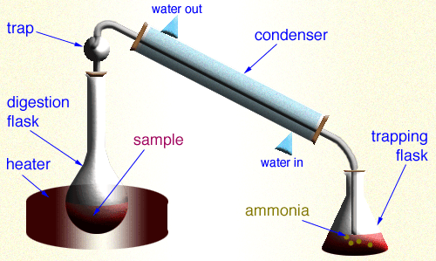
- Ether Extract (EE)
Principle:-
Crude fat or ether extract is estimated by extracting the known amount of feed sample through fat solvent like petroleum ether, hexane, benzene, diethyl ether, chloroform etc. for a time period of 5-6 hours at 55-60 ̊C in specially made Soxhlet’s apparatus.
- Take 1 gram (W₁) of feed sample in a piece of filter paper.
- Make a thimble of the paper so that sample may not leave the thimble during extraction.
- Pace it in the extractor tube of Soxhelet’s Apparatus.
- Adjust the apparatus with receiving flask having N-hexane or Petroleum ether as solvent.
- Dip the receiving flask in water bath and make sure that condenser is working properly and cool water is running through it.
- Maintain the temperature of water bath around 40-60ºC.
- Heat it for 4-6hours at the rate of 80-90 drops per minute.
- Solvent will rise up in the form of vapors, condensed and collected in the extractor tube and solvent will be siphoned back to receiving flask.
- Just before the end of the experiment, collect the solvent from collector tube in container just below the point where solvent is siphoned back to the receiving flask.
- Repeat this procedure until 3-4 ml of solvent left in the receiving flask.
- Transfer the contents of receiving flask in a pre-weighed (W₂) petri dish.
- Give 2-3 washing to flask with solvent for complete cleaning.
- Put the petri dish in an oven at 60 ̊C till all the solvent will evaporate.
- Place it in desiccator to cool down.
- Then weigh the petri dish (W₃)
EE (%) = (W₃-W₂)/W₁) ×100
Soxhlet Apparatus
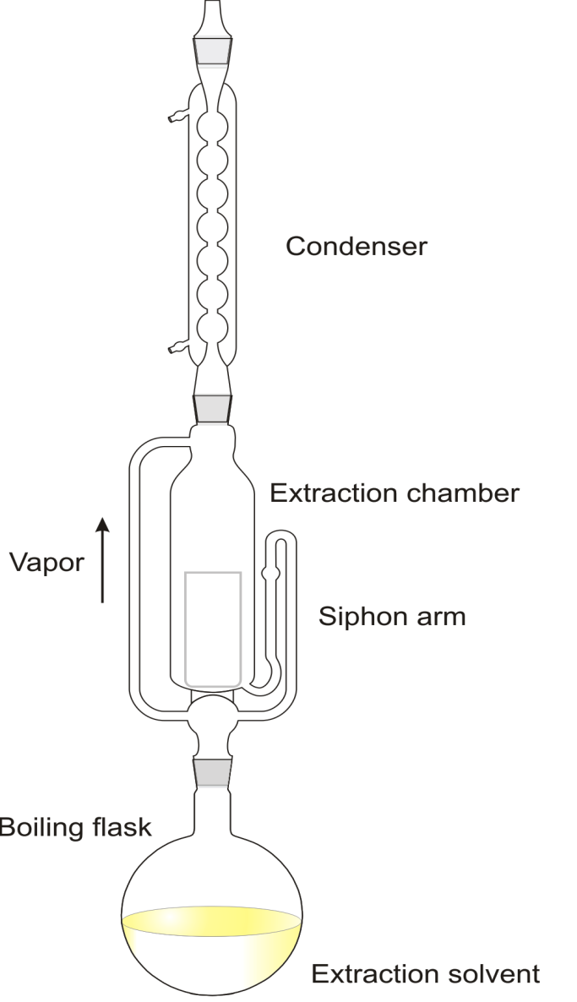
- Crude Fiber (CF)
- Take 1-2 grams (W₁) of feed sample in a beaker.
- Add 100 ml of 1.25% NaOH in it.
- Boil it very gently for half an hour.
- During boiling volume of solution should remain 100 mL. Add distilled water to cover any evaporative losses.
- After ½ hours filter the solution through ordinary cloth with the help of suction pump.
- Give 2-3 washing with distilled water.
- Transfer the residues in the beaker and add 100 ml of 1.25% of H₂SO₄ to it.
- Again boil it gently for 1/2 hours.
- Again filter it with suction pump and give 2-3 washings with water.
- Transfer the residues in a pre-weighed crucible.
- Put the crucible in an oven at 105 ̊ C for few hours.
- Remove the crucible from oven and place in desiccator.
- Weigh the crucible after cooling it (W₂).
- Ignite the crucible at oxidizing flame till no more fumes evolve.
- Put the crucible in furnace at 550 ̊ C for 2 hours.
- Remove the crucible, cool it down in desiccator and weigh it (W₃).
- Calculate the crude fiber by following formula

CF (%) = (W₂-W₃)/W₁) × 100
Suction Pump for Filtration
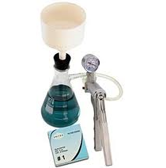

- Ash
Principle:
The feed or fecal matter contains both organic & inorganic matter in it. When such sample is heated at 550 ̊C for 5 hours or at 650 ̊C for 2 hours the organic matter get oxidized as CO₂. The remaining material left is the inorganic matter.
- Take 2 gram of sample in pre-weighed crucible (W₁)
- Char it at oxidizing flame till no more fumes evolve.
- Transfer it in furnace at 550̊C for 5 hours.
- Remove the crucible from furnace.
- And place it in oven at 105ºC for 10-15 minutes to reduce the temperature of crucible.
- Then remove the crucible from oven and place it in desiccator to cool down.
- Then weigh the crucible again (W₂).
- Calculate the %ash by using following formula.
Organic matter (%) = (W₁-W₂)/W₁) × 100
Ash (%) = 100- % Organic matter
Muffle Furnace
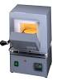
- Nitrogen Free Extract
It mostly includes sugars and starches and also some of more soluble hemicelluloses and some of more soluble lignin. It is not necessary to determine nitrogen free extract chemically. This required only a simple mathematical calculation. It is determined by difference that is all those fractions discussed as far are added together and subtracted from 100 as follows.
Calculation:
Nitrogen free extract (%) = 100 – (CP% + EE % + CF% + Ash%)

GENERAL ANALYSIS TESTS
Determination of Neutral Detergent Fiber (NDF)
Reagents
- Neutral detergent solution (ND): 18.6gm of EDTA + 6.8gm of sodium tetraborate + 100ml of distilled water + 30ml of sodium lauryl sulfate + 10ml of 2-ethoxyethanol.4.54gm of disodium hydrogen phosphate + 100ml of water, cool and mix the above solution in this one and make up to volume 1000ml with water.
- Acetone
- Sodium sulfite
Procedure
- Take 1gm of dry, well-ground homogenized feed sample and pas through 1mm mesh in 500ml capacity flask.
- Add 0.5g of sodium sulfite.
- Add 100mL of ND solution across the wall of cylinder otherwise soap will form.
- Rapidly bring to boiling temperature and boil gently for an hour while placing the watch glass on the flask for condensing purpose.
- Remove the flask, cool and filter through suction assembly.
- Wash the residue with hot water (85-95 ̊C) to remove ND solution and then acetone (20mL) to remove water.
- Shift the residue in crucible and put at 105 ̊ C till constant weight.
- Weigh the residue. Residue will have NDF and silica.
- Burn the sample for determine NDF or use it for ADF determination.
Determination of Acid Detergent Fiber (ADF)
Reagents
- Acid detergent solution (AD solution)
- Acetyl trimethyle ammonium bromide + sufficient amount of 1N H₂SO₄ to dissolve it and make up the volume 1000ml with water.
- Acetone
- 72% H₂SO₄
- NaOH
- Phenolphthalein
Procedure of ADF determination
- Take 1gm of sample in 500mL capacity flask and add to it 100mL AD solution across the wall of flask to avoid soap formation.
- Place watch glass on the flask and bring it to boil rapidly and then gently boil for an hour.
- Remove, cool and filter through suction assembly.
- Give washing with hot water (85-95 ̊C) and finally with 5mL of acetone.
- Shift in a china crucible and place in an oven at 105 ̊C for 3 hours.
- Cool and weigh the residue.
- Residue will have ADF and silica.
- Determine ADF from weight loss after burning the residue in furnace at 550ºC for 2 hours.
Hemicellulose
Hemicellulose can be calculated by subtracting ADF from NDF. Because NDF contains cellulose, hemicellulose and lignin while ADF contains cellulose and lignin so hemicellulose may be calculated as follows:
Hemicellulose (%) = NDF% -ADF%
Procedure of cellulose determination
- Place crucible + residue left after boiling with AD solution in 250ml capacity beaker and add 5ml of 72% H₂SO₄ in the crucible.
- Mix the contents with the help of glass rod.
- Cover the beaker for hour.
- Again add 72% H₂SO₄ in the crucible shake well and again cover the beaker for 1 an hour.
- Again add 75% H₂SO₄ in crucible in amounts that spills away from crucible in to the beaker.
- Place a cover on beaker for an hour. In this way whole cellulose will be solubilized in the acid and hydrolyzed into glucose.
- Add water into the beaker to make up about 100mL volume.
- Filter it and give several washings with water to remove the entire acid form residue.
- Give final washing with 5mL of acetone.
- Place the residue in china dish and place in an oven at 105 ̊C for 1-2 hours and then weigh it.
- Weight lost will be the cellulose and the rest is silica and lignin.
Procedure of lignin determination
- Burn the residue left over cellulose determination on oxidizing flame.
- Place the crucible in muffled furnace at 500 ̊C for 2 hours.
- Lignin will be oxidized and calculate the content of lignin as lost weight.
Procedure of silica determination
- Rest of residue remaining in crucible after burning in furnace is silica.
Inorganic phosphorus
- Extract inorganic phosphorus from feed stuff with 0.75M trichloracetic acid.
- Decolorize the extract with charcoal.
- Concentration of phosphorus is determined in the extract with help of spectrophotometer.

INGREDIENT SPECIFIC TESTS
KOH Solubility (Soybean Meal)
Principle:
KOH solubility is conducted to estimate the extent of cooking of soybean meal. Soy protein is more soluble in 0.2% KOH solution when it is undercooked and less soluble when it is overcooked. So, in first step protein is dissolved in 0.2% KOH solution and then amount of KOH soluble protein is estimated by the principle of CP determination.
- Take 1.5 gram of well ground, homogenized sample who’s crude protein has already been determined.
- Sieve the sample through US No. 60 mesh in a container.
- Add to it 75 ml of 0.2% KOH solution and stir it for 20 minutes.
- After that take a part from this solution and centrifuge it for few minutes at 2000 rpm.
- Take 10mL of supernatant in Micro-Kjeldahl digestion flask for digestion.
- Add 5g of digestion mixture and 25 mL of concentrated H₂SO₄ to the digestion flask.
- Then follow the procedure of crude protein determination to estimate the protein value of the sample.
- Calculate KOH solubility by using following formula.
- 73-85% values are indicates of optimally cooked soybean meal.
10mL of solution contains CP = A
75ml of solution contains CP = A/10 x 75 = B
1 gram of sample contain CP = B/1.5 = C
Actual crude protein of that sample = D
KOH solubility = C/D x 100 = E%

Urease Activity (soybean Meal)
This test is also aimed at the estimation of extent of cooking of soybean meal during processing.
- Dissolve 0.14 gram of phenol res in 7mL of 0.1 N NaOH and 35 mL of water.
- Dissolve 21g of reagent grade urea in 300 ml of water
- Dissolve these 2 solutions in each other.
- Adjust the urea-phenol solution to amber color by titrating with 0.1N H₂SO₄.
- Place 1 teaspoon of soybean meal in a petri dish.
- Wet the sample evenly by adding amber colored phenol red solution drop wise.
- Let it stand for 5 minute and read reaction according to following rule.
- Very active: 75% of more area is covered with active red or pink particles. Estimated rise in pH = 2.0.
- Active: 50% or more area is covered with active red or pink particles. Estimated rise in pH = 0.3-0.5.
- Moderately active: 25% of more area is covered with active red of pink particles. Estimated rise in pH = 0.05-0.1.
- Trace activity: 1-5active red or pink spots. Estimated rise in pH = 0.02-0.05.
- Not Active: No visible red or pink particle. Estimated rise in pH = 0.
- Over Cooked: No red or pink particles in additional 25 minute.

