Practical 1

Introduction to Microsoft Project

- Microsoft Project is a software program designed to assist project managers. It is a powerful tool with many options and features to help a project manager to develop schedules, track project progress, manage resource assignment, produce reports etc. These practicals are only an introduction to Microsoft Project to give you an appreciation of some of the features you can expect from project management software. However, if you plan to use a tool like Microsoft Project in the workplace you should study the capabilities of the software in more depth so that you are aware of the various options available to you (and have an understanding of the subtleties associated with some of those options). If you wish to learn more about Microsoft Project 2013, there are excellent books available on the market (e.g. “Microsoft Project 2013 the missing manual” by Bonnie Biafore) as well as videos and tutorials that can be found online.
- If you have not done so already, create a folder for the course you are studying (e.g. PPMP20007) and then create a subfolder within this course folder called ProjectPracticals. You will save the work that you do in practical 1 in the ProjectPracticals folder in a file called practical1.
- Open Microsoft Project.
- Select “blank Project”
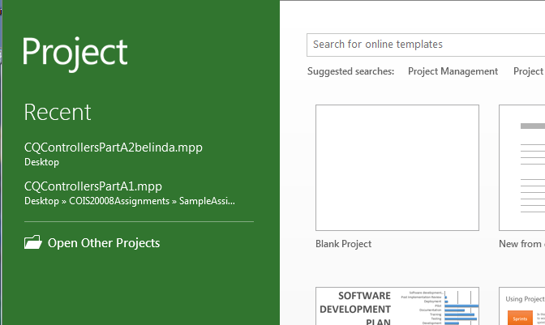
Microsoft Project opens with a Gantt Chart view.
In the first window on the left hand side you will see the task and duration columns.
If necessary, expand this window (using the “split bar”) to view the start, finish, predecessor and resource columns. 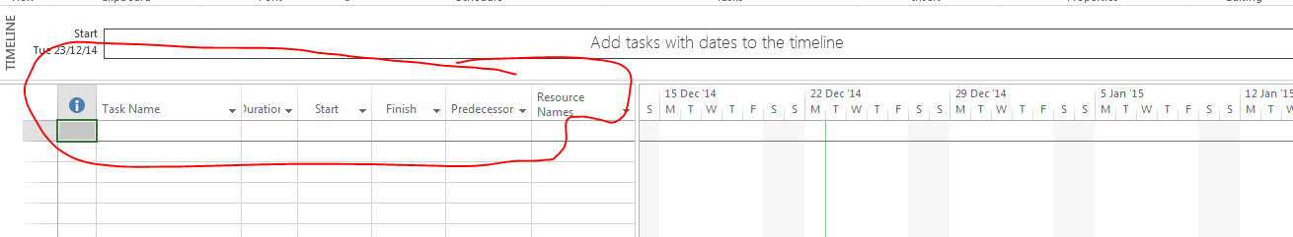
The window on the right hand side is a calendar that will display a Gantt chart view of your project.
Along the top you will see the options available on the “ribbon” for the task “tab”. You will also see various other tabs - file, resource, project, view and format.
- Explore the various options (e.g. if you click on the File tab you will see New, Save, Print, Help options etc.).
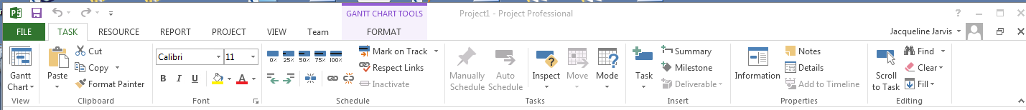
- Click on the View tab and view the drop down options under “Gantt chart”.
Observe that the Gantt chart option has been selected.
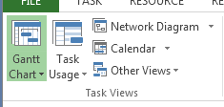

- Note that there are various options if you click on the down arrow on the Gantt chart and note that there are more views available. When you have developed your first schedule (at the end of practical 2), you can try out some of the alternative views (e.g. network diagram).

- Hover over an icon or option in the ribbon. You should see a pop-up window telling you the function of the icon. (e.g. if you hover over the Network Diagram option the pop-up window will explain the purpose of the Network Diagram view - “display tasks represented as boxes ….”).
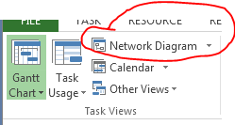
You will get the opportunity to view your schedule using the Network Diagram view in practical 2.
As you can see Microsoft Project provides you with a large number of options and functions. These lab exercises will introduce the basic steps to allow you to develop a schedule, add resource information and track the progress of a project.
You may like to spend some time becoming familiar with the various ribbons and options available before continuing with the practicals. Note that options on the Team ribbon are beyond the scope of this course.

Creating a New Project File

Create a blank Project
- You created a blank project when you clicked on “blank project” at the beginning of this practical.

Enter Project Information – change the start date
- Click the Project tab and select Project Information.
The Project Information dialog box will now be displayed. This allows you to set dates for the project, select the calendar to use etc. The start date will be set to today’s date by default.
- Set the start date to Monday of next week. You achieve this by selecting the date in the calendar and then clicking OK. The Project Information dialog box will now disappear. (Note that the screen shots shown in this document will have different dates to your exercises. The screenshots in this document were created in 2015 and are only representative of what you should see.)

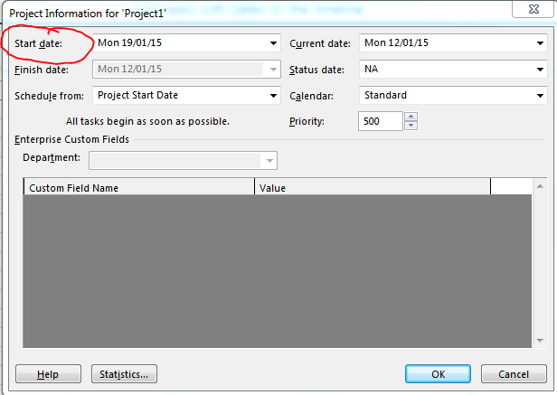

Enter Project Properties – change the title and author
- Click the File tab and select Info to view the project information on the right-hand side.
- Click on the “Project Information” drop down box on the right-hand side (above the information about the start date etc.)
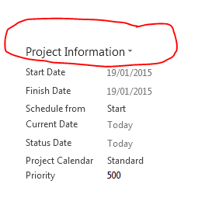
- Select “Advanced Properties”.
- Type New Billing System in the Title text box and type your name in the Author text box, then click OK.
- Click on the “back-arrow” symbol to return to the normal view of the project.
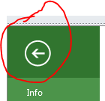

Enter holiday information
- Click the Project tab (if it is not already selected) and select “change working time” from the Properties group.
- You will see the “change working time” window appear.
The standard calendar (Project calendar) is the default. Note that it assumes a 5 day working week with 8 hour days and Saturday and Sunday as the non-working days of the week.
To enter additional holidays etc., you must enter and name the exceptions in the exceptions tab of the table at the bottom of the window. For the purpose of this exercise, we will assume that you need to enter the Xmas and New Year holidays and that this company always takes 2 weeks of leave over Xmas and New Year. The holiday is to commence on the 24th of December and finish two weeks later (10 working days).
- Enter the 2 weeks of Xmas holiday information in the table. Call the exception “Xmas vacation”. If you click on the drop down box in the start column, you will be able to use the calendar that appears to select the start date. You can set the finish date in a similar way.
- Your dialog box should appear similar to the screen below, although the year may be different depending on when you complete these practicals.
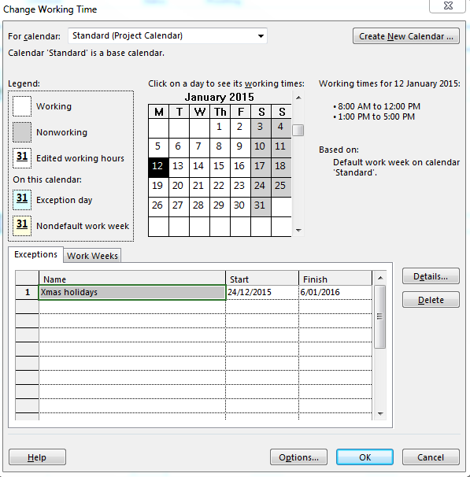
Enter the WBS
Assume that you have already worked out your work breakdown structure, resources, time estimates and predecessor/successor relationships for our example project.
- Click on the “Task tab”.
- Enter the following information in the “Task Name” column.
Requirements Analysis
Information gathering
Define Requirements
Disk Storage Upgrade
Purchase
Install
Software Modifications
Database Changes
Design DB Changes
Modify DB
Programs
Design Programs
Program A
Code program A
Unit test A
Program B
Code program B
Unit test B
Program C
Code program C
Unit test C
Program D
Code program D
Unit test D
Program R1
Code program R1
Unit test R1
Integration
Integrate
Test
Advertising Brochure
Design
Print
Mail Out
- To delete a task click on the task, right -click the mouse and select “delete task” from the menu. Try this now with the Modify DB task.
- To re- insert the Modify DB task, click on the “Programs” entry that was below the modify DB task that you just deleted. Right-click the mouse and select insert task. A new blank task should now be available for you to enter the Modify BD task. Enter the Modify DB task. (Note that you could have used the undo arrow to get the modify db task re-inserted. There are undo and redo arrows available at the top of the Microsoft Project window if you make an error.)

