Chapter No 12
Online Communities

Online community is a virtual community whose members interact with one another via internet.
- Examples: Facebook, twitter, G-mail, Skype.
It is virtual community and its members are connected through internet. They do have their interaction with each other through internet and physically they might be far from each other but virtually they are connected to each other.
An online community purpose is to serve as common ground for people share the same set of values and interest. 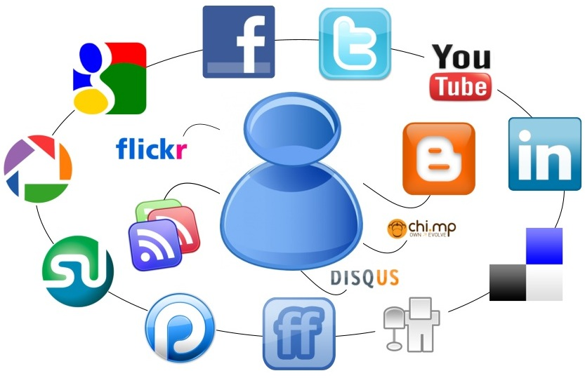
Online communities:
- online communities are generally regarded as online ‘spaces’

- used for a variety of social and professional groups interacting via internet

- Depend upon social interaction and exchange between user online

- Can be organizational, regional or topically depending on the business

- Have different levels of interactions and participation among their members

- Organization both large and small are setting up internal

Types of online communities:
- Collaborative group
- Social spaces
- Ethnic groups
- Geographical related
- Educational
- Customer community
- Media community
- Consumer community
- Partner community
- Event Community
- Internal Community
- Online trading
- Online banking
- Video Call

Online Features:
- Blogs
- invite friends
- Wiki
- advertising engine
- Discussion forums
- Community Chat
- Groups
- Opinion Polls
- Media Sharing (Video, Picture, Audio……)
- News Letter

- Categories of online communities
We can divide the online communities into following categories:
News group, forums and emails: Member can share and view the information in delayed fashion.
Instant messaging and chat: Immediate sharing of thoughts with community members
Content: Information, article and news about specific topic to a particular group
- Characteristics of online community:
Online communities may exhibit following characteristic, for example:
- They provide neutral ground for all parties;
- Easily accessible and highly accommodating;
- Conversation is the main activity;
- They allow people to keep a low profile, and a few others.
While these may be characteristics to help classify online communities, they may not all apply to a specific online community nor does an online community need to embody each of these characteristics.
- Participants of online community:
We can divide the online community participants into two major type:
- Public participation : public participants, or posters, are those who join virtual communities and openly express their beliefs and opinions
- Non-public participation, also called lurking. Lurkers are participants who join a virtual community but do not contribute.
Both lurkers and posters frequently enter communities to find answers and to gather general information.
For example, there are several online communities dedicated to technology. In these communities, posters are generally experts in the field who can offer technological insight and answer questions, while lurkers tend to be technological novices who use the communities to find answers and to learn.

Online Expectations

Following are the expectation from any online community members
As a contributor to Community Forums and Email Discussion List,
You should:
- Understand that all posts are in the public domain.
- Check your facts on anything you post. Do not under any circumstances post virus warnings or anything else designed to be "forwarded to everyone you know" to list or the forum.
- Treat other members of the forums and email list with the respect you want to receive in return. You never know when you'll actually be auditioning for your next position. Please report bullying or any indecent behaviour to us.
- Summarize email responses sent directly to you and post the entire summary back to the list. A summary should include attributions so others can pick up conversations offline if necessary with original posters. When you send a summary back to the list, use the word "SUMMARY" as the first word of the "Subject" line.
- Edit all unnecessary quoted messages of your email posts, and make sure that you send only plain text messages and no attachments to the list.
- Quote only the most relevant part of a previous post when you post to the forums.
- Make sure your email address is included in the body of the message you post to the email discussion list.
- Create a professional profile when registering for the forums.
- If you find SPAM on the Community Forums/Email Discussion list. Report the matter to concern site admin or forum admin immediately so that relevant solution could be made to kill the SPAMs.
You should NOT:
- Directly attack anyone for anything on the list. Take issue with ideas, not personalities. This is the easiest way to be evicted from our community.
- Point out other members' grammatical, spelling, or usage errors. This forum is not the place to exercise editorial frustration.
- Express political, religious or cultural opinions. Other forums are designed for these kinds of debates, they are not appropriate for professional community.
- Post ads in any form (see above).
- Say anything that you wouldn't want others to find with a search engine, because your emails are archived and indexed. Remember, both emails and forum posts are searchable by major search engines.
- Register using your work address, because people change jobs and it's sometimes impossible to gain access to that email if there's an issue.

Web Pages
What is web page?
- A web page (or webpage) is a web document that is suitable for World Wide Web and the web browser. or
- A single, usually hypertext document on the World Wide Web that can incorporate text, graphics, sounds, etc.
A web browser displays a web page on a monitor or mobile device. The web page is what displays, but the term also refers to a computer file, usually written in HTML or comparable Mark-up language. Web browsers coordinate the various web resource elements for the written web page, such as style sheets, scripts and images, to present the web page.
Two types of web pages:
- Static
Static pages show the same content each time they are viewed.
- Dynamic:
Dynamic pages have content that can change each time they are accessed.
These pages are typically written in scripting languages such as PHP, Perl, ASP, or JSP.`

Difference between website and webpage:
A Web page is not the same thing as a Web site. A Web site is a collection of pages but a Web page is an individual HTML document. This is a good distinction to know, as most techies have little tolerance for people who mix up the two terms.

Security considerations while developing web pages:

Web development takes into account many security considerations, such as data entry error checking through forms, filtering output, and encryption. Malicious practices such SQL as injection can be executed by users with ill intent yet with only primitive knowledge of web development as a whole. Scripts can be used to exploit websites by granting unauthorized access to malicious users that try to collect information such as email addresses, passwords and protected content like credit card numbers

Avoiding plagiarism and behaving ethically online

INTRODUCTION: Cases of plagiarism among professional writers have gained increasing media attention in recent years. As a result, many students of professional writing fear that they may be “stealing or committing intellectual “theft,” whenever they make use of any existing material in their writing. They have been warned against such uses by several sources

What Is Plagiarism?

Definition: In an instructional setting, plagiarism occurs when a writer deliberately uses someone else’s language, ideas, or other original (not common-knowledge) material without acknowledging its source.

However, as industry professionals in technical communication are well aware, the message is not that simple in our field. The issue of plagiarism is particularly contentious for technical and professional writers, as opposed to academic writers, because of the types of writing activities we regularly engage in. Technical communicators commonly perform a variety of types of composing activities that could be considered plagiarism in the context of the classroom. Such activities include:

Using boilerplate materials and templates

Relying on existing designs and layouts in the creation of texts

Collaboratively creating written works

Ghost writing texts for popular media consumption

Assigning the status of “honorary authorship” in published scientific research to lab supervisors or advisors who have contributed little to the writing process

Cutting, pasting, and re-purposing existing content, including collating information from technical documents and product specifications

Single sourcing

These common workplace writing practices do not follow the current model for single-authored, original works that is the focus of much technical communication writing instruction.

BUT CAN WORDS AND IDEAS REALLY BE STOLEN?
According to U.S. law, the answer is yes.

Turning in someone else's work as your own

Copying words or ideas from someone else without giving credit

Failing to put a quotation in quotation marks

Giving incorrect information about the source of a quotation

Changing words but copying the sentence structure of a source without giving credit

Using an image, video or piece of music in a work you have produced without receiving proper permission or providing appropriate citation is plagiarism.

Copying media (especially images) from other websites to paste them into your own papers or websites.

Making a video using footage from others’ videos or using copyrighted music as part of the soundtrack.

Performing another person’s copyrighted music (i.e., playing a cover).

Ethics code for online writers
Internet allows anybody with access to publish globally and instantaneously. This technological advance has changed the world for the better, but overall consideration of ethics has not kept pace with technology. In addition, while there is a free and casual attitude about much online writing, many online writers don't realize that they can be held accountable for theft of intellectual property, defamation and other acts.
Following are the main ethical consideration for online technical writers
Readers have the right to expect:
Original content. All content is the original creation of the author except when clearly attributed, such as by quotation marks, citations and credits.
Respect for intellectual property. All text, photos and other media from outside sources is republished only with the explicit permission of its owner or as authorized by an applicable license (e.g., Creative Commons), with the exception of brief quotations from written works in the context of discussing those works.
Links where credit is due: Where the creator of content referenced on this website has made it possible to link to that content, a link is given here. Where the content is not directly linkable, as in a book, a full citation or link to a general information page will suffice. In general, links are favoured over reproduction of content.
Disclosure of comps: Where a free or discounted product or service has been accepted, a corresponding disclosure is made.
No quid pro quo: Before accepting an invitation for a free or discounted product or service, the author advised the provider of that product or service that favourable coverage would not be provided in exchange for the comp, and that all reports on the product or service would represent the author's actual opinions.
Disclosure of conflicts of interest: Where the author has a relationship with the subject of coverage beyond a casual or typical customer relationship, that relationship is disclosed. Financial and employment relationships, including those of close friends, associates and family members, will also be disclosed.
Disclosure in the first instance: Where disclosures are required, they are made in the original entry on the subject. Repeated disclosures will not necessarily appear in subsequent entries in the same series. However, where separate discussion of the same subject occurs, re-acknowledgement is made with a separate statement or by linking to the original disclosure.
Fact checking: The author of any factual statement has made a good-faith effort to confirm the accuracy of that statement. Statements of opinion, however, are just that.
Corrections: Where factual errors are discovered or reported, corrections will be made promptly by editing or in a subsequent entry.
Faithfulness to the historical record: Except where overriding legal or ethical concerns prevail (such as when remedying an invasion of privacy), substantive changes and corrections will be made in such a way as not to distort the historical record: by noting "edited to add" or the equivalent, or by making clarifying statements later without changing the original.
Fair comment (for website operators): This website allows registered users to comment on the content contained herein. Free and fair comment will be permitted so long as it is civil and conforms to this website's terms of service, including this document.
Terms of service (for website operators): This website abides by a published list of rules that cover, among other things, participatory conduct, use of anonymity, and consequences for violations of the terms. It can be found by clicking the "Terms of Service" or equivalent link on any page of this website. Anyone posting on this site agrees to these rules in the act of registering to participate. Further, this site may operates on a platform (such as Blogger.com or WordPress.com) that has a separate terms-of-service document. This site adheres to those terms.

