INSTALLATION ART
Installation art is an artistic genre of three-dimensional works that are often site-specific and designed to transform the perception of a space. Generally, the term is applied to interior spaces, whereas exterior interventions are often called public art, land art or intervention art; however, the boundaries between these terms overlap.
Installation art can be either temporary or permanent. Installation artworks have been constructed in exhibition spaces such as museums and galleries, as well as public and private spaces. The genre incorporates a broad range of everyday and natural materials, which are often chosen for their "evocative" qualities, as well as new media such as video, sound, performance, immersive virtual reality and the internet. Many installations are site-specific in that they are designed to exist only in the space for which they were created, appealing to qualities evident in a three-dimensional immersive medium. Artistic collectives such as the Exhibition Lab at New York's American Museum of Natural History created environments to showcase the natural world in as realistic a medium as possible. Likewise, Walt Disney Imagineering employed a similar philosophy when designing the multiple immersive spaces for Disneyland in 1955. Since its acceptance as a separate discipline, a number of institutions focusing on Installation art were created. These included the Mattress Factory, Pittsburgh, the Museum of Installation in London, and the Fairy Doors of Ann Arbor, MI, among others.
Installation art came to prominence in the 1970s but its roots can be identified in earlier artists such as Marcel Duchamp and his use of the readymade and Kurt Schwitters' Merz art objects, rather than more traditional craft based sculpture. The "intention" of the artist is paramount in much later installation art whose roots lie in the conceptual art of the 1960s. This again is a departure from traditional sculpture which places its focus on form. Early non-Western installation art includes events staged by the Gutai group in Japan starting in 1954, which influenced American installation pioneers like Allan Kaprow. Wolf Vostell shows his installation 6 TV Dé-coll/age in 1963^{[3]} at the Smolin Gallery in New York.

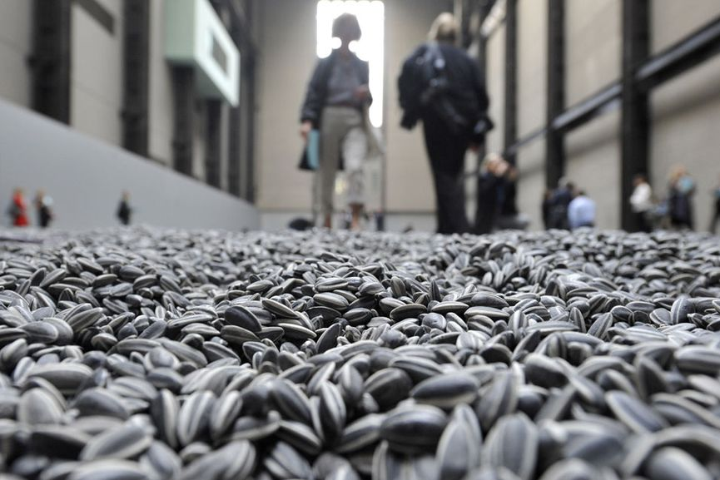

Ai Weiwei - The Dissident
One of the most controversial figures associated with installation art is certainly Ai Weiwei. Expanding the definition of art to include new forms of social engagement, his dramatic actions highlight the widening gap between the ideal and the real in Chinese society. Some of his most memorable pieces are the installation Remembering where he campaigned to bring justice to the victims of the 2008 earthquake in Sichuan, the installation Sunflower Seeds consisted of 100 million porcelain seeds made by 1600 artisans commenting on the mass production and consumption, and lately a controversial piece addressing the plight of Syrian immigrants.

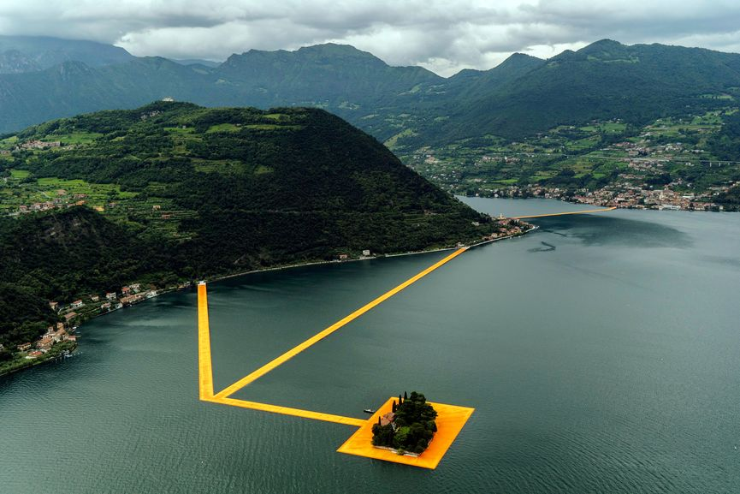

Christo - Enhancing the Genre of Land Art
Christo and his wife Jeanne-Claude enhanced the genre of land art, presenting a different approach to the environment and raising our expectations of it. Creating large-scale installations such as wrapping of the Reichstag in Berlin, Running Fence in Sonoma and The Gates in New York City’s Central Park, they have repeatedly rejected all theories that their projects contain any kind of deeper meaning other than their immediate aesthetic impact. After an artistic and personal relationship that lasted over fifty years, Jeanne-Claude died in 2009. Christo continued working, and this year, he created the most ambitious project ever. Conceived by the couple, but executed by Christo alone, Floating Piers was a monumental installation in Italy that consisted of 3 kilometers long runway that floats on water, allowing people to walk freely across it.

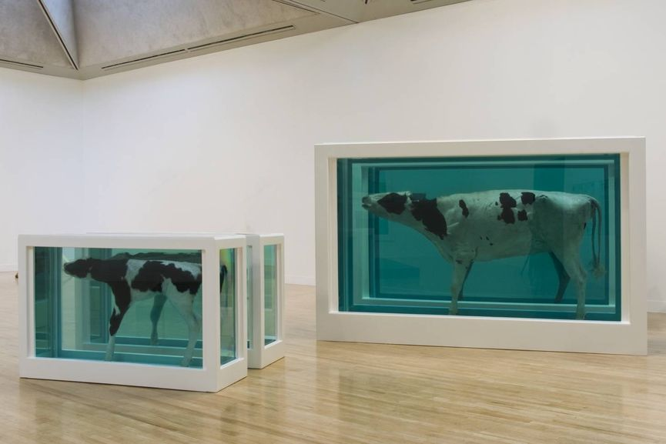

Damien Hirst - The Enfant Terrible
The wealthiest living British artist, Damien Hirst is a self-styled enfant terrible of contemporary art. Fusing any person’s biggest questions and concerns, his works explore the idea of death, how it fits into life, and how both of these interact with art. The piece A Thousand Years from 1991 that portrayed a dead cow’s head in a tank being consumed by maggots and flies, was the first of its kind, launching Hirst straight into the limelight of the artistic world of the 1990s. Involving an entire zoo of dead animals, his famous series Natural History included various preserved creatures placed in steel and glass tanks filled with formaldehyde solution. The piece from this series The Physical Impossible of Death in the Mind of Someone Living became representative of British art of the 20th century.

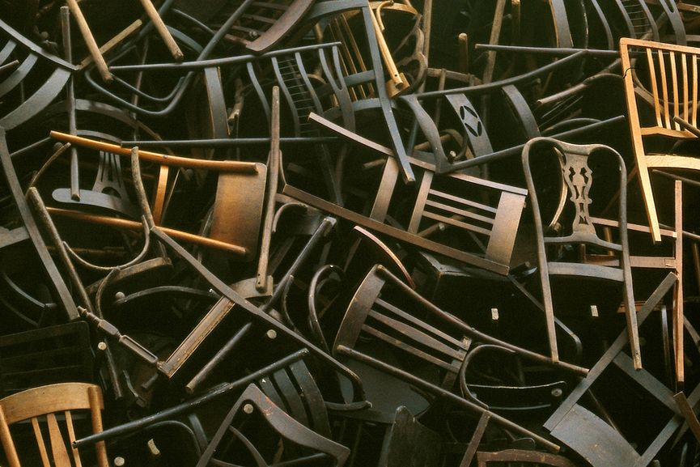

Doris Salcedo - Exploring Political and Mental Archeology
Sculptures and installations of Doris Salcedo function as political and mental archeology. Using domestic materials charged with different meanings, she depicts burdens and conflicts with precise economical means. Researching Columbia’s recent political history, her early sculptures such as La Casa Vuida combined domestic furniture with textiles and clothing directly linked to personal and political tragedy. Recently, her works became increasingly installation-based, turning the gallery space into vertiginous environments charged with politics and history. The piece Noviembre 6 y 7 from 2002 commemorating the seventeenth anniversary of the violent seizing of the Supreme Court in Bogota involved wooden chairs that were slowly lowered against the facade of the new Palace of Justice building. This created “an act of memory” that re-inhabited the space of forgetting.

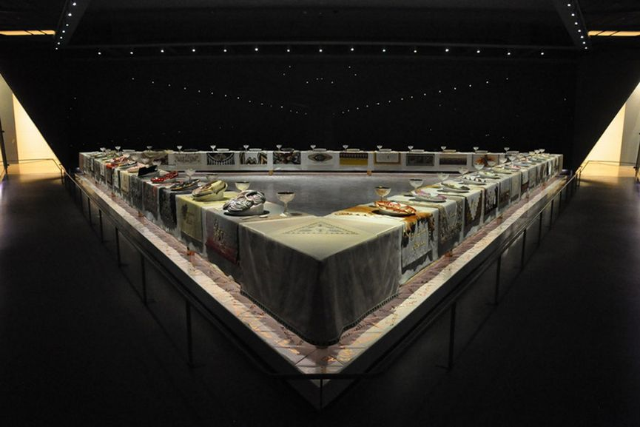

Judy Chicago - The Pioneer of the Feminist Movement
An American artist, art educator and writer, Judy Chicago is best known for her large collaborative art installation pieces which examine the role of women in history and culture. As one of the pioneers of the Feminist Art Movement in the 1970s, she called attention to women’s roles as artists and aimed to alter the conditions under which art was produced and received. As an attempt to redress women’s traditional underrepresentation in the visual arts, she placed the female subject in the center of her practice. Her most celebrated piece The Dinner Party from 1979 celebrated the achievements of women throughout history, featuring explicit vaginal imagery. She also employed “domestic” and “feminine” arts such as needlework and embroidery, introducing them to the world of high art.

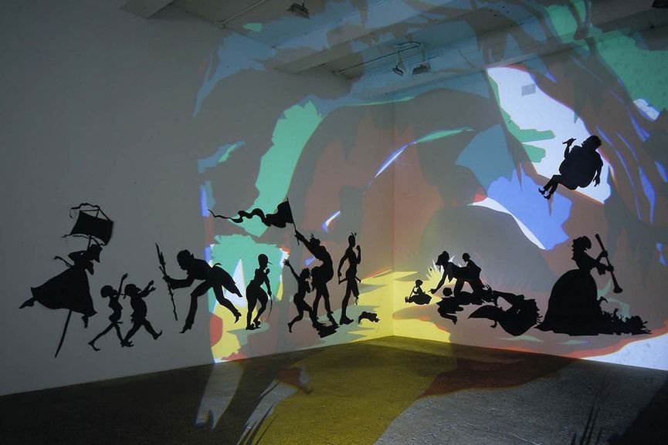

Kara Walker - Exploring the History of Racism
An African-American installation and conceptual artist, Kara Walker has been exploring the history of the American South with her wall-sized cut paper silhouettes. Exploring and illustrating histories of racism, these vignettes are drawn from various sources such as historical novels or slave testimonials. Using imagery of mammies, pickninnies, sambos and other racial stereotypes, these silhouettes present a powerful metaphor which she describes as something that “says a lot with very little information”. She invites the public to explore the origins of racial inequality, but also the vast social and economic inequalities that persist in America. Relying on humor and viewer interaction, her works are deeply engaging.

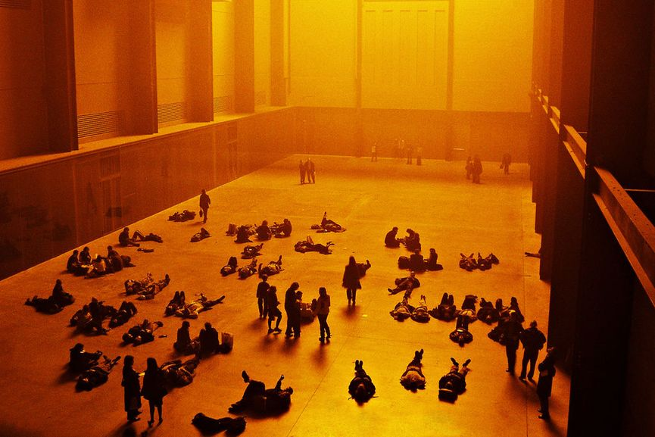

Olafur Eliasson - Taking Responsibility
Working with the purpose of turning thinking into doing, the art of Olafur Eliasson is relevant to the individual as well as the public. Concerned with the environment and its safety, he uses natural elements such as light, water, air temperature and fog with makeshift technical devices to transform museum galleries and public areas into immersive environments. One of his most famous works is The Weather Project from 2008 when Eliasson installed a giant artificial sun inside the Tate Modern. Among his famous art installations created outdoors, the project Green River included dying the rivers of Moss, Los Angeles, Bremen, Tokyo, and Stockholm with nontoxic powder to remind their inhabitants of its fluidity. “It is not just about decorating the world… but about taking responsibility,” Olafur Eliasson said of his practice in a 2009 TED Talk

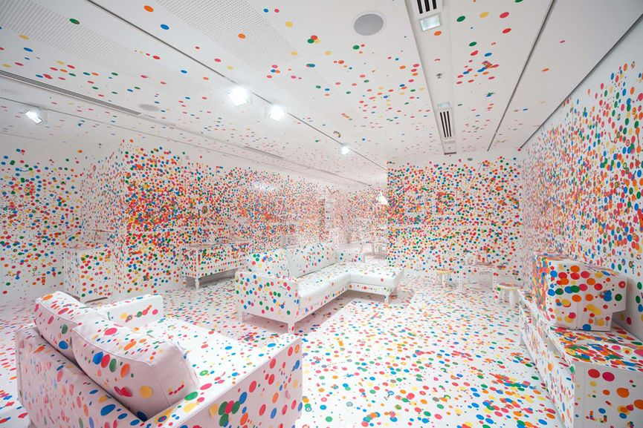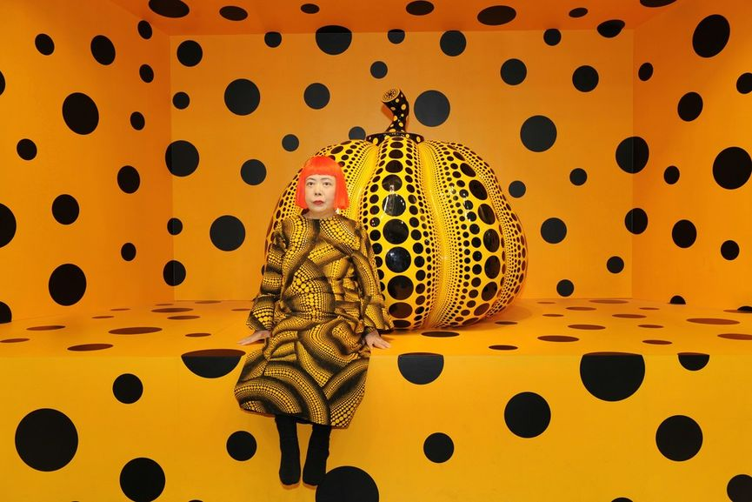

Yayoi Kusama - Creating an Immersive Sensory Experience
A famous provocative avant-garde artist from Japan, Yayoi Kusama is one of the most prominent figures in her country’s present-day culture. Becoming active in New York avant-garde circles during the formative years of Pop Art and Minimalism, her practice was seminal to the development of assemblage, environmental art, performative practices, and later, installation art. In the mid-1960s, she began developing her interests in the optics and interactive elements of mirrors, electric lights, sound and kinetics. Becoming famous for her provocative happenings and exhibitions, her extraordinary artistic endeavors spans various media and continues to appeal to the imagination and the senses. She has lived voluntarily in a psychiatric institution since 1977, traveling often to her studio in Tokyo. Much of her practice has been marked with obsessiveness and the struggle with her psychological trauma.

