REPORT: submitted to: Ma’am Mehlah Jabeen submitted by: Group no 08 Department: Mathematics Program: BS math 2nd Subject name: citizenship education and community engagement

Institution name: University of Sargodha sub campus Bhakkar TITLE: Providing basic information about electronic media and devices to children Group members: Ainee Fatima BMTF19BM040 Eman Khalid BMTF19BM008 Aqeedat Hussain BMTF19BM004 Kashaf Aftab BMTF19BM036 Rumsha nisar BMTF19BM054 Summary of the report: This project is done to provide a short course to those children who are (from 5th to 12th grade or class). As all of us know the critical situation of whole world and educational institution are closed due to the lockdown and as children are totally free that’s why we choose this project to teach how they can use electronic devices and internet as well. This project is done by the 5 members as mentioned above.
Ainee fatime BMTF19BM040

Devices provided by me: During my project I have provided different devices these are as follows …. Android phone OPPOA1k Android phone VIVO 1906 DELL latitude i5 DELL latitude i3 PC (personal computer) Data of the students: Abdulahad s/o M.shahid age 9 grade: 4 Ahmed zahid s/o Zahid age 13 grade:8
Abdullah s/o Aijaz Ali age 16 grade:10 Amina shahid d/O shahid qamar age 18 grade :2nd year Memona imran d/o Imran Ali age 16 grade:10 Aiman vasiq d/o Vasiq rana age 17 grade:1st year
Ali zman s/o Zman Mudassir age 12 grade:7
Fahim Raza s/o Abid Rao age 15 grade:9
Umer zman s/o zman mudassir age 12 grade:6
Time period of their tution:
4PM to 6PM
Detail of the workdone of theproject:
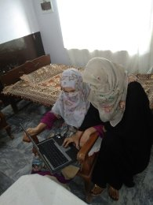
HER name is Amina shahid as mentioned above.
- As she is a mature girl of FSC pre medical so I taught her how to use laptop for creating a document in word processor and how to use Power Point to prepare a presentation.
- I taught her how she can use internet and how she canbrowse and search wanted information using Baidobrowser Opera Browser and Google chrome.,
- I gave her information about different apps and websites.
- I had asked her not to use internet and related devices to harass any one.
- I told her avoid negative use of all these things.
- I taught her about privacy settings and issues and all that.
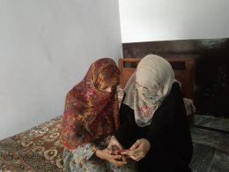
Her name is Aiman vasiq as mentioned before. She is also mature enough to understand the use of internet etc.
- First off all I had finished all of her confusions aboutthese devices and internet.
- She I taught her how can use GMAIL account andhow she can create GMAIL account.
- I gave her info how she can take different appsthrough play-store.
- I also told her about leg pulling, harassment andprivacy settings.
- I asked her how she can use these devices for herbeneficial use and how she can avoid negativethings.

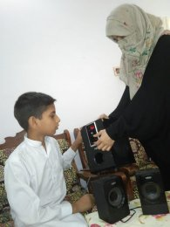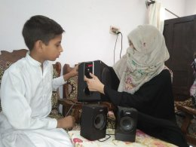
His name is Ali zman as he is grade 7 student so I gave him basic information about basic devices and entertaining activities like games , cartoons etc
- Taught him how he can on personal computer .
- How he can attach external speakers to the personal computer.
- I asked him the method of installing a game in cell phone.
- I told him the method of making a call and message and using different smart things and points of his age.
- I asked him to avoid extreme use of mobile or pc for entertainment.
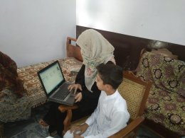
His name is fahim raza he is a student of grade 9.
- As he is big enough to understand the general use of electronic media and devices so firstly I gave her information practically the use of these devices.
- Then I told him the use of internet to search different things like educational data and essays past papers etc.
- And then I asked him the privacy settings and advised him to provoke the negativity.
- I asked her to avoid cyber bullying.
- I taught him the whole use of electronic devices for educational use.

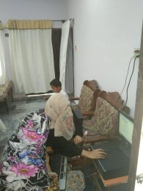
HER name is Memona imran her age is almost 16 and she is a student of Punjab college so she already knows different things to someextent.But I helped her to make clear more things like……..
- I told her how to write essay how to make and prepare presentation on Microsoft Power Point and Microsoft Word.
- I asked her how she can use social media like instagram, facebook twitter and tumbler.
- I also told her the most important thing in my point of view and that is about leg pulling and cyber bullying and harssment that how we should avoid all these evils courageously.
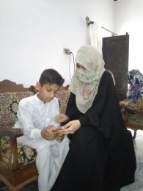
As mentioned above that he is of 12 year old and his name is umer zman so according to his age and mental level I had treated him.
- Firstly I gave him the basic information about social media and electronic devices. Then I taught how to make a call or message any one along with the privacy settings.
- Then I taught him to install a game and how he can get a meaning from dictionary and the installation of dictionary and other such useful things ,
- I told him the important info which was beneficial for him and according to his mental level.
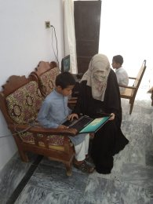
His name is Ahmad zahid and he is the student of grade 9.
- Firstly I told him how to on and off a laptop and how to upon a file and then exit.
- Then I taught how to install a program and use it like games and whatsApp.
- I taught him how to send and type message make a call as well as emergency call.
- Then I told him how to talk to a stranger in case of wrong call.
- Then I taught him about the basics of information technology and devices.
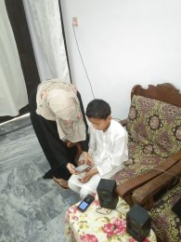
The name of this student is Abdul Ahad and his age is almost 9 year old and he is the student of grade 4.
- According to his age I provided him basic information about android phone to answer the coming call make a call and message and emergency call etc.
- I taught how to install a game and how to use different applications and his course is going on yet so gradually I will teach him many more things.
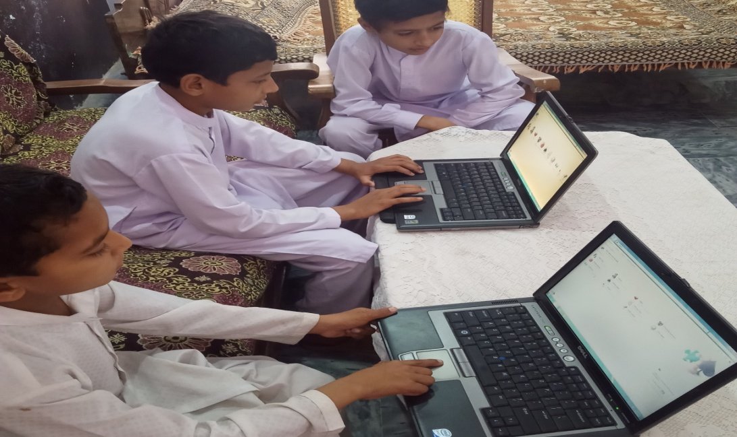
Importance of my project: After giving a very small amount of my time to the pearls of my country I realized that the reason of our backwardness is somewhat that we neglect our young generation. In fact the schooling is not only purpose to educate the children but we should do some efforts to elaborate their qualities and enhance their abilities so my project is very important because it is about teaching and all that. After I have completed my project I am able to teach children in a friendly way .I am extremely excited to do this because this helps them to broad their vision and do something perfect as I assure them that they can contact me ever they want.
THE END
Eman Khalid
BMAF19BMOO8

PROJECT: CITIZENSHIP EDUCATION AND COMMUNITY ENGAGEMENT
ROLL NO: BMAF19BM008
BSMATHEMATICS II
REPORT:
Title of the Project:
Providing basic information about electronic media and devices to children.
Introduction:
My project is to providing about IT, electronic media and electronic devices to those children who are unaware of these devices.
Actually, I belong to a village where people don’t know about social media and electronic devices except a few ones. So, I want to give information about social media and electronic devices to the children from class 3 to 10, so that, they don’t face difficulties in higher classes as we faced.
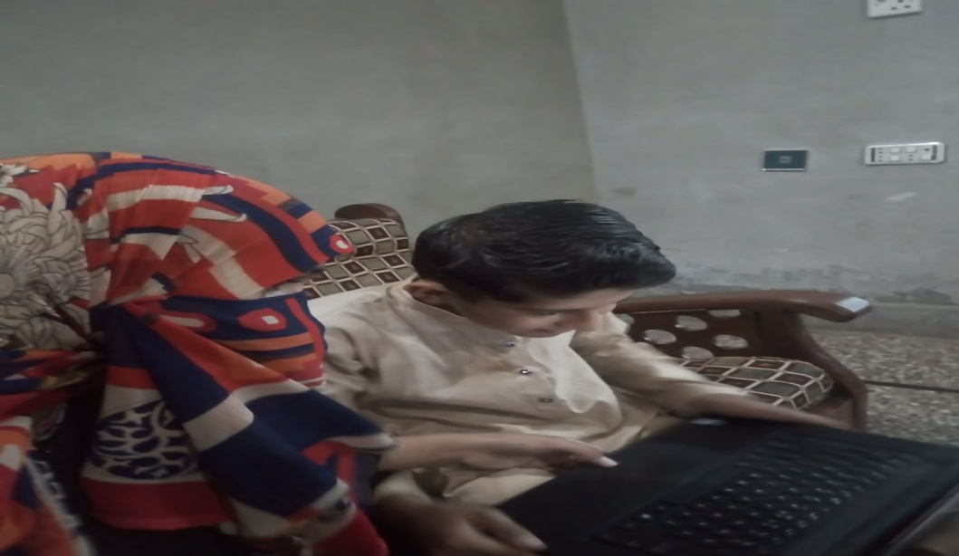
Objectives:
The main objective of my project is to make children able to operate electronic devices for the sake of knowledge. Also, I want to make them able to use electronic devices positively. In this competitive world, my project will help them in every step of their studies.
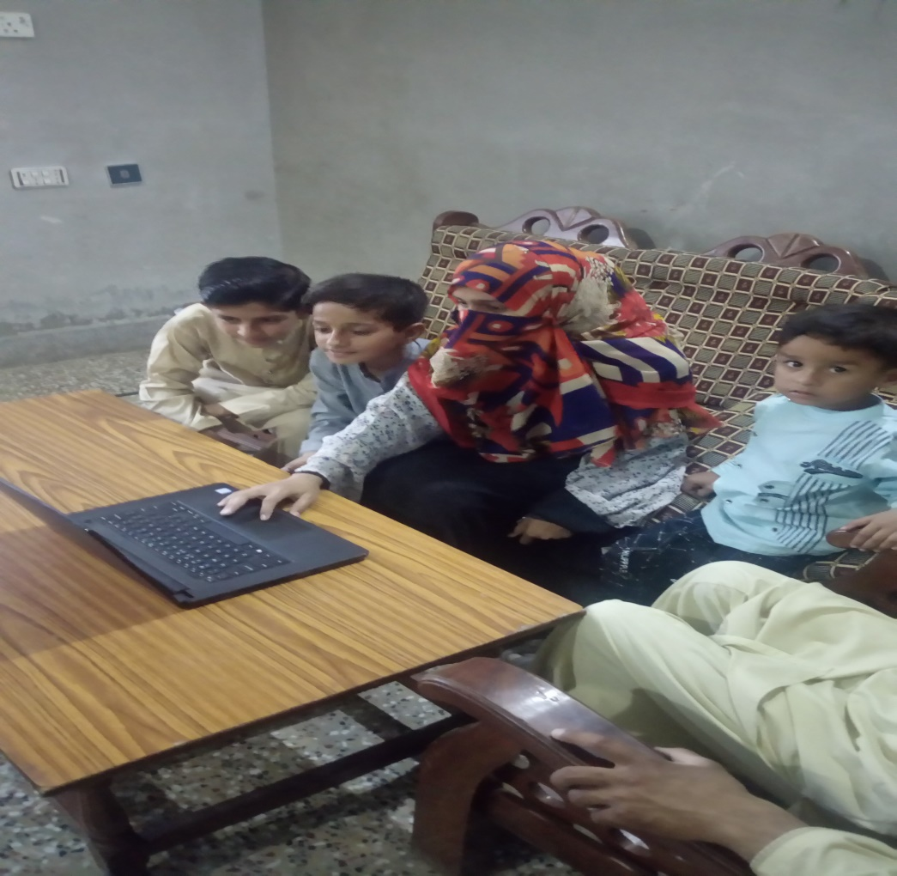
Plan of Action:
I have done my project in following steps,
- First of all, I have found out the children who need my help.
- Then I convinced their parents to send them to my house for learning.
- I have provided them free of cost classes
- I have told them how to operate electronic devices.
- I told them how to download different useful apps for their studies.
- I told them the use of MS Word. Power Point and MS excel to make slides and assignments.
- I have told them about different websites useful them.
- I told them how to share data between different devices.
- I will tell them not to cheat others through the negative use of these devices.
- I told them not to make unnecessary friends on internet.
- I have told them to apply privacy settings.
- I will assure them my help in future.
I hope that my project have helped the society somehow. I hope that you will appreciate my efforts.
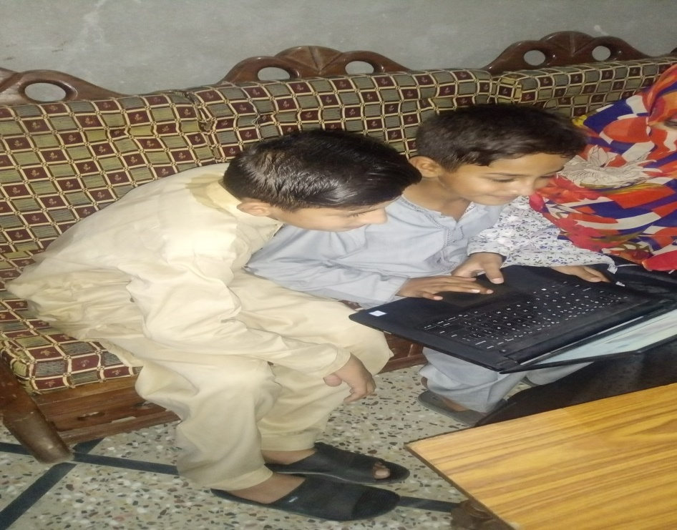
Importance of my project:
My project is somehow important for the students of my area who don’t know anything about technology. My project has helped the students to use computer and cell phone for the study purpose. I hope that, next time, the students will not go to anyone for help but will find the answers of their questions themselves using internet.
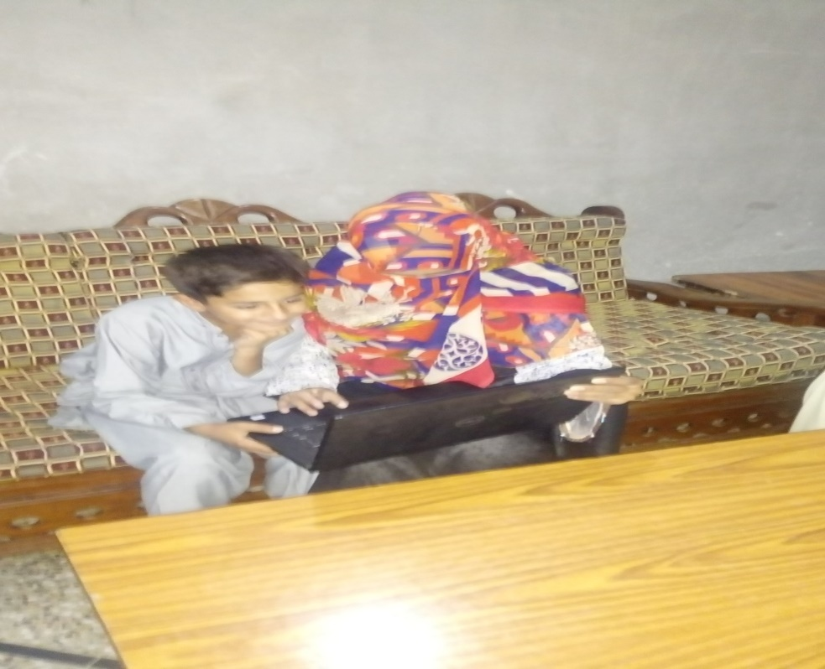
I have given my 100% to this project. I hope that you will like my small efforts.
THE END

Rumsha Nisar
BMTF19BM054
Project:Citizenship Education And Community Engagement.
Roll No: BMTF10BM054
BS Mathematics Il
Report:
Title of project:
Providing Basic Information About Electronic Media And Devices.
Introduction:
Actually my project is providing basic information about IT,electronic media and electronic devices being used now-a-days like mobile phones,typing pad.And my aim is to provide information about socialmedia to those children who was unaware about these devices.

Report Of Project:
- First of all ,I went to the houses of many children and conviced their parents to send their children.
- I teached them how to use mobile phones and laptop.I told them about information and technology.

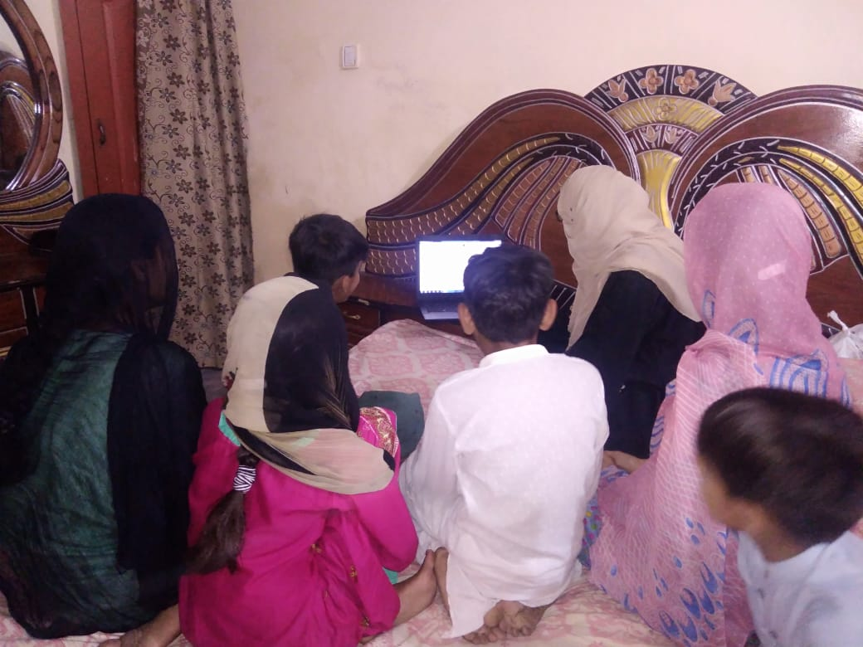
- I teached them how they can get help in their studies from internet.

- I told the students from class three to six that how they can call their parents in difficulty.
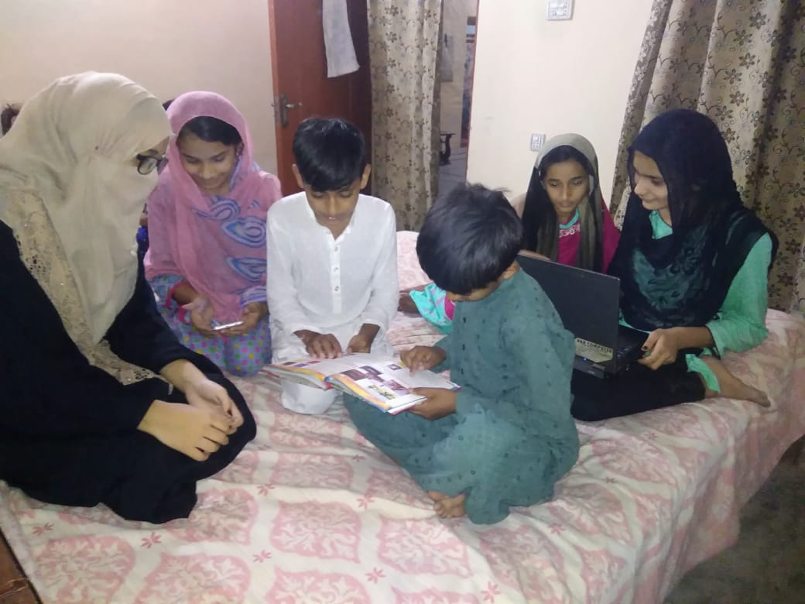
- I teached the students of 10th class how to make assignments and presentations on laptop.
- I teached them about privacy setting.
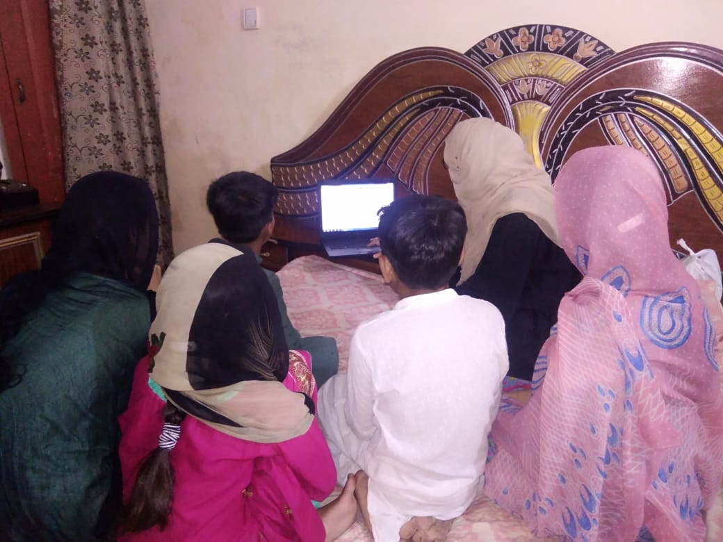
- I teached them how to use electronic media in positive way.
- I teached them different apps and websites use in daily life.
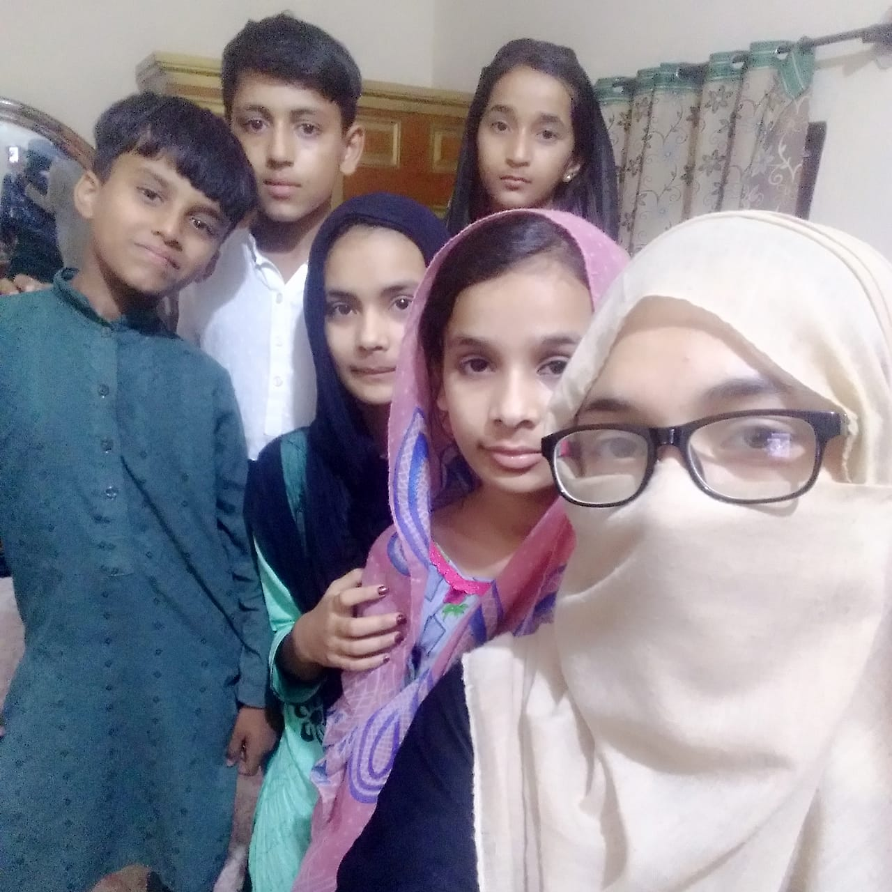it

Importance of my project:
My project is very useful for those students who don't know about information of technology and social media.They don't know about the use of mobile phones and MS Word.

The End
AQEEDAT HUSSAIN
BMA19BM004

IMPORTANCE
The project is very important because in this project I taught the children about computer and its uses. Through this project children learned how to use computer. This project is for learning about electronic media. I gave awareness to children about the use of computer and electronic media. They learnt to use computer for their benefit. This project is useful for children who were unaware of the use of computer.
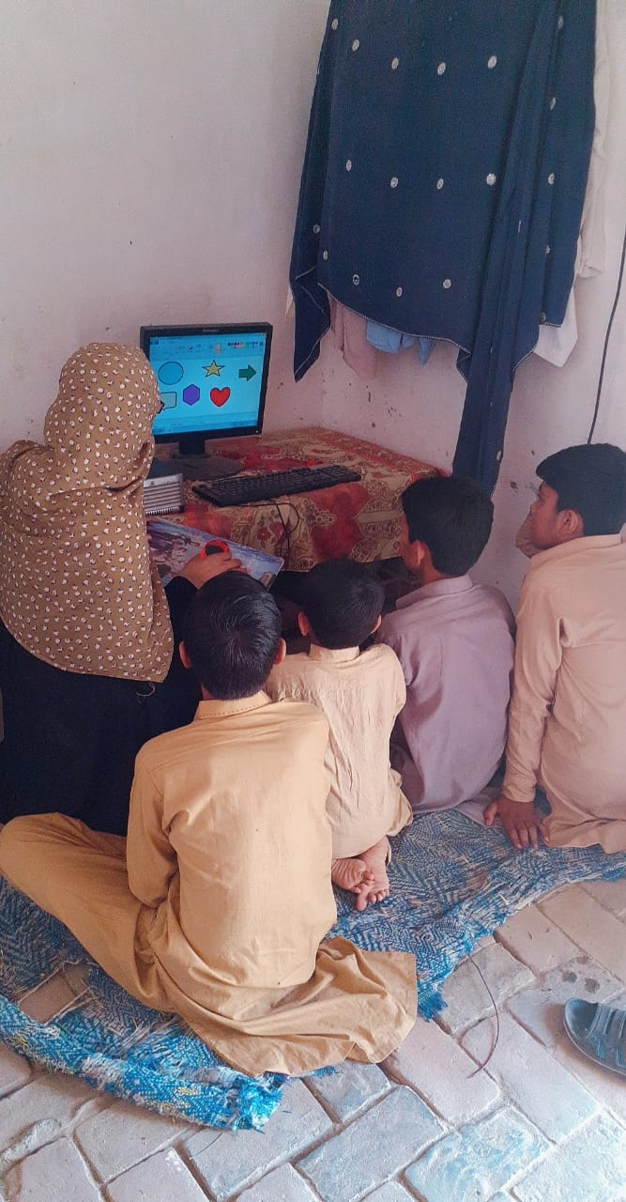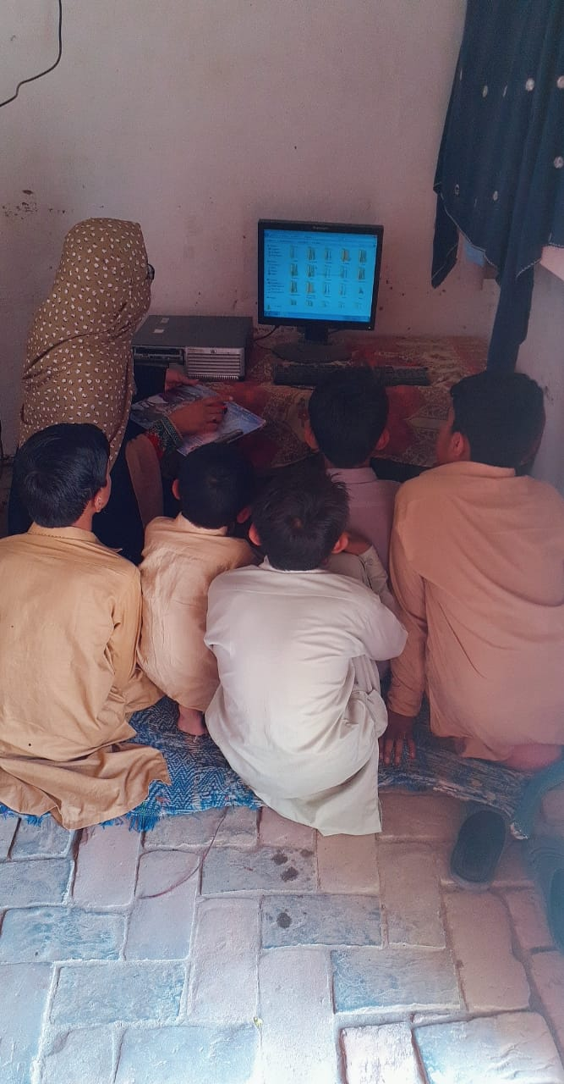
REPORT
About Children:
I have taught 05 students.
- Mohammad Aslam Age 13 years Class 07
- Mohammad Danish Age 12 years Class 06
- Abdul Raffi Age 08 years Class 05
- Atta Mohammad Age 13 years Class 07
- Mohammad Ismail Age 14 years Class 08
First of all, I met the parents of children for send their children to learn computer system. Then, children came to my home and I told them about computer.
- Aslam was unable to painting. I taught him how to paint and sketch thing on computer.
- Danish was unable to start computer. I told him how to operate computer and other applications.
- Raffy was unable to open window, I told him about the applications of computer.
- Atta Mohammad did not know the basics of computer. I helped him in that case.
- Ismail was unable to open the PC and about all uses of computer. I told him how to open the PC and told him about the uses of computer.
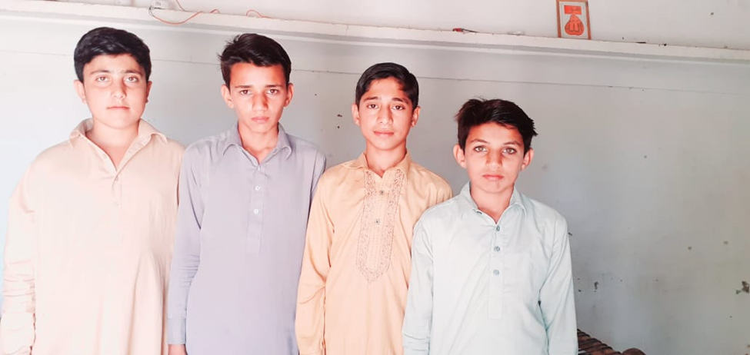
Devices used in my project:
I have used a PC in my project. The model of my PC is 12.
- I told the children to open the PC.
- I told them about working of the computer.
- I told them about painting.
- I told them about the uses of computer in our daily life.
- I told them the use of computer for gaming and also for studies.
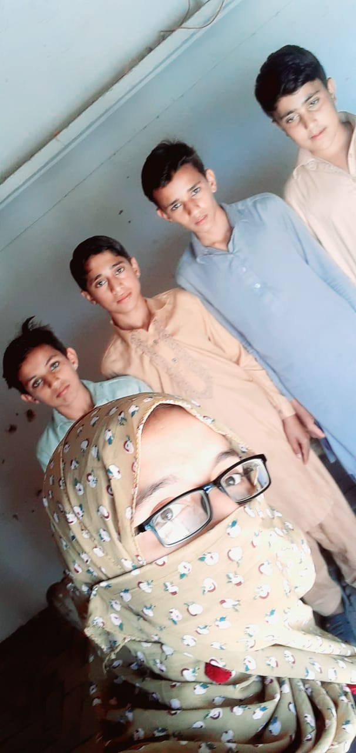

THE END

Kashaf Aftab
BMTF19BM036
Report Of Project:
- First of all,I insisted the parents of these children who are unaware of my selected topic.
- SecondlyI arranged the needed things like internet communication and other devices that are required.
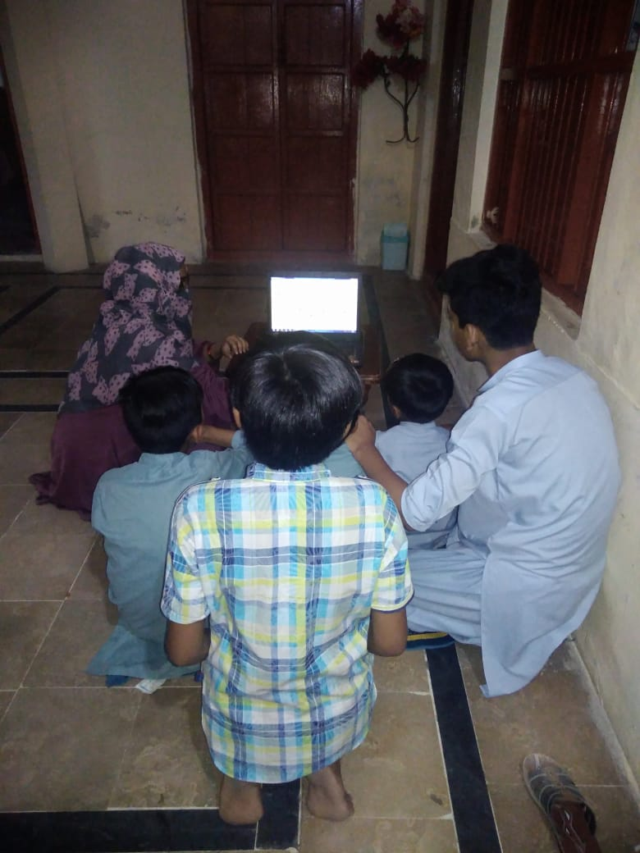
- Then I was start teaching them.
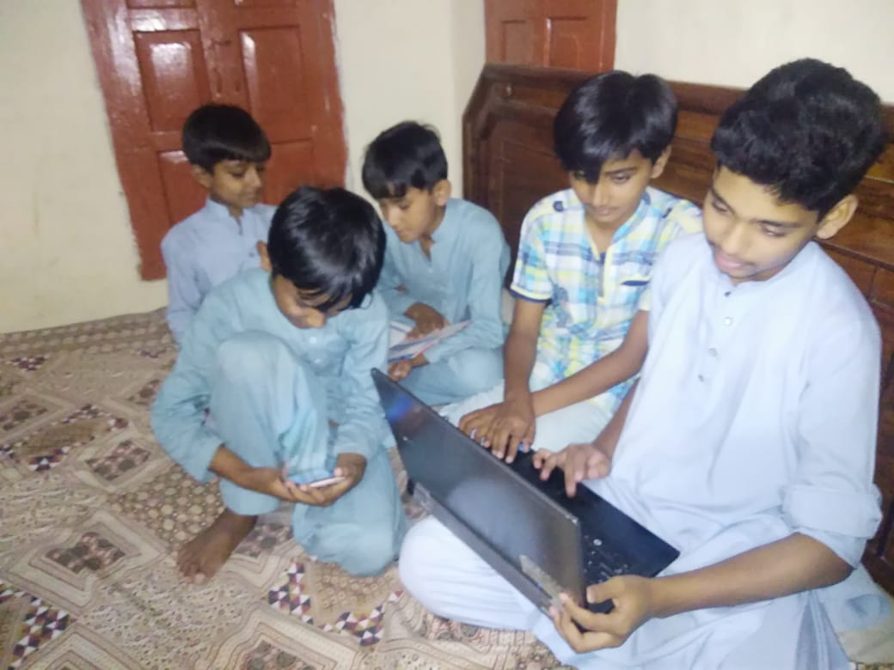

- I told them how they can get help from internet in their studies.
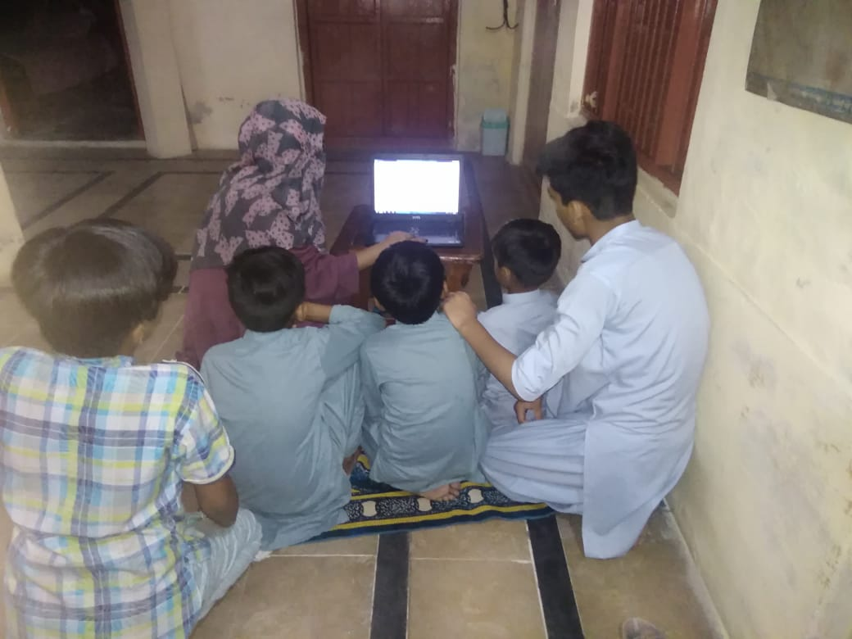

- I teached them how they can search different things on internet.
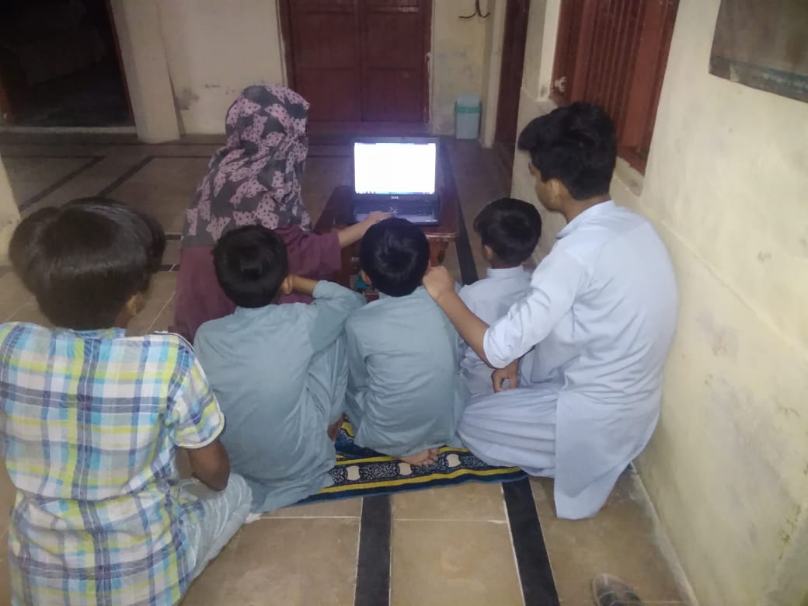

- I teached them the use of MS Word, other websites and apps useful to them.
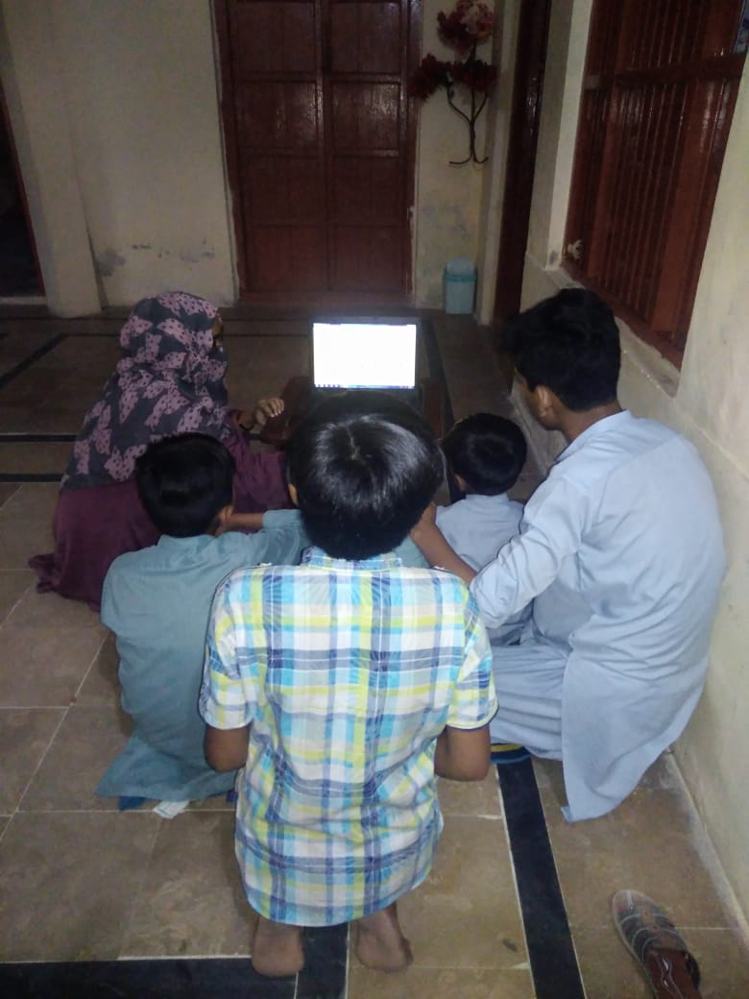
- I told them the importance of internet.

- I also told them about privacy setting.
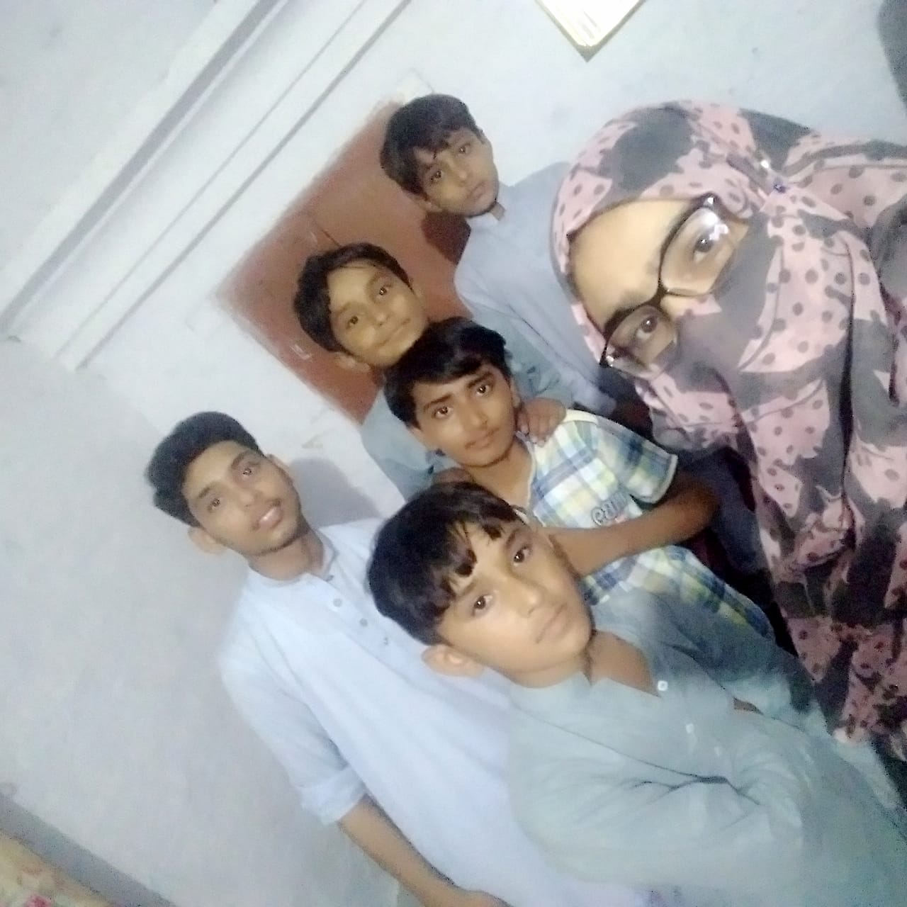

The End

