Topic: Mitosis

CELL LIFE AND REPRODUCTION
The eukaryotic cells spend most of their "life" in interphase of the cell cycle, that is subdivided into the three phases, G1, S and G2. During interphase, the cell preforms its expected functions. Though, the cell has many common functions, such as DNA replication, it also has certain specific functions. For example; a heart cell, would surely perform certain different activities than a kidney cell or a liver cell. The remaining part of the cell cycle is used for cell division: dividing the nucleus and cytoplasm.
“The cell cycle is a series of events that takes place in a cell as it grows and divides, a cell spends most of its time in what is called an interphase during which it grows replicates the DNA and prepares for cell division.”
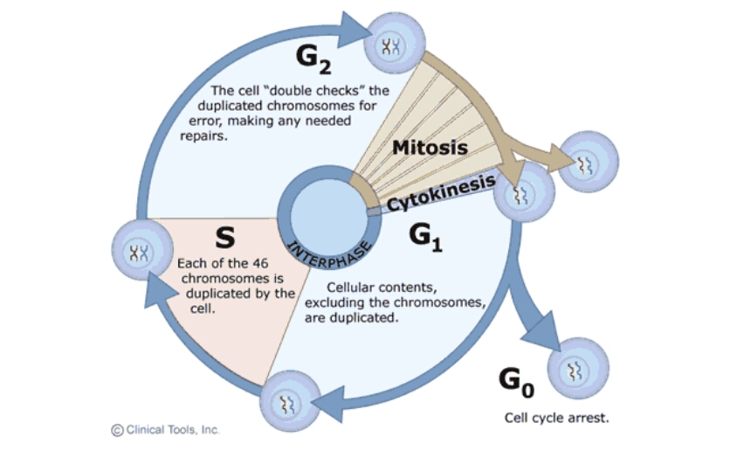

WHAT EXACTLY IS MITOSIS?

“Mitosis is a part of the cell cycle, in which, replicated chromosomes are separated into two new nuclei. Cell division gives rise to genetically identical cells in which the total number of chromosomes is maintained.”

The mitotic division is preceded by S-phase of interphase
In general, mitosis (division of the nucleus) is preceded by the S stage of interphase (during which the DNA is replicated) and is often followed by cytokinesis; which divides the cytoplasm, organelles and cell membrane of one cell into two new cells containing roughly equal shares of these cellular components. The different stages of Mitosis all together define the mitotic (M) phase of an animal cell cycle—the division of the mother cell into two daughter cells genetically identical to each other
Discovery: The term "mitosis", coined by Walther Flemming in 1882, is derived from the Greek word μίτος (mitos, "warp thread)
PHASES OF MITOSIS
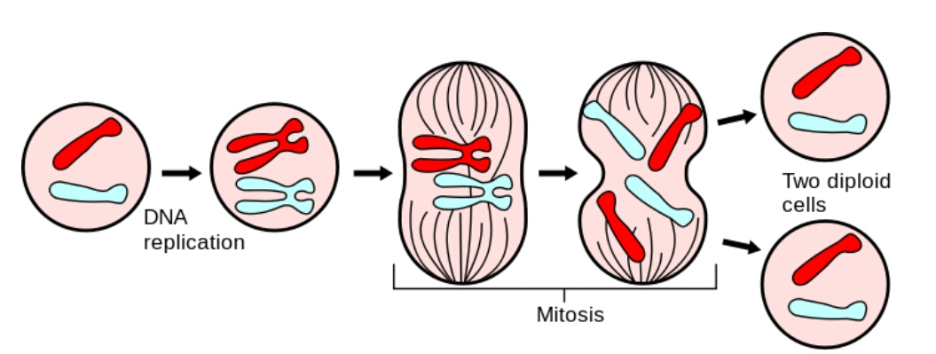
The cell spends most of its life in the INTERPHASE WHICH COCSISTS OF:
- First gap (sometimes referred to as growth) phase, G1. During this phase, a cell undergoes rapid growth and the cell performs its routine functions. During this phase the biosynthetic and metabolic activities of the cell occur at a high rate. The synthesis of amino acids and hundreds of thousands or millions of proteins that are required by the cell occurs during this phase. Proteins produced include those needed for DNA replication. If a cell is not dividing, the cell enters the G0 phase from this phase.
- The G0 phase is a resting phase where the cell has left the cycle and has stopped dividing. Non-dividing cells in multicellular eukaryotic organisms enter G0 from G1. These cells may remain in G0 for long periods of time, even indefinitely, such as with neurons. Cells that are completely differentiated may also enter G0. Some cells stop dividing when issues of sustainability or viability of their daughter cells arise, such as with DNA damage or degradation, a process called cellular senescence. Cellular senescence occurs when normal diploid cells lose the ability to divide, normally after about 50 cell divisions.
- Dividing cells enter the Synthesis (S) phase from G1. For two genetically identical daughter cells to be formed, the cell's DNA must be copied through DNA replication. When the DNA is replicated, both strands of the double helix are used as templates to produce two new complementary strands. These new strands then hydrogen bond to the template strands and two double helices form. During this phase, the amount of DNA in the cell has effectively doubled, though the cell remains in a diploid state.
- The second gap (growth) (G2) phase is a shortened growth period in which many organelles are reproduced or manufactured. Parts necessary for mitosis and cell division are made during G2, including microtubules used in the mitotic spindle.
THE MITOTIC PHASE OCCURS AFTER THE INTERPHASE, it has two further parts
- The division of nucleus: karyokinesis
- The division of cytoplasm: cytokinesis
Now, the karyokinesis is further divided into four phases which are: prophase, metaphase, anaphase and telophase.
- PRE-PROPHASE
In plant cells only, prophase is preceded by a pre-prophase stage. In highly vacuolated plant cells, the nucleus has to migrate into the center of the cell before mitosis can begin. This is achieved through the formation of a phragmosome, a transverse sheet of cytoplasm that bisects the cell along the future plane of cell division. In addition to phragmosome formation, preprophase is characterized by the formation of a ring of microtubules and actin filaments (called preprophase band) underneath the plasma membrane around the equatorial plane of the future mitotic spindle. This band marks the position where the cell will eventually divide. The cells of higher plants (such as the flowering plants) lack centrioles; instead, microtubules form a spindle on the surface of the nucleus and are then organized into a spindle by the chromosomes themselves, after the nuclear envelope breaks down. The preprophase band disappears during nuclear envelope breakdown and spindle formation in prometaphase.

- PROPHASE
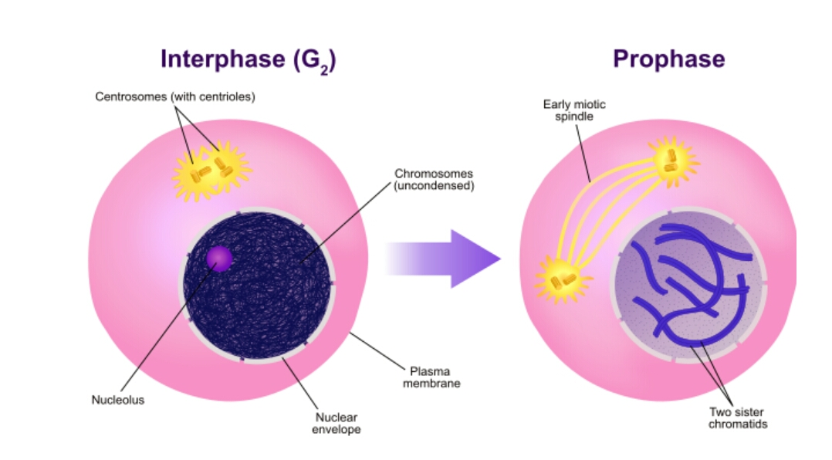
Prophase is the first and longest phase of mitosis. During prophase, the chromatin (DNA) coils up into visible chromosomes, each made up of two sister chromatids held together by the centromere. Also, during this phase, the nucleolus disappears, and the spindle begins to form. Most animal cells contain structures known as centrosomes, consisting of a pair of centrioles. During prophase, the centrioles begin to move to opposite ends, or poles, of the cell. As the centrioles migrate, the fiber-like spindle begins to elongate between the centrioles. The spindle is a thin, cage-like structure made out of microtubules. In plant cells, the spindle forms without centrioles. The spindle plays an essential role moving chromosomes and in the separation of sister chromatids

- PRO-METAPHASE
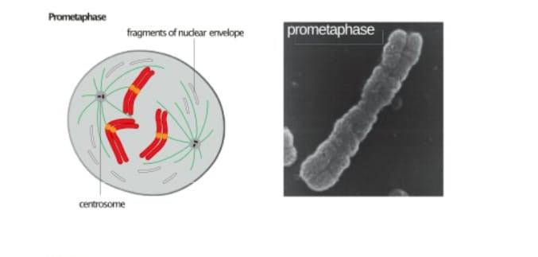
At the beginning of prometaphase in animal cells, the nuclear envelope disintegrates into small membrane vesicles. When this happens, microtubules invade the nuclear space. This is called open mitosis, and it occurs in some multicellular organisms. Fungi and some protists, such as algae, undergo a variation called closed mitosis where the spindle forms inside the nucleus, or the microtubules penetrate the intact nuclear envelope.
In late prometaphase, kinetochore microtubules begin to search for and attach to chromosomal kinetochores. A kinetochore is a proteinaceous microtubule-binding structure that forms on the chromosomal centromere during late prophase. A number of polar microtubules find and interact with corresponding polar microtubules from the opposite centrosome to form the mitotic spindle.
- METAPHASE
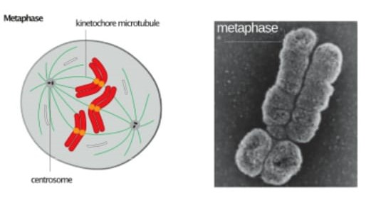
After the microtubules have located and attached to the kinetochores in prometaphase, the two centrosomes begin pulling the chromosomes towards opposite ends of the cell. The resulting tension causes the chromosomes to align along the metaphase plate or equatorial plane, an imaginary line that is centrally located between the two centrosomes (at approximately the midline of the cell). To ensure equitable distribution of chromosomes at the end of mitosis, the metaphase checkpoint guarantees that kinetochores are properly attached to the mitotic spindle and that the chromosomes are aligned along the metaphase plate. If the cell successfully passes through the metaphase checkpoint, ONLY THEN, it proceeds to anaphase.
- ANAPHASE
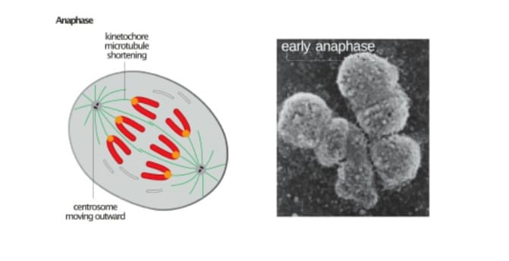
Anaphase is the phase in which the sister chromatids separate. The sister chromatids are pulled apart by the shortening of the microtubules of the spindles. One sister chromatid moves to one pole of the cell, and the other sister chromatid moves to the opposite pole. This process occurs when the proteins that bind sister chromatids together are cleaved, resulting in unattached identical chromosomes, essentially separate daughter chromosomes. These separate chromosomes are pulled apart by shortening spindle fibers, and pulled toward the centrosomes to which they are attached. At the end of anaphase, the spindle fibers degrade. At this time, each pole of the cell has a complete set of chromosomes, identical to the amount of DNA at the beginning of G1 of the cell cycle.
There are two parts of anaphase Anaphase-A and anaphase-B: During anaphase A, the cohesions that bind sister chromatids together are cleaved, forming two identical daughter chromosomes. Shortening of the kinetochore microtubules pulls the newly formed daughter chromosomes to opposite ends of the cell.
During anaphase B, polar microtubules push against each other, causing the cell to elongate. In late anaphase, chromosomes also reach their overall maximal condensation level, to help chromosome segregation and the re-formation of the nucleus. In most animal cells, anaphase A precedes anaphase B, but some vertebrate egg cells demonstrate the opposite order of events.

- TELOPHASE
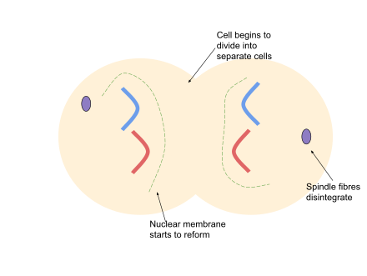
Telophase (from the Greek word τελος meaning "end") is a reversal of prophase and prometaphase events. At telophase, the polar microtubules continue to lengthen, elongating the cell even more. If the nuclear envelope has broken down, a new nuclear envelope forms using the membrane vesicles of the parent cell's old nuclear envelope. The new envelope forms around each set of separated daughter chromosomes (though the membrane does not enclose the centrosomes) and the nucleolus reappears. Both sets of chromosomes, now surrounded by new nuclear membrane, begin to "relax" or decondense. Mitosis is complete. Each daughter nucleus has an identical set of chromosomes. Cell division may or may not occur at this time depending on the organism.
AS KARYOKINESIS ENDS THE PROCESS OF CYTOKINESIS BEGAINS
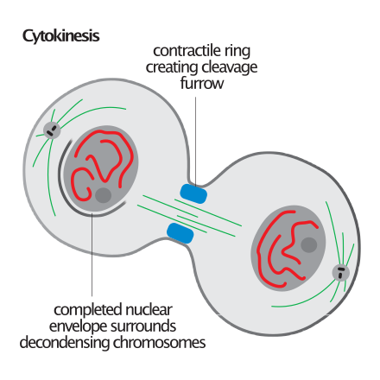
Cytokinesis is not a phase of mitosis but rather a separate process, necessary for completing cell division. In animal cells, a cleavage furrow (pinch) containing a contractile ring develops where the metaphase plate used to be, pinching off the separated nuclei. In both animal and plant cells, cell division is also driven by vesicles derived from the Golgi apparatus, which move along microtubules to the middle of the cell. In plants, this structure coalesces into a cell plate at the center of the phragmoplast and develops into a cell wall, separating the two nuclei. The phragmoplast is a microtubule structure typical for higher plants, whereas some green algae use a phycoplast microtubule array during cytokinesis. Each daughter cell has a complete copy of the genome of its parent cell. The end of cytokinesis marks the end of the M-phase.
There are many cells where mitosis and cytokinesis occur separately, forming single cells with multiple nuclei. The most notable occurrence of this is among the fungi, slime molds, and coenocytic algae, but the phenomenon is found in various other organisms. Even in animals, cytokinesis and mitosis may occur independently, for instance during certain stages of fruit fly embryonic development.
Plant cells have walls, so cytokinesis cannot proceed with a cleavage furrow. Instead, during telophase a cell plate forms across the cell in the location of the old metaphase plate.
During telophase, membrane-enclosed vesicles derived from the Golgi apparatus migrate to the center of the cell where the metaphase plate used to be and fuse to form a cell plate. Eventually, the growing cell plate fuses with the existing plasma membrane, producing two daughter cells, each with its own plasma membrane. A new cell wall forms between the two membranes of the cell plate.
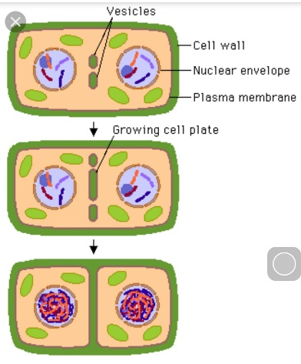
IMPORTANCE OF MISOSIS
Mitosis is a very important phenomenon, which has a vital role in the sustainability of life. Without mitosis a lot of life functions would have been impossible. Mitosis helps in a great deal of functions, some of which have been stated below:
- Development and growth of body
Development and growth: The number of cells within an organism increases by mitosis. This is the basis of the development of a multicellular body from a single cell, i.e., zygote and also the basis of the growth of a multicellular body.

- Regeneration and cell replacement
Cell replacement: In some parts of the body, e.g. skin and digestive tract, cells are constantly sloughed off and replaced by new ones. New cells are formed by mitosis and so are exact copies of the cells being replaced. In like manner, red blood cells have a short lifespan (only about 4 months) and new RBCs are formed by mitosis.
Regeneration: Some organisms can regenerate body parts. The production of new cells in such instances is achieved by mitosis. For example, starfish regenerate lost arms through mitosis.

- A-sexual reproduction
Asexual reproduction: Some organisms produce genetically similar offspring through asexual reproduction. For example, the hydra reproduces asexually by budding. The cells at the surface of hydra undergo mitosis and form a mass called a bud. Mitosis continues in the cells of the bud and this grows into a new individual. The same division happens during asexual reproduction or vegetative propagation in plants.
THE DIFFERENT TYPES OF MITOSIS
The mitosis process in the cells of eukaryotic organisms follow a similar pattern, but with variations in three main details. "Closed" and "open" mitosis can be distinguished on the basis of nuclear envelope remaining intact or breaking down. An intermediate form with partial degradation of the nuclear envelope is called "semi open" mitosis. With respect to the symmetry of the spindle apparatus during metaphase, an approximately axially symmetric (centered) shape is called as "orthomitosis", distinguished from the eccentric spindles of "pleuromitosis", in which mitotic apparatus has bilateral symmetry. Finally, a third criterion is the location of the central spindle in case of closed pleuromitosis: "extranuclear" (spindle located in the cytoplasm) or "intranuclear" (in the nucleus).
- Closed intranuclear pleuromitosis is typical of Foraminifera, some Prasinomonadida, some Kinetoplastida, the Oxymonadida, the Haplosporidia, many fungi (chytrids, oomycetes, zygomycetes, ascomycetes), and some Radiolaria (Spumellaria and Acantharia); it seems to be the most primitive type. Fig :
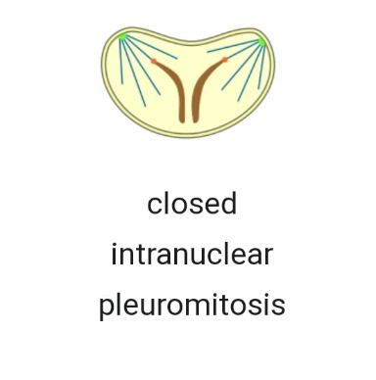
- Closed extranuclear pleuromitosis occurs in Trichomonadida and Dinoflagellata. Fig;
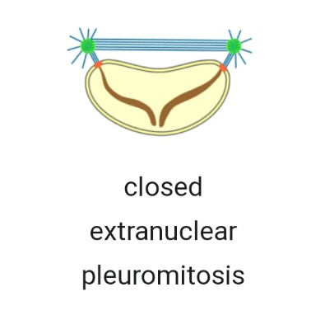
- Closed orthomitosis is found among diatoms, ciliates, some Microsporidia, unicellular yeasts and some multicellular fungi. Fig:
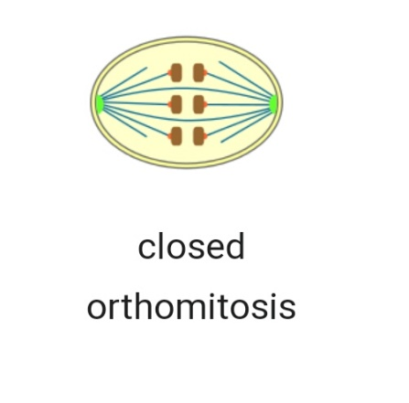
- Semiopen pleuromitosis is typical of most Apicomplexa. Fig:
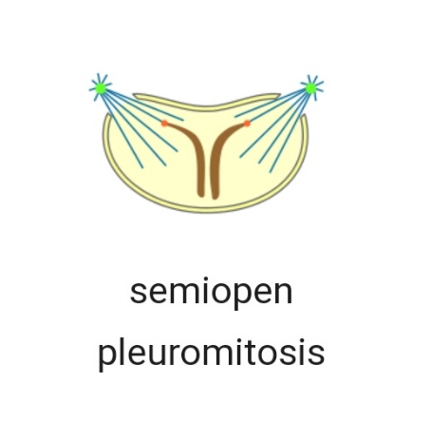
- Semiopen orthomitosis occurs with different variants in some amoebae (Lobosa) and some green flagellates (e.g., Raphidophyta or Volvox). Fig;
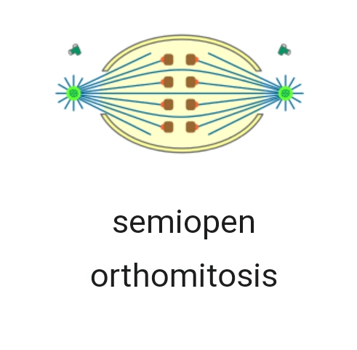
- Open orthomitosis is typical in mammals and other Metazoa, and in land plants; but it also occurs in some protists. Fig;
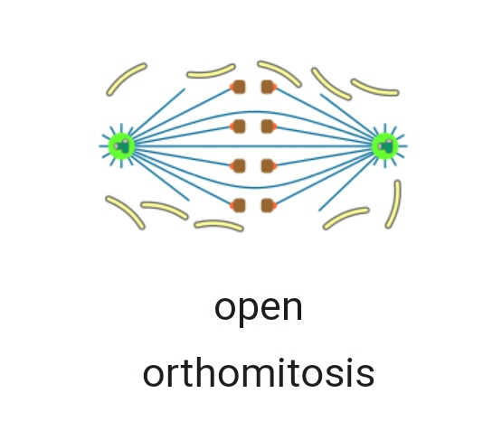
ERRORS IN MITOSIS
In nondisjunction, sister chromatids fail to separate during anaphase. One daughter cell receives both sister chromatids from the non-disjoining chromosome and the other cell receives none. As a result, the former cell gets three copies of the chromosome, a condition known as trisomy, and the latter will have only one copy, a condition known as monosomy. On occasion, when cells experience nondisjunction, they fail to complete cytokinesis and retain both nuclei in one cell, resulting in binucleated cells.
Anaphase lag occurs when the movement of one chromatid is impeded during anaphase. This may be caused by a failure of the mitotic spindle to properly attach to the chromosome. The lagging chromatid is excluded from both nuclei and is lost. Therefore, one of the daughter cells will be monosomic for that chromosome.
Endoreduplication (or endoreplication) occurs when chromosomes duplicate but the cell does not subsequently divide.
Karyokinesis without cytokinesis originates multinucleated cells called coenocytes.
CANCER is also a disease linked with mitosis. it occurs when mitotic check points start to behave abnormally and as a result cells start to divide exclusively and this situation results in tumor formation which if it spreads to other parts of body, it results in cancer.

--------------------------------------------------------------------
Test yourself :
  - Plat cells lack ________ and so their mitosis is a bit different from animal cells:
- Cytoplasm
- Centrioles
- Cell wall
- Golgi apparatus
  - In anaphase lag:
- A chromosome is lost
- One of daughter nuclei will become monosomic
- Both a and b
- None
  - Cancer is:
- Abnormal division of cells
- Cell death
- False theory
- Normal division
- In mammals the type of mitosis that occurs is:
- Semiopen orthomitosis
- Both
- Open orthomitosis
- None
- Pre-prophase occurs in:
- Animals
- Plants
- Bacteria
- All of above
- Sister chromatids get separated in:
- Prophase
- Metaphase
- Anaphase
- Telophase
- Nuclear envelope stays intact and nucleus has a bilateral symmetry during mitosis:
- Closed pleuromitosis
- Open pleuromitosis
- Closed orthomitosis
- None of above
- In chromosomal non-disjunction:
- One nucleous will be trisomal and one will be monosomal
- Both nuclei will be trisomal
- Cytoplasm will dry out
- Nuclei will be empty of chromosomes
- Closed orthomitosis occurs in:
- Birds
- Unicellular yeast
- Bacteria
- Mammals
- DNA is replicated in:
- S-phase
- G0-phase
- Prophase
- Pro-metaphase
-------------------------------------------------------------------
THE END

