Strains
Strain is defined as the ratio of change in dimension to original dimension of a body when it is deformed. It is a dimensionless quantity as it is a ratio between two quantities of same dimension.
3.1. Linear Strain
Linear strain of a deformed body is defined as the ratio of the change in length of the body due to the deformation to its original length in the direction of the force. If l is the original length and dl the change in length occurred due to the deformation, the linear strain e induced is given by e=dl/l.
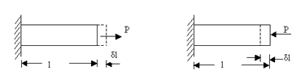
Linear strain may be a tensile strain, et or a compressive strain ec according as dl refers to an increase in length or a decrease in length of the body. If we consider one of these as +ve then the other should be considered as –ve, as these are opposite in nature.
3.2. Lateral Strain
Lateral strain of a deformed body is defined as the ratio of the change in length (breadth of a rectangular bar or diameter of a circular bar) of the body due to the deformation to its original length (breadth of a rectangular bar or diameter of a circular bar) in the direction perpendicular to the force.
3.3. Volumetric Strain
Volumetric strain of a deformed body is defined as the ratio of the change in volume of the body to the deformation to its original volume. If V is the original volum and dV the change in volume occurred due to the deformation, the volumetric strain ev induced is given by ev ev=dV/V
Consider a uniform rectangular bar of length l, breadth b and depth d as shown in figure. Its volume V is given by,
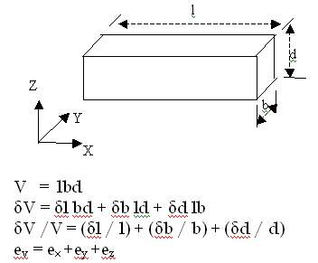
This means that volumetric strain of a deformed body is the sum of the linear strains in three mutually perpendicular directions.
3.4. Shear Strain
Shear strain is defined as the strain accompanying a shearing action. It is the angle in radian measure through which the body gets distorted when subjected to an external shearing action. It is denoted by *.
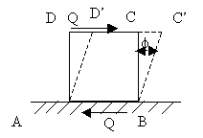
Consider a cube ABCD subjected to equal and opposite forces Q across the top and bottom forces AB and CD. If the bottom face is taken fixed, the cube gets distorted through angle φ to the shape ABC’D’. Now strain or deformation per unit length is
Shear strain of cube = CC’ / CD = CC’ / BC = φ radian
Poison’s ratio:
Poisson's ratio is the ratio of transverse contraction strain to longitudinal extension strain in the direction of stretching force. Tensile deformation is considered positive and compressive deformation is considered negative.
n = - e_{transverse} / e_{longitudinal}
Hook’s Law
When the elastic materials are stretched, the atoms and molecules deform until stress is been applied and when the stress is removed they return to their initial state. Mathematically, Hooke’s law is commonly expressed as:
F = –k.x
In the equation,
F is the force
x is the extension length
k is the constant of proportionality known as spring constant in N/m

Solved Example
A spring is displaced by 5 cm and held in place with a force of 500 N. What is the spring constant of the spring?
Solution:
We know that the spring is displaced by 5 cm, but the unit of the spring constant is Newton per meter. This means that we have to convert the distance to meters. Converting the distance to meters, we get
5 cm = 0.05 m
Now substituting the values in the equation, we get
F = –k.x
Now, we need to rework the equation so that we are calculating for the missing metric which is the spring constant, or k. Looking only at the magnitudes and therefore omitting the negative sign, we get
500 N/0.05 m = k
k = 1000 N/m
Therefore, the spring constant of the spring is 1000 N/m.
Temperature Stresses and strains
Increase or decrease of temperature of a free body causes the body to expand or contract and no stresses are induced. However, if the deformation of the body is constrained, some stresses are induced in the body, and such developed stresses are called temperature stresses which may be tensile or compressive based on either the contraction is prevented or extension is prevented. A bar whose ends are fixed to rigid supports, so that the expansion is prevented, is considered. Let the length of the bar be l subjected to an increase in temperature T°. The expansion of the bar will be
δl = lαT
Where α is the coefficient of thermal expansion of the material of the bar.
Because of the end conditions the bar is not allowed ...
