Pharmaceutical Marketing

Submitted to:
Dr.Nayab Tahir
Dr.Shazia Akram
Submitted by:
Ifrah Arif
Roll# 06
College of Pharmacy
University of Sargodha

- What is Motivation?
Motivation is the word derived from the word ’motive’ which means needs, desires, wants or drives within the individuals. It is the process of stimulating people to actions to accomplish the goals. In the work goal context the psychological factors stimulating the people’s behaviour can be -
- desire for money
- success
- recognition
- job-satisfaction
One of the most important functions of management is to create willingness amongst the employees to perform in the best of their abilities. The process of motivation consists of three stages:-
- A felt need or drive
- A stimulus in which needs have to be aroused
- When needs are satisfied, the satisfaction or accomplishment of goals.
Therefore, we can say that motivation is a psychological phenomenon which means needs and wants of the individuals have to be tackled by framing an incentive plan.
There is some famous quote about motivation:
“Live the Life of Your Dreams: Be brave enough to live the life of your dreams according to your vision and purpose instead of the expectations and opinions of others.”
― Roy T. Bennett, The Light in the Heart

2.Motivation and Morale - Relationship and Differences
Morale can be defined as the total satisfaction derived by an individual from his job, his work-group, his superior, the organization he works for and the environment. It generally relates to the feeling of individual’s comfort, happiness and satisfaction.
According to Davis, “Morale is a mental condition of groups and individuals which determines their attitude.
There are two states of morale:
High morale - High morale implies determination at work- an essential in achievement of management objectives. High morale results in:
- A keen teamwork on part of the employees.
- Healthy and safe work environment.
- Effective communication in the organization.
- Increase in productivity.
- Greater motivation.
Low morale - Low morale has following features:
- High rate of employee absenteeism and turnover.
- Dissatisfaction with the superiors and employers.
- Poor working conditions.
- Employees frustration.
- Decrease in productivity.
- Lack of motivation.
Difference:
Though motivation and morale are closely related concepts, they are different in following ways:
- While motivation is an internal-psychological drive of an individual which urges him to behave in a specific manner, morale is more of a group scenario.
- Higher motivation often leads to higher morale of employees, but high morale does not essentially result in greatly motivated employees as to have a positive attitude towards all factors of work situation may not essentially force the employees to work more efficiently.
- While motivation is an individual concept, morale is a group concept. Thus, motivation takes into consideration the individual differences among the employees, and morale of the employees can be increased by taking those factors into consideration which influence group scenario or total work settings.
- Motivation acquires primary concern in every organization, while morale is a secondary phenomenon because high motivation essentially leads to higher productivity while high morale may not necessarily lead to higher productivity.

3.Importance of Motivation:
Motivation is a very important for an organization because of the following benefits it provides:

1.Puts human resources into action
Every concern requires physical, financial and human resources to accomplish the goals. It is through motivation that the human resources can be utilized by making full use of it. This can be done by building willingness in employees to work. This will help the enterprise in securing best possible utilization of resources.

2.Improves level of efficiency of employees
The level of a subordinate or a employee does not only depend upon his qualifications and abilities. For getting best of his work performance, the gap between ability and willingness has to be filled which helps in improving the level of performance of subordinates. This will result into-
  - Increase in productivity,
  - Reducing cost of operations,
  - Improving overall efficiency.
3.Leads to achievement of organizational goals
The goals of an enterprise can be achieved only when the following factors take place:
- There is best possible utilization of resources,
- There is a co-operative work environment,
- The employees are goal-directed and they act in a purposive manner,
- Goals can be achieved if co-ordination and co-operation takes place simultaneously which can be effectively done through motivation.
- Builds friendly relationship
Motivation is an important factor which brings employees satisfaction. This can be done by keeping into mind and framing an incentive plan for the benefit of the employees. This could initiate the following things:
- Monetary and non-monetary incentives,
- Promotion opportunities for employees,
- Disincentives for inefficient employees.
5. Leads to stability of work force
Stability of workforce is very important from the point of view of reputation and goodwill of a concern. The employees can remain loyal to the enterprise only when they have a feeling of participation in the management. The skills and efficiency of employees will always be of advantage to employees as well as employees. This will lead to a good public image in the market which will attract competent and qualified people into a concern. As it is said, “Old is gold” which suffices with the role of motivation here, the older the people, more the experience and their adjustment into a concern which can be of benefit to the enterprise.
4.Motivation Incentives - Incentives to motivate employees
Incentive is an act or promise for greater action. It is also called as a stimulus to greater action. Incentives are something which are given in addition to wagers.
Besides monetary incentive, there are some other stimuli which can drive a person to better. This will include job satisfaction, job security, job promotion, and pride for accomplishment. Therefore, incentives really can sometimes work to accomplish the goals of a concern. The need of incentives can be many:-
- To increase productivity,
- To drive or arouse a stimulus work,
- To enhance commitment in work performance,
- To psychologically satisfy a person which leads to job satisfaction,
- To shape the behavior or outlook of subordinate towards work,
- To inculcate zeal and enthusiasm towards work,
7.To get the maximum of their capabilities so that they are exploited and utilized maximally.
Therefore, management has to offer the following two categories of incentives to motivate employees:
Monetary incentives- Those incentives which satisfy the subordinates by providing them rewards in terms of rupees. Money has been recognized as a chief source of satisfying the needs of people. Money is also helpful to satisfy the social needs by possessing various material items. Therefore, money not only satisfies psychological needs but also the security and social needs. Therefore, in many factories, various wage plans and bonus schemes are introduced to motivate and stimulate the people to work.
Non-monetary incentives- Besides the monetary incentives, there are certain non-financial incentives which can satisfy the ego and self- actualization needs of employees. The incentives which cannot be measured in terms of money are under the category of “Non- monetary incentives”. Whenever a manager has to satisfy the psychological needs of the subordinates, he makes use of non-financial incentives. Non- financial incentives can be of the following types:
> Security of service
> Praise or recognition
> Suggestion scheme
> Promotion opportunities
Positive Incentives:
Positive incentives are those incentives which provide a positive assurance for fulfilling the needs and wants. Positive incentives generally have an optimistic attitude behind and they are generally given to satisfy the psychological requirements of employees. For example-promotion, praise, recognition, perks and allowances, etc. It is positive by nature.
Negative Incentives:
Negative incentives are those whose purpose is to correct the mistakes or defaults of employees. The purpose is to rectify mistakes in order to get effective results. Negative incentive is generally resorted to when positive incentive does not works and a psychological set back has to be given to employees. It is negative by nature. For example- demotion, transfer, fines, penalties.

5.Types of Motivation:
Motivation can be further divided into two different types.
- Intrinsic Motivation
- Extrinsic Motivation

Intrinsic Motivation | Extrinsic Motivation
The act of being motivated by internal factors to perform certain actions and behavior is called Intrinsic Motivation. | Whenever an individual performs an action or behavior because the individual is affected by the eternal factors such as rewards or punishments, such form of motivation is called Extrinsic Motivation.
There is neither pressure nor any sort of reward for the actions you perform due to intrinsic motivation. | You get rewarded as promised for the actions you perform due to extrinsic motivation.
The needs or causes that lead to intrinsic motivation are:  - Autonomy: the need to have complete control over one’s own life.  - Relatedness: the need to maintain companionship or connection with others.  - Competence: the need to do be the best and/or succeed. | The needs or causes that lead to extrinsic motivation (and not limited to) are:  - Money  - Praise  - Competition  - Threat of a punishment
Intrinsic incentives are hard to figure. In a class or workplace, different individuals will/might require different approaches. | Extrinsic incentives can be used to motivate a whole group, thus increasing productivity in workplace or creating a better learning environment in classrooms.
Fostering intrinsic motivation can be a lengthy process, requiring special treatment. | Extrinsic Motivation often occur instantly as soon as the subject understands the perks of performing certain

6.Theories of Motivation:
Some of the most important theories of motivation are as follows:
1. Maslow’s Need Hierarchy Theory
2. Alderfer's Hierarchy of Motivational Needs
3. Herzberg’s Motivation Hygiene Theory (Two-Factor Theory)
4. McClelland’s Need Theory
5. Douglas McGregor Theory (Theory of “X” and Theory of “Y”)
6.Vroom’s Expectancy Theory
7. Porter and Lawler’s Expectancy Theory
1. Maslow’s Hierarchy of Needs Theory:
Abraham Maslow is well renowned for proposing the Hierarchy of Needs Theory in 1943. This theory is a classical depiction of human motivation. This theory is based on the assumption that there is a hierarchy of five needs within each individual. The urgency of these needs varies. These five needs are as follows-
Physiological needs-
These are the basic needs of air, water, food, clothing and shelter. In other words, physiological needs are the needs for basic amenities of life.
Safety needs-
Safety needs include physical, environmental and emotional safety and protection. For instance- Job security, financial security, protection from animals, family security, health security, etc.
Social needs-
Social needs include the need for love, affection, care, belongingness, and friendship.
Esteem needs-
Esteem needs are of two types: internal esteem needs (self- respect, confidence, competence, achievement and freedom) and external esteem needs (recognition, power, status, attention and admiration).
Self-actualization need- This include the urge to become what you are capable of becoming / what you have the potential to become. It includes the need for growth and self-contentment. It also includes desire for gaining more knowledge, social- service, creativity and being aesthetic.
According to Maslow, individuals are motivated by unsatisfied needs. As each of these needs is significantly satisfied, it drives and forces the next need to emerge. Maslow grouped the five needs into two categories - Higher-order needs and Lower-order needs. The physiological and the safety needs constituted the lower-order needs. These lower-order needs are mainly satisfied externally. The social, esteem, and self-actualization needs constituted the higher-order needs. These higher-order needs are generally satisfied internally, i.e., within an individual.
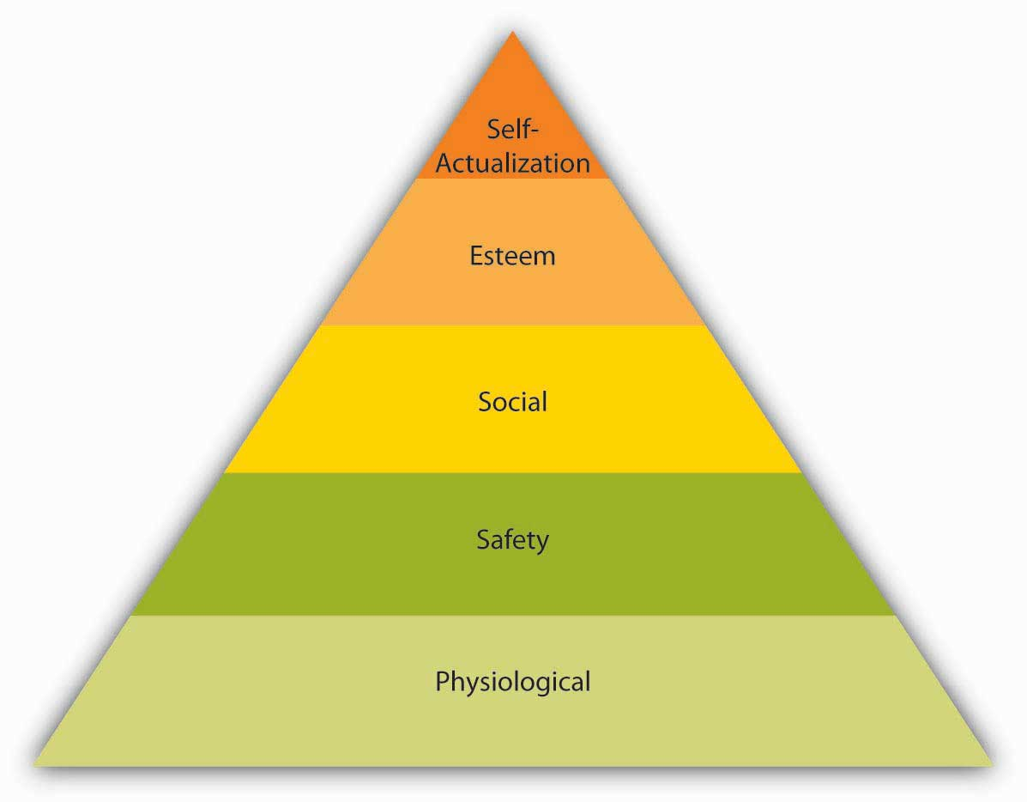

FIGURE: Maslow’s Need Hierarchy Model
Implications of Maslow’s Hierarchy of Needs Theory for Managers
- As far as the physiological needs are concerned, the managers should give employees appropriate salaries to purchase the basic necessities of life. Breaks and eating opportunities should be given to employees.
- As far as the safety needs are concerned, the managers should provide the employees job security, safe and hygienic work environment, and retirement benefits so as to retain them.
- As far as social needs are concerned, the management should encourage teamwork and organize social events.

Limitations of Maslow’s Theory:
- It is essential to note that not all employees are governed by same set of needs. Different individuals may be driven by different needs at same point of time. It is always the most powerful unsatisfied need that motivates an individual.
- The theory is not empirically supported.
- The theory is not applicable in case of starving artist as even if the artist’s basic needs are not satisfied, he will still strive for recognition and achievement.

- Alderfer's Hierarchy of Motivational Needs :
Clayton Alderfer reworked Maslow's Need Hierarchy to align it more closely with empirical research. Alderfer's theory is called the ERG theory -- Existence, Relatedness, and Growth.
• Existence refers to our concern with basic material existence requirements; what Maslow called physiological and safety needs.
• Relatedness refers to the desire we have for maintaining interpersonal relationships; similar to Maslow's social/love need, and the external component of his esteem need.
• Growth refers to an intrinsic desire for personal development; the intrinsic component of Maslow's esteem need, and self-actualization
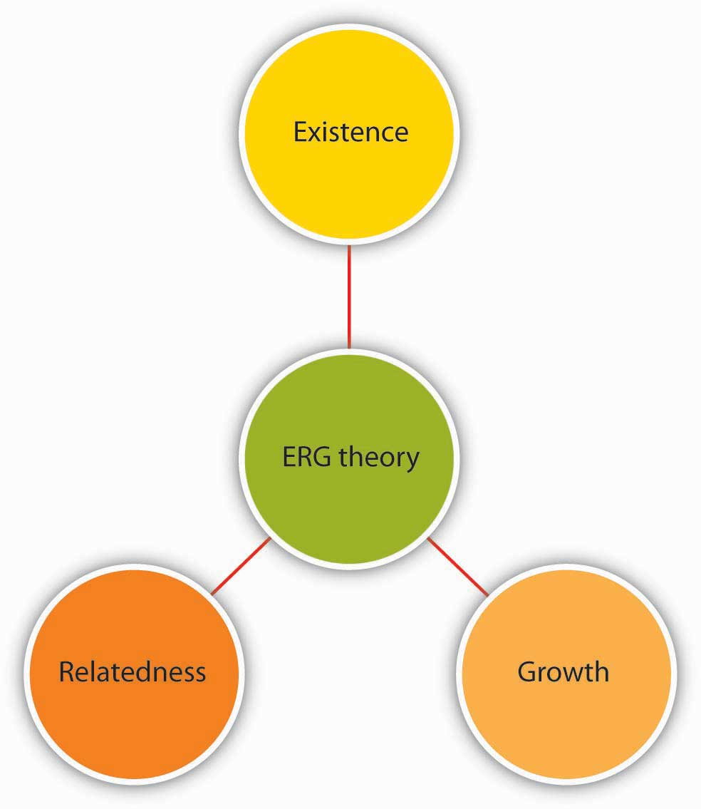
Alderfer's ERG theory differs from Maslow's Need Hierarchy insofar as ERG theory demonstrates that more than one need may be operative at the same time.
Level of Need | Definition | Properties
Growth | Impel a person to make creative or productive effects on himself and his environment. | Satisfied through using capabilities in engaging problems; creates a greater sense of wholeness and fullness as a human being.
Relatedness | Involve relationships with significant others. | Satisfied by mutually sharing thoughts and feelings; acceptance, confirmation, under- standing, and influence are elements
Existence | Includes all of the various forms of material and psychological desires | When divided among people one person's gain is another's loss if resources are limited

3. Herzberg’s Motivation Hygiene Theory (Two-Factor Theory)
Frederick Herzberg approached the question of motivation in a different way. By asking individuals what satisfies them on the job and what dissatisfies them, Herzberg came to the conclusion that aspects of the work environment that satisfy employees are very different from aspects that dissatisfy them.
Herzberg labeled factors causing dissatisfaction of workers as “hygiene” factors because these factors were part of the context in which the job was performed, as opposed to the job itself. Hygiene factors included company policies, supervision, working conditions, salary, safety, and security on the job. To illustrate, imagine that you are working in an unpleasant work environment.
In contrast, motivators are factors that are intrinsic to the job, such as achievement, recognition, interesting work, increased responsibilities, advancement, and growth opportunities. According to Herzberg’s research, motivators are the conditions that truly encourage employees to try harder.
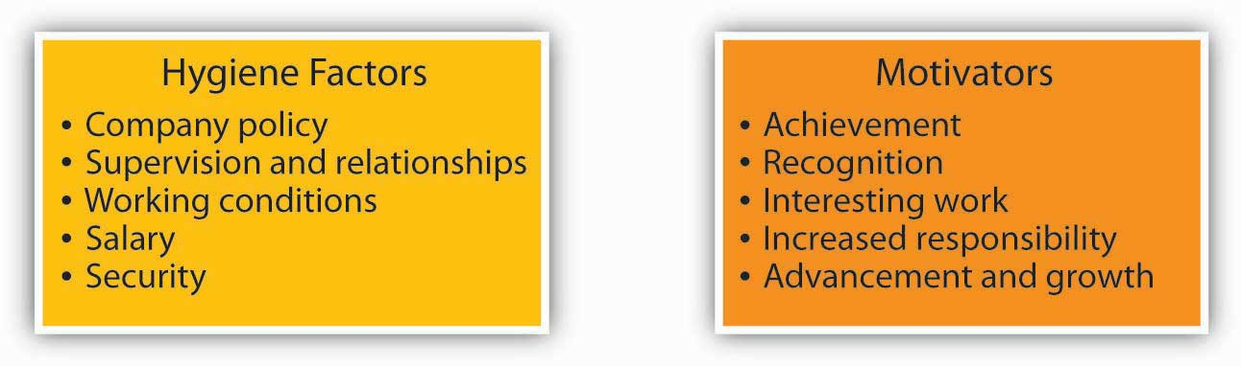

4.McClelland’s Theory of Needs:
According to David McClelland, regardless of culture or gender, people are driven by three motives:
- Achievement
- Affiliation
- Influence.
Since McClelland's first experiments, over 1,000 studies relevant to achievement motivation have been conducted. These studies strongly support the theory.

• Achievement: The need for achievement is characterized by the wish to take responsibility for finding solutions to problems, master complex tasks, set goals, get feedback on level of success.

• Affiliation: The need for affiliation is characterized by a desire to belong, an enjoyment of teamwork, a concern about interpersonal relationships, and a need to reduce uncertainty.

• Power: The need for power is characterized by a drive to control and influence others, a need to win arguments, a need to persuade and prevail

According to McClelland, the presence of these motives or drives in an individual indicates a predisposition to behave in certain ways. Therefore, from a manager's perspective, recognizing which need is dominant in any particular individual affects the way in which that person can be motivated.

- Theory of “X” and Theory of “Y”:
Douglas McGregor observed two diametrically opposing view points of managers about their employees, one is negative called “Theory of X” and one is positive called “Theory of Y”
  - Theory of X :
Following are the assumptions of managers who believe in the “Theory of X” in regard to their employees.
• Employees dislike work; if possible avoid the same
• Employees must be coerced, controlled or threatened to do the work
• Employees avoid responsibilities and seek formal direction
• Most employees consider security of job, most important of all other factors in the job and have very little ambition
  - Theory of Y:
Following are the assumptions of managers who believe in the “Theory of Y” in regard to their employees.
• Employees love work as play or rest
• Employees are self-directed and self-controlled and committed to the organizational objectives
• Employees accept and seek responsibilities
• Innovative spirit is not confined to managers alone, some employees also possess it.
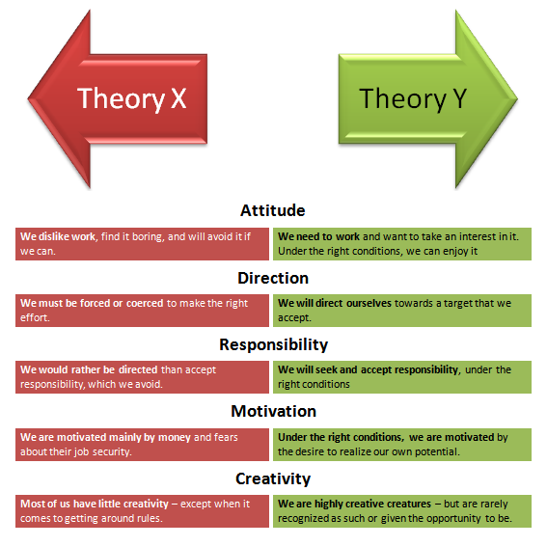

Theory of X assumes Maslow’s lower level needs dominate in employees. Whereas Theory of Y, assumes Maslow’s higher level needs dominate in employees.

6.Vroom's Expectancy Theory:

Vroom's expectancy theory separates effort, performance and outcomes, while Maslow and Herzberg focus on the relationship between internal needs and the resulting effort expended to fulfil them. He stated that effort, performance and motivation are linked in a person's motivation. He uses the variables Expectancy, Instrumentality and Valence to account for this.
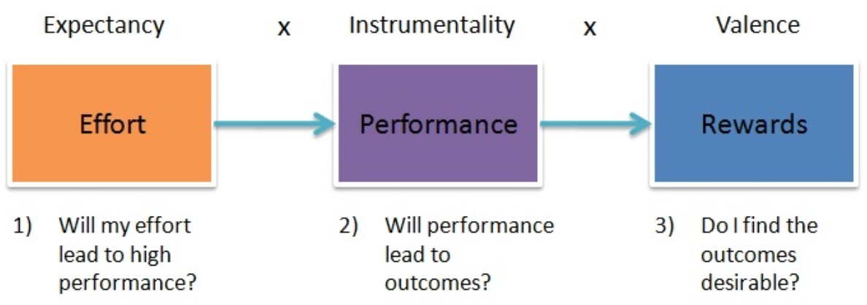
Expectancy
Expectancy is the idea that increasing the amount of effort will increase performance (if I work harder then I will perform better.) This is affected by:
- Having the right resources available (e.g. raw materials, time)
- Having the right skills to do the job
- Having the necessary support to get the job done (e.g. supervisor support, or correct information on the job)

Instrumentality
Instrumentality is the idea that if you perform better, then the outcome will be achieved. (If I perform well, there I will achieve the desired outcome.) This is affected by:
- Clear understanding of the relationship between performance and outcomes – e.g. the rules of the reward 'game'
- Trust in the people who will take the decisions on who gets what outcome
- Transparency of the process that decides who gets what outcome

Valence
Valence is the perceived value the employee puts on the outcome. For the valence to be positive, the person must prefer attaining the outcome than not attaining it.
The three elements are important behind choosing one element over another because they are clearly defined: effort-performance expectancy (E-->P expectancy) and performance-outcome expectancy (P-->O expectancy).
E-->P expectancy: our assessment of the probability that our efforts will lead to the required performance level.
P-->O expectancy: our assessment of the probability that our successful performance will lead to certain outcomes.

Application:
Vroom's theory can equally apply to any situation where someone does something because they expect a certain outcome. For example, people recycle paper because they believe it's important to conserve resources and take a stand on environmental issues (valence); they believe that the more effort they put into recycling the more paper people in general will recycle (expectancy); and they believe that the more paper recycled the fewer resources will be used (instrumentality).

7.Porter and Lawler’s Expectancy Theory:
Porter and Lawler (Lyman W Porter and Edward E Lawler) used Victor Vroom’s Expectancy Theory as a foundation to develop their expectancy model. Similar to Vroom’s theory Porter and Lawler concluded that an individual’s motivation to complete a task is affected by the reward they expect to receive for completing the task. However Porter and Lawler introduced additional aspects to the expectancy theory as they felt that Vroom's theory was too simple.
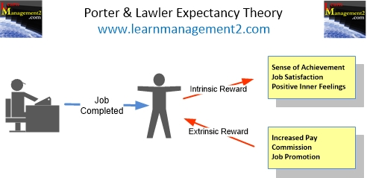
Intrinsic and Extrinsic Rewards:
Porter and Lawler categorized the reward as intrinsic and extrinsic
- Intrinsic rewards are the positive feelings that the individual experiences from completing the task e.g. satisfaction, sense of achievement.
- Extrinsic rewards are rewards emanating from outside the individual such as bonus, commission and pay increases.
Porter and Lawler's Expectancy Theory Model suggested that an individual's view regarding the attractiveness and fairness of the rewards will affect motivation.

Ability and Perception:
Porter and Lawler said that motivation is also affected by
- the individual’s ability to perform the task and
- their perception of the task

7.Staff Motivation
Employees are the building blocks of an organization. Organizational success depends on the collective efforts of the employees. The employees will collectively contribute to organizational growth when they are motivated.
Below mentioned are some tips for motivating the staff/employees in an organization:
Evaluate yourself
In order to motivate, encourage and control your staff’s behavior, it is essential strengths and opportunities to neutralize and lower the negative impact of your weaknesses and organizational threats. The manager should adopt the approach “You’re OK - I’m OK”.
Be familiar with your staff-
The manager should be well acquainted with his staff. The more and the better he knows his staff, the simpler it is to get them involved in the job as well as in achieving the team and organizational goals. This will also invite staff’s commitment and loyalty. A cordial superior-subordinate relationship is a key factor in job-satisfaction.
Provide the employees certain benefits
Give your staff some financial and other benefits. Give them bonuses, pay them for overtime, and give them health and family insurance benefits. Make sure they get breaks from work. Let them enjoy vacations and holidays.
Provide feedback to the staff constantly
The staff members are keen to know how they are performing. Try giving a regular and constructive feedback to your staff. This will be more acceptable by the staff. Do not base the feedback on assumptions, but on facts and personal observations.
Acknowledge your staff on their achievements
A pat on the back, some words of praise, and giving a note of credit to the employee / staff member at personal level with some form of broad publicity can motivate the staff a lot. Make it a point to mention the staff’s outstanding achievements in official newsletters or organization’s journal.
Ensure effective time management
Having control over time ensures that things are done in right manner. Motivate your staff to have “closed” times, i.e., few hours when there are no interruptions for the staff in performing their job role so that they can concentrate on the job, and “open” times when the staff freely communicate and interact. Plan one to one sessions of interaction with your staff where they can ask their queries and also can get your attention and, thereby, they will not feel neglected. This all will work in long run to motivate the staff.
Have stress management techniques in your organization
Create an environment in which you and your staff can work within optimum pressure levels. Ensure an optimistic attitude towards stress in the workplace. Have training sessions on stress management, and ensure a follow-up with group meetings on the manner stress can be lowered at work. Give your staff autonomy in work. Identify the stress symptoms in employees and try to deal with them.
Use counselling technique
The employees’ / staff feelings towards the work, their peer, their superiors and towards the future can be effectively dealt through the staff counseling. Counselling provides an environment, incentive and support which enable the employee to achieve his identity.

8.Motivation Strategies to Increase Productivity
A great indication of a successful manager is one who has employees who are motivated to perform their jobs at a high level.
It is easy to see that higher employee motivation leads to more productivity and therefore more profitable business growth.
Supervisors and managers need to utilize a number of different strategies and techniques to increase their employee’s motivation and productivity.
Trust
This is one of the most important aspects in any organization and it is a two way street. Employees want to know that their manager is looking out for their best interests, which motivates them to succeed. In turn, leaders also want to know that they can trust their staff to do their jobs properly. It is up to the manager to ensure this trust is built with their employees and to be able to communicate effectively with each individual and foster positive relationships.
Reward System
Incentives are a great way to promote motivation. Employers can use many types of incentives or reward programs to increase productivity and motivation among staff. Incentives can come in many forms, whether it be bonuses, paid time off, travel perks, or vouchers. It offers employees something to strive for and gives them a bit of healthy competition.
Career Advancement
Employees are much more likely to achieve if it means that a career advancement lies ahead of them. As a manager, there are avenues and opportunities for your employees to advance in their positions. Manager can also provide them with opportunities for further qualifications or on the job workshops. It lets them know they are valued and makes them more committed to their positions. In fact, LMA’s L.E.A.D Survey 2013 showed that 79% of employees said that opportunities for training and development is ‘Quite’ or ‘Very Important’ to their decision to stay in their current organizations.
Happiness
At the end of the day, if employees are happy in their jobs they are more motivated to do the best job they can. As a manager, you need to be aware of whether your employees are satisfied or not. Don’t assume that simply having a conversation with them regarding their happiness will be enough, they may smile and say yes if they think it is what you want to hear or if they are worried their job is on the line. The process to happiness and job satisfaction can be influenced by ensuring the previous factors are evident in your company and letting happiness be an organic process.

8.References:
- What is Motivation? By “Prachi Juneja” and Reviewed By Management Study Guide Content Team
- What is Motivation? By Robert Tanner, MBA/Last Updated Mar 15, 2020
- Management Matters Most in Motivation By Susan M. Heathfield Updated September 12, 2019
- What Is Motivation In Management? - Definition, Process & Types By Shauna Kelley
- How Great Managers Motivate Their Employees By Susan M. Heathfield Updated March 02, 2020
- Chapter 5: Theories of Motivation Publisher: Saylor Academy
- 7 Most Important Types of Motivation | Business Management Article shared by : Smriti Chand
- MOTIVATION & ITS THEORIES

