WHAT IS PROJECT MANAGEMENT?

Project management is defined as a collection of proven techniques for proposing, planning, implementing, managing, and evaluating projects, combined with the art of managing people. It is the application of knowledge, skills, tools, and techniques to a broad range of activities to meet the specified requirements of a particular project.
While there are many project management techniques and tools, there are considerable differences in applying these methods to different projects. For example, a large, complex, multiyear construction project is very different from a 12-month ISO 9001 quality management system implementation or a three-month process improvement and machinery upgrade project.
While the basic principles apply in all situations, the project management methodology musts be scaled to fit the benefit-to-cost ratio for each situation. Managers often fail to use project planning tools and techniques appropriate to the anticipated outcomes of the project and the resources available.
Aspiring project managers may utilize a wide range of project management tutorials and other resources, including college-based, association-based, and consultant-sponsored classes and courses. The Project Management Institute offers certification as a Project Management Professional (PMP) to those who pass a rigorous exam and demonstrate their proficiency by planning and managing a successful project.

THE 5 STAGES OF THE PROJECT PLANNING PROCESS
The life cycle of a project has five stages.

Stage 1: Visualizing, selling, and initiating the project
An effective way to get buy-in for a project or idea is to link it to what is important to the person or group you are approaching and demonstrate that you are openly soliciting their input. By doing so, they can help shape the concept.

Stage 2: Planning the project
Assuming the project concept and feasibility have been determined, the plan-do-check-act (PDCA) cycle (see figure below) is directly applicable to project planning and management.
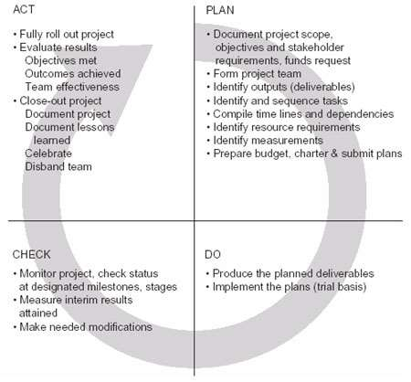
Using the PDCA Cycle for Project Management

Stage 3: Designing the processes and outputs (deliverables)
When the project is approved, the project team may proceed with the content design along with the persons or items needed to implement the project.
The design process includes defining:
- Measurements
- The monitoring method
- Status reporting protocols
- Evaluation criteria
- Design of the ultimate processes and outputs
- Implementation schedules

Stage 4: Implementing and tracking the project
The project design team may also implement the project, possibly with the help of additional personnel. A trial or test implementation may be used to check out the project design and outputs to determine if they meet the project objectives.
Using the planned reporting methods, the implementation team monitors the project and reports on its status to appropriate interested parties at designated project milestones. Interim results may also be communicated to interested parties. The implementation team makes any course corrections and trade-offs that may be necessary and are approved.

Stage 5: Evaluating and closing out the project
The implementation team officially closes the project when the scheduled tasks have been completed.
Usually evaluations are done to determine:
- Objectives met versus objectives planned
- Actual tasks and events scheduled versus planned
- Resources used versus planned resource usage
- Costs versus budget
- Organizational outcomes achieved versus planned outcomes; any unplanned outcomes
- Effectiveness of project planning team (optional)
- Effectiveness of implementation team (optional)
- Team’s compilation of project documents, evaluations, and lessons learned
The project is then officially closed out. Participants are recognized for their contributions, and the team disbands.
For some projects, many organizations find value in a post-implementation assessment of the outcomes achieved from implementing the project. This may occur several months after project completion.

PROJECT OUTPUTS VS. OUTCOMES
Frequently the project management terms “outputs” and “outcomes” are used as if their meanings were interchangeable; however, they are not.
- Outputs are defined as what the project produces. Project outputs may be an improved process, installation of a new machine, a benchmarking study, etc. Outputs of the project team process itself may be project plans and supporting documents, status reports, and the like.
- Outcomes are defined as the effects that the implementation of the project has on the overall organization and should support the strategic direction of the organization. Outcomes may consist of measurable improvements in customer satisfaction, profits or cost containment, improved market position and market penetration, etc. For ease of understanding, outcomes are usually expressed as dollar values.

