EXPERIMENT NO
IMPLEMENTATION OF UNIVERSALITY OF NAND AND NOR GATES
OBJECTIVE
To study and implement any logic expression by using only NAND or NOR gates.
THEORY
Digital circuits are more frequently constructed with NAND or NOR gates than with AND and OR gates. NAND and NOR gates are easier to fabricate with electronic components and are the basic gates used in all IC digital logic families. Because of the prominence of NAND and NOR gates in the design of digital circuits, rules and procedures have been developed for conversion from Boolean function given in terms of AND, OR, and NOT into equivalent NAND and NOR logic diagram.
TASK 1: NAND GATE IMPLEMENTATION OF BOOLEAN FUNCTIONS
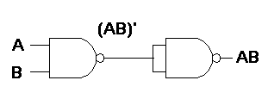
If we can show that the logical operations AND, OR, and NOT can be implemented with NAND gates, then it can be safely assumed that any Boolean function can be implemented with NAND gates. Figure-2 below shows such implementation:

Figure 2a: AND gate operation

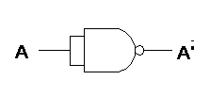
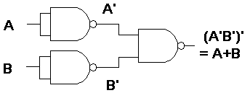
Figure 2b: OR gate operation

Figure 2c: NOT gate operation
PROCEDURE
1. Insert the IC on the trainer’s breadboard.
2. Use any one or more of the NAND gates of the IC for this experiment.
3. Any one or more Logic Switches of the trainer (S2 to S9) can be used for input to the NAND gate.
4. For output indication, connect the output pin of the circuit to any one of the LEDs of the trainer (L0 to L15).
5. Connect the circuit as per Fig. 1(a) above.
6. Connect +5V to pin 14 (Vcc) and Ground to pin 7 (GND) of the IC.
7. By setting the switches to 1 and0, verify that the output of the circuit conforms to that of an AND gate. Record your observation in the table below:

Inputs |  | Output Desired
A | B | x=A.B | Observed
0 | 0 | 0
0 | 1 | 0
1 | 0 | 0
1 | 1 | 1

Verify OR gate operation using NAND gates. Show your results to the lab instructor.

Inputs |  | Desired Output
A | B | x=A+B | Observed
0 | 0 | 0
0 | 1 | 1
1 | 0 | 1
1 | 1 | 1
Verify NOT gate operation using NAND gates

Show your results to the lab instructor.

Inputs | Output
A | Desired X=A' | Observed
0 | 1
1 | 0

LAB ASSIGNMENT
P1. Implement AND, OR and NOT operation using NOR gate. Show truth table and logic diagram.

