Experiment No-8
To Study and Implement RC Series Circuit.
OBJECTIVES:
- To study and draw the phasor diagram of the current and the voltage.
- To calculate the impedance values in the circuit (RC).
APPARATUS:
- Resistors
- Capacitors
- AC Power Supply
- Digital Multimeter (DMM)
- Connecting wires
Theory:
A sinusoidal signal is applied to a series resistive-capacitance circuit, and the voltages develop across the resistor and the capacitor is investigated for amplitude and phase relationship to the input.
RC Series Circuit:
Consider a simple RC circuit as shown in fig.8.1 in which resistor, R and capacitor, C are connected in series with a voltage supply of V volts. Let us think the current flowing in the circuit is I (amp) and current through resistor and capacitor is I_{R} and I_{c} respectively. Since both resistance and capacitor are connected in series, so the current in both the elements and the circuit remains the same. i.e I_{R} = I_{c} = I. Let V_{R} and V_{c} be the voltage drop across resistor and capacitor. When the resistor is connected in series to the capacitor in AC circuit, this results the in-phase between the load current I and voltage V_{R}. While the current at capacitor is 90° leads applied Voltage V_{C.} The total voltage is presented by the summation of Vectors as V_{T}=V_{R} + V_{C.}

Fig.8.1 RC Series Circuit

Phasor Diagram for RC Circuit:
Before drawing the phasor diagram of series RC circuit, one should know the relationship between voltage and current in case of resistor and capacitor.
- In case of resistor, the voltage and the current are in same phase or we can say that the phase angle difference between voltage and current is zero.

- In capacitor, the voltage and the current are not in phase. The voltage lags that of current by 90º or in other words, voltage attains its maximum and zero value 90º after the current attains it.
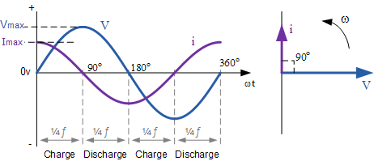

- The following steps are used to draw the phasor diagram of RC Series circuit
- Take the current I (r.m.s value) as a reference vector.
- Voltage drop in resistance VR = IR is taken in phase with the current vector.
- Voltage drop in capacitive reactance VC = IXC is drawn 90 degrees behind the current vector, as current leads voltage by 90 degrees (in the pure capacitive circuit).
- The vector sum of the two voltage drops is equal to the applied voltage V (r.m.s value).
Now,
V_{R} = I_{R} and V_{C} = IX_{C}
Where X_{C} = I/2πfC
In right triangle OAB,
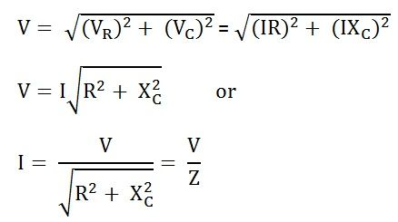
Impedance of series RC circuit:
Z is the total opposition offered to the flow of alternating current by an RC series circuit and is called impedance of the circuit. It is measured in ohms (Ω).
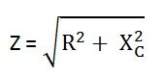

Phase angle:
From the phasor diagram shown above, it is clear that the current in the circuit leads the applied voltage by an angle ϕ and this angle is called the phase angle.

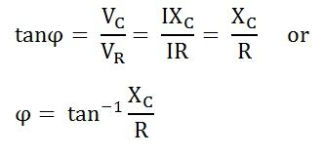

Power in RC Series Circuit:
If the alternating voltage applied across the circuit is given by the equation.
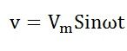
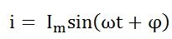
The average power consumed in the circuit over a complete cycle is given by:
P=VI CosΦ, where CosΦ=R/Z
And reactive power consumed by the circuit is given by:
Q=VI SinΦ

Procedure:
- Connect the circuit as shown in fig.8.1.
- Apply the power supply to the experimental circuit. Read the values from the instruments and record the results in Table 8-1
- Change the power supply according to the listed in Table 8-1, then record the data in Table 8-1
- Calculate the values of R, Xc, Z_{t}, Ѳ, pf, P, S and Q record them in Table 8-1.
- Draw the phasor diagram of current versus voltage.

Observation Table 8-1:

Measured Values |  |  |  | Calculated values
V_{T}  (V) | I  (A) | V_{c}  (V) | V_{R}  (V) | R  (Ω) | X_{c}  (Ω) | Z_{T}  (Ω) | Ѳ | PF | P  (W) | S  (VA) | Q  (VAR)
4
15
Phasor diagrams:

Conclusions:

Comments:

