Multimedia System and Design
Classes : Ex PPP BSCS 6th D and E
Class: Ex PPP BSCS 6th D
Midterm Assignment
Assignment No. 1: Visiting Cards / Business Cards
Size of card: Width= 3.3 inch
Height= 2.1 inch
Your evaluation of Assignment 1(15 marks) depends upon these points
Logo  (2) | No pixelation  (2) | Clear cutting of any object  (2) | Shapes properly made (3) | Icons properly utilized (2) | Font matching  (2) | Picture matching  (2)

Assignment No. 2: LOGO + Pamphlet / Flyer (15 marks)
Logo:- 5 marks, pamphlet :- 10 marks
You have to make a logo of a (burger, pizza) restaurant and also suggest name of that restaurant, also make a one sided pamphlet for that.
Logo size: width = 10 inch, height = 10 inch
Pamphlet size: width = 8.5 inch, height = 11 inch
Sr No. | Roll no. | Name | Assignment
1 | BSCS-F17-LC-001 | Azam Noor | 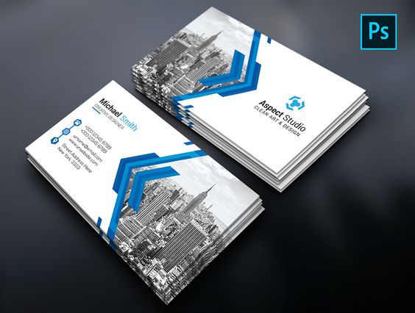
2 | BSCS-F17-LC-004 | Muhammad Kashif | 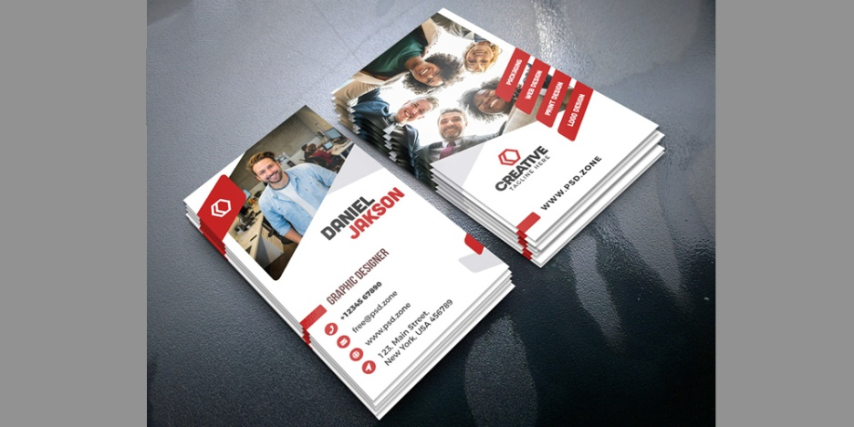
3 | BSCS-F17-LC-039 | Muhammad Noman Khalid Tarar | 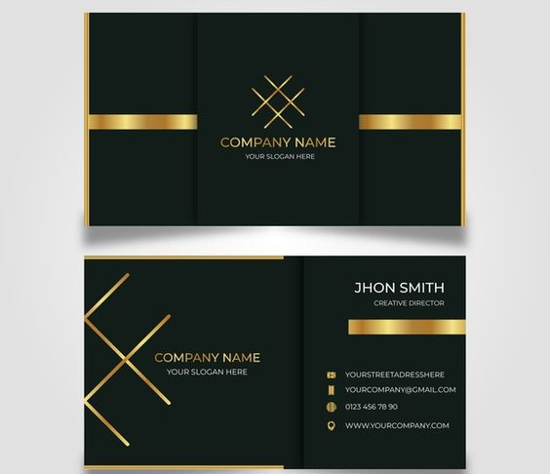
4 | BSCS-F17-LC-044 | Ali Mohsin
5 | BSCS-F17-LC-055 | Abdul Rouf | 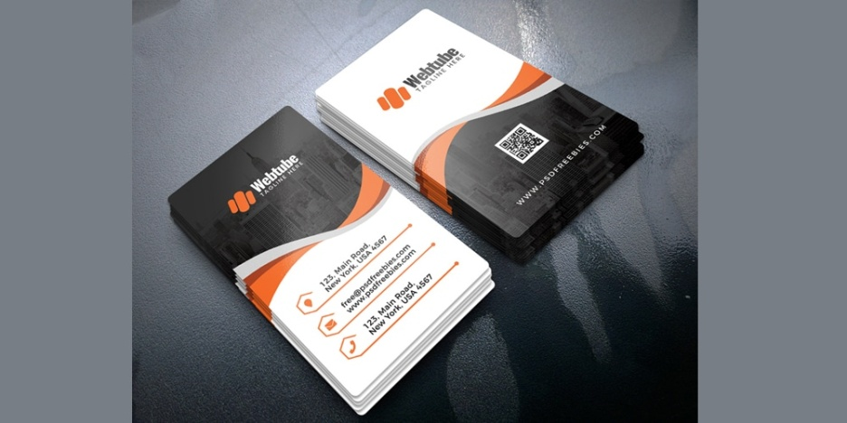
6 | BSCS-F17-LC-084 | Muhammad Ans Waheed | 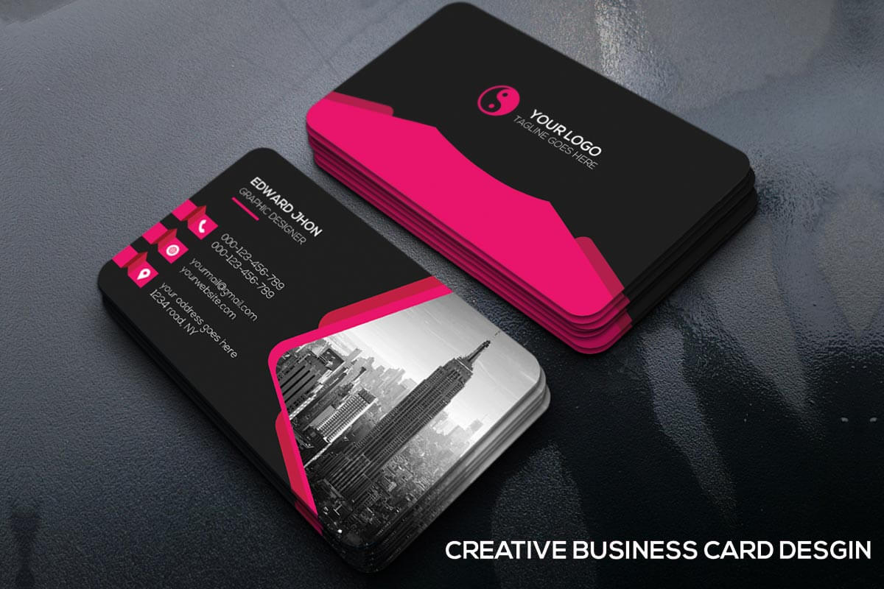
7 | BSCS-F17-LC-089 | Zeeshan Ali | 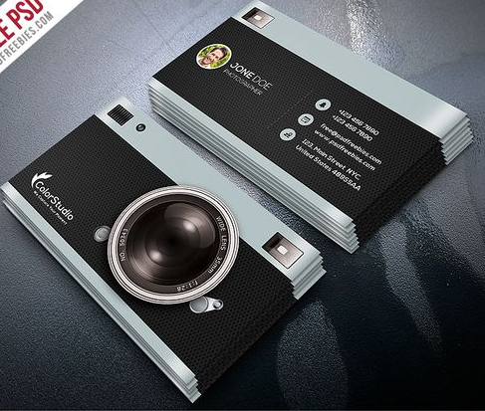
8 | BSCS-F17-LC-092 | Haider Ali | 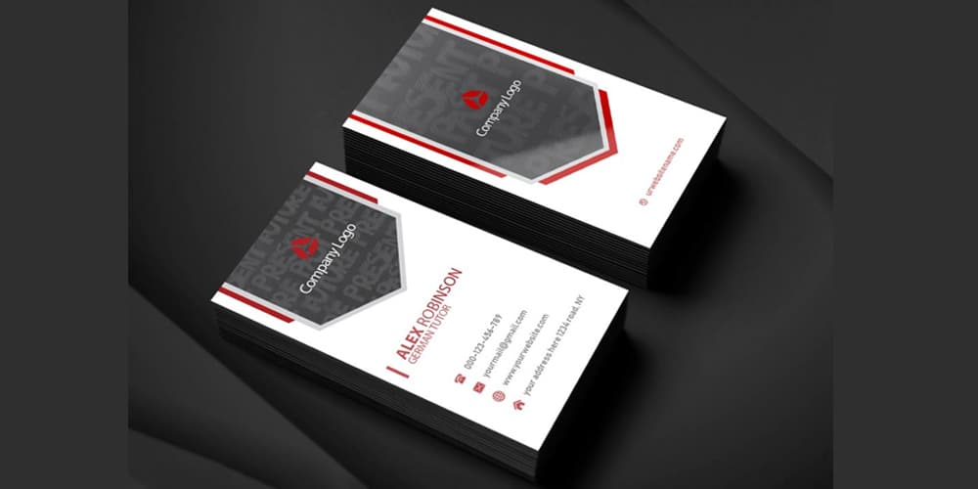
9 | BSCS-F17-LC-098 | Muhammad Naveed | 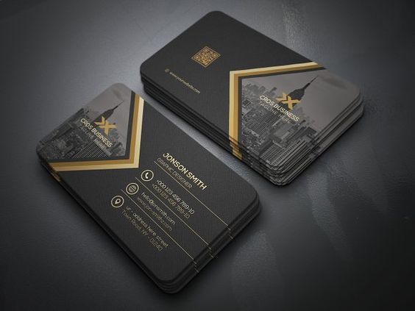
10 | BSCS-F17-LC-099 | Muhammad Ali | 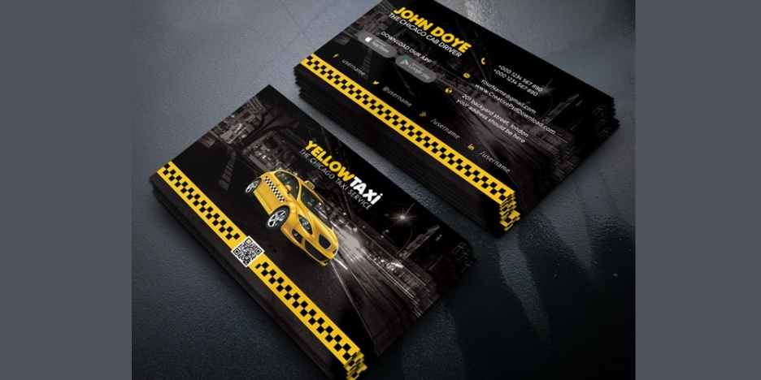
11 | BSCS-F17-LC-110 | Saqlain Raza | 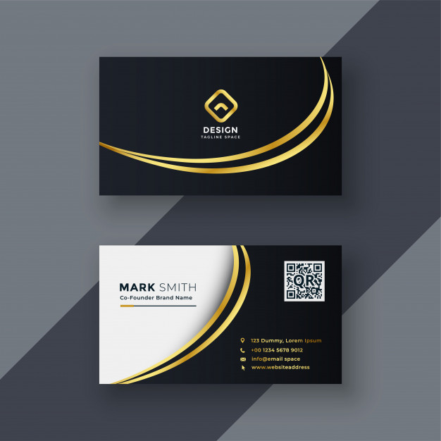
12 | BSCS-F17-LC-115 | Farhan Ali | 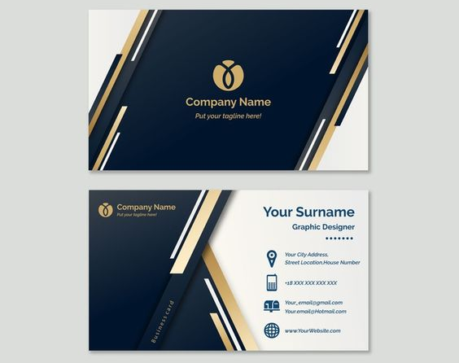
13 | BSCS-F17-LC-117 | Muhammad Asad | 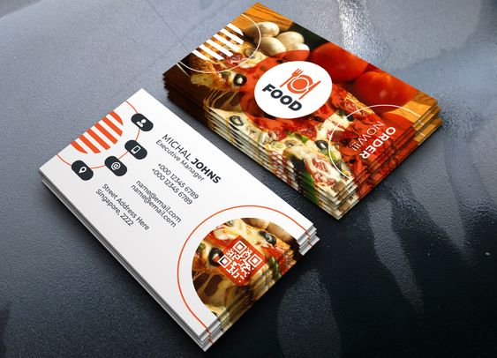
14 | BSCS-F17-LC-131 | Muhammad Saeed
15 | BSCS-F17-LC-147 | Imran Asghar | 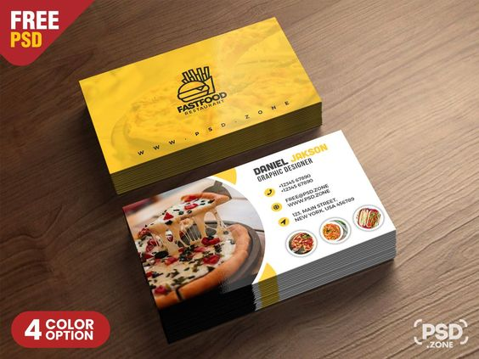
16 | BSCS-F17-LC-159 | Atiq Zafar | 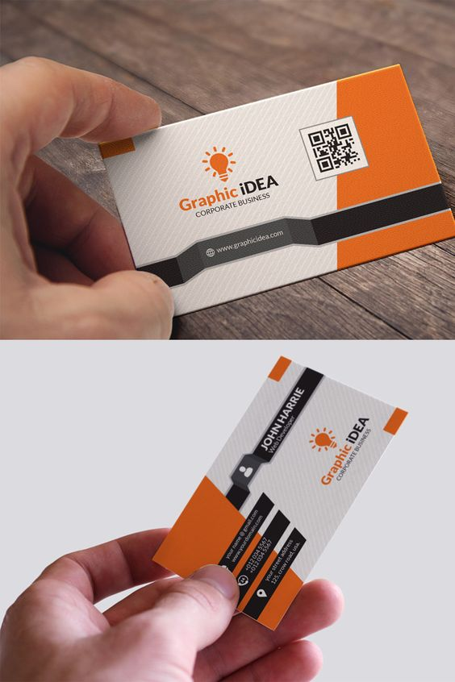
17 | BSCS-F17-LC-165 | Muhammad Roshan | 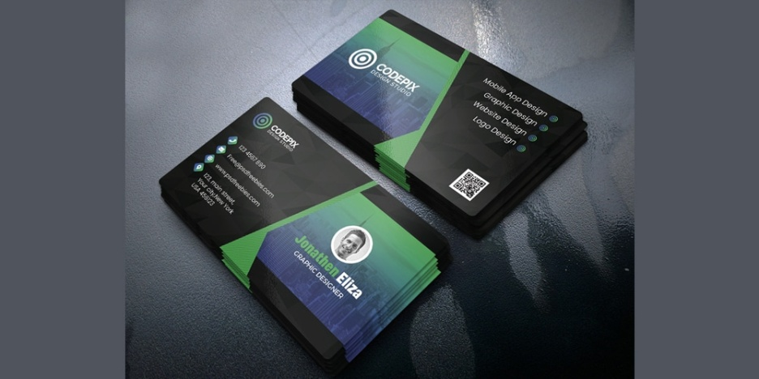
18 | BSCS-F17-LC-170 | Muhammad Abdullah Tariq | 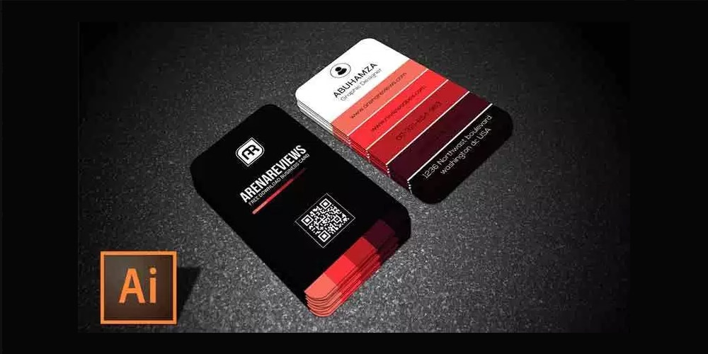
19 | BSCS-F17-LC-189 | Syed Zawahir Abbas Kazmi | 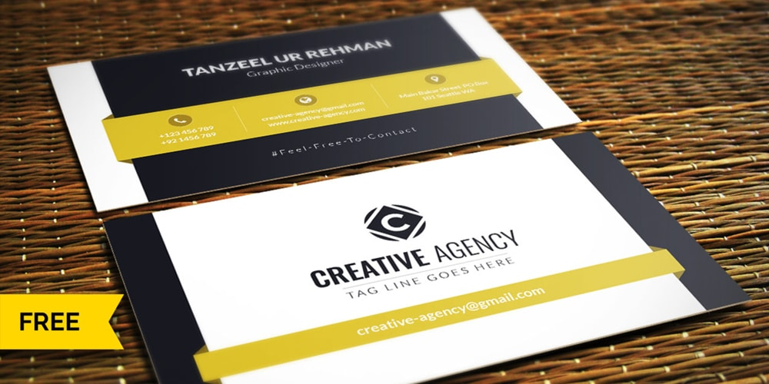
20 | BSCS-F17-LC-191 | Junaid Majeed | 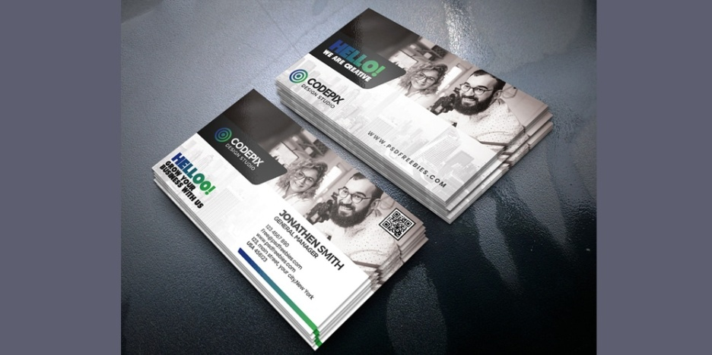
21 | BSCS-F17-LC-199 | Hamza Ghulam Nabi | 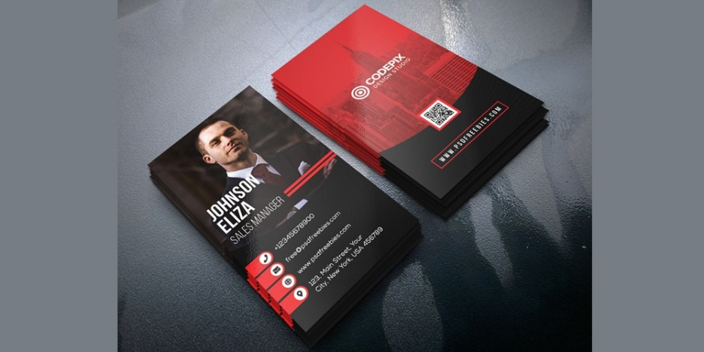
22 | BSCS-F17-LC-205 | Usama Sarfaraz | 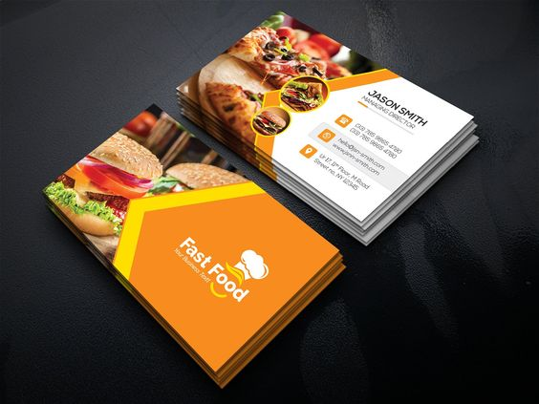
23 | BSCS-F17-LC-206 | Sohail Ahmed | 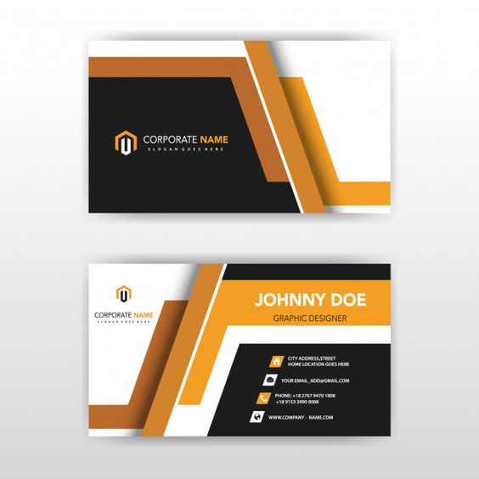
24 | BSCS-F17-LC-218 | Muhammad Abdul Ahad
25 | BSCS-F17-LC-227 | Muhammad Waleed Waheed | 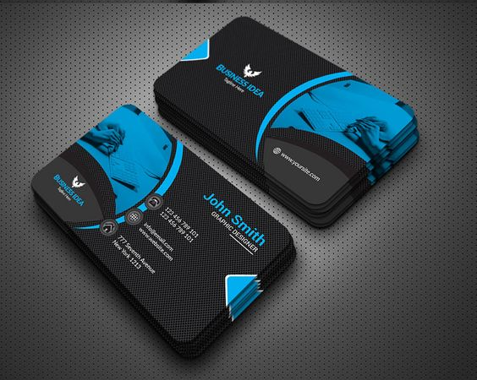
26 | BSCS-F17-LC-229 | Wasim Ahmad | 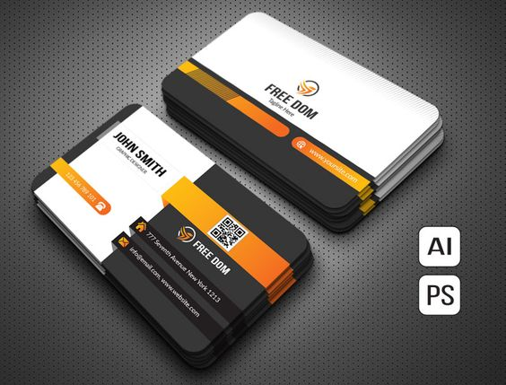
27 | BSCS-F17-LC-255 | Muhammad Usama Bin Azam | 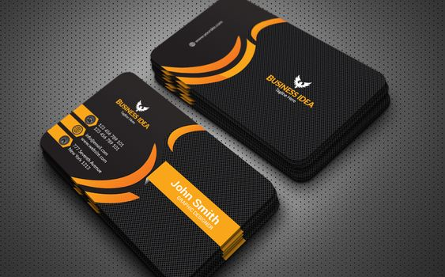
28 | BSCS-F17-LC-267 | Bilal Zaheer | 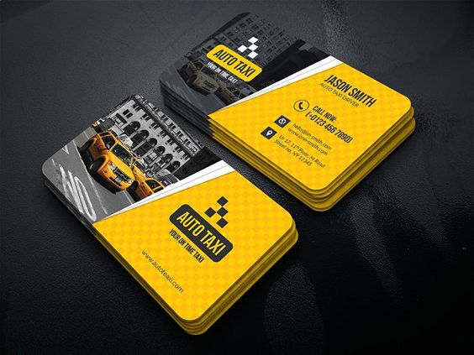
29 | BSCS-F17-LC-269 | Muhammad Awais Ur Rehman | 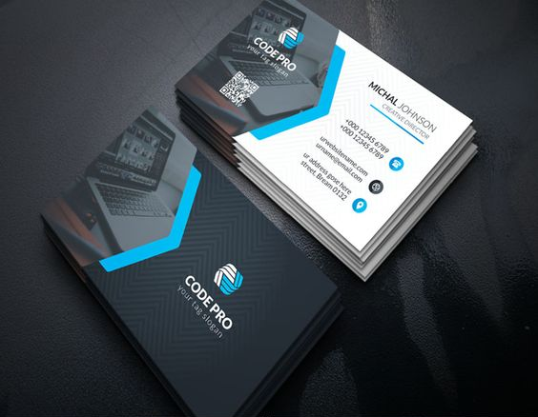
30 | BSCS-F17-LC-282 | Asim Zia | 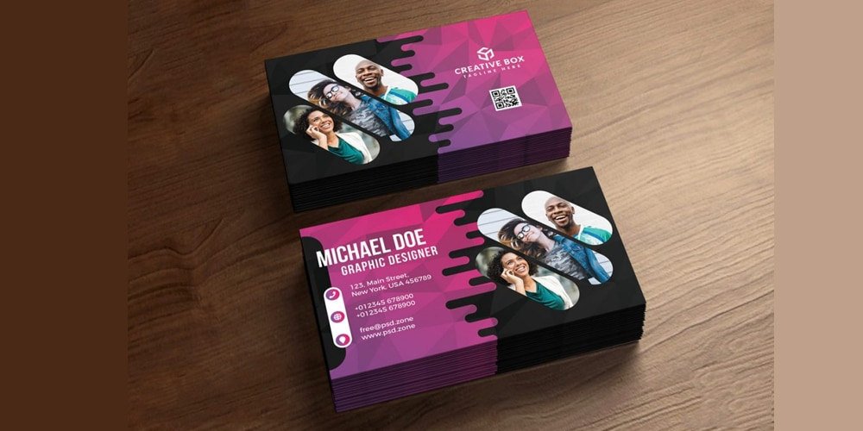
31 | BSCS-F17-LC-285 | Ahsan Farooq | 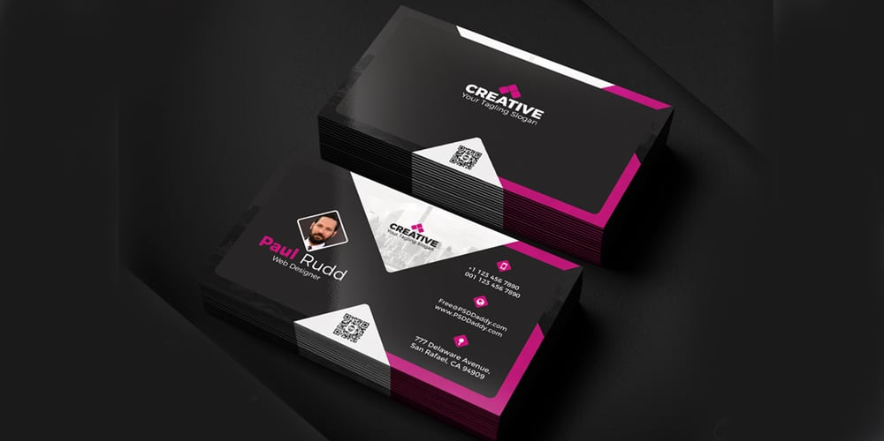
32 | BSCS-F17-LC-286 | Shah Zaib | 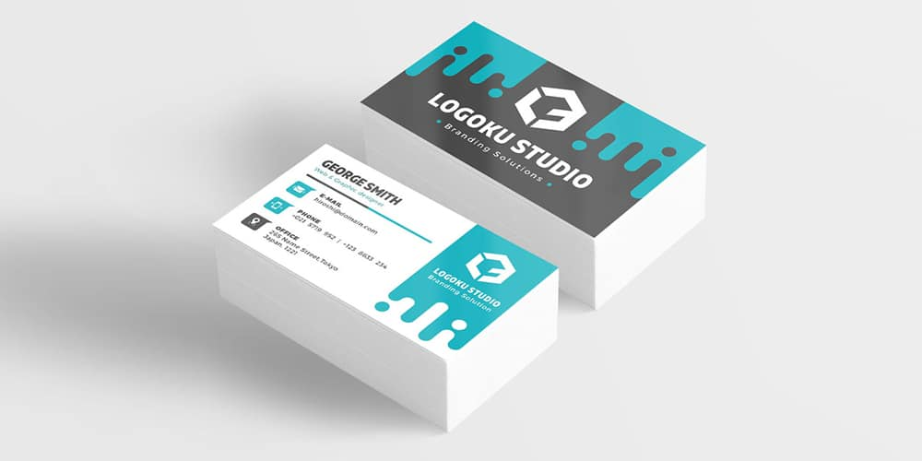
33 | BSCS-F17-LC-296 | Muhammad Hamza | 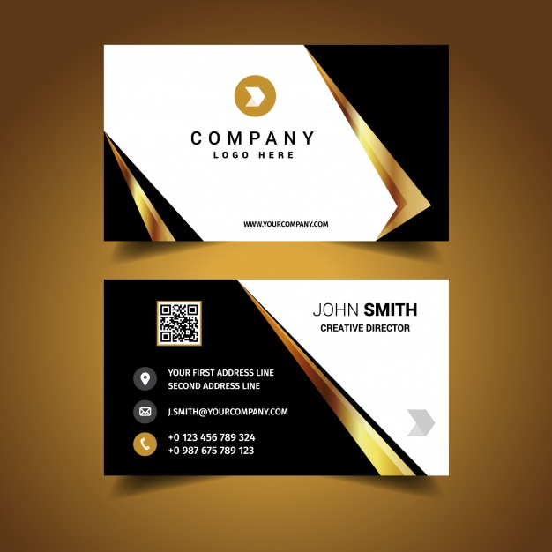
34 | BSCS-F17-LC-305 | Ibtisam Ehsan | 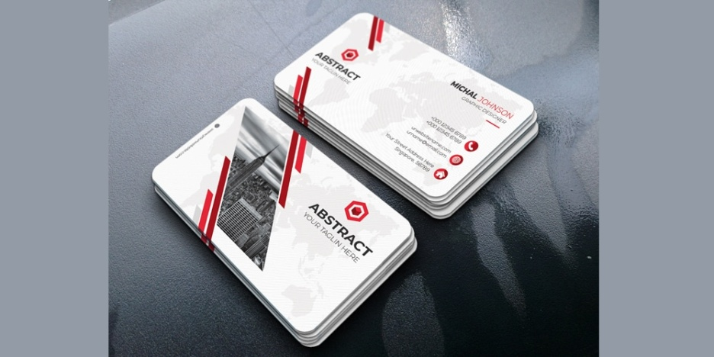
35 | BSCS-F17-LC-324 | Muhammad Talha | 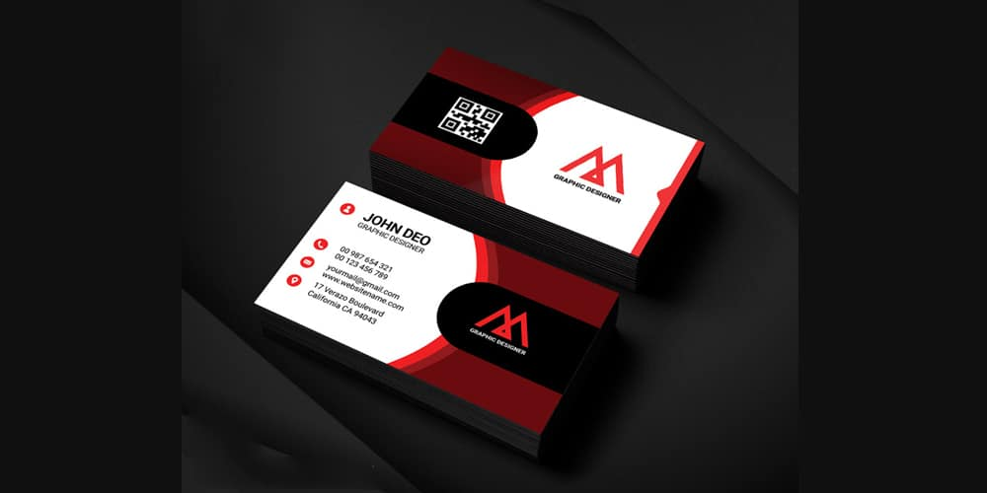
36 | BSCS-F17-LC-331 | Hamza Ahmad | 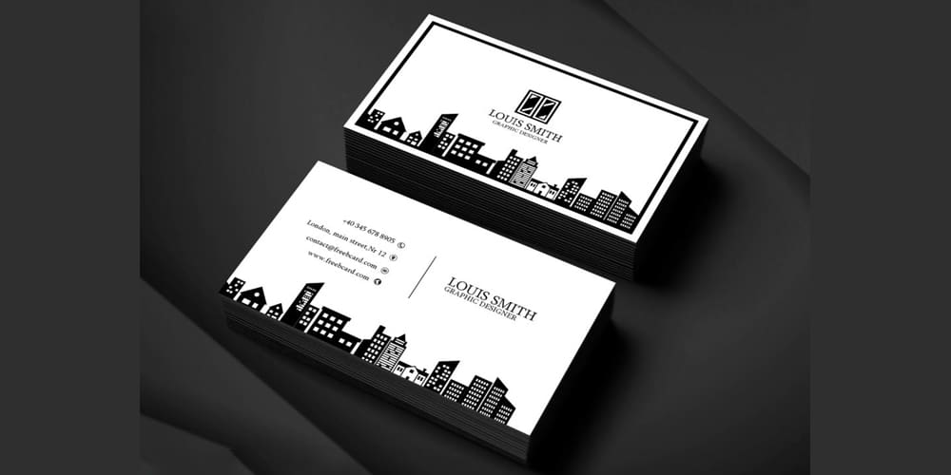
37 | BSCS-F17-LC-379 | Ghulam Dastgir | 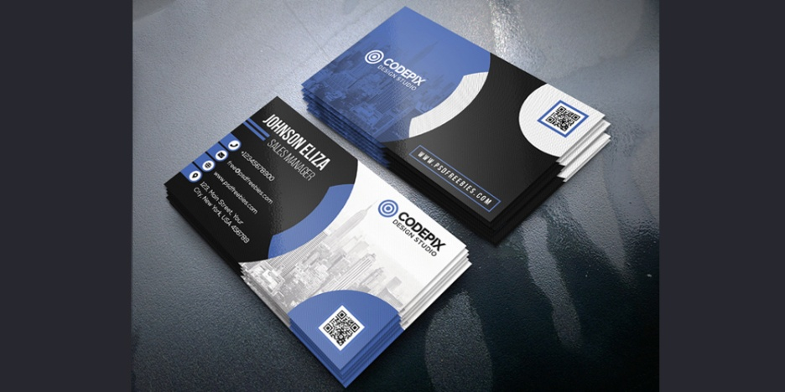

Multimedia System and Design
Class: Ex PPP BSCS 6th E
Midterm Assignment
Assignment No. 1: Visiting Cards / Business Cards
Size of card: Width= 3.3 inch
Height= 2.1 inch
Your evaluation of Assignment 1(15 marks) depends upon these points
Logo  (2) | No pixelation  (2) | Clear cutting of any object  (2) | Shapes properly made (3) | Icons properly utilized (2) | Font matching  (2) | Picture matching  (2)

Assignment No. 2: LOGO + Pamphlet / Flyer (15 marks)
Logo:- 5 marks, pamphlet :- 10 marks
You have to make a logo of a (burger, pizza) restaurant and also suggest name of that restaurant, also make a one sided pamphlet for that.
Logo size: width = 10 inch, height = 10 inch
Pamphlet size: width = 8.5 inch, height = 11 inch
Sr No. | Roll no. | Name | Assignment
1 | BSCS-F16-LC-017 | Mumhammad Areeb Ali | 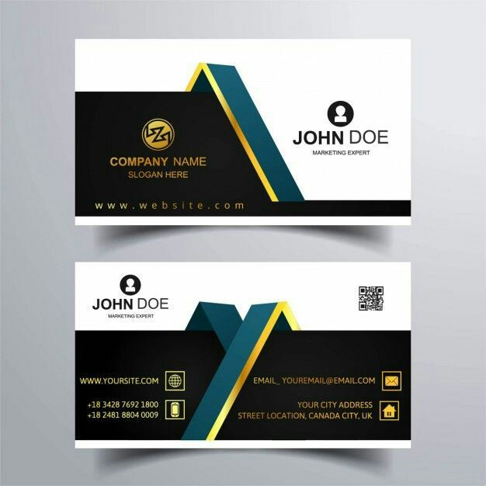
2 | BSCS-F17-LC-002 | Muhammad Saad Rashid
3 | BSCS-F17-LC-003 | Muhammad Noman | 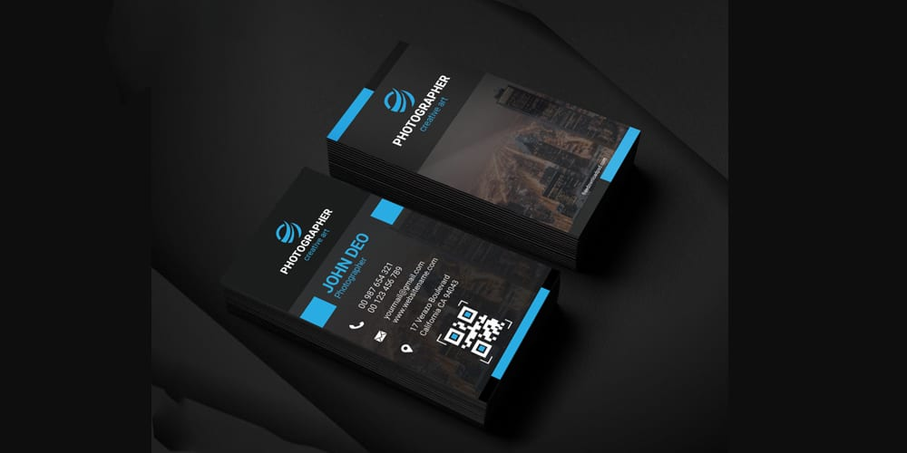
4 | BSCS-F17-LC-025 | Junaid Ahmad | 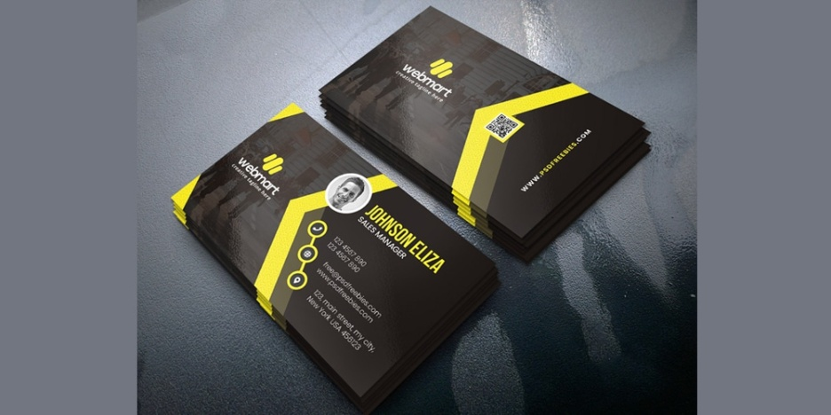
5 | BSCS-F17-LC-038 | Mudassar Hussain | 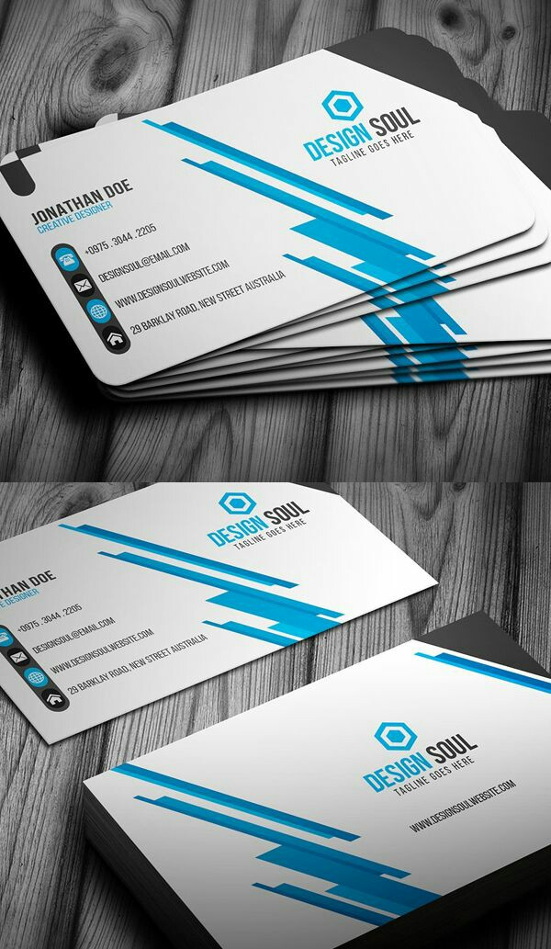
6 | BSCS-F17-LC-046 | Muhammad Asad Raza
7 | BSCS-F17-LC-048 | Zain Bin Tariq | 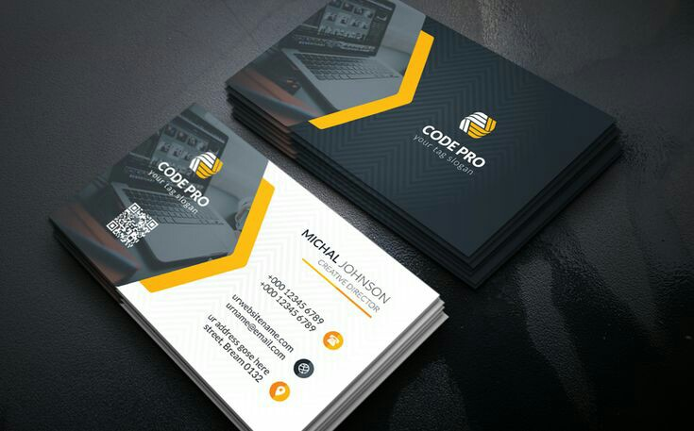
8 | BSCS-F17-LC-057 | Awais Mahmood | 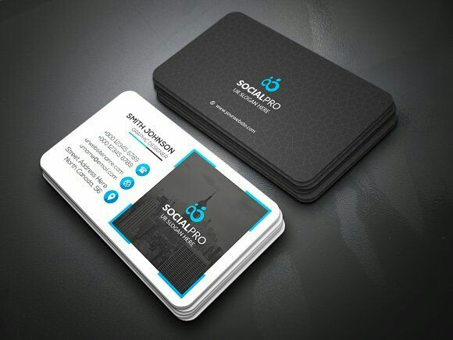
9 | BSCS-F17-LC-067 | Hamza | 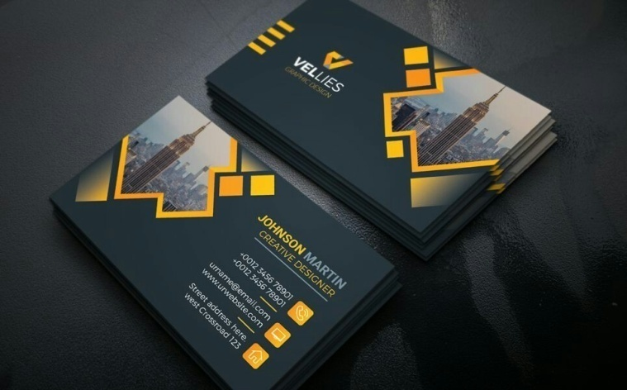
10 | BSCS-F17-LC-071 | Usman Saif Bhatti | 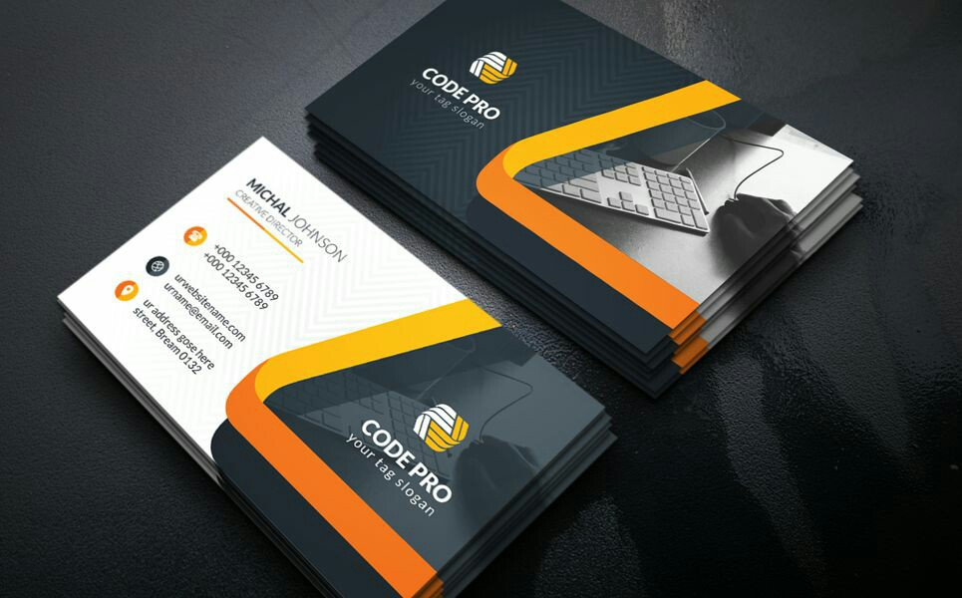
11 | BSCS-F17-LC-073 | Aneeq Naeem | 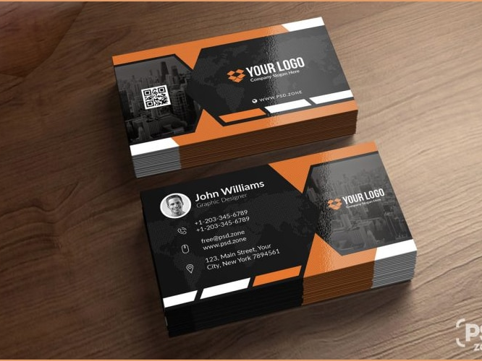
12 | BSCS-F17-LC-118 | Muhammad Hammad Anwar | 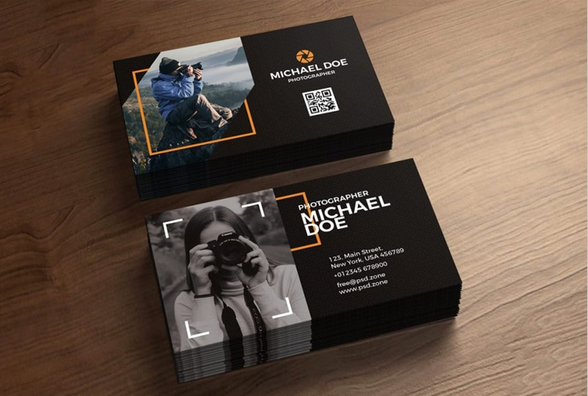
13 | BSCS-F17-LC-122 | Hamid Abdul Latif | 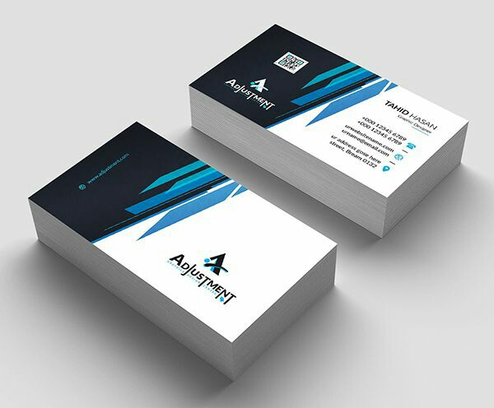
14 | BSCS-F17-LC-130 | Muhammad Ateeq Akber | 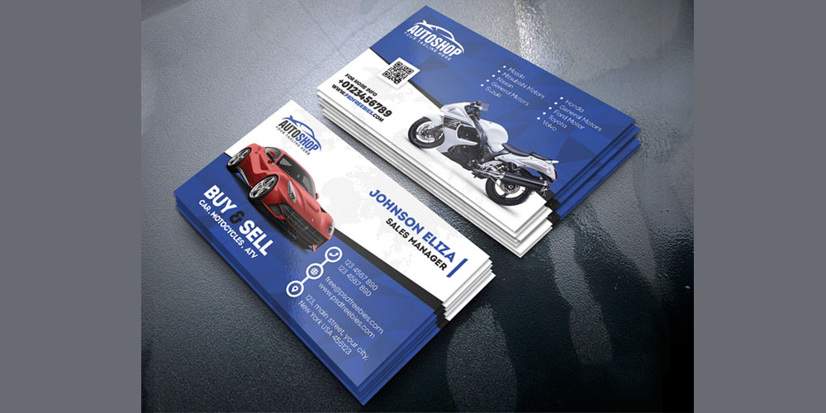
15 | BSCS-F17-LC-143 | Muhammad Rizwan Ahmad
16 | BSCS-F17-LC-151 | Usama Zafar | 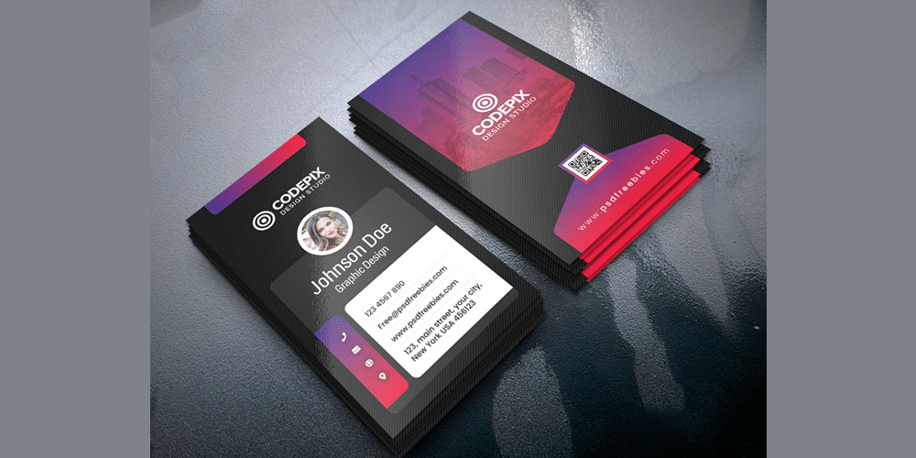
17 | BSCS-F17-LC-153 | Muhammad Qasim Rana | 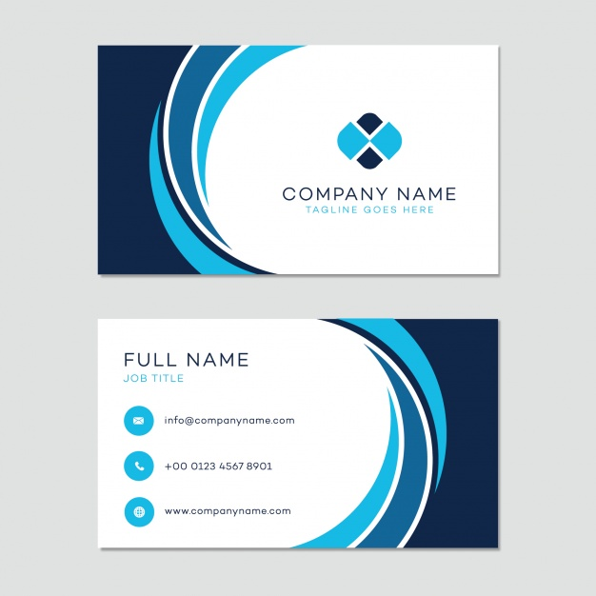
18 | BSCS-F17-LC-168 | Usman Bin Khalid | 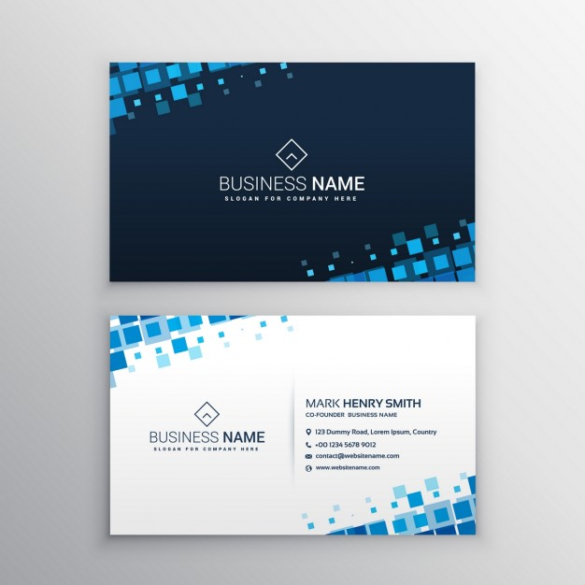
19 | BSCS-F17-LC-172 | Qaiser Shahzad
20 | BSCS-F17-LC-178 | Ali Hamza | 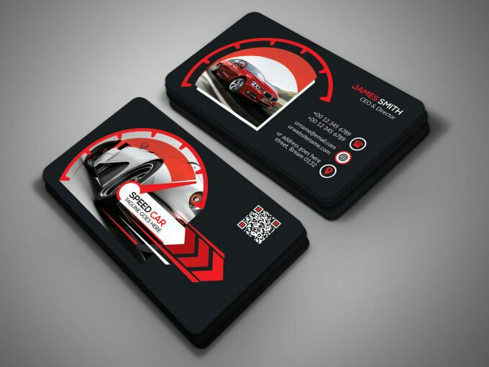
21 | BSCS-F17-LC-182 | Yousaf Anwar | 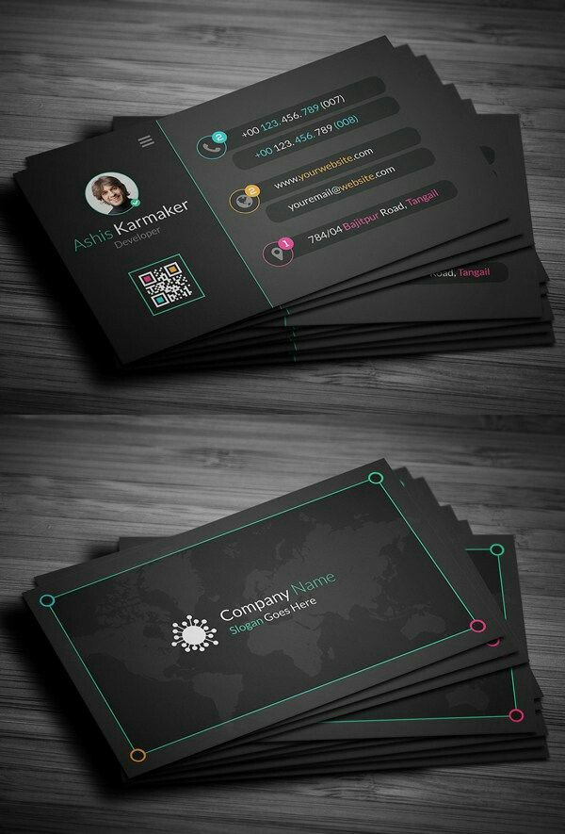
22 | BSCS-F17-LC-192 | Muhammad Shahid | 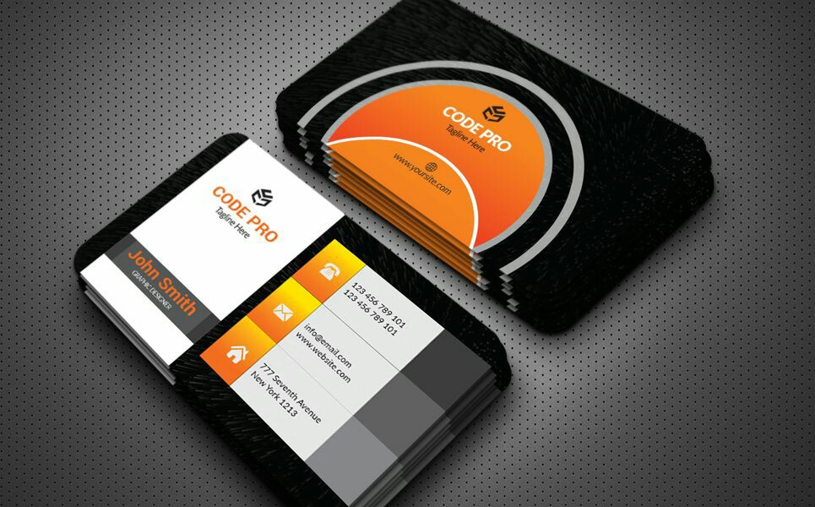
23 | BSCS-F17-LC-193 | Muhammad Umar Rasheed | 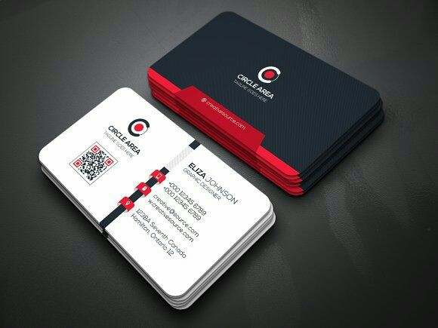
24 | BSCS-F17-LC-214 | Nouman Shoukat | 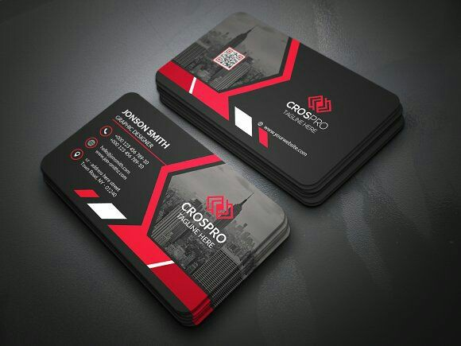
25 | BSCS-F17-LC-222 | Hamza Ali
26 | BSCS-F17-LC-226 | Rehman Javed
27 | BSCS-F17-LC-231 | Muhammad Sikandar Aziz
28 | BSCS-F17-LC-232 | Muhammad Abu Bakar | 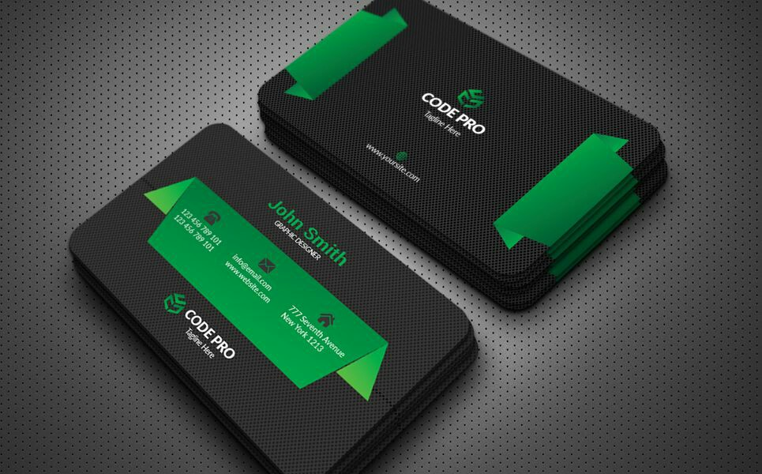
29 | BSCS-F17-LC-233 | Muhammad Junaid Asghar | 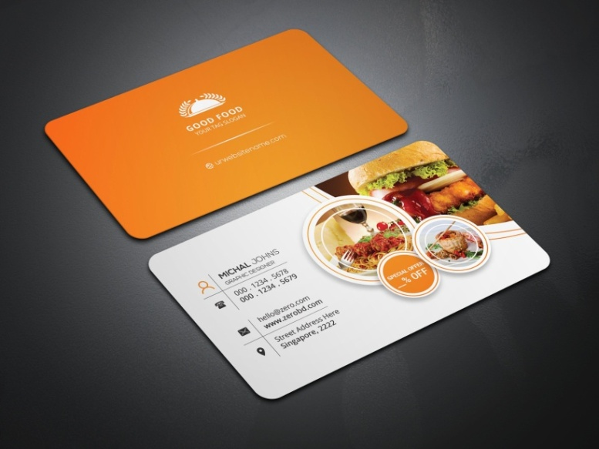
30 | BSCS-F17-LC-246 | Mehran Shakeel
31 | BSCS-F17-LC-259 | Qaisar Shehzad
32 | BSCS-F17-LC-273 | Haris Iqbal | 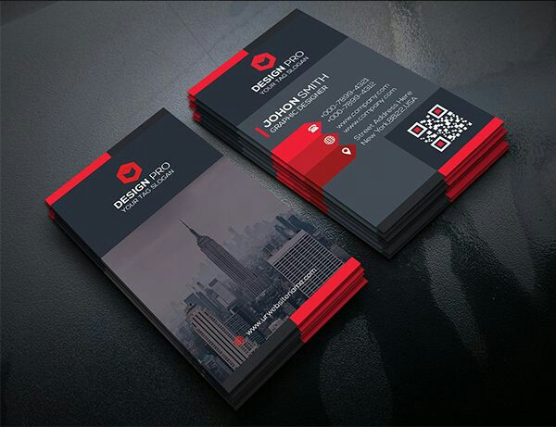
33 | BSCS-F17-LC-274 | Zaeem Farooq | 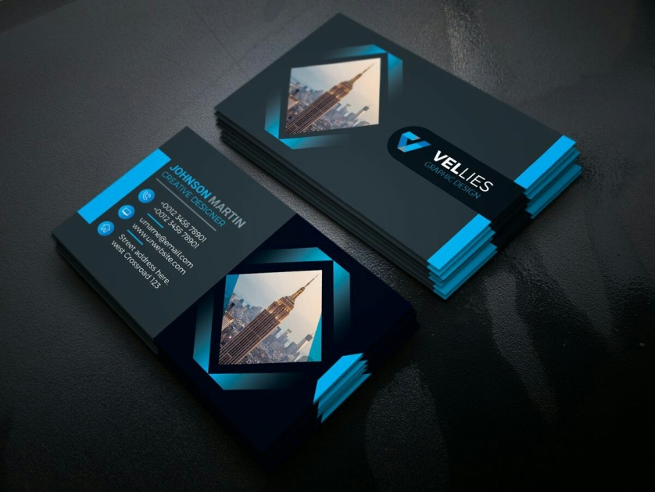
34 | BSCS-F17-LC-297 | Moeez Khan
35 | BSCS-F17-LC-300 | Hassan Ali
36 | BSCS-F17-LC-303 | Zain Wajid
37 | BSCS-F17-LC-307 | Rana Muhammad Javeed
38 | BSCS-F17-LC-314 | Muhammad Mamoon Latif | 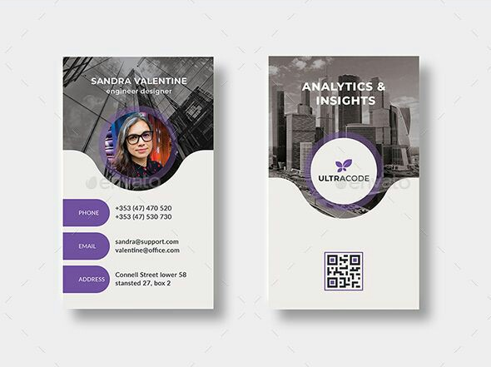
39 | BSCS-F17-LC-333 | Ammar Ali
40 | BSCS-F17-LC-337 | Asad Ali
41 | BSCS-F17-LC-354 | Muneeb Tahir
42 | BSCS-F17-LC-358 | Muhammad Ammar Ahmad | 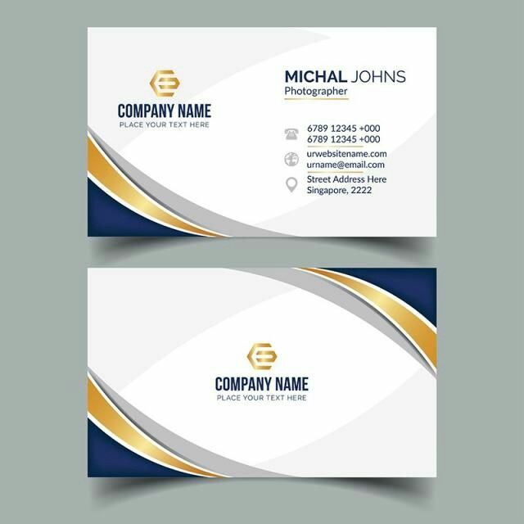
43 | BSCS-F17-LC-359 | Zeeshan Ahmad | 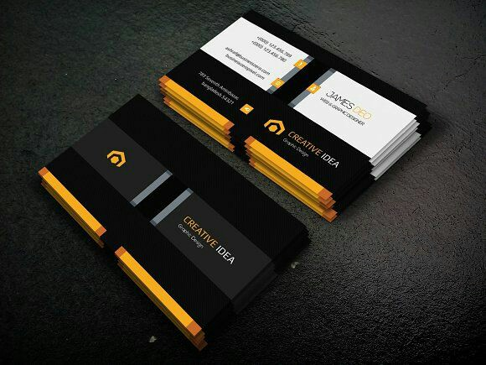
44 | BSCS-F17-LC-368 | Muhammad Zain Ud Din | 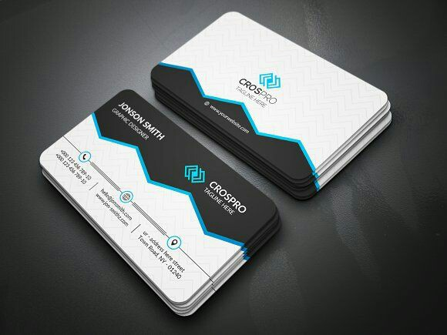
45 | BSCS-F17-LC-381 | Yousaf Sarwar | 