Explain about Multi-tier architecture ?
A tier is an abstract concept that defines a group of technologies that provides one or more services to its clients. In multi-tier architecture each tier contains services that include software object or DBMS. Multi-tier architecture is composed of clients, resources, components (service), and containers.
Clients, Resources and Components
A client refers to a program that requests a service from a component. A resource is anything a component needs to provide a service, and a component is part of tier that consists of a collection of classes or a program that performs a function to provide the service. A container is software that manages a component and provides a component with system services. The following image is representing the Client, Resource and Component model.
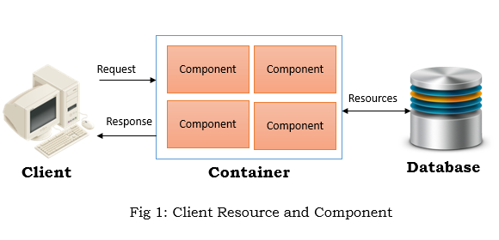
The relationship between a container and a component is sometimes referred to as a contract, whose terms are governed by an application programming interface (API). An API defines rules a component must follow and the services a component will receive from the container.

