Phamraceutical Care

Individualization & Optimization of Dosage Regimen

Submitted
To
Madam Shazia Akram

Submitted
By
Hasnain Ahmad
Roll No.1
PhD.
Pharmaceutics
2019-2022

Date: 01 April 2020

CONTENTS
- DOSE REGIMEN DESIGN
  - Reasons for dose regimen design
  - Causes of inter subject variabilities
- DOSAGE REGIMEN DESIGNS IN RENAL IMPAIRMENT
2.1 Pharmacokinetics in renal impaired patients
2.2 Dose adjustment in renal impaired patients
2.3 References
3. DOSAGE REGIMEN DESIGN IN HEPATIC IMPAIRMENT
3.1 Pharmacokinetics in Hepatic impaired patients
3.2 Dose adjustment in hepatic impaired patients
3.3 References

1)Dosage Regimen Design
1.1) Reasons for dose regimen design:
Dose adjustment or dose regimen design may be patient oriented or drug oriented or both.
Drug oriented regimen adjustment requires when prescribed drug is with narrow therapeutic index, also known as critical dose drugs.
Patient oriented regimen adjustment requires when there is intersubject pharmacokinetic variability
Intersubject pharmacokinetic variability means difference in drug concentration at site of action because of difference in absorption, distribution, metabolism and excretion between individuals.
1.2) Causes of Intersubject Pharmacokinetics Variability:
Major causes of Intersubject Pharmacokinetics Variability are:
- Age
- Body Weight
- Disease and
- Drug-Drug Interactions.
2) DOSAGE REGIMEN DESIGNS IN RENAL IMPAIRMENT:

Renal failure (also kidney failure or renal insufficiency) is a medical condition in which the kidneys fail to adequately filter waste products from the blood. The two main forms are acute kidney injury, which is often reversible with adequate treatment, and chronic kidney disease, which is often not reversible.

2.1) Pharmacokinetics in renal impaired patients:
- Absorption:
Absorption or T_{max} may be decreased due to disease related decrease in gastro intestinal motility.
- Distribution:
- The plasma protein binding of acidic drug is decreased due to hypoalbuminemia, accumulation of endogenous substances which competitively displace acidic drugs from their binding sites on albumin, and a conformational change of the binding sites on the albumin molecule.
- The plasma binding of basic drugs appears to be generally unaffected.
- The volume of distribution of several drugs is significantly increased in patients with severe renal dysfunction. An increased volume of distribution may be the result of fluid overload, decreased protein binding.

- Metabolism:
Renal impairment affects both phase l, ll and renal metabolism.
- reduction and hydrolysis are slower. This may increase serum concentrations of the parent drug and consequent toxicity if the drug is metabolised to inactive metabolites. E.g erythromycin.
- reduced acetylation may result into accumulation of drug.
- renal drug metabolism may be impaired in patients with reduced kidney function is for example decrease in metabolism of imipenem, an antibiotic that is partly eliminated by metabolism by renal brush border dehydropeptidase and by renal excretion.
Uremic toxins that accumulate in the body in chronic renal failure have been implicated in these alterations in drug-metabolizing enzyme activity
- Renal excretion:
Depending on the etiology of renal dysfunction, the normal histology of the glomeruli and the tubules may be differentially affected. However, the functions of all segments of a diseased nephron are assumed to be equally affected.
All these parameters lead to accumulation of active drug, in active drug (in case of pro drug), or polar drug metabolites (conjugation of glucuronides and sulfates) in body of patient. That result in prolong halflife, and change in apparent volume of distribution (edema condition)
Morphine is a good example illustrating the significance of the accumulation of drug metabolites in patients with renaldysfunction.Morphine is eliminated by metabolism to
five metabolites:morphine-3-glucuronide, morphine-6-glucuronide, normorphine, codeine and morphine-N-oxide,Renal excretion of morphine itself only accounts for approximately 4% of its overall elimination. However, when given standard doses of morphine, patients with renal dysfunction showed typical signs of morphine intoxication, i.e., respiratory depression, mental distortion, and hypotension. Subsequent studies showed that the major morphine metabolites, i.e., morphine-3-glucuronide and morphine-6-glucuronide, which are normally excreted by renal mechanisms, extensively accumulate in patients with renal dysfunction. Morphine-6-glucuronide is a stronger opioid analgesic than morphine itself and that the prolonged respiratorydepression in renal failure patients receiving
morphine, due to high plasma levels of morphine-6-
glucuronide .
Pharmacokinetic and dose adjustment in patient with renal dysfunction, roger K Verbeek, clin pharmacol(2009)65 :757-773
How is renal function assessed?
- The loss of excretory function in the diseased kidney can be quantified by GFR, Creatinine clearance is most extensively use as a measurement of GFR
- Measurement of BUN (Blood Urea Nitrogen), increase BUN levels indicate renal disease.
2.2) DOSE ADJUSTMENT IN RENAL IMPAIRED PATIENTS:
Drug adjustment is generally not required until CrCl falls below 1ml / s (GFR 60 ml/min). There are many methods for determination of CL_{cr} from serum creatinine, Cockcroft and gault equation, estimated GFR using modification of diet in renal disease (MDRD) formula and chronic kidney Disease Epidemiology Collaboration (CKD-EPI) equations. However Cockcroft and gault method has gained general acceptance (Schneider et al, 2003; splinter et al, 1990
CrCl (ml/min) = (140 - age) x weight (kg)
72 x SCr (mg/dl)
Multiply CrCl result by 0.85 for females
If actual weight is ≥ 20% IBW, use Adj BW.

Case 6: Determine creatinine Cl for an 80yrs old man weighing 70 kg using both formulas, also calculate the dose of ofloxacin when serum creatinine is 2mg/dl (usual dose is 400 mg / day).
Solution: CrCl (ml/min) = (140-80 ) x 70 = 4200 = 29.16ml/min
72 x 2 144
Dose of ofloxacin = 29.16 x 400 = 97.2 mg/day
120
- A child with renal impairment, creatinine clearance is determining by following formula:
Schwartz formula for creatinine clearance for children:
Cl _{cr} = KL/ S_{cr}
L = length in cm
S_{cr} = mg/dl
K = factor = 0.33 for neonates, 0.45 for infants, 0.55 for 2-12 yr , 0.77 for 13- 18 adolescents.
Schwartz GJ, Haycock GB, Edelmann CM Jr, Spitzer A: A simple estimate of glomerular filtration rate in children derived from body length and plasma creatinine. Pediatrics 58:259-263, 1976.
Calculating dose from Cl_{cr:}
Dose = creatinine clearance of patient × normal dose
Normal creatinine clearance
. Drug accumulation sufficient to be of clinical concern occurs in patients with RI if ≥30% of the drug is eliminated unchanged in the urine anddose reduction needs to be considered, depending on the degree of RI and fraction of drug excreted unchanged
- Drug Classes Requiring Dosage Adjustment/in CKD

 | Drug Class | Avoid in Stages 4 & 5 of CKD
B | Beta Blockers | Sotalol
A | ACE Inhibitors/ARBs* | Olmesartan
N | NSAIDS**,Opioids | All NSAIDS, meperidine
D | Diuretics | Potassium sparing diuretics, thiazide diuretics
D | Diabetic medications | Glyburide, metformin, exanitide
C | Cholesterol medications
A | Antimicrobials  (Dose reductions are often delayed for 24-48 hours to allow for aggressive dosing/drug to reach steady state) | Nitrofurantoin
M | Miscellaneous | New anticoagulants
P | Psychotropics | Lithium, topiramate
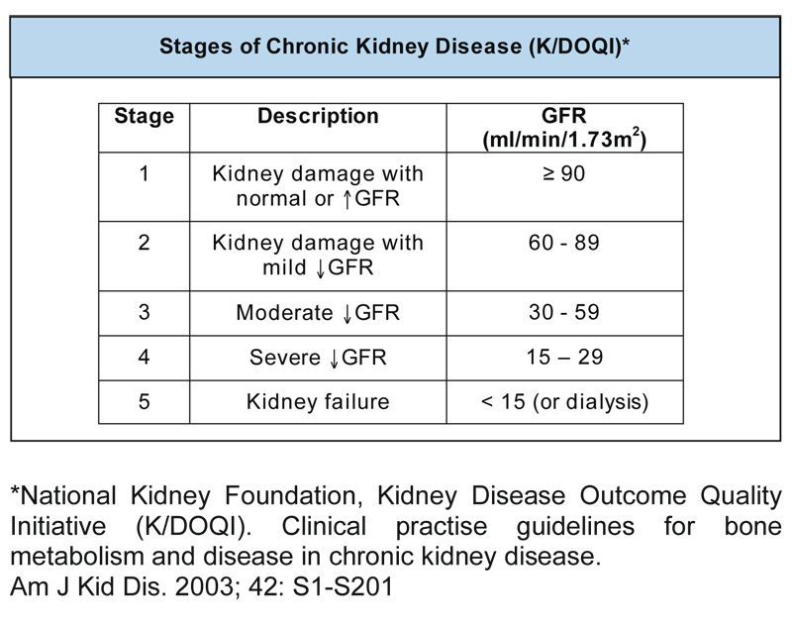

Serum Creatinine The normal serum creatinine range for men is 0.5-1.5 mg/dL. The normal range for women is 0.6-1.2 mg/dL.
Creatinine Clearance Normal creatinine clearance for healthy men is 97-137 mL/min. Normal creatinine clearance for healthy women is 88-128 mL/min.
Blood Urea Nitrogen (BUN) The normal BUN level for healthy individuals is 7-20 mg/dL in adults, and 5-18 mg/dL in children
2.3 References:
- National kidney foundation,kidney disease outcome quality initiative (KDOQI) guidelines.
- Www. Druginfo.usask.ca, volume 29 , issue no 3 nov 2012
- Cockcroft. D.W., & Gault, M.H. (1976). Prediction of creatinine clearance from serum creatinine. Nephron (16), 31-41
- National Kidney Disease Education Program. (2010, January). Chronic kidney disease andndrug dosing: Information for providers. NKDEP. Retrieved from http://www.nkdep.nih.gov/resources/ckd-drug-dosing-508.pdf.)
- Food and Drug Administration. (2010, March). Guidance for industry: pharmacokinetics in patients with impaired renal function - study design, data analysis, and impact on dosing and labeling. FDA. Retrieved from http://www.fda.gov/downloads/Drugs/GuidanceComplianceRegulatoryInformation/Guidances/UCM204959.pdf.
- What factors need to be considered when dosing patients with renal impairment?
Prepared by UK Medicines Information (UKMi) pharmacists for NHS healthcare professionals www.ukmi.nhs.uk/activities/medicinesQAs/default.asp
Date prepared: 7th May 2013

3) DOSAGE REGIMEN DESIGN IN HEPATIC IMPAIRMENT:
Liver failure is the inability of the liver to perform its normal synthetic and metabolic function as part of normal physiology. That may be Hepatitis, Cirrhosis, liver cancer, Hereditary diseases, or others

3.1) Pharmacokinetic in hepatic impaired patients:
- Absorption:
Bioavailability is reduced; the effect of liver disease on the bioavailability of orally administered drugs is the result of reduced presystemic hepatic metabolism.
- Distribution:

- Many drugs that are highly bound to albumin or α1-acid glycoprotein have a significantly higher UNBOUND FRACTION in patients with chronic liver disease. Mechanisms for decreased binding of certain drugs to plasma proteins include (1) reduced albumin and α1-acid glycoprotein synthesis leading to low levels of these important binding proteins in plasma of patients with chronic liver disease, (2) accumulation of endogenous compounds, such as bilirubin, inhibiting plasma protein binding of certain drugs, and (3) possible qualitative changes in albumin and α1-acid glycoprotein. As a result of the lower plasma binding, the distribution volume of certain drugs may be larger in these patients.
- Water-soluble drugs will have asignificant increase in their volumes of distribution in patients with ascites possibly necessitating larger loading doses. For example, the apparent volume of distribution of the β-lactam antibacterial cefodizime was shown to be three times larger in patients with cirrhosis compared to healthy individuals.
- Metabolism:

Hepatic clearance depends upon: blood flow, intrinsic clearance, fraction of drug bound. In liver impairment,
- hepatic portal vein shunt, so no blood supply
- Hepatocytes damage or necrosis so it will effect microsomal enzymes and thus metabolic activity,
- Decrese production of proteins especially albumin, so fraction of unbound drug increase.all these factors reduce hepatic clearance.
Extraction ratio of drug will indicate whether it is depend only on blood flow (low extraction ration drugs), or on both hepatocytes and blood flow (high extraction ratio drug). Here is some example of high and low extraction ratio of drugs.
Some examples of drugs with high and low hepatic extraction
High extraction ratio | Low extraction ratio
Antidepressants  Chlorpromazine/haloperidol  Calcium channel blockers  Morphine  Glyceryl trinitrates  Levodopa  Propranolol | Non-steroidal  anti-inflammatory drugs  Diazepam  Carbamazepine  Phenytoin  Warfarin
PHASE I: in early stages of liver impairment there is decrease in CYP2C19
Intermediate stage decresae in both CYP1A2 AND CYP 2C19
In last stage, decrease in CYP1A2, CYP2C19, CYP2D6, AND CYP2E1
PHASE II: conjugation reactions are thought to be less effective than CYP450 reactions., however impaired glucuronidation was found for some drug in study like morphine, oxazepam, zidovudine.
- Biliary excretion:
Reduced formation or secretion of bile into the duodenum will lead to a decreased clearance of substances, both endogenous and exogenous, that are eliminated by biliary excretion.such as ampicillin, piperacillin, certain cephalosporins, clindamycin, and ciprofloxacin.
- Renal excretion:
The hepatorenal syndrome may be defined as unexplained progressive renal failure occurring in patients with chronic liver disease in the absence of clinical, laboratory, or anatomical evidence of other known causes of renal failure.
Reduced renal excretion has been reported for a number of drugs mainly excreted in unchanged form by the kidneys such as the diuretics furosemide , H2-receptor antagonist’s cimetidine and ranitidine, and in patients with advanced cirrhosis.
Estimations of creatinine clearance based on serum creatinine measurements (e.g., Cockroft-Gault method) in these patients are often inaccurate.The measured creatinine clearance seems to be inaccurate because of an increased fractional tubular secretion of creatinine in patients with cirrhosis as the glomerular filtration rate deteriorates. The serum cystatin C level, another endogenous marker for renal function, may reflect glomerular filtration more accurately in cirrhotic patient.
In any case, in patients with advanced chronic liver disease, dosage modification is not only necessary for drugs predominantly cleared by the liver but may also be indicated for renally cleared drugs
3.2) DOSING ADJUSTMENT IN HEPATIC IMPAIRMENT:
Liver metabolizing ability is assessed in this method from the determination of the CHILD- PUGH score. The Child-Pugh classification incorporates five variables to assess the severity of liver disease: serum bilirubin, serum albumin, prothrombin time, the presence of encephalopathy, and the presence of ascite. Disease severity is then classified as mild (class A), moderate (class B), or severe (class C) this classification scheme is useful in following an individual patient’s disease course and may offer the clinician some guidance for dose adjustment.
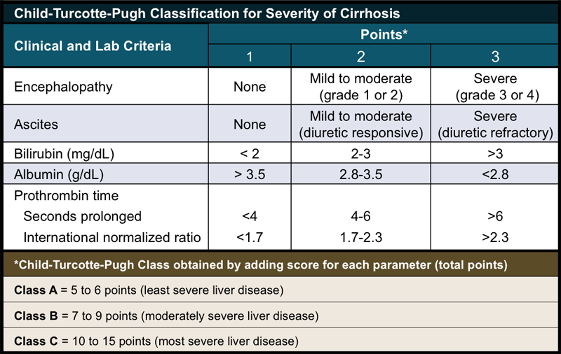
Patient with score 8-9 require 25% reduction of their initial dose foe the drugs that are more than 60 % metabolized , however patient with 10 or more score require 50% reduction in initial dose , after initial dose further therapy is based on pharmacological and adverse effects of the drugs. Most of drug literature provides data about their subsequent dose reduction with respect to different child- Pugh score
When no recommendations for dosage adjustment in patients with hepatic dysfunction based on their Child-Pugh score are available, the following general considerations will be helpful.
- for severe liver dysfunction (albumin ,30g/L, INR> 1.2 )
- if drug is high extraction reduce dose by 50%
- if drug is low extraction reduce by 25 %

Case 7: Case 7: a 55 year of female was admitted to hosp after developing an episode of ventricular arrhythmia. Pt had multiple medical problems like liver cirrhosis, hypertension and ischemic heart disease. Her labs value: SCr 1.1mg/dl, Salbumin 3.2g/dl, total bilirubin 4.5mg/dl prothrombin time 8 s longer than control Physical examination shows that pt was alert without any signs of encephalopathy, and had mild ascites
Physician wanted to start lidocain what would be starting dose.
Answer:
Calculation of the Child-Pugh score:
Serum albumin 3.2g/dL Score=2
Bilirubin 4.5mg/dL Score=3
Prothrombin time 8s> control Score=3
Ascites Mild Score=2
Encephalopathy Absent Score=1
Total Child-pugh score=11
According to the child-pugh score the starting dose of the lidocaine in this patient should be 50% of the average recommended dose of lidocaine. Lidocaine dose can be adjusted after the start of therapy according to the therapeutic and the adverse effect of lidocaine.

3.3) References:
- Prescribing in liver disease , Andrew sloss, Paul Kubler , clinical pharmacologist , royal Brisbane hospital , Brisbane
- Effect of advanced liver disease on drug pk, , GiovanniDI Perri , 8th international workshop on clinical pharmacology, U.S.A
- Drug use in liver disease , by drug info service of chrischurch hospital, October 2003
- Basic Pharmacokinetic , Mohsen A. Hedaya (book)
- Pharmacokinetic and Dose Adjustment in patient with Hepatic Dysfunction , roger k Verbeek , Clin Pharmacol (2008) 64 :1147-1161 Link :www.farm.ucl.ac.be/Full-texts-FARM/Verbeeck-2008-2.pd
- Clinical pharmacokinetic and pharmacodynamic considerations in patients with liver disease. An update.Morgan DJ¹, McLean AJ. Clin Pharmacokinet. 1995 Nov;29(5):370-91 Link : http://www.ncbi.nlm.nih.gov/pubmed/8582120

