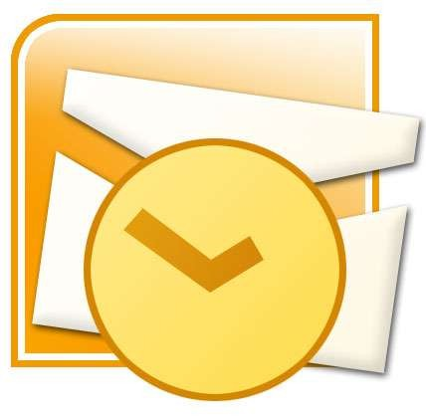

Microsoft Outlook
Basic

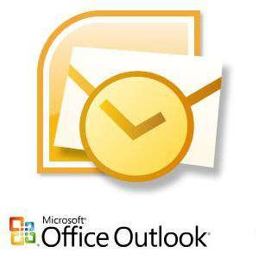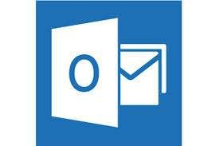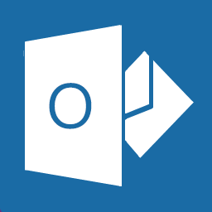What is Microsoft Outlook ?
Microsoft Outlook is a personal information manager from Microsof available as a part of the Microsoft Office suite. The current version i Microsoft Office Outlook 2013 for Windows and Microsoft Offic Outlook 2011 for Mac.
t,
s
e

s b

Although often used mainly as an email application, it also include a calendar, task manager, contact manager, note taking, a journal & we browsing.

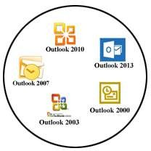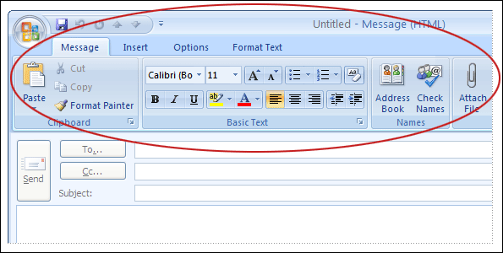Ribbon Option in Outlook.

The Ribbon Option is the top portion of outlook windows that appear when you create a new mail massage or reply/forward to an old massage in MS. Outlook.

Look familiar? If you've used Microsoft Office Word, the Ribbon for Outlook messages will be familiar to you. Major commands and menu are broken up into TABS. Because the Outlook editor is based on Word, many of the commands and options that are available in Word are available when you create messages in Outlook.

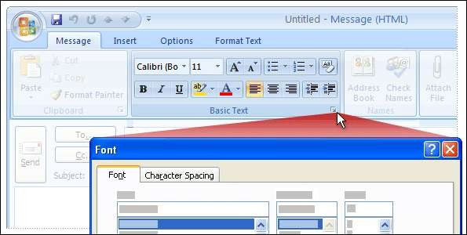More Option Button in Ribbon
- A small arrow at the bottom of a group means there's more available than what you see.

- For example, to see the full list of font options, you would click the arrow next to the Basic Text group on the Message tab of a new e-mail message.

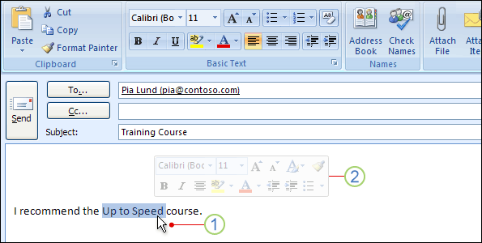Mini Toolbar
- The Mini toolbar allows you to quickly access formatting commands right where you need them: in the body of an e-mail message.

- Select or highlight your text and then point at this selection

The Mini toolbar appears, but is almost INVISIBLE. If you point to it (meaning you roll your mouse curser over it), it becomes solid, and you can click a formatting option.

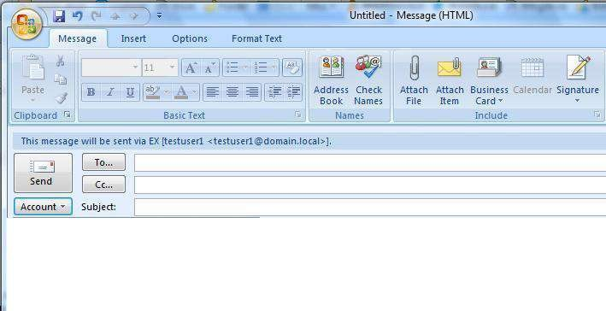Create New Massage
Creating an e-mail message is the most frequent task we will perform in Outlook. After learning the basics, you will be able to personalize email messages you send.

NOTE: Microsoft Office Outlook uses an editor based on Word for e-mail messages, which means that you can get assistance with the by pressing F1, and then search in Word Help.

Start a new message
On the File menu, point to New, and then click Mail Message.
Keyboard shortcut To create a new e-mail message, press CTRL+SHIFT+M In the Subject box, type the subject of the message.

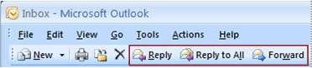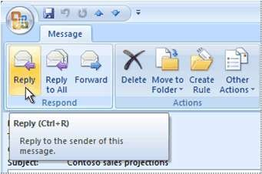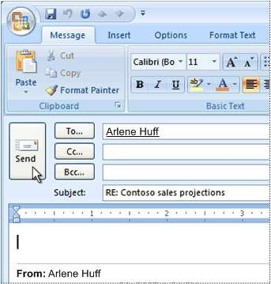Reply, Forward & Send Massage

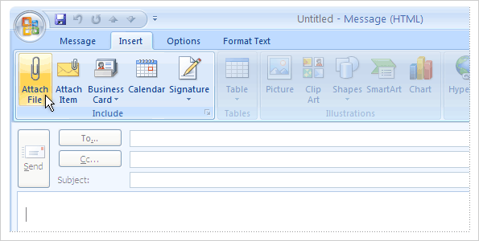Insert Ribbon

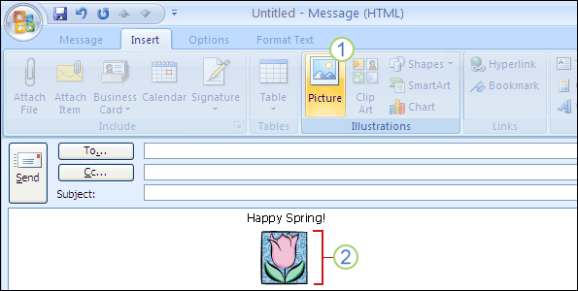Insert Ribbon

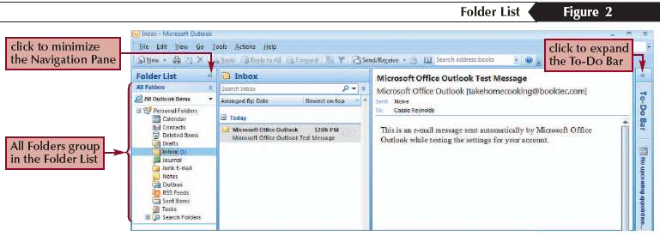Navigation Between Components

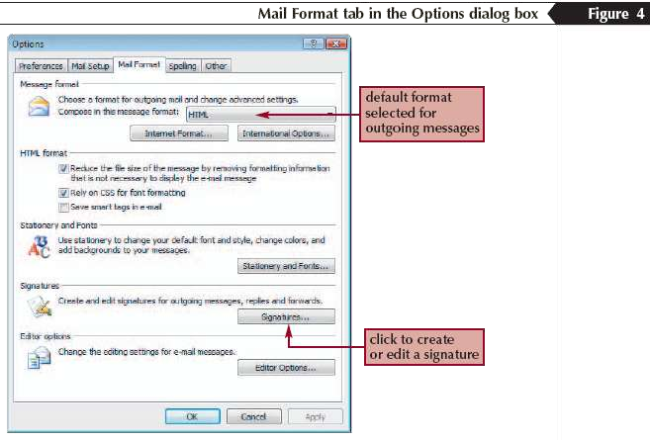Mail Format

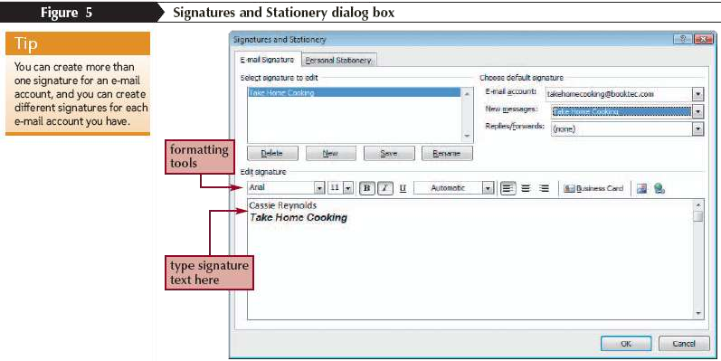Email Signature

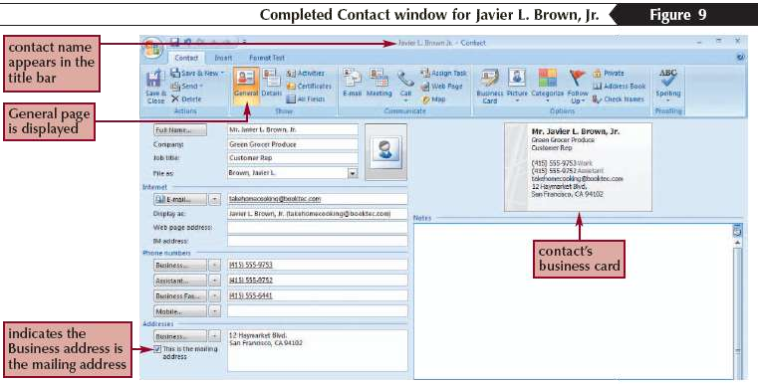Creating a Contact

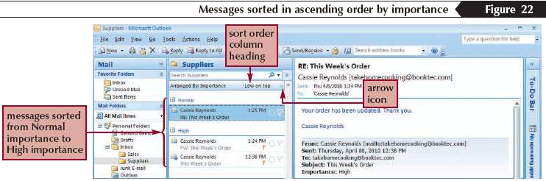Sort Email Massages

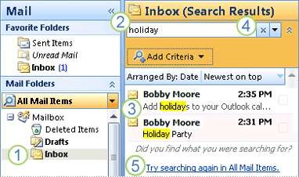Search Option

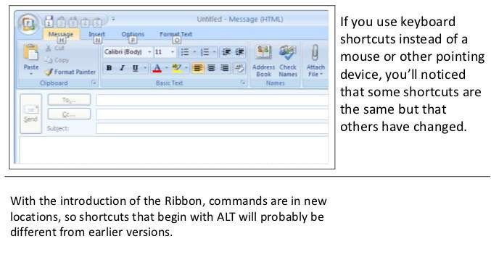Shortcuts

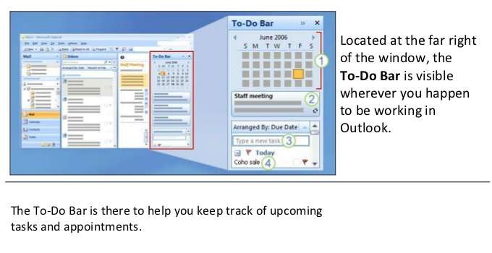To-Do Bar

