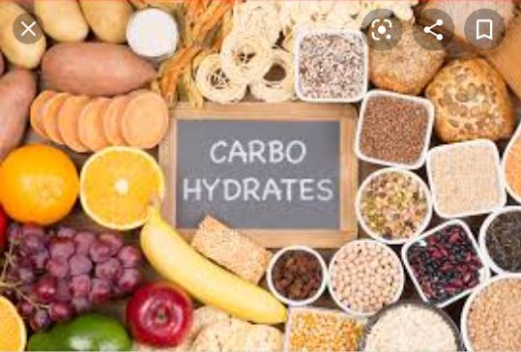
- TITLE NAME: CARBOHYDRATES

All the living things are made of certain chemical compounds,which are generally classified as organic and inorganic.Most important organic compounds in living organisms are carbohydrates,proteins,lipids and nucleic acid.Carbohydrates are the most important organic compound.
- INTRODUCTION OF CARBOHYDRATES:

In 19 century substances such as wood,starch, were found to be composed mainly of molecules containing atoms of C,H,O other molecules also found to have similar ratio of hydrogen and oxygen.Carbohydrates literally mean hydrates of carbon .

Carbohydrates are sugar ,starches,and fibers found in friut grains,vegitables and milk products.The American Diabates Association notes that carbohydrates are the body’s main source of energy.They are called carbohydrates because at the chemical level ,they containC,H,O.

The recommended daily ammount(RDA) of carbs for adult is 135grams according to NATIONAL INSTITUTES OF HEALTH.However people with dibetes should not eat more than 200 grams carbs per day,while pregnant women need at least 175grams.
- DEFINITION OF CARBOHYDRATES:

The polyhydroxy aldehyde or ketones or complex substances which on hydrolysis yield polyhydroxy aldehyde or ketones subunits.
- MAIN SOURCE OF CARBOHYDRATES:

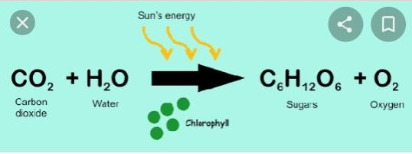
The main source of carbohydrates are green plants.These are the primary products of photosynthesis. Other compounds of plants are produced from carbohydrates by following changes.During photosynthesis process plants get carbondioxide from atmosphere and water from soil and form glucose in the persence of sunlight and chlorophyll.

- DIAGRAMATICALLY

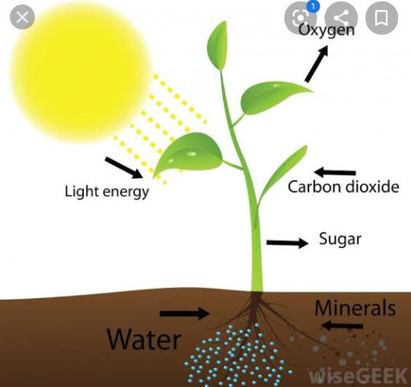
- GENERAL FORMULA:
Their general formula _{Cx(}H_{2O)y} where (x)is the whole number from three to many thousands where (y)may be same or different whole number.we can also use anyother subscription on the place of x and y.Like if we use m and n.Then formula will be written as _{Cm(}H_{2O)n.}

It is not necessary that m=n in many cases m is not equal to n.so it is not necessary that every carbohydrate following that rule.But if m=n then we can say the formula will be written as;
_{Cn(}H_{2O)n}
There are many examples in which carbohydrates unfollowing that rule.
Like Deoxyribose its formula is C₅H₁₀O₄ and Rhamnose its general formula is C₆H₁₂O_{5.},these are chemically carbohydrates but they are not going to follow that rule ,so every time we can not say that carbohydrates going to follow that rule.
Now some examples which follow that rule but not carbohydrate like foramaldehyde and acetic acid these following that rule because value of n is equal but these are not carbohydrates .
- GOOD AND BAD CARBOHYDRATES:
Carbohydrates are found in foods you know are good for you (vegetables) and ones you know are not(doughnuts).This has lead to idea that some carbs are good and some are bad.

Carbs normally considered bad include pasteries,sodas,highely processed foods,white rice,white bread and other white flour foods .bad carbs rarely have any nutrirional value

Carbs usually considered good and complex carbs such as whole grains,friuts,vegetables beans and legumes.

Check list for determining carbohydrates are good or bad.
- GOOD CARBS:
- Low or moderate in calories
- High in nutrients
- High in naturally occuring fiber
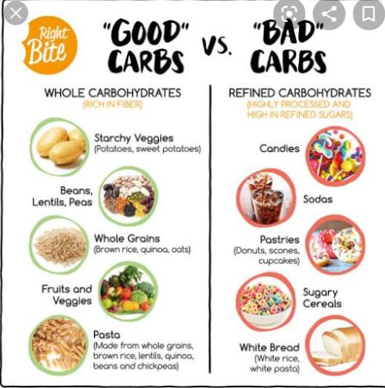
- Very low in devoid of cholesterol and trans fats
- BAD CARBS:
- High in calories
- Full of sugars
- Low in many nutrients
- Sometimes high in saturated fats
- Sometimes high in cholesterol
- BIOLOGICAL SIGNIFICANCE OF CARBOHYDRATES:
There are many biological significance of carbohydrates .
- STORAGE ROLE:
Carbohydrates play a storage role .They stored metabolic fuel for living organism for example starch in plants and glycogen in animals.
- STRUCTURAL ROLE:
Carbohydrates also play structural role like cellulose,hemicellulose,and lignin provide protective function to cell wall of plants.
- COMMUNICATION ROLE:
Carbohydrates bond to lipid and protein form glycoprotein and lipoprotein
Carbohydrates also act as harmone(thyroid_stimulating harmone)
Carbohydrates also act as enzyme(phosphotase,lipase,pepsinigen)
Also act as receptor.
- SIMPLE AND COMPLEX CARBOHYDRATES:
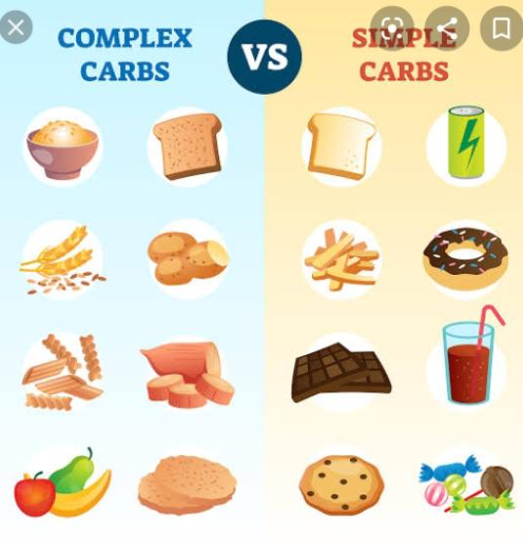
Carbohydrates are classified as simple and complex.Simple carbs are digested and absorbed more quickely easily than complex carbs according toNIH.Simple carbohydrates contain just one or two sugars such as fructose and galactose.The single sugars are called monosacchrides.carbohydrates with two sugars such as sucrose,lactose, and maltose are called disacchrides according to NIH.

Simple carbs are also in candy,soda,syrups.However these foods are made with processed and refined sugars and do not have vitamins,minerals or fibers.They are called “empty calories”and can lead to weight gain according to NIH.

Complex carbohydrates have three or more sugars.They are often referred as starchy foods and include foods and beans,peas,lentils,peanuts,potatoes,whole grain breads and cereals.
- CARBOHYDRATES DEFICIENCY:

Not getting enough carbs can cause problems.Without sufficient fuel the body gets no energy.Additionally ,without sufficient glucose ,the centerl nervous system suffers,which may cause dizziness or mental and physical weakness.A deficiency of glucose or low blood sugar called hypoglycemia.

If the body has insufficient carbohydrate intake or stores,it will consume protein for fuel.This is problematic because the body needs to make muscles.Using protein for fuel instead of carbohydrate also put stress in kidneys,leading the passage of painful byproducts in the urine.
- CLASSIFICATION OF CARBOHYDRATES:

Carbohydrates are also called”sacchrides”drived from Greek word sachkron meaning sugar.carbohydrates may be sugar or non_sugar.
- Sugar carbohydrates :
Sugar carbohydrates are sweet in taste and crystaline so all monosacchrides and disacchrides called sugar carbohydrates
- Non sugar carbohydrates :
Non sugar carbohydrates are not sweet in taste and not crystaline.All polysacchrides are called non sugars carbohydrates .

So we classify the carbohydrates into three groups
- Monosaccharides
- Oligosaccharides
- Polysaccharides
Here we only discuss the two groups Monosaccharides and oligosaccharides.
First of all we discuss the monosaccharides.

- MONOSACCHARIDES:

Monosaccharides are simplest carbohydrates that they cannot be hydrolyzed into smaller carbohydrates .

- CHARACTERISTICS OF MONOSACCHARIDES:
- These are simple sugars
- They are sweet in taste or easily soluble in water
- They can not be hydrolyzed into simple sugars
- Chemically they are either polyhydroxy aldehyde or ketones
- All carbon atoms except one,have hydroxyle group.
- BASIS OF CLASSIFICATION OF MONOSACCHARIDES:
Monosaccharides are classified according to three different charecteristics on following basis
- Placement of its carbonyl group
- The number of carbon atoms it contains
- Its chain handedness
- Classification on basis of placement of its carbonyl compound:
We classified the monosaccharides on basis of its functional group either it will have aldehyde or keto group.
- Aldo sugar:
If carbonyl group is an aldehyde then monosaccharide is aldose sugar.

- Ketose sugar:
If carbonyl group is ketone then monosaccharides is called ketose sugar.

- Classification on basis of number of carbon atoms:
Monosaccharides are classify on basis of number of carbon atoms.
- Monosaccharides with three carbon atoms are called trioses
- Those with four carbon atoms are called tetroses
- Those with five carbon atoms called pentoses
- Those with six carbon atoms called hexoses
- Those with seven carbon atoms called heptoses
- Classification on basis of its chain handedness:

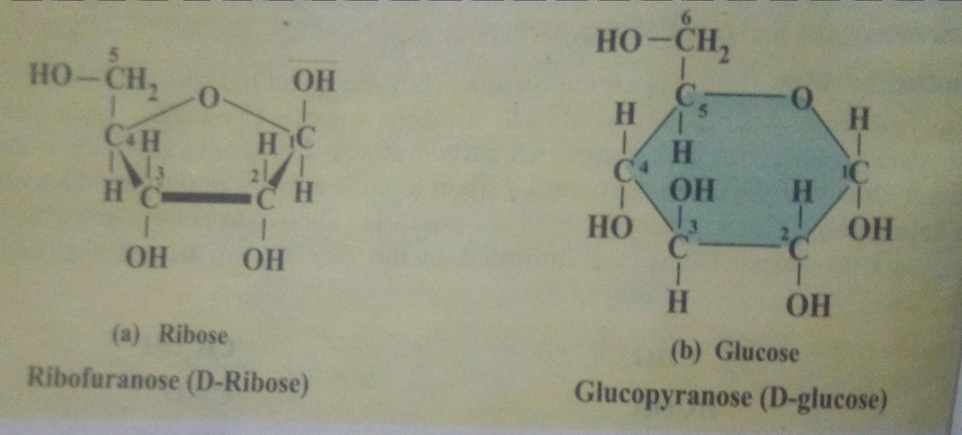
Each c atoms bearing a hydroxyle group(oH) with the exception of the first and last carbons are asymmetric.

Most of ribose form ring structure when in solution for example ribose will form five cornered ring known as ribofuranose,wherease glucose will form six cornered ring called glucopyranose.
- MONOSACCHARIDES USE IN LIVING ORGANISMS:
- Monosaccharides are major fuel source for metabolism ,being used both as an energy source.
- In many animals including humans this storage form is glycogen,espacially in liver and muscle cells.In plants starch is used for the same purpose.
- GLUCOSE CIRCULIZATION IN SOLUTION:
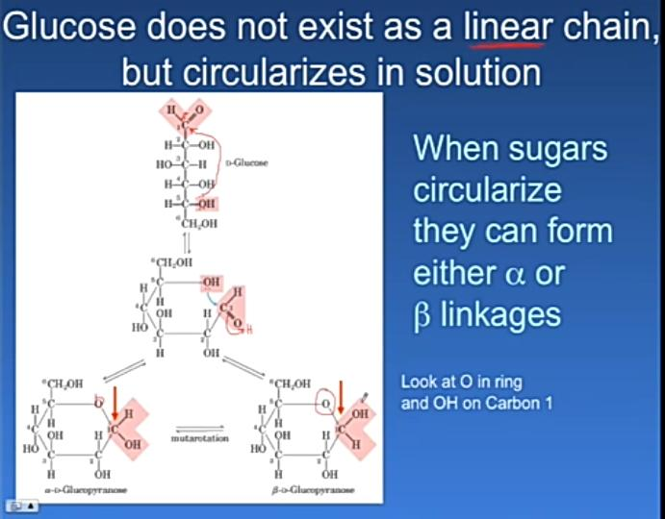

- OLIGOSACCHARIDES:

The carbohydrates that give two to ten monosaccharides on hydrolysis called oligosaccharides.

- TWO BASIC TYPES OF OLIGOSACCHARIDES:

Oligosaccharides are classified on the basis how many monosaccharides units it give on hudrolysis.
- DISACCHARIDES:
The ones yielding two monosaccharides unit called disaccharides.
- TRISACCHARIDES:
The ones yielding three monosaccharides unit on hydrolysis called trisaccharides and so on.
- IMPORTANT DISACCHARIDES:

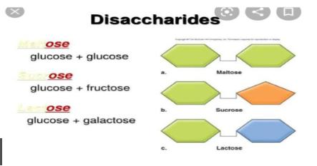
- GLYCOSIDIC BOND:

The covlant bond between two monosaccharides are called glycosidic bond.

- For example we consider there is two molecules of glucose or fructose or galctose the bond occur between them called glycosidic bond.

When glycosidic bond form between two molecules a water molecule is release.

The bond present between two carbohydrates called glycosidic bond.The bond present between two amino acid called peptide bond.The bond present between two nucleic acid called phosphodiester bond.

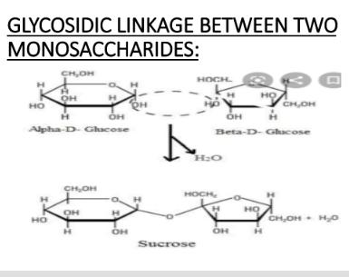
- DIETARY DISACCHARIDES:

- Fructo_oligosaccharides which are found in many vegetables,are short chains of fructose molecules.
- They differ fro fructans such as inulin,which as polysaccharides have a much higher dgree of polymerization than Fos and other oligosaccharides.
- Galactooligosaccharides which also occur naturally,consist of short chains of galactose molecules.
- These compounds can not be digested in human small intestine,where they promote the growth of bifidobacteria which are benifited to gut health.
- Manan oligosaccharides are widely used in animals feed to improve gastrointestinal health.They are normally obtained from the yeast cell wall of S.C.Mos different from other oligosaccharides in that they are not fermentable and their primary mode of actions include agglutination of type 1 fimbria pathogens and immunomodulation.
- SOURCES OF OLIGOSACCHARIDES:
There are many sources of oligosaccharides.

- Oligosaccharides are component of fiber from plant tissues.Fos and inulin are present in Jerusalem, onions and asparagus.
- Inulin is a significant part of daily diet of most of word’s population.
- Fos can also be synthesize by enzymes of fungus Aspergillus niger acting on sucrose.Gos is naturally found in soybeans and can also synthesize from lactose.Fos,Gos and inulin are also sold as nutritional supplements .
- FUNCTION OF DISACCHARIDES:

There are many functions of disaccharides.
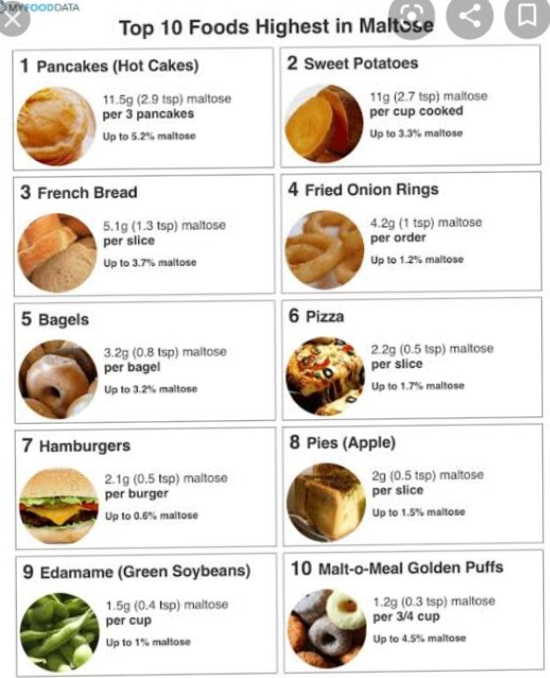
- In your body disaccharides functions is to provide your body with quick source of energy.Because,they are only made up of two sugar molecules they are easily broken down by enzyme in your digestive system
- Simple monosaccharided or disaccharides .Many healthy foods like friut,vegetables,naturally contain sugar and should not be avoided as thay benefit your health.
- CARBOHYDRATES BENEFIT AND THEIR FUNCTIONS:

- The right kind of carbs can be incridibly good for your health.Not only are they necessary for your health,but they carry a variety of added benefits.

A study published in the journal of nutrition in 2009 followed middle age women for 20 months and found that participants who ate more fiber lost weight,while those who decreased their fiber intake gained weight.

Another recent study linked fat loss with low_fat diets not low carbs ones.
While some studies have found that low carbs diets do help people lose weight,a mete analysis conducted in 2015 and published in the lancet found when viewed long tern,low fat and low carbs diets had similar success rate.

People lost more weight early on while on low carbs diets but after a year they were all in similar places.
Whole unprocessed friuts and vegetables are well known for their nutrients content.Some are even considered superfoods because of it _and all of leafy greens,bright sweet potatoes,juicy barries and apples contain carbs.

One plentifull source of good carbs is whole grains.It is found that those eating the most whole grains had significantly higher ammounts of fibers,energy and polyunsaturated fats.

Carbohydrates provide fuel for centeral nervous system and energy for working muscles.They also prevent protein from being used as an energy source and enable fat metabolism according to lawa state university .
In fact the RDA of carbohydrates is based on the ammount of carbs the brain needs to function.
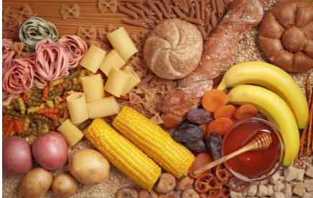
- MCQS FROM TOPIC CARBOHYDRATES:

- The most abundant bimolecule on earth:
a)Nucleic acid
b)proteins
c)lipids
d)carbohydrates
- The major functions of carbohydrates include:
a)structural formula
b)storage
c)both a and b
d)non of these
- The general formula of carbohydrates :
a)(CH2O)_{n}
b)(C4H2O)_{n}
c)(C6H2O)_{n}
- Carbohydrates are:
a)polyhydroxy aldehyde or phenol
b)polyhydroxy aldehyde or ketones
c)polyhydroxy aldehyde or alchols
- Glycogen in animals are stored in:
a)liver and spleen
b)liver and muscles
c)liver and bile
d)liver and adipose tissues
- Carbohydrates accounts:
a)30%plants and 20% animals
b)30%plants and 10%animals
c)30%plants and 1%animals
- Which of the following is triose:
a)glucose
b)ribulose
c)glyceraldehyde
- Which of the following is reducing sugar:
a)glucose
b)dihydroxy acetone
c)erythulose
d)none of these
- Oligosaccharides linked to protein called:
a)Glycoprotein
b)glycolipid
c)galactoside
- Sucrose is a:
a)monosaccharide
b)disaccharide
c)polysaccharide.

THE END.

