Exercise # 15
CITRUS DISEASES
Citrus is attacked by many pathological diseases. Fungal, bacterial, viral and nematode diseases are causing severe yield losses in citrus. The important fungal and bacterial diseases of citrus are, citrus wither tip (Colletotrichum gloeosporioides); citrus scab (Elsinoe fawcettii); stem-end rot (Lasiodiplodia theobromae; Diplodia natalensis; Botryodiplodia theobromae); foot rot/ gummosis (Phytophthora citrophthora); citrus canker (Xanthomonas axonopodis pv. citri); and citrus greening (Candidatus liberobacter asiaticus). Among viral problems of citrus, citrus tristeza virus (CTV) is the most important. Citrus nematode i.e. Tylenchulus semipenetrans is responsible for slow decline in citrus trees. Former biotic factors collectively succumb the citrus towards decline know as citrus decline or citrus tree decline.
Materials
Diseased samples of above mentioned diseases.
Procedure
- Visit the nearby orchard, identify the above mentioned diseases and collect their samples.
- Preserve the diseased samples and fix them on your practical manual.
- Culture fungal pathogens and study them in detail.
- Culture the possible bacterial pathogens and study their colonies morphology.
- Cut the cross or transverse sections of infected portions and study the differences between healthy and diseased tissues.
- Write down the characteristic symptoms of all above mentioned diseases on your practical manual.
Questions
- What is gummosis?
A disease in which gummy material also known as ozz comes out from infected area of the plant/tree known as gummosis.
- Name out the nutritional deficiency of citrus having citrus greening like symptoms?
Zn deficiency has greening like symptoms on citrus plants.
- What is the name of bacterial group causing citrus greening?
Candidatus genus the cause of greening disease belongs to fastidious bacteria group.
- Do citrus greening bacteria attack xylem or phloem?
Phloem.
- Which is the insect vector of citrus greening?
The insect vector of greening disease is citrus psyllid.
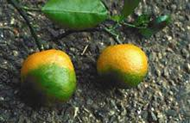
Citrus Greening
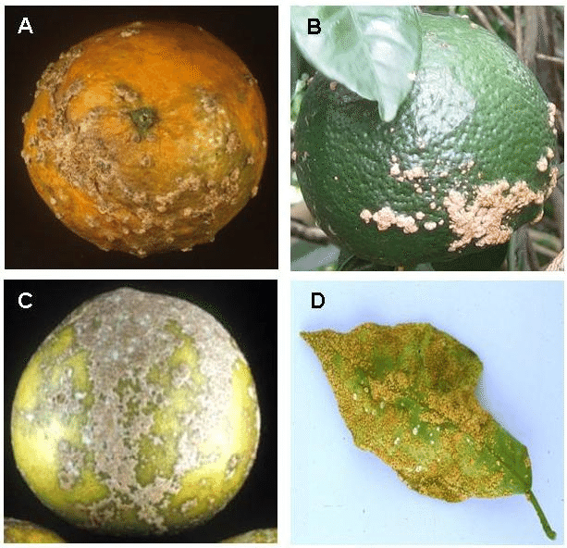
Citrus Scab
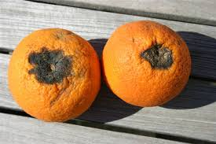
Stem End Rot
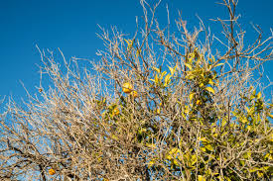
Citrus Wither Tip
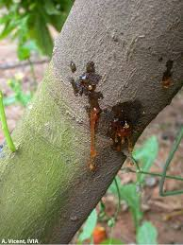
Gummosis
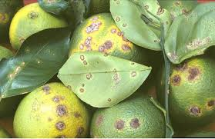
Citrus Canker
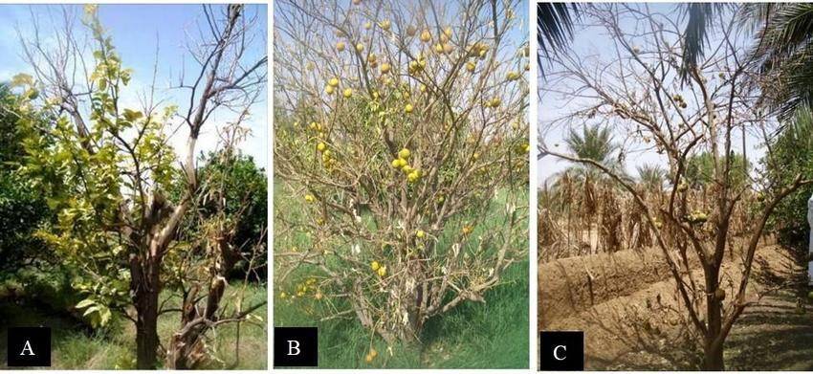
Citrus Tristeza Virus
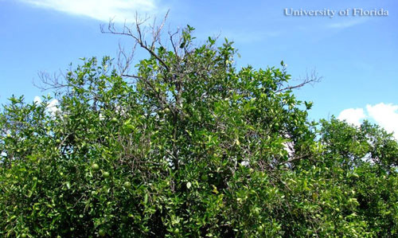
Citrus Nematode

