Topic:
Endoplasmic reticulum
Contents:
- History
- Origin
- Definition
- Occurrence
- Location
- Morphology
- Types
- Isolation
- Modifications
- Functions
- Diseases

Endoplasmic reticulum
History:
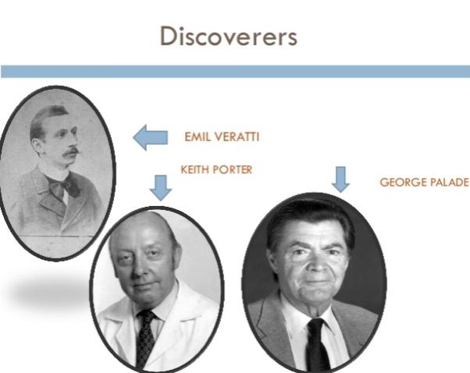
Endoplasmic reticulum discovered in 1902 by Italian scientist Emil Veratti. Then it was observed in 1945 by Porter, Claude and Fullam. They noted presence of a network or reticulum of strands associated with vesicle-like bodies in the cytoplasm of the cultural fibroblast or thinly-spread tissue culture cells. Further electron microscopy by Porter and Thompson (1947) has revealed that these strands of reticulum are vesicular bodies inter-connected, so as to form a complex network in the inner endoplasmic part of the cytoplasm.
As this network is concentrated in the endoplasm of the cell more than in the ectoplasm, therefore, it is known as endoplasmic reticulum (ER), or ergastoplasm or vacuolar system of the cell. The endoplasmic reticulum is not visible in the cytoplasm of a living cell under the phase-contrast microscope but With electron microscopy, the lacy membranes of the endoplasmic reticulum were first seen in 1969 by Keith R. Porter, Albert Claude, and Ernest F.Fullam. Palade And Porter mentioned key characteristics of Endoplasmic reticulum and ribisomes.
Origin:
- Multistep mechanism
Although the origin of the new endoplasmic reticulum membrane has not been fully understood. Several views are there. In fact, one of the possible functions attributed to the endoplasmic reticulum is that of membrane biosynthesis.
The protein components of endoplasmic reticulum and other membranes may be assembled by activity of the endoplasmic reticulum. There is certainly convincing evidence that Golgi membranes and many cytoplasmic vesicles can be derived from endoplasmic reticulum. Moreover, endoplasmic reticular membranes appear to be continuously synthesized, having a relatively high rate of turnover.
At the same time, the several elements of endoplasmic reticulum in the cell are asynchronous in this respect, they are not all replaced at the same time or with the same rate. It has also been suggested that membranes of the endoplasmic reticulum are formed not from pre-existing elements but from the ground substance of the cytoplasm. Thus, the process by which a membrane is modified chemically and structurally is called membrane differentiation.
- From nuclear membrane
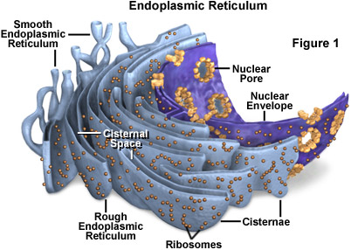
The vacuoles derived from the evagination of the outer membrane of the nuclear envelop, which separates from its inner parter, leaving cavities between. Shortly after the separation, small vesicles appear near the nuclear envelop suggesting that parts of the envelop give rise to elements of the endoplasmic reticulum. Thus the endoplasmic reticulum seems to have its origin from the nuclear envelop in undifferentiated cells.
Definition:
The endoplasmic reticulum (ER) is a large organelle made of membranous sheets and tubules that begin near the nucleus and extend across the cell. The endoplasmic reticulum creates, packages, and secretes many of the products created by a cell. Ribosomes, which create proteins, line a portion of the endoplasmic reticulum.
Occurrence:
The endoplasmic reticulum occurs in all the eukaryotic cells except erythrocytes (R.B.Cs) of mammals. It is absent in prokaryotes. Its development varies considerably in various cell types. It is small and undifferentiated in eggs and in undifferentiated embryonic cells. Only a few vacuoles are present in the spermatocytes and muscle cells. However, it is highly organized in cells synthesizing proteins or in cells that are engaged in lipid metabolism.
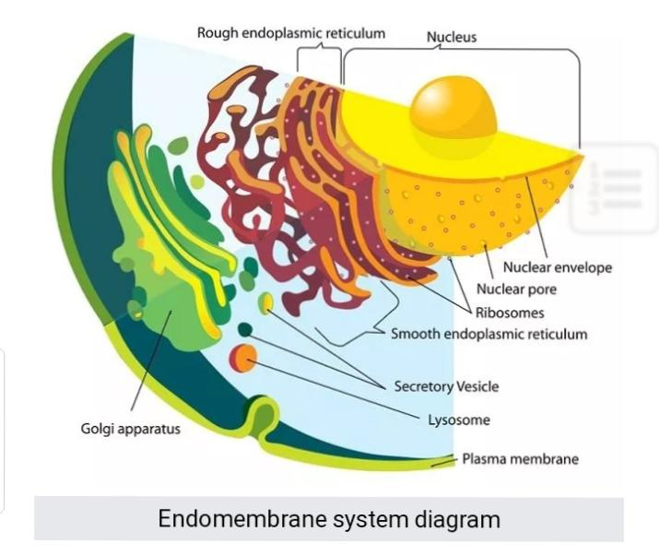
The entire structure can account for a large proportion of the endomembrane system of the cell. For instance, in cells such as liver hepatocytes that are specialized for protein secretion and detoxification, the ER can account for more than 50% of the total lipid bilayer of the cell. Similarly, the ER membrane system is particularly prominent in pancreatic beta cells that secrete insulin, or within activated B-lymphocytes that produce antibodies.
Location:
The endoplasmic reticulum processes most of the instructions from the nucleus. As such, the endoplasmic reticulum surrounds the nucleus and radiates outward. In cells that secrete many products for the rest of the body, the endoplasmic reticulum can account for more than 50% of the cell.
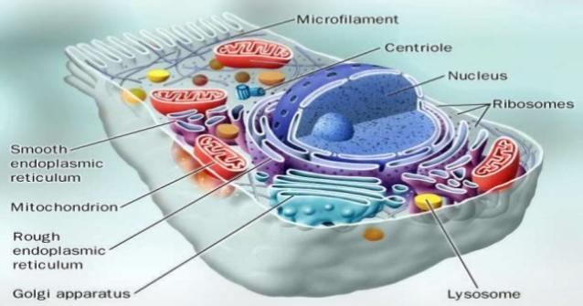
In general, the nucleus expresses mRNA (messenger RNA), which tells the cell how to build proteins. The rough endoplasmic reticulum has many ribosomes, which are the primary location of protein production. This portion of the organelle creates proteins and begins to fold them into the proper formation. The smooth endoplasmic reticulum is the primary location for lipid synthesis. As such, it does not contain any ribosomes. Rather, it conducts a series of reactions which create the phospholipid molecules necessary to create various membranes and organelles.
The rough version of the endoplasmic reticulum is often closer to the nucleus, whereas the smooth endoplasmic reticulum is further from the nucleus. However, both versions are connected to each other and the nucleus through a series of small tubules.
Morphology:
The endoplasmic reticulum has been found in all kinds of mature cells except the mature mammaliane erythrocyte, which is also devoid of a nucleus. Actually the first description of these structures seemed with electron microscope by Porter, Claude and Fullam in 1945 in cultured cells. These are membrane bounded. The name cisternae were given by Sjostrand and the name tubules was given by Kurosumi (1954). Rounded and irregular sacs or vesicles were observed by Weiss 1953.
Morphologically the endoplasmic reticulum is composed of following three kinds of structures, viz, Cisternae ,Tubules and Vesicles.

Cisternae or lamellae
They are long, flattened and usually un-branched tubules, which are arranged in parallel arrays. They are of uniform width throughout and their thickness varies from 40-50 µ.This pattern of reticulum is characteristic of basophilic regions of the cytoplasm and of those cells, which are active in protein synthesis. Lamellae or cisternae occur in the liver-cells, plasma cells, brain-cells and in notochord cells etc.
Tubules
The tubules are small, smooth-walled, branched tubular spaces having a diameter of about 50-190µ. These occur in cells that are busy in the synthesis of steroids like cholesterol, glycosides and hormones. These are haphazardly arranged in the cytoplasm of developing spermatids of guinea pig, muscles cells and other non-secretary cells.
Vesicles
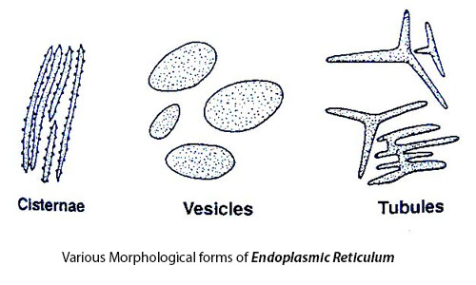
The vesicles range in diameter from 25 to 500 µ and are for the most part rounded in shape. These are abundant in the cells engaged in the protein synthesis as in hepatic and pancreatic cells. All these three patterns of endoplasmic reticulum may occur in the same cell or in different cells.
Their arrangement also differs in different cells viz., as parallel rows in the liver-cells of mammals; haphazardly in pancreatic cells or in the form of a net-work of tubules in striated muscle cells. In notochordal cells of Ambyostoma larva, the parttern of cisternae is of still another type.
Ultra structure:
All the three structures of the endoplasmic reticulum are bounded by a thin membrane of 50 to 60 A° thick. Like the plasma membrane, nucleus, etc., its membrane is also formed of three layers. The outer and inner dense layers are composed of protein molecules and the two middle thin and transparent layers are of phospholipids.
The endoplasmic reticular membrane is continuous with the plasma membrane, nuclear membrane and membrane of Golgi complex. The lumen of the endoplasmic reticulum acts as a passage for the secretary products and Palade (1956) has observed the secretary granules in it.
Types:
On the basis of presence and absence of ribosomes, there are two types;
Granular and rough walled Endoplasmic reticulum
When the particles or ribosomes are present on the wall of E.R., it is called rough walled E.R. These particles are always present at the outer surface of the E.R., i.e., on the surface of the limiting membrane facing the continuous phase the matrix of the cytoplasm.
The elements with rough surfaces are high in ribonucleic acid and are intensely basophilic. The membranes themselves are not rough, but associated with their outer surfaces are tiny particulate components 100 to 150 A° in diameter.
These are called ribonucleoprotein (RNP) particles or ribosomes and contain as the average 40% RNA and 60% protein. The elements having ribosomes are usually of the cisternal type and are found in cells active in protein synthesis.
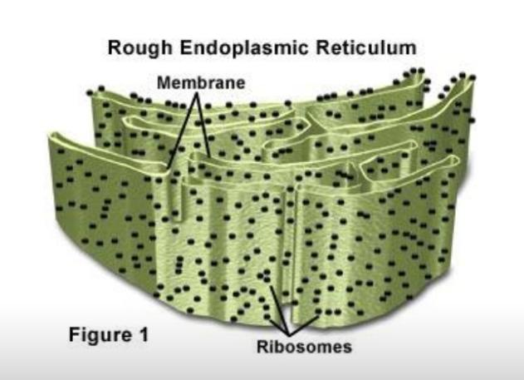

Biochemical studies have indicated that the ribosomes are important in protein synthesis, even though the membranes are not always necessary for this activity. Other functions will be explained later. The smooth surfaced E.R. is often continuous with the rough surfaced ER- thereby making the absence or presence of ribosomes the only significant difference between the two.

Smooth walled Endoplasmic reticulum
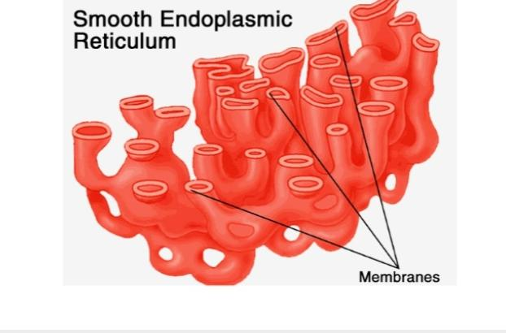
The name smooth walled is given to that portion of endoplasmic reticulum that is devoid of ribosomes, like the rough walled endoplasmic reticulum smooth form shows a characteristic morphology which is tubular rather than cisternae. The smooth walled endoplasmic reticulum is found in the cells that are active in the synthesis of steroid compounds such as cholesterol, glycerides and the hormones (testosterone and progesterone).
It is studies by Fawcett (1960). They are also present in the pigmented epithelial cells of the retina which are involved in the metabolism of vitamin A in the production of visual pigment. Glycogen storing cells of the liver contain the smooth, tubular elements of the endoplasmic reticulum.
Isolation
Endoplasmic reticulum can also be isolated mechanically with the help of centrifuge. When tissue or cells are disrupted by homogenization the E.R. is fragmented into many smaller closed vesicles called microsomes (100 nm diameter), which are relatively easy to purify
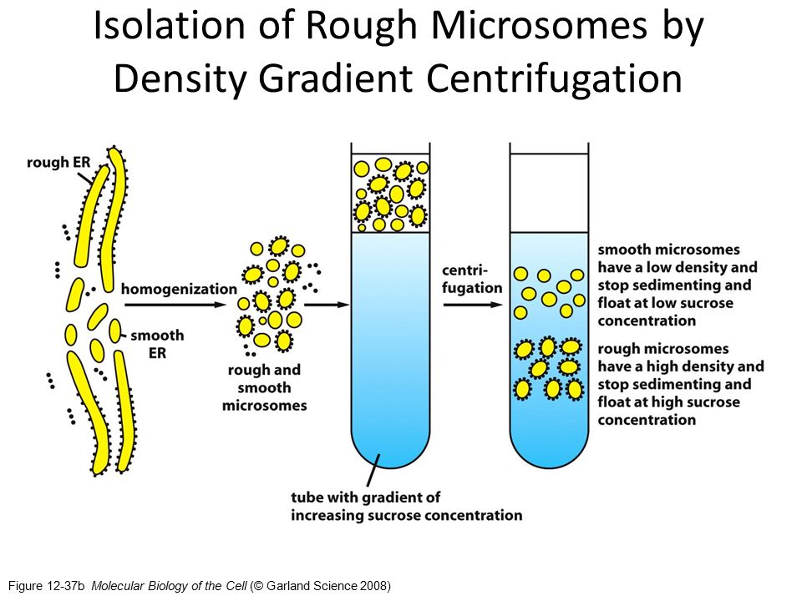
Microsomes derived from rough E.R. are studied with ribosomes and are called rough microsomes. Many vesicles’ of size similar to that of rough microsomes, but lacking attached ribosomes, are also found in these homogenates. Such smooth microsomes are derived in part from smooth portions of the ER and in part from vesiculated fragments of plasma membrane, Golgi complex and mitochondria (the ratio depending on the tissue).

Modifications:
Sarcoplasmic reticulum
Sarcoplasmic reticulum, found in the skeletal and cardiac muscles is a highly modified form of smooth ER. It was first reported by Veratti (1902) as delicate plexuses in skeletal muscles surrounding the myofibrils. Electron microscopy showed it to be composed of a network of membrane like tubules which run longitudinally in the interfibrillar sarcoplasmic space for the length of each sarcomere. At the level of H and I bands, these tubules merge with large cisternal structures.
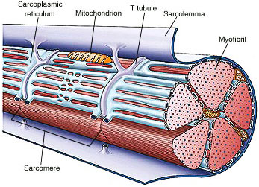
At the H band level this cistena, called the central cistena, forms a sieve-like structure round the myofibrils. At the level of I band, these tubules merge with the large terminal cisternae, from which transverse tubules extend peripherally to the sarcolemma and are continuous with and are deep invaginations of it.
It is generally believed that sarcoplasmic reticulum plays a role not only in distributing energy-rich material needed for muscular contraction but also in providing the necessary channels for transmitting impulses along the surface and conveying the action potenital from the surface to the myofirls within. Moreover, they store calcium ions during relaxation of muscles.
The only structural difference between this organelle and the smooth endoplasmic reticulum is the medley of proteins they have, both bound to their membranes and drifting within the confines of their lumens. This fundamental difference is indicative of their functions: The endoplasmic reticulum synthesizes molecules, while the sarcoplasmic reticulum stores calcium ions and pumps them out into the sarcoplasm when the muscle fiber is stimulated. After their release from the sarcoplasmic reticulum, calcium ions interact with contractile proteins that utilize ATP to shorten the muscle fiber. The sarcoplasmic reticulum plays a major role in excitation-contraction coupling.
Ergastoplasm:
There are certain regions in the cytoplasm that stain with basic dyes. To these regions various names have been given like chromidial substance, basoplasm, ergastoplasm and so forth. The term ergastoplasm was given by Grimier in 1899 to those cytoplasmic filaments in the cells of exocrine glands which stained readily with basic stains.
Weiss (1953) referred to the cisternal elements as ergastoplasmic sacs. In nerve cells, such areas are called Nissl bodies. Electron microscopic studies reveal it to be an accumulation of ribosomes situated on the parallel lamellae offer stakes of accumulated freely in the groundplasm.
Studies of Casperson (1955), Brachet (1957) and others have demonstrated that the basophilic nature of ergastroplasm is due to the ribonucleic acid. Smooth E.R. areas of cytoplasm are never ergastoplasm.
Functions:

Protein Synthesis and Folding
Protein synthesis occurs in rough endoplasmic reticulum. Although translation for all proteins begins in the cytoplasm, some are moved into the ER in order to be folded and sorted for different destinations. Proteins that are translocated into the ER during translation are often destined for secretion. Initially, these proteins are folded within the ER and then moved into the Golgi apparatus where they can be dispatched towards other organelles.
For instance, the hydrolytic enzymes in the lysosome are generated in this manner. Alternately, these proteins could be secreted from the cell. This is the origin of the enzymes of the digestive tract. The third potential role for proteins translated in the ER is to remain within the endomembrane system itself. This is particularly true for chaperone proteins that assist in the folding of other proteins. The genes encoding these proteins are upregulated when the cell is under stress from unfolded proteins.

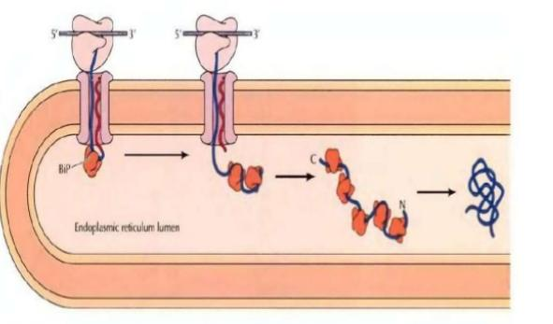
Fig. Packaging and folding of proteins

Lipid Synthesis
The smooth endoplasmic reticulum plays an important role in cholesterol and phospholipid biosynthesis. Therefore, this section of the ER is important not only for the generation and maintenance of the plasma membrane but of the extensive endomembrane system of the ER itself.
The SER is enriched in enzymes involved in sterol and steroid biosynthetic pathways and is also necessary for the synthesis of steroid hormones. Therefore the SER is extremely prominent in the cells of the adrenal gland that secrete five different groups of steroid hormones that influence the metabolism of the entire body. The synthesis of these hormones also involves enzymes within the mitochondria, further underscoring the relationship between these two organelles.

Calcium Store
The SER is an important site for the storage and release of calcium in the cell. A modified form of the SER called sarcoplasmic reticulum forms an extensive network in contractile cells such as muscle fibers. Calcium ions are also involved in the regulation of metabolism in the cell and can change cytoskeletal dynamics.
The extensive nature of the ER network allows it to interact with the plasma membrane and use Ca²⁺ for signal transduction and modulation of nuclear activity. In association with mitochondria, the ER can also use its calcium stores to induce apoptosis in response to stress.
Mechanical Support
ER contributes to the mechanical support of the cytoplasm by dividing existence compartments- This makes possible the existence of ionic gradients and electrical potentials along ER membranes his concept has been specially applied to sarcoplasmic reticulum.
Exchange of ions and any other fluid
The membranes of the endoplasmic reticulum may regulate the exchange between the inner compartment and cavity and the cytoplasm matrix .The following statistic gives an impressive idea of the surface area available for exchange; 1 gm of liver contains about 8 to 12 square meter of endoplasmic reticulum. After isolation, microsomes expand, or shrink according to the osmotic pressure of the fluid. Diffusion and active transports may take place across the membrane of the endoplasmic reticulum.
Intracellular circulation
The endoplasmic reticulum may act as a kind of circulatory system for intracellular circulation of various substances. Membrane flow may be an important mechanism for carrying particles, molecules and ions into and out of the cells by way of vascular system. The “pinocytosis,” or “cellular drinking” also takes place by endoplasmic reticulum.
By this mechanism, particles attached to the surface of the cell or suspended m the fluid medium can be incorporated into the cytoplasm. The similar mechanism but working in a reverse direction can affect the transport of a particle from the interior of the cytoplasm to the outer medium.
The continuities observed in some cases between the endoplasmic reticulum and the nuclear envelope suggests that the membrane flow may also be active at this point. This flow would provide one of the several mechanisms for export of RNA and nucleoproteins from the nucleus to the cytoplasm.
Synthesis of glycogen
The smooth endoplasmic reticulum of the glycogen storing cells of the liver and the cells of certain plants is found to be associated with the synthesis, storage and metabolism of the glycogen. But, Porter (1961) and Peter {1963) have suggested that smooth type of endoplasmic reticulum is related to glycogenolysis (breakdown of glycogen) and not to glycogenesis (synthesis of the glycogen).
Detoxification
Smooth ER is also involved in the detoxification of many endogenous and exognous compounds. Prolonged administration of certain drugs (phenobarbitol) results in the increased activity of enzymes related to detoxification, as well as other enzymes, and a considerable hypertrophy of the SER (Claude, 1970). This is also applicable to administered steroid hormones.
Synthesis of cholesterol and steroid hormones:
Cholesterol is an important precursor of steroid hormones. The major site of cholesterol synthesis is the ER. In liver cells the SER is believed to be concerned with both the synthesis and storage of cholesterol.
In the testis, ovary and the adrenal cortex the SER has a role in the synthesis of steroid hormones. The enzymes catalysing biosynthesis of androgens have been located in the SER. There is a strong correlation between the amounts of SER in cells and the capacity to synthesize steroid hormones.
Cell differentiation
Some specific instances of development have been studies in detail which more or less confirm the contention that the ER is important in the process of cell differentiation. Not only this much, ER also plays role in coordinating the differentiation.
Formation of micro-bodies
Closely related with the ER are micro bodies, which are small granular bodies filled with the electeron dense substance and limited by a single membrane. Micro-bodies are formed as dilations of the ER and frequently show connections with the ER cisternae.
They are rich in the enzymes peroxidase (and are hence also called peroxisomes), catalase and D-ammo acid oxidase. In plant cells the enzymatic content is different and the bodies are called glyoxysomes because they include enzymes of the glyoxylate cycle.
Enzyme activities and cellular metabolism:
Numerous enzymes mainly those involved in the metabolism of steroids (cholesterol and glycerides), phospholipids and hormones (testosterone and progresterone) are associated with the membranes of smooth endoplasmic reticulum.
These membranes provide an increased inner surface for various metabolic reactions and they themselves take an active part in them by means of attached enzymes. This facilitates free union of enzymes with their substrates.
Role of endoplasmic reticulum in intra-cellular impulse conduction:
The existence of endoplasmic reticulum separating the cytoplasm into two compartments makes possible the existence of ionic gradients and electrical potentials across these intra-cellular membranes.
This idea has been applied to the sarcoplasmic reticulum, a specialized form of the smooth surfaced endoplasmic reticulum found in striated muscles which is now being considered as intra-cellular conducting system. On the basis of some evidences, it has been postulated that the sarcoplasmic reticulum transmits impulses from the surface membrane into deep regions of the muscle fibers.
Formation of plasmodesmata:
Electron microscopic studies suggest that the endoplasmic reticulum in plants plays a special role in the interconnection of cells through the cytoplasmic strands called plasmodesmata.
Role of E. R. during cell Division:
During cell division, some of the elements of reticulum contribute in the formation of the new nuclear membrane after karyogamy. The nuclear membrane breaks up into fragments in the early part of the division which finally disintegrate into small vesicles (Moses 1960).
These vesicles move towards the pole of the spindle as the metaphase starts, where they are indistinguishable from the elements offer. From the polar ends of the cell, elements offer as well as the fragmented vesicles migrates into the regions around the chromosomes, which are grouping at the poles. Most of these elements of ER join or fuse around each group of daughter chromosomes to form a new nuclear envelop.
Transportation of message from genetic material:
ER provides passage for the genetic material to pass from the nucleus to the various organelles in the cytoplasm, thereby controlling the synthesis of proteins, fats and carbohydrates.
ATP synthesis:
ER membranes are the sites of ATP synthesis in the cell. The ATP is used as a source of energy for all the intracellular metabolism and transport of materials.
Formation of cell organelles:
Most of cell Organelles like Golgi complex, mitochondria, lysosomes, nuclear membrane and cell plate etc., are usually developed from endoplasmic reticulum.
Diseases:
Endoplasmic reticulum (ER) dysfunction might have an important part to play in a range of neurological disorders, including cerebral ischaemia, sleep apnoea, Alzheimer's disease, multiple sclerosis, amyotrophic lateral sclerosis, the prion diseases, and familial encephalopathy with neuroserpin inclusion bodies. Protein misfolding in the ER initiates the well studied unfolded protein response in energy-starved neurons during stroke, which is relevant to the toxic effects of reperfusion. The toxic peptide amyloid β induces ER stress in Alzheimer's disease, which leads to activation of similar pathways, whereas the accumulation of polymeric neuroserpin in the neuronal ER triggers a poorly understood ER-overload response. In other neurological disorders, such as Parkinson's and Huntington's diseases, ER dysfunction is well recognised but the mechanisms by which it contributes to pathogenesis remain unclear. By targeting components of these signalling responses, amelioration of their toxic effects and so the treatment of a range of neurodegenerative disorders might become possible.

Multiple choice questions

- A eukaryotic cell without endoplasmic reticulum is
- RBCs of mammals
- Egg cell
- WBCs
- None of these
- In rapidly dividing cells ER is
- Highly developed
- Poorly developed
- Absent
- Non functional
- The most important function of ER is
- Secretion of material
- Protein synthesis
- To give shape to cell
- Detoxification
- The term endoplasmic reticulum was coined by
- Reinert
- Johnson
- Pomaret
- Porter
- Protein glycosylation occurs in
- Lumen of mitochondria
- Lumen of rough endoplasmic reticulum
- Lumen of smooth endoplasmic reticulum
- Lumen of lysosomes
- SER in the retinal cells are called as
a) Sarcoplasmic reticulum
b) Retinal reticulum
c) Myeloid bodies
d) Amyloid bodies
7- The functions of RER include
a) Protein synthesis and detoxification
b) Protein synthesis and post translational modification
c) Protein synthesis and phospholipid biosynthesis
d) Protein synthesis only
8- In RER, ribosomes are located on
a) the cytoplasmic side
b) on the luminal side
c) both a and b
d) all through out
9-. Which of the following statements are incorrect regarding ER?
a) The adipose tissue has both SER and RER
b) Plasma cells has RER only
c) RBC lacks both RER and SER
d) Hepatocytes has both RER and SER
10-. The ER and bodies linked with it during ultracentrifugation are separated as a fraction known as
a) Episome
b) Polysome
c) Microsome
d) Quantasome

