Topic:
Embryonic Development In insects

Dr. Muhammad Asam Riaz
Assistant Professor
Entomology

University College of Agriculture
University of Sargodha

Embryonic Development In insects

- What is embryogenesis in insects?

- It is defined as the developmental process which starts when the egg of insect has been fertilized and in the result a larvae or immature arises from the egg.
- Within the fertilized egg a lot of processes involved which includes multiplication of cells by mitosis which further grows and then organs and tissues of the immature are developed within the egg.
- There is extreme variation in the embryogenesis of the insects from species to species, and most variation is noted in the insects which are parasite for other insects.

Here is the further description about the embryogenesis in the insects which is described:
- What are the different eggs membranes present in egg?

- The insect lays egg at the places where the egg is unable to effect by the external environment, by temperature, humidity which can affect the developments occurring in the eggs.
- Insect eggs are almost full with the yolk and size varies from 0.02-20mm.
- There are present some layers present which are very resistant and act as insulator which prevent from desiccation of egg and this anatomy of egg layers are impenetrable found throughout the kingdom animalia.
- There are present layer and a protective hard covering vitelline and chorion and these layer provide protection to the internal contents that are zygote and macromolecule in the fertile egg.
- There are present nutritional material such as lipids, yolk, carbohydrates which are helpful in the growth and development of the embryo in the egg.
- Embryonic polarity, segmented and gastrulating are established by protein and mRNAs.

- What is egg cleavage?

- There comes a time in the fertilized egg when division of cell into smaller cells occurred.
- Unlike all other living organism, there is unusual type of cleavage that is it undergoes only the subdivision of nucleus (karyokinesis) not the division of cytoplasm (cytokinesis).
- In the result of this type of cleavage a large no. of nuclei reside.
- It is also noted that there is variation in cleavage in egg also that is some insects belonging to collembolan have total cleavage but dipluran has evolved only nuclear division.
- In the result of cleavage (nuclear division) individual celled are formed called blastomeres.
- Blastoderm:
- After the subdivision of of the into small nuclei, then they are surrounded by the island of cytoplasm and each nuclei is separated from each other.
- Each nuclei and its island of cytoplasm surrounding it is collectively called energids which migrate to to the margin of the egg upon excess of thickness of energits in the egg.
- Energids appear as tubercles at the margin and at the margin this divion continues but some nuclei remain present in the egg yolk which become vitallophages and their objective is to break down the yolk for the nurishment of embryo.
- Due to the continuos approch of the energids, the egg layer starts to diminish and starts to surround the divided nuclei and this shows the end of this division of nuclear material.
- Then finally the single sheet of small cells are formed at the margin of the egg is called blastoderm of cell.
How germ cells are formed?
- After the formation of blastoderm of cell the divided nuclei reach at the particular place in the egg and don’t move at the periplasm and away from the blastoderm.
- Then the nuclei stop dividing and germ cells are formed which will remain separate and they at the end move to the ovaries or testes to form primary oocytes or spermatocytes.
- When the adults insects mate, these germ cells will divide meiotically to form gametes of the coming offspring’s (eggs or sperm)
- These cells will not divide in the future so that they will remain safe from the potential errors in the replication of genetic material required to develop the coming generation.
- How the germ band is formed?
- The blastoderm become very thick in the ventral region of the egg because of increased cell division and this region is called germ band and in the future embryo body is formed there.
- Then the germ band start to increase in size and differentiate into head like region which is called protocephlon and narrow tail like region called as protocorm.
- How Serosa is formed?
- When the germ band is formed, then the remaining cells present in the blastoderm form a covering/sac of yolk of the egg and called serosa.
- This sac is formed when fold appear at the periphery of the germ band at the ventral side and is fused.
- Then the cells in the serosa start to grow and enclose the embryo at the dorsal surface of a small amniotic cavity surrounded by amniotic membrane.
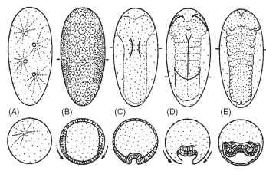
Diagram of the basic pattern of early insect embryo-genesis: ventral views of eggs, anterior poles at top, are shown above cross sections at the levels indicated by bars in top row. (A) Syncytial cleavage. (B) Formation of the cellular blastoderm. (C) Gastrulation. The prospective mesoderm begins invigilation along the midline of the germ anlage. (D) Germ band after gastrulation, with segment borders (dotted) and amniotic folds forming: arrows indicate the movement of the serosal cells to enclose and cover the developing germ band. (E) Advanced germ band stage, with appendage buds, and transient coelomic sacs formed by the mesoderm.
- What is gastrulation?
- The germ band of the egg form a layered embryo and the cells in the germ band move into the yolk of the egg and form a multicellular layer.
- From the ventral mid line of the germ band a longitudinal furrow is formed by movement of cells upward amd this is called gastral grove.
- The inner layer of the gastral groove is called mesoderm. The trunk of the insect is constituted by the germ band.
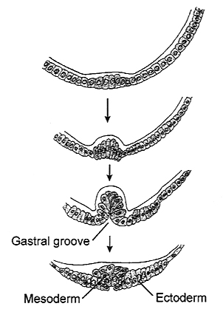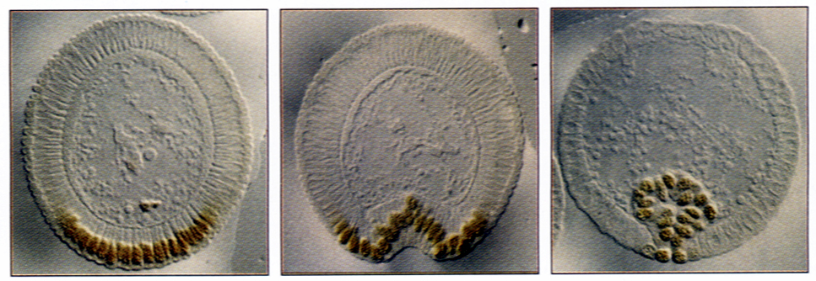

Origin of the Mesoderm from Cells Expressing Twist
- What is segmentation?
- It is defined as procedure in which repeated units of alike groups of cells, the metameres, are formed.
- The process of segmentation starts just after or simultaneously with gastrulation.

- The embryo is divided into three embryonic stages on the basis of segmentation:
- Protopod phase:
Segments are absent or indistinct but undeveloped appendages on head and tail.
- Polypod phase:
It has a clear segments and each segment bears a pair of appendages.
- Oligopod phase:
Segments present but later on lack appendages.

- What is organogenesis?
- When the segmentation of germ band is completed, then the embryogenesis start developing the organ system of the larva or nymph by the differentiation of ectodem and mesoderm. This is called organogenesis.
- From the ectoderm of the germ layer skin/epidermis, numerous bristles and hairs on the larva or adult body is formed.
- The nervous system of the insects is also developed from the ectodermal cells of in the ventral region of the germ band which involves the multiplication of neuroblasts in the embryonic ectoderm and develops neural groves and neural ridge.
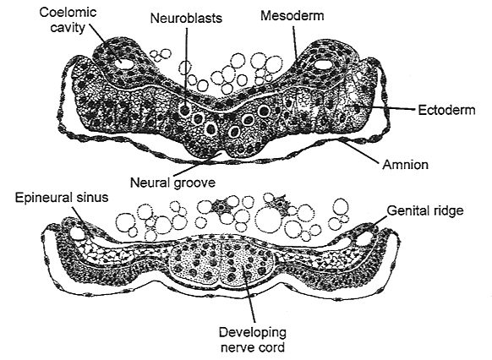

- tracheal system, ocelli, salivary glands, a prothoracic gland, corpora allata, molting glands, oenocytes, silk glands, exocrine glands, brain nervous system, sense organs, foregut and hindgut, respiratory system, external genitalia, all these are developed from the ectoderm.
- From the mesoderm layer internal organ are developed which are hemocytes, subesophageal glands,Malpighian tubules pair of transient coelomic sacs, heart, blood, circulatory system, muscles, endocrine glands, fat body, gonads (ovaries and testes).
- From the endoderm hind gut is developed.

- End of embryogenesis/hatching?
- Embryogenesis ends when the yolk content is completely consumed
- At these stage immature insects is fully formed at ready to hatch and larva comes out either by chewing its way out of the chorion or uses a special egg burster.
- Egg breaks along the hatching line and hatching is known as eclosion.

