Marketing Mix, SWOT Analysis and Types of Customers
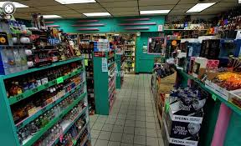
Types of Customers / Consumers
- Seasonal Customers: These customers visit markets in changing seasons for seasonal shopping.
- Need-Based Customers: These customers only visit in the market when they have some need to buy something, otherwise they are not interested to visit markets.
- Impulse Buying: They do not have any planning to buy products but all at sudden they make their mind to buy something.
- Window Shopping: Mostly visit shops to collect information or for the sake of enjoyment. Sometimes they get motivated to buy some products.
- Discount-Driven Customers: These customers only visit in markets which prices are low, discounts are offers and sales are started.
- Habitual Customers: These customers repeatedly visit markets and they have good sense of buying behavior and they have good experience of market search.
Marketing Mix: 4Ps / 7Ps of Marketing
- Products/Services: How can you develop your products or services?
- Prices/Fees: How can we change our pricing model?
- Place/Access: What new distribution options are there for customers to experience our product, e.g. online, in-store, mobile etc.
- Promotion: How can we add to or substitute the combination within paid, owned and earned media channels?
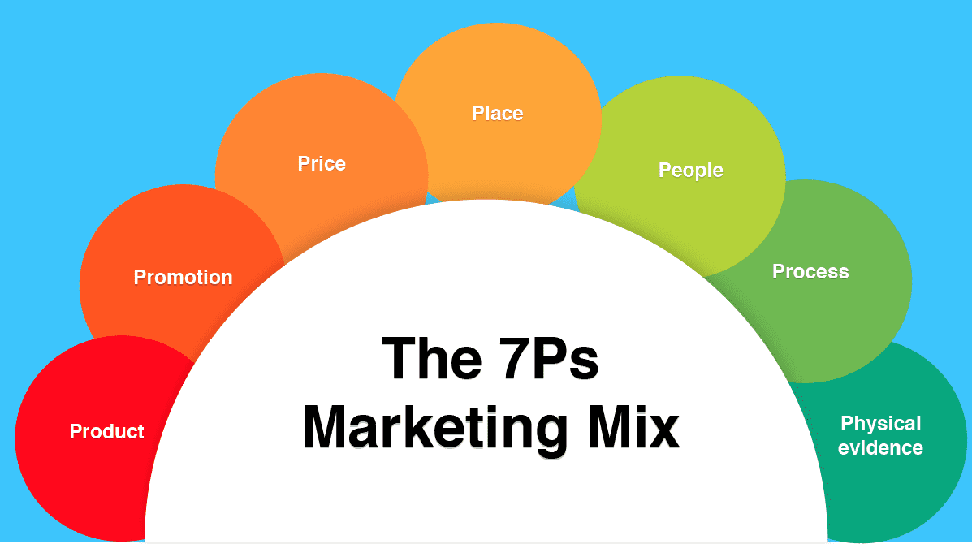
- Physical Evidence: How we reassure our customers, e.g. impressive buildings, well-trained staff, great website?
- People: Who are our people and are there skills gaps?
- Process: It’s about managing the overall business?

SWOT Analysis
A type of study undertaken by an organization to identify its internal strengths and weaknesses, as well as its external opportunities and threats.

