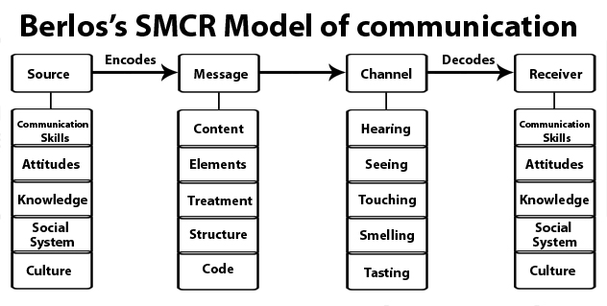

Berlo’s model follows the SMCR model. This model is not specific to any particular communication.
Berlo’s model includes a number of factors under each of the elements:
Source: The source is situated where the message originates.
Communication skills – It is the skill of the individual to communicate. For example, the ability to read, write, speak, listen etc.
Attitudes – This includes attitudes towards the audience, subject and towards oneself. For example, for the student, the attitude is to learn more and for teachers, it is to help teach.
Knowledge– Communicating also means that the person needs to be knowledgeable about the subject or topic. For e.g. a teacher needs to know about the subject in detail that he or she teaches so that they can communicate properly such that the students understand here.
Note: It refers, not to the general knowledge, but to the knowledge of the subject that the person is communicating and their familiarity with it.
Social system – The social system includes the various aspects of society like values, beliefs, culture, religion and a general understanding of society. It is where the communication takes place.
For example, classrooms differ from country to country just like people’s behaviours and how they communicate, etc.
Note: We can communicate only to the extent that the social system allows. When we communicate, we take the social system into account.
Culture: Culture of a particular society also comes under the social system.
According to this model, people can communicate only if the above requirements are met in the proper or adequate proportion.
Encoder: The sender of the message, from where the message originates, is referred to as the encoder. So the source encodes the message here.
Message
Content – The body of a message, from the beginning to the end, comprises its content. For example, whatever the class teacher teaches in the class, from beginning to end, is the content of the message.
Elements – It includes various things like language, gestures, body language, etc. They constitute all the elements of a particular message. Any content is accompanied by some elements.
Treatment – It refers to the packing of the message and the way in which the message is conveyed or the way in which it is passed on or delivered.
Note: When there is too much treatment, communication will not go smoothly.
Structure– The structure of the message refers to how it is arranged; the way people structure the message into various parts.
Note: Message is the same, but if the structure is not properly arranged then the receiver will not understand the message.
Code– The code of the message refers to the means through which it is sent and in what form. It could be, for example, language, body language, gestures, music, etc. Even culture is a code. Through this, people give and receive messages and communication takes place.
Note: Only when the code is clear, the message will be clear. The wrong usage may lead to misinterpretation.
Channel– It refers to the five sense organs. The following are the five senses:
- Hearing
- Seeing
- Touching
- Smelling
- Tasting
Communication occurs through one or more of these channels.
Hearing: The use of ears to receive the message. For example, orally transmitted messages, interpersonal communication etc.
Seeing: Visual channels, for example, Watching television so the message is conveyed through the scene/film.
Touching: The sense of touch can be used as a channel to communicate. For example, we touch, buy food, hugging our loved ones,etc.
Smelling: Smell also can be a channel to communicate. For example, perfumes, food, fragrances etc. Charred smell communicates something is burning. People can deduct which food is being cooked by its smell etc.
Tasting : The tongue is a muscular organ used in the act of eat and taste food. For example, while a food is being shared, the communication can happen regarding its taste.
Note: Despite not mentioning a medium, we need to assume that as communication is taking place, channels can be any of the 5 senses or combination.
Decoder : The person who receives the message and decodes it is referred to a decoder.
Receiver: The receiver needs to think all the contents and elements of the source, so as to communicate/responds to sender effectively.;
Berlo’s model believes that for effective communication to take place, the source and the receiver need to be on the same level. Only then communication will happen or take place properly. Hence, the source and the receiver should be similar.
For example, if the communication skill of the source is good, then the receiver should have equally good listening skills.
It cannot be said that the receiver does not receive the whole message because even though he may receive it, but may not be able to interpret its meaning. For effective communication, the source and the receiver need to be on the same level.
Note: Self-image differs from person to person. For communication, the person should consider the receiver, speak accordingly and give them what they need.
Criticism of Berlo’s SMCR model of communication:
- There is a lack of feedback. The effects are practically unknown.
- It does not mention the barriers to communication.
- There is no room for noise.
- It is a rather complex model.
- It is a linear model of communication.
- It requires people to be on the same level for effective communication to happen. However, that rarely happens in everyday life.
- The main drawback of the model is that it omits the usage of sixth sense as a channel of communication, which is an asset to human beings (thinking, understanding, analyzing etc.)

