Introduction to Prokaryotic and Eukaryotic cell
Prokaryotic cell
The word prokaryote comes from the Greek πρό (pro, 'before') and κάρυον (karyon, 'nut' or 'kernel').
A microscopic single-celled organism that has neither a distinct nucleus with a membrane nor other specialized organelles.
OR
A prokaryote is a unicellular organism that lacks a membrane-bound nucleus, mitochondria, or any other membrane-bound organelle.
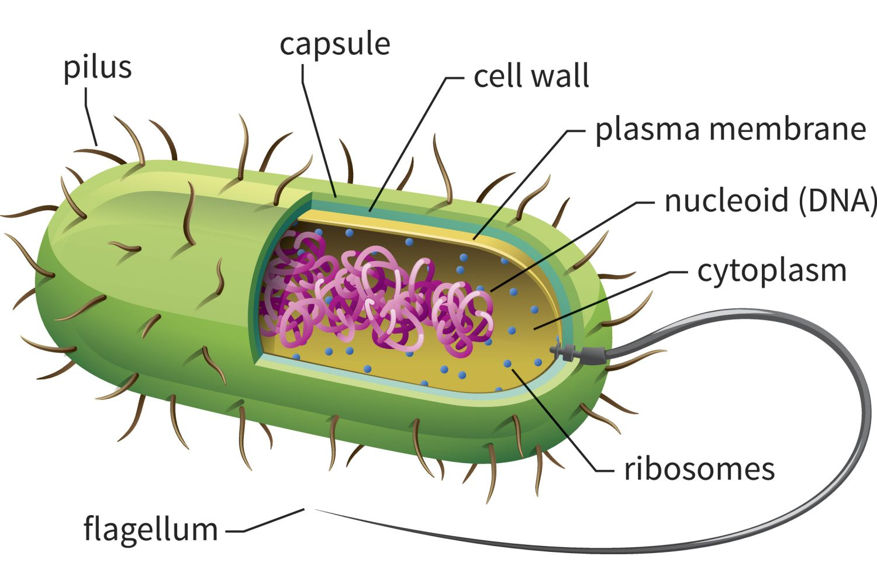
Prokaryotes are divided into mainly two domains, Archaea and Bacteria. Species with nuclei and organelles are placed in the third domain, Eukaryota. Prokaryotes are asexual, reproducing without fusion of gametes and the first living organisms are thought to have been prokaryotes. The term prokaryote however is now used informally to refer to bacteria and archaea, because in the late 1970s Carl Woese determined that bacteria and archaea were less closely related than previously thought.

In the prokaryotes, all the intracellular water-soluble components (proteins, DNA and metabolites) are located together in the cytoplasm and are enclosed by the cell membrane, rather than in separate cellular compartments. Bacteria, however, do possess protein-based bacterial microcompartments, which are thought to act as primitive organelles that are enclosed in protein shells. Some prokaryotes, such as cyanobacteria, may form large colonies. Others, such as myxobacteria, have multicellular stages in their life cycles.
Molecular studies have provided insight into the evolution and interrelationships of the three domains of biological species. Eukaryotes are organisms, including humans, whose cells have a well-defined membrane-bound nucleus (containing chromosomal DNA) and organelles. The division between prokaryotes and eukaryotes reflects the existence of two very different levels of cellular organization. Distinctive types of prokaryotes include extremophiles and methanogens; these are common in some extreme environments.
History
The microbiologists Roger Stanier and C. B. van Niel firmly established the division between prokaryotes and eukaryotes in their 1962 paper. The concept of a bacterium (though spelled procaryote and eucaryote there). That paper cites Édouard Chatton's 1937 book Titres et Travaux Scientifiques for using those terms and recognizing the distinction. One reason for this classification was so that what was then often called blue-green algae (now called cyanobacteria) would not be classified as plants but grouped with bacteria.
Structure
Prokaryotes have a prokaryotic cytoskeleton that is more primitive than that of the eukaryotes. Besides homologues of actin and tubulin (MreB and FtsZ), the helically arranged building-block of the flagellum, flagellin, is one of the most significant cytoskeletal proteins of bacteria, as it provides structural backgrounds of chemotaxis, the basic cell physiological response of bacteria. At least some prokaryotes also contain intracellular structures that can be seen as primitive organelles. Membranous organelles (or intracellular membranes) are known in some groups of prokaryotes, such as vacuoles or membrane systems devoted to special metabolic properties, such as photosynthesis or chemolithotrophy. In addition, some species also contain carbohydrate-enclosed microcompartments, which have distinct physiological roles (e.g. carboxysomes or gas vacuoles).
Most prokaryotes are between 1 µm and 10 µm, but they can vary in size from 0.2 µm (Mycoplasma genitalium) to 750 µm (Thiomargarita namibiensis).
Prokaryotic cell structure
Prokaryotic cell is comprising of
- Cell wall
- Cell membrane
- Flagellum
- Pili
- Cytoplasm
- Ribosomes
- Nucleoids
- Capsule and Glycocalyx
- Inclusions
- Mesosomes
Cell wall (except genera Mycoplasma and Thermoplasma)
A cell wall is a structural layer surrounding some types of cells, just outside the cell membrane. It can be tough, flexible, and sometimes rigid. It provides the cell with both structural support and protection, and also acts as a filtering mechanism. Cell walls are present in most prokaryotes (except mollicute bacteria). Unlike plant cells the prokaryotes cell wall is made up of peptidoglycan not cellulose.

Cell wall of bacteria
Around the outside of the cell membrane is the bacterial cell wall. Bacterial cell walls are made of peptidoglycan (also called murein), which is made from polysaccharide chains cross-linked by unusual peptides containing D-amino acids.
Bacterial cell walls are different from the cell walls of plants and fungi which are made of cellulose and chitin, respectively. The cell wall of bacteria is also distinct from that of Archaea, which do not contain peptidoglycan. The cell wall is essential to the survival of many bacteria, although L-form bacteria can be produced in the laboratory that lack a cell wall. The antibiotic penicillin is able to kill bacteria by preventing the cross-linking of peptidoglycan and this causes the cell wall to weaken and lyse. The lysozyme enzyme can also damage bacterial cell walls.
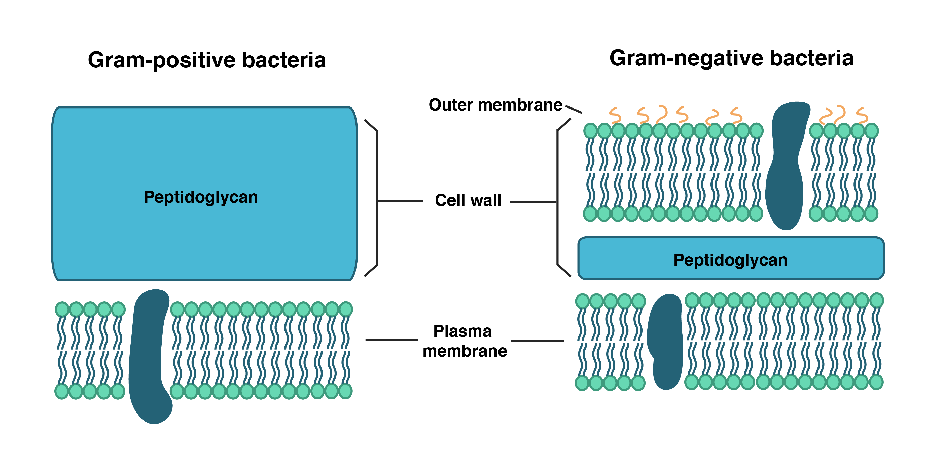
There are broadly speaking two different types of cell wall in bacteria, called gram-positive and gram-negative. The names originate from the reaction of cells to the Gram stain, a test long-employed for the classification of bacterial species.
Gram-positive bacteria possess a thick cell wall containing many layers of peptidoglycan and teichoic acids. In contrast, gram-negative bacteria have a relatively thin cell wall consisting of a few layers of peptidoglycan surrounded by a second lipid membrane containing lipopolysaccharides and lipoproteins. Most bacteria have the gram-negative cell wall and only the Firmicutes and Actinobacteria (previously known as the low G+C and high G+C gram-positive bacteria, respectively) have the alternative gram-positive arrangement. These differences in structure can produce differences in antibiotic susceptibility, for instance vancomycin can kill only gram-positive bacteria and is ineffective against gram-negative pathogens, such as Hemophilus influenzae or Pseudomonas aeruginosa.
Cell wall of archaea
Although not truly unique, the cell walls of Archaea are unusual. Whereas peptidoglycan is a standard component of all bacterial cell walls, all archaeal cell walls lack peptidoglycan, though some methanogens have a cell wall made of a similar polymer called pseudopeptidoglycan. There are four types of cell wall currently known among the Archaea.
One type of archaeal cell wall is that composed of pseudopeptidoglycan (also called pseudomurein). This type of wall is found in some methanogens, such as Methanobacterium and Methanothermus. While the overall structure of archaeal pseudopeptidoglycan superficially resembles that of bacterial peptidoglycan, there are a number of significant chemical differences.
Like the peptidoglycan found in bacterial cell walls, pseudopeptidoglycan consists of polymer chains of glycan cross-linked by short peptide connections. However, unlike peptidoglycan, the sugar N-acetylmuramic acid is replaced by N-acetyltalosaminuronic acid, and the two sugars are bonded with a β,1-3 glycosidic linkage instead of β,1-4. Additionally, the cross-linking peptides are L-amino acids rather than D-amino acids as they are in bacteria.
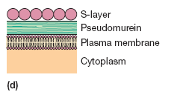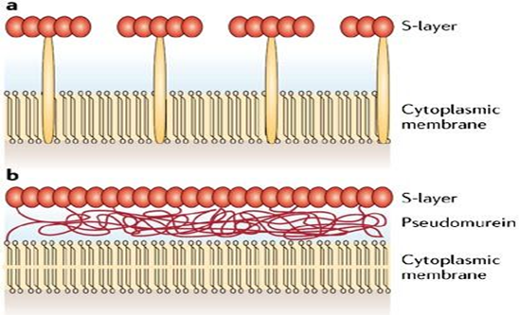

A second type of archaeal cell wall is found in Methanosarcina and Halococcus. This type of cell wall is composed entirely of a thick layer of polysaccharides, which may be sulfated in the case of Halococcus. Structure in this type of wall is complex and not fully investigated.
A third type of wall among the Archaea consists of glycoprotein, and occurs in the hyperthermophiles, Halobacterium, and some methanogens. In Halobacterium, the proteins in the wall have a high content of acidic amino acids, giving the wall an overall negative charge. The result is an unstable structure that is stabilized by the presence of large quantities of positive. sodium ions that neutralize the charge. Consequently, Halobacterium thrives only under conditions with high salinity.
In other Archaea, such as Methanomicrobium and Desulfurococcus, the wall may be composed only of surface-layer proteins, known as an S-layer. S-layers are common in bacteria, where they serve as either the sole cell-wall component or an outer layer in conjunction with polysaccharides. Most Archaea are Gram-negative, though at least one Gram-positive member is known.
Cell membrane
The cell membrane (also known as the plasma membrane (PM) or cytoplasmic membrane, and historically referred to as the plasmalemma) is a biological membrane that separates the interior of all cells from the outside environment (the extracellular space) which protects the cell from its environment. The cell membrane consists of a lipid bilayer, including cholesterols (a lipid component) that sit between phospholipids to maintain their fluidity at various temperatures. The membrane also contains membrane proteins, including integral proteins that go across the membrane serving as membrane transporters, and peripheral proteins that loosely attach to the outer (peripheral) side of the cell membrane, acting as enzymes shaping the cell.
The cell membrane controls the movement of substances in and out of cells and organelles. In this way, it is selectively permeable to ions and organic molecules. In addition, cell membranes are involved in a variety of cellular processes such as cell adhesion, ion conductivity and cell signaling and serve as the attachment surface for several extracellular structures, including the cell wall, the carbohydrate layer called the glycocalyx, and the intracellular network of protein fibers called the cytoskeleton. In the field of synthetic biology, cell membranes can be artificially reassembled.
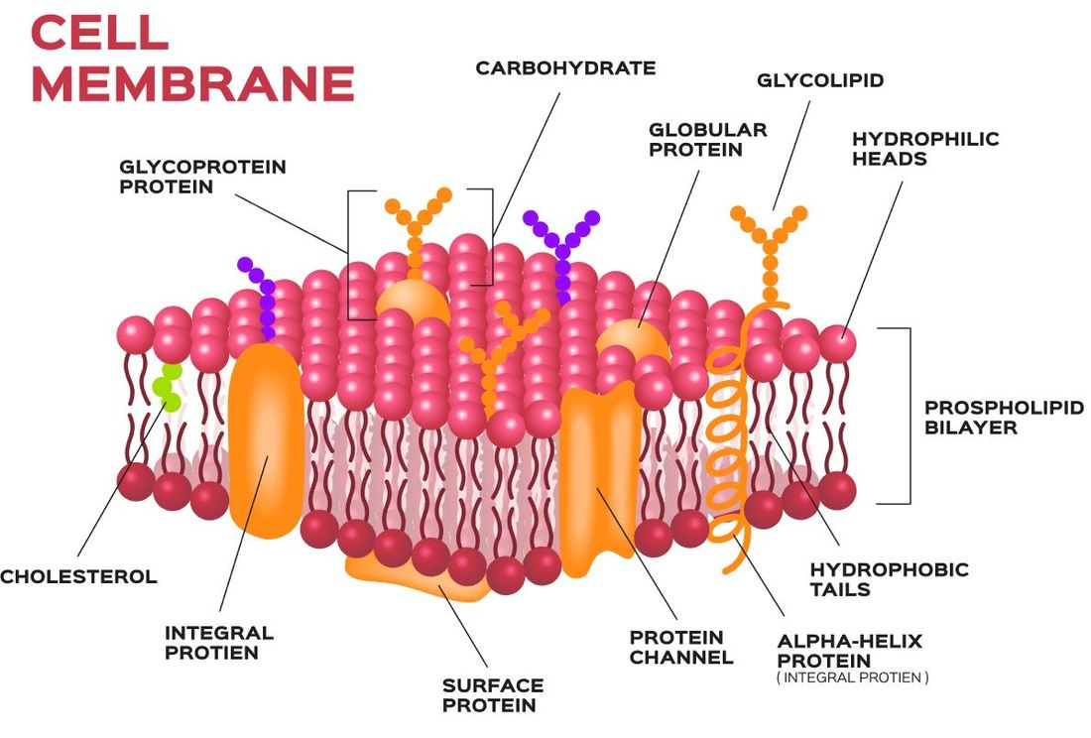
Prokaryotes are divided into two different groups, Archaea and Bacteria, with bacteria dividing further into gram-positive and gram-negative. Gram-negative bacteria have both a plasma membrane and an outer membrane separated by periplasm, however, other prokaryotes have only a plasma membrane. These two membranes differ in many aspects. The outer membrane of the gram-negative bacteria differs from other prokaryotes due to phospholipids forming the exterior of the bilayer, and lipoproteins and phospholipids forming the interior. The outer membrane typically has a porous quality due to its presence of membrane proteins, such as gram-negative porins, which are pore-forming proteins. The inner, plasma membrane is also generally symmetric whereas the outer membrane is asymmetric because of proteins such as the aforementioned. Also, for the prokaryotic membranes, there are multiple things that can affect the fluidity.
One of the major factors that can affect the fluidity is fatty acid composition. For example, when the bacteria Staphylococcus aureus was grown in 37◦C for 24h, the membrane exhibited a more fluid state instead of a gel-like state. This supports the concept that in higher temperatures, the membrane is more fluid than in colder temperatures. When the membrane is becoming more fluid and needs to become more stabilized, it will make longer fatty acid chains or saturated fatty acid chains in order to help stabilize the membrane.
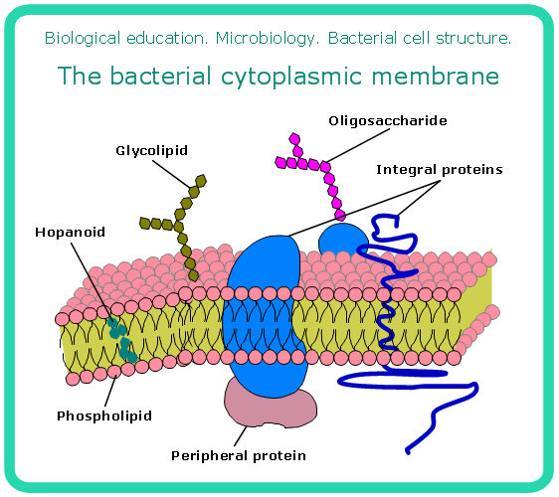
Bacteria are also surrounded by a cell wall composed of peptidoglycan (amino acids and sugars). Some eukaryotic cells also have cell walls, but none that are made of peptidoglycan. The outer membrane of gram-negative bacteria is rich in lipopolysaccharides, which are combined poly- or oligosaccharide and carbohydrate lipid regions that stimulate the cell's natural immunity.
The outer membrane can bleb out into periplasmic protrusions under stress conditions or upon virulence requirements while encountering a host target cell, and thus such blebs may work as virulence organelles. Bacterial cells provide numerous examples of the diverse ways in which prokaryotic cell membranes are adapted with structures that suit the organism's niche. For example, proteins on the surface of certain bacterial cells aid in their gliding motion. Many gram-negative bacteria have cell membranes which contain ATP-driven protein exporting systems.
Flagellum
A flagellum (/fləˈdʒɛləm/; plural: flagella) is a lash-like appendage that protrudes from the cell body of certain bacteria and eukaryotic cells termed as flagellates. A flagellate can have one or several flagella. The primary function of a flagellum is that of locomotion, but it also often functions as a sensory organelle, being sensitive to chemicals and temperatures outside the cell. The similar structure in the archaea functions in the same way but is structurally different and has been termed the archaellum.
Flagella are organelles defined by function rather than structure. Flagella vary greatly. Both prokaryotic and eukaryotic flagella can be used for swimming but they differ greatly in protein composition, structure, and mechanism of propulsion. The word flagellum in Latin means whip.
Bacterial flagella
Bacterial flagella are helical filaments, each with a rotary motor at its base which can turn clockwise or counterclockwise. They provide two of several kinds of bacterial motility.
The bacterial flagellum is made up of the protein flagellin. Its shape is a 20-nanometer-thick hollow tube. It is helical and has a sharp bend just outside the outer membrane; this "hook" allows the axis of the helix to point directly away from the cell. A shaft runs between the hook and the basal body, passing through protein rings in the cell's membrane that act as bearings. Gram-positive organisms have two of these basal body rings, one in the peptidoglycan layer and one in the plasma membrane. Gram-negative organisms have four such rings:
The L ring associates with the lipopolysaccharides, the P ring associates with peptidoglycan layer, the M ring is embedded in the plasma membrane, and the S ring is directly attached to the plasma membrane. The filament ends with a capping protein.
The flagellar filament is the long, helical screw that propels the bacterium when rotated by the motor, through the hook. In most bacteria that have been studied, including the Gram-negative Escherichia coli, Salmonella typhimurium, Caulobacter crescentus, and Vibrio alginolyticus, the filament is made up of 11 protofilaments approximately parallel to the filament axis. Each protofilament is a series of tandem protein chains. However, Campylobacter jejuni has seven protofilaments.
The basal body has several traits in common with some types of secretory pores, such as the hollow, rod-like "plug" in their centers extending out through the plasma membrane. The similarities between bacterial flagella and bacterial secretory system structures and proteins provide scientific evidence supporting the theory that bacterial flagella evolved from the type-three secretion system.
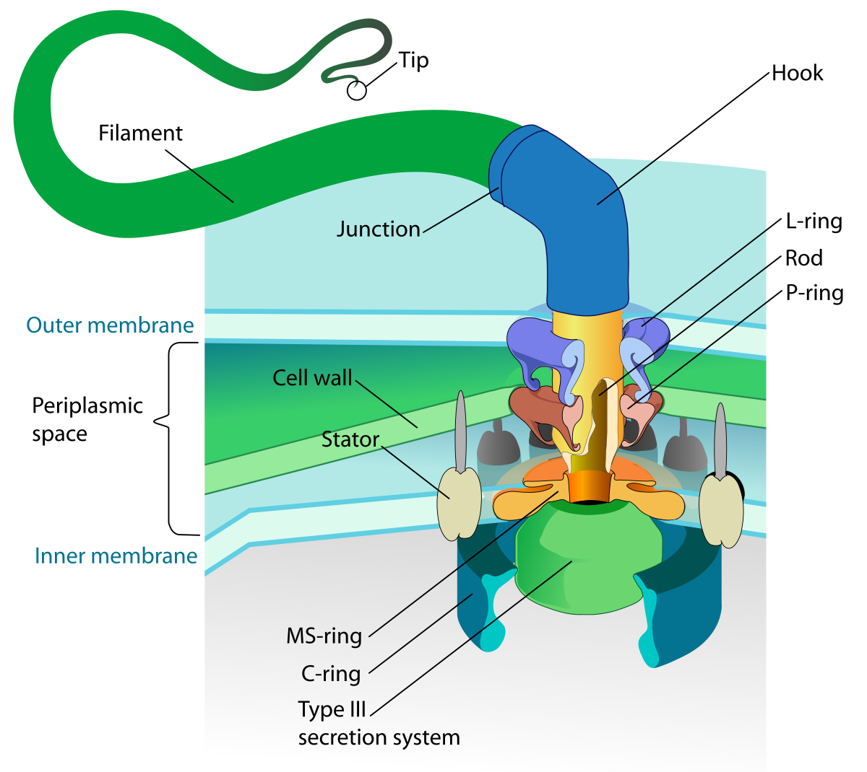
Archaeal flagella
Archaeal flagella (archaella) are superficially similar to bacterial flagella, but are different in many details and considered non-homologous.
The archaellum possessed by some archaea is superficially similar to the bacterial flagellum; in the 1980s, they were thought to be homologous on the basis of gross morphology and behavior. Both flagella and archaella consist of filaments extending outside the cell, and rotate to propel the cell. Archaeal flagella have a unique structure which lacks a central channel. Similar to bacterial type IV pilins, the archaeal flagellins (archaellins) are made with class 3 signal peptides and they are processed by a type IV prepilin peptidase-like enzyme. The archaellins are typically modified by the addition of N-linked glycans which are necessary for proper assembly or function.
Difference between archaeal and bacterial flagella
Discoveries in the 1990s revealed numerous detailed differences between the archaeal and bacterial flagella. These include:
- Bacterial flagella are motorized by a flow of H+ ions (or occasionally Na+ ions); archaeal flagella are almost certainly powered by ATP. The torque-generating motor that powers rotation of the archaeal flagellum has not been identified.
- While bacterial cells often have many flagellar filaments, each of which rotates independently, the archaeal flagellum is composed of a bundle of many filaments that rotates as a single assembly.
- Bacterial flagella grow by the addition of flagellin subunits at the tip; archaeal flagella grow by the addition of subunits to the base.
- Bacterial flagella are thicker than archaella, and the bacterial filament has a large enough hollow "tube" inside that the flagellin subunits can flow up the inside of the filament and get added at the tip; the archaellum is too thin (12-15 nm) to allow this.
- Many components of bacterial flagella share sequence similarity to components of the type III secretion systems, but the components of bacterial flagella and archaella share no sequence similarity. Instead, some components of archaella share sequence and morphological similarity with components of type IV pili, which are assembled through the action of type II secretion systems (the nomenclature of pili and protein secretion systems is not consistent).
These differences could mean that the bacterial flagella and archaella could be a classic case of biological analogy, or convergent evolution, rather than homology. However, in comparison to the decades of well-publicized study of bacterial flagella (e.g. by Howard Berg), archaella have only recently begun to garner scientific attention.
Pili
A pilus word is used in Latin for 'hair'; plural: pili is a hair-like appendage found on the surface of many bacteria and archaea. The terms pilus and fimbria (Latin for 'fringe'; plural: fimbriae) can be used interchangeably, although some researchers reserve the term pilus for the appendage required for bacterial conjugation. All pili in the latter sense are primarily composed of pilin proteins, which are oligomeric.
We can say that pili are dozens of structures that can exist on the bacterial and archaeal surface. And some bacteria, viruses or bacteriophages attach to receptors on pili at the start of their reproductive cycle.
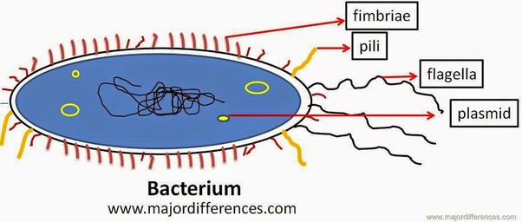
Pili are antigenic. They are also fragile and constantly replaced, and sometimes with pili of different composition, resulting in altered antigenicity. The specific host responses to old pili structure are not effective on the new structure. Recombination genes of pili code for variable (V) and constant (C) regions of the pili (similar to immunoglobulin diversity).
Fimbriae
To initiate formation of a biofilm, fimbriae must attach bacteria to host surfaces for colonization during infection. A fimbria is a short pilus that is used to attach the bacterium to a surface. They are sometimes called "attachment pili". Fimbriae are either located at the poles of a cell or are evenly spread over its entire surface. Mutant bacteria that lack fimbriae cannot adhere to their usual target surfaces, and thus cannot cause diseases.
Some fimbriae can contain lectins. The lectins are necessary to adhere to target cells because they can recognize oligosaccharide units on the surface of these target cells. Other fimbriae bind to components of the extracellular matrix. Fimbriae found in Gram-negative have the pilin subunits covalently linked.
Some aerobic bacteria form a thin layer at the surface of a broth culture. This layer, called a pellicle, consists of many aerobic bacteria that adhere to the surface by their fimbriae or "attachment pili". Thus, fimbriae allow the aerobic bacteria to remain on the broth, from which they take nutrients, while they congregate near the air.
Cytoplasm
A gel-like substance composed mainly of water that also contains enzymes, salts, cell components, and various organic molecules.
The cytoplasm of a prokaryotic cell is everything that is present inside the bacterium. In contrast to a eukaryotic cell, there is not a functional segregation inside bacteria. The cytoplasm houses all the chemicals and components that are used to sustain the life of a bacterium, with the exception of those components that reside in the membrane(s), and in the periplasm of Gram-negative bacteria.
The cytoplasm is bounded by the cytoplasmic membrane. Gram-negative bacteria contain another outer membrane. In between the two membranes lies the periplasm.
When viewed in the light microscope, the cytoplasm of bacteria is transparent. Only with the higher magnification available using the transmission electron microscope does the granular nature of the cytoplasm become apparent. The exact structure of the cytoplasm may well be different than this view, since the cytoplasm is comprised mainly of water. The dehydration necessary for conventional electron microscopy likely affect the structure of the cytoplasm.
Ribosomes
Cell structures responsible for protein production.
OR
The sequence of DNA that encodes the sequence of the amino acids in a protein, is transcribed into a messenger RNA chain. Ribosomes bind to messenger RNAs and use its sequence for determining the correct sequence of amino acids to generate a given protein. Amino acids are selected and carried to the ribosome by transfer RNA (tRNA) molecules, which enter the ribosome and bind to the messenger RNA chain via an anti-codon stem loop. For each coding triplet in the messenger RNA, there is a transfer RNA that matches and carries the correct amino acid for incorporating into a growing polypeptide chain. Once the protein is produced, it can then fold to produce a functional three-dimensional structure.
Bacterial ribosomes
Prokaryotic ribosomes are around 20 nm (200 Å) in diameter and are composed of 65% rRNA and 35% ribosomal proteins. Eukaryotic ribosomes are between 25 and 30 nm (250–300 Å) in diameter with an rRNA-to-protein ratio that is close to 1. Crystallographic work has shown that there are no ribosomal proteins close to the reaction site for polypeptide synthesis. This suggests that the protein components of ribosomes do not directly participate in peptide bond formation catalysis, but rather that these proteins act as a scaffold that may enhance the ability of rRNA to synthesize protein.
The unit of measurement used to describe the ribosomal subunits and the rRNA fragments is the Svedberg unit, a measure of the rate of sedimentation in centrifugation rather than size. This accounts for why fragment names do not add up: for example, bacterial 70S ribosomes are made of 50S and 30S subunits.
Nucleoid
Area of the cytoplasm that contains the prokaryote's single DNA molecule.
OR
The nucleoid (meaning nucleus-like) is an irregularly shaped region within the cell of a prokaryote that contains all or most of the genetic material. The length of the DNA chromosome is very large compared to the dimensions of the cell, and so must be compacted to fit. In contrast to the nucleus of a eukaryotic cell, it is not surrounded by a nuclear membrane. Instead, the nucleoid forms by condensation and functional arrangement with the help of chromosomal architectural proteins and RNA molecules as well as DNA supercoiling. The length of a genome widely varies (generally at least a few million base pairs) and a cell may contain multiple copies of it.
There is not yet a high-resolution structure known of a bacterial nucleoid, however key features have been researched in Escherichia coli as a model organism. In E. coli, the chromosomal DNA is on average negatively supercoiled and folded into plectonemic loops, which are confined to different physical regions, and rarely diffuse into each other. These loops spatially organize into mega base-sized regions called macrodomains, within which DNA sites frequently interact, but between which interactions are rare. The condensed and spatially organized DNA forms a helical ellipsoid that is radially confined in the cell. The 3D structure of the DNA in the nucleoid appears to vary depending on conditions and is linked to gene expression so that the nucleoid architecture and gene transcription are tightly interdependent, influencing each other reciprocally.
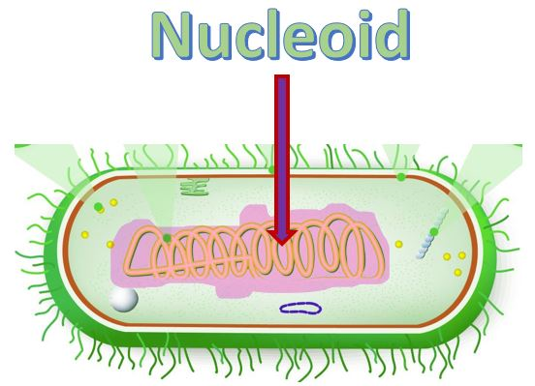
Capsule and Glycocalyx
A gelatinous capsule is present in some bacteria outside the cell membrane and cell wall. The capsule may be polysaccharide as in pneumococci, meningococci or polypeptide as Bacillus anthracis or hyaluronic acid as in streptococci. Capsules are not marked by normal staining protocols and can be detected by India ink or methyl blue; which allows for higher contrast between the cells for observation.
A glycocalyx, literally meaning "sugar coat" (glykys = sweet, kalyx = husk), is a network of polysaccharides that project from cellular surfaces of bacteria, which classifies it as a universal surface component of a bacterial cell, found just outside the bacterial cell wall. A distinct, gelatinous glycocalyx is called a capsule, whereas an irregular, diffuse layer is called a slime layer. This coat is extremely hydrated and stains with ruthenium red.
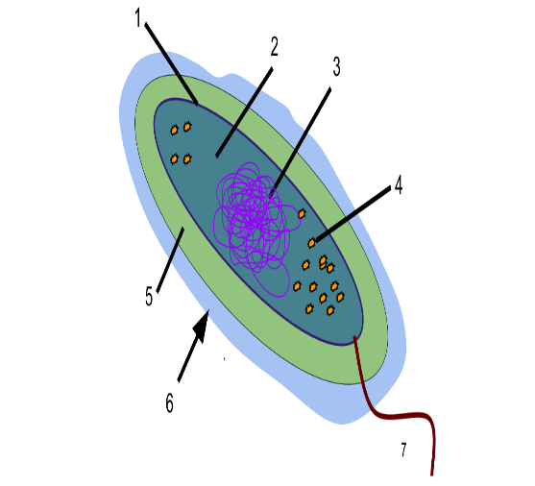
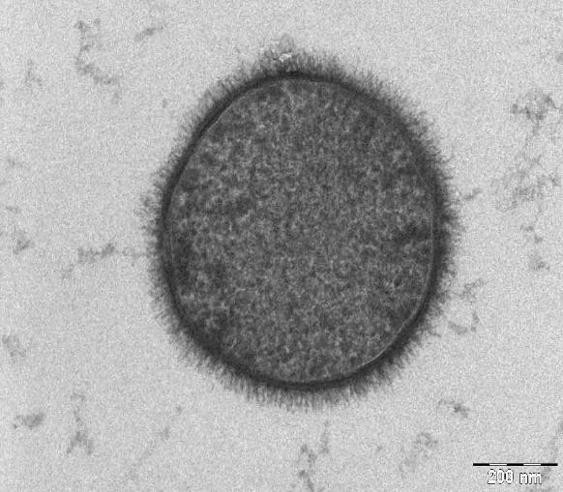
Bacteria growing in natural ecosystems, such as in soil, bovine intestines, or the human urinary tract, are surrounded by some sort of glycocalyx-enclosed microcolony. It serves to protect the bacterium from harmful phagocytes by creating capsules or allowing the bacterium to attach itself to inert surfaces, such as teeth or rocks, via biofilms (e.g. Streptococcus pneumoniae attaches itself to either lung cells, prokaryotes, or other bacteria which can fuse their glycocalices to envelop the colony).
The glycocalyx exists in bacteria as either a capsule or a slime layer. Item 6 points at the glycocalyx. The difference between a capsule and a slime layer is that in a capsule polysaccharide are firmly attached to the cell wall, while in a slime layer, the glycoproteins are loosely attached to the cell wall.
Inclusions
It contains the inclusion bodies like ribosomes and larger masses scattered in the cytoplasmic matrix.
OR
Cytoplasmic inclusions are diverse intracellular non-living substances that are not bound by membranes. Inclusions are stored nutrients, secretory products, and pigment granules.
Mesosomes
Mesosomes or chondroids are folded invaginations in the plasma membrane of bacteria that are produced by the chemical fixation techniques used to prepare samples for electron microscopy. Although several functions were proposed for these structures in the 1960s, they were recognized as artifacts by the late 1970s and are no longer considered to be part of the normal structure of bacterial cells. These extensions are in the form of vesicles, tubules, and lamellae.
Simply mesosomes are infoldings of prokaryotic cell membrane. They carry out aerobic respiration having similar role to mitochondrial cristae.
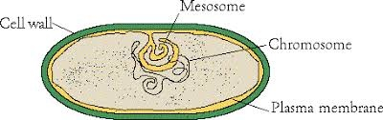
Reproduction
Bacteria and archaea reproduce through asexual reproduction, usually by binary fission. Genetic exchange and recombination still occur, but this is a form of horizontal gene transfer and is not a replicative process, simply involving the transference of DNA between two cells, as in bacterial conjugation.
Binary fission in prokaryotes In prokaryotes binary fission the single DNA molecule first replicates, then attaches each copy to a different part of the cell membrane. When the cell begins to pull apart, the replicated and original chromosomes are separated. The consequence of this asexual method of reproduction is that all the cells are genetically identical, meaning that they have the same genetic material (barring random mutations). Unlike the processes of mitosis and meiosis used by eukaryotic cells, binary fission takes place without the formation of a spindle apparatus on the cell. Like in mitosis (and unlike in meiosis), the parental identity is preserved.
DNA transfer
DNA transfer between prokaryotic cells occurs in bacteria and archaea, although it has been mainly studied in bacteria. In bacteria, gene transfer occurs by three processes. These are
- bacterial virus (bacteriophage)-mediated transduction,
- plasmid-mediated conjugation, and
- natural transformation.
Transduction
Transduction of bacterial genes by bacteriophage appears to reflect an occasional error during intracellular assembly of virus particles, rather than an adaptation of the host bacteria. The transfer of bacterial DNA is under the control of the bacteriophage's genes rather than bacterial genes.
conjugation
Conjugation in the well-studied E. coli system is controlled by plasmid genes, and is an adaptation for distributing copies of a plasmid from one bacterial host to another. Infrequently during this process, a plasmid may integrate into the host bacterial chromosome, and subsequently transfer part of the host bacterial DNA to another bacterium. Plasmid mediated transfer of host bacterial DNA (conjugation) also appears to be an accidental process rather than a bacterial adaptation.
Bacterial conjugation is the transfer of genetic material between bacterial cells by direct cell-to-cell contact or by a bridge-like connection between two cells. The genetic material that is transferred through bacterial conjugation is a small plasmid, known as F-plasmid (F for fertility factor), that carries genetic information different from that which is already present in the chromosomes of the bacterial cell. In fact, the F-plasmid can replicate in the cytoplasm separately from the bacterial chromosome. This takes place through a pilus.
It is a mechanism of horizontal gene transfer as are transformation and transduction although these two other mechanisms do not involve cell-to-cell contact.
A cell that already has a copy of the F-plasmid is called an F-positive, F-plus or F+ cell, and is considered a donor cell, while a cell that does not have a copy of the F-plasmid is called an F-negative, F-minus or F– cell, and is considered a recipient cell.
The transfer of the F-plasmid takes place through a horizontal connection by which the donor cell and the recipient cell directly contact each other or form a bridge between the two through which the genetic material is transferred. In cases where the F-plasmid of a donor cell has been integrated in the cell’s genome (i.e., in the chromosome), a part of the chromosomal DNA may also be transferred to the recipient cell together with the F-plasmid.
Mechanism
In order to transfer the F-plasmid, a donor cell and a recipient cell must first establish contact. At this point, when the cells establish contact, the F-plasmid in the donor cell is a double-stranded DNA molecule that forms a circular structure. The following steps allow the transfer of the F-plasmid from one bacterial cell to another:
- The F+ (donor) cell produces the pilus, which is a structure that projects out of the cell and begins contact with an F– (recipient) cell.
- Pilus attaches to recipient cell and brings the two cells together.
- The mobile plasmid is nicked and a single strand of DNA is then transferred to the recipient cell. Because the F-plasmid consists of a double-stranded DNA molecule forming a circular structure, i.e., it is attached on both ends, an enzyme (relaxase, or relaxosome when it forms a complex with other proteins) nicks one of the two DNA strands of the F-plasmid and this strand (also called T-strand) is transferred to the recipient cell.
- In the last step, the donor cell and the recipient cell, both containing single-stranded DNA, replicate this DNA and thus end up forming a double-stranded F-plasmid identical to the
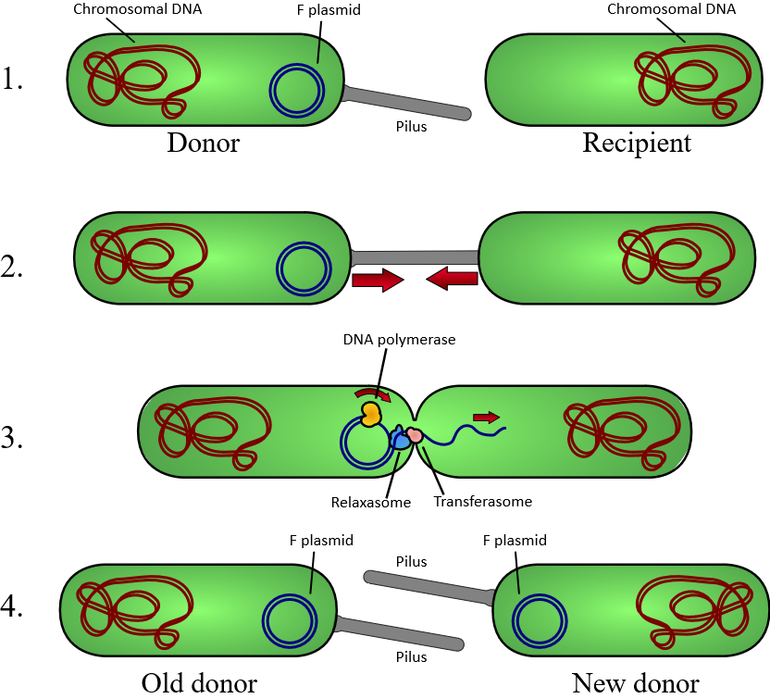
- original F-plasmid. Given that the F-plasmid contains information to synthesize pili and other proteins (see below), the old recipient cell is now a donor cell with the F-plasmid and the ability to form pili, just as the original donor cell was. Now both cells are donors or F+.

Natural bacterial transformation
Natural bacterial transformation involves the transfer of DNA from one bacterium to another through the intervening medium. Unlike transduction and conjugation, transformation is clearly a bacterial adaptation for DNA transfer, because it depends on numerous bacterial gene products that specifically interact to perform this complex process.
For a bacterium to bind, take up and recombine donor DNA into its own chromosome, it must first enter a special physiological state called competence. About 40 genes are required in Bacillus subtilis for the development of competence. The length of DNA transferred during B. subtilis transformation can be as much as a third to the whole chromosome. Transformation is a common mode of DNA transfer, and 67 prokaryotic species are thus far known to be naturally competent for transformation.
Among archaea, Halobacterium volcanii forms cytoplasmic bridges between cells that appear to be used for transfer of DNA from one cell to another. Another archaeon, Sulfolobus solfataricus, transfers DNA between cells by direct contact. Frols found that exposure of S. solfataricus to DNA damaging agents induces cellular aggregation, and suggested that cellular aggregation may enhance DNA transfer among cells to provide increased repair of damaged DNA via homologous recombination.
Sociality
While prokaryotes are considered strictly unicellular, most can form stable aggregate communities. When such communities are encased in a stabilizing polymer matrix ("slime"), they may be called "biofilms". Cells in biofilms often show distinct patterns of gene expression (phenotypic differentiation) in time and space. Also, as with multicellular eukaryotes, these changes in expression often appear to result from cell-to-cell signaling, a phenomenon known as quorum sensing.
Biofilms may be highly heterogeneous and structurally complex and may attach to solid surfaces, or exist at liquid-air interfaces, or potentially even liquid-liquid interfaces. Bacterial biofilms are often made up of microcolonies (approximately dome-shaped masses of bacteria and matrix) separated by "voids" through which the medium (e.g., water) may flow easily. The microcolonies may join together above the substratum to form a continuous layer, closing the network of channels separating microcolonies.
This structural complexity—combined with observations that oxygen limitation (a ubiquitous challenge for anything growing in size beyond the scale of diffusion) is at least partially eased by movement of medium throughout the biofilm—has led some to speculate that this may constitute a circulatory system and many researchers have started calling prokaryotic communities multicellular.
Differential cell expression, collective behavior, signaling, programmed cell death, and (in some cases) discrete biological dispersal events all seem to point in this direction. However, these colonies are seldom if ever founded by a single founder (in the way that animals and plants are founded by single cells), which presents a number of theoretical issues.
Most explanations of co-operation and the evolution of multicellularity have focused on high relatedness between members of a group (or colony, or whole organism). If a copy of a gene is present in all members of a group, behaviors that promote cooperation between members may permit those members to have (on average) greater fitness than a similar group of selfish individuals.
Should these instances of prokaryotic sociality prove to be the rule rather than the exception, it would have serious implications for the way we view prokaryotes in general, and the way we deal with them in medicine. Bacterial biofilms may be 100 times more resistant to antibiotics than free-living unicells and may be nearly impossible to remove from surfaces once they have colonized them. Other aspects of bacterial cooperation—such as bacterial conjugation and quorum-sensing-mediated pathogenicity, present additional challenges to researchers and medical professionals seeking to treat the associated diseases.
Environment
Prokaryotes have diversified greatly throughout their long existence. The metabolism of prokaryotes is far more varied than that of eukaryotes, leading to many highly distinct prokaryotic types. For example, in addition to using photosynthesis or organic compounds for energy, as eukaryotes do, prokaryotes may obtain energy from inorganic compounds such as hydrogen sulfide. This enables prokaryotes to thrive in harsh environments as cold as the snow surface of Antarctica, studied in cryobiology, or as hot as undersea hydrothermal vents and land-based hot springs.
Prokaryotes live in nearly all environments on Earth. Some archaea and bacteria are extremophiles, thriving in harsh conditions, such as high temperatures (thermophiles) or high salinity (halophiles). Many archaea grow as plankton in the oceans. Symbiotic prokaryotes live in or on the bodies of other organisms, including humans.

Classification
In 1977, Carl Woese proposed dividing prokaryotes into the Bacteria and Archaea (originally Eubacteria and Archaebacteria) because of the major differences in the structure and genetics between the two groups of organisms. Archaea were originally thought to be extremophiles, living only in inhospitable conditions such as extremes of temperature, pH, and radiation but have since been found in all types of habitats. The resulting arrangement of Eukaryota (also called "Eucarya"), Bacteria, and Archaea is called the three-domain system, replacing the traditional two-empire system.
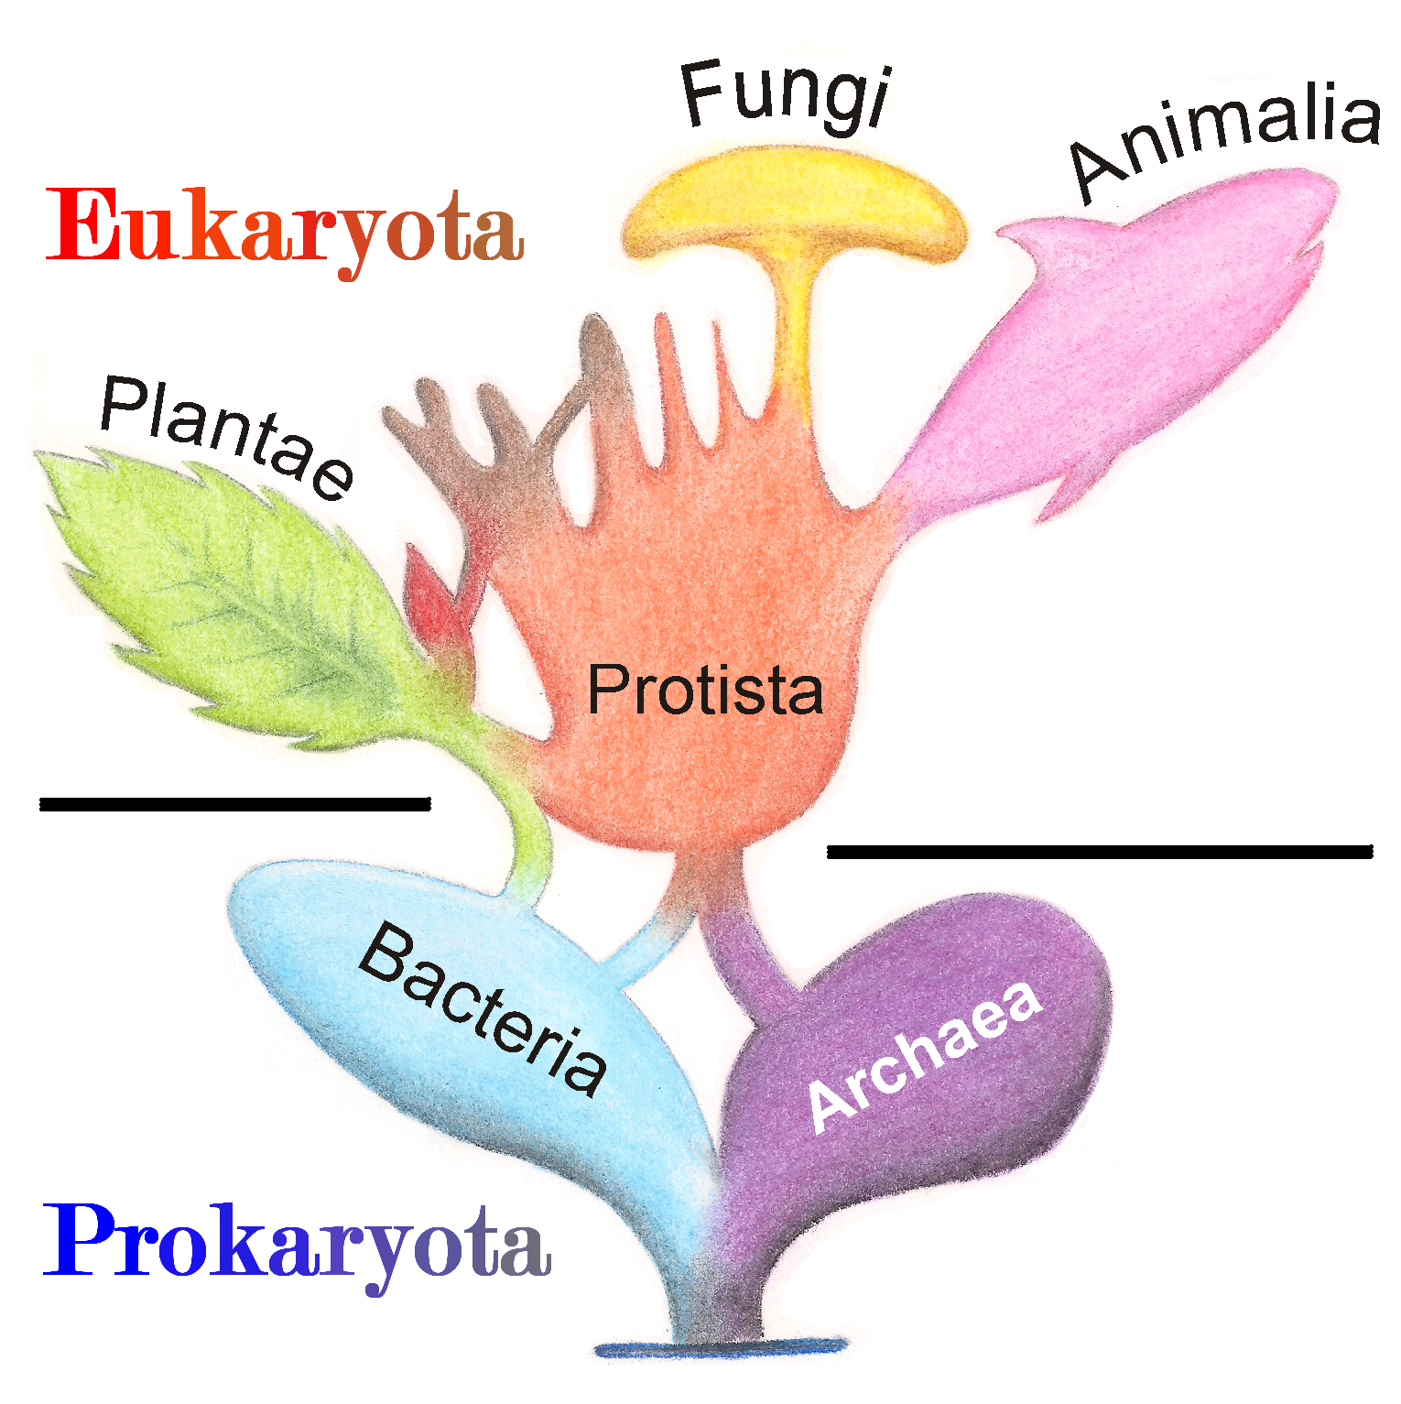
Evolution
A widespread current model of the evolution of the first living organisms is that these were some form of prokaryotes, which may have evolved out of protocells, while the eukaryotes evolved later in the history of life.
Some authors have questioned this conclusion, arguing that the current set of prokaryotic species may have evolved from more complex eukaryotic ancestors through a process of simplification. Others have argued that the three domains of life arose simultaneously, from a set of varied cells that formed a single gene pool. This controversy was summarized in 2005;
There is no consensus among biologists concerning the position of the eukaryotes in the overall scheme of cell evolution. Current opinions on the origin and position of eukaryotes span a broad spectrum including the views that eukaryotes arose first in evolution and that prokaryotes descend from them, that eukaryotes arose contemporaneously with eubacteria and archaebacteria and hence represent a primary line of descent of equal age and rank as the prokaryotes, that eukaryotes arose through a symbiotic event entailing an endosymbiotic origin of the nucleus, that eukaryotes arose without endosymbiosis, and that eukaryotes arose through a symbiotic event entailing a simultaneous endosymbiotic origin of the flagellum and the nucleus, in addition to many other models, which have been reviewed and summarized elsewhere.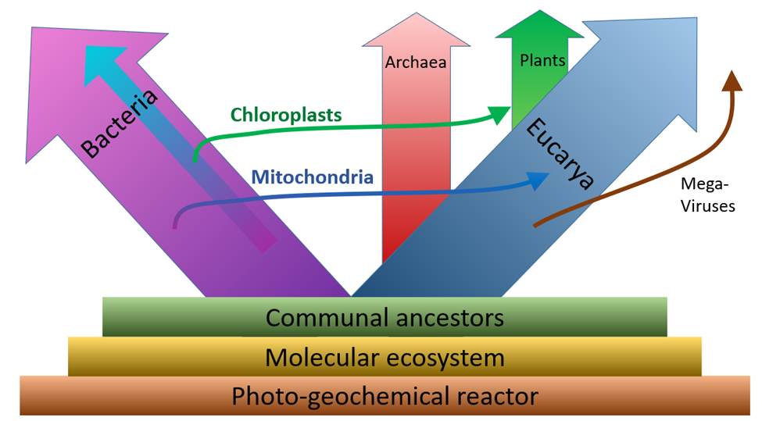
The oldest known fossilized prokaryotes were laid down approximately 3.5 billion years ago, only about 1 billion years after the formation of the Earth's crust.
Eukaryotes only appear in the fossil record later, and may have formed from endosymbiosis of multiple prokaryote ancestors. The oldest known fossil eukaryotes are about 1.7 billion years old. However, some genetic evidence suggests eukaryotes appeared as early as 3 billion years ago.
While Earth is the only place in the universe where life is known to exist, some have suggested that there is evidence on Mars of fossil or living prokaryotes. However, this possibility remains the subject of considerable debate and skepticism.

Relationship to eukaryotes
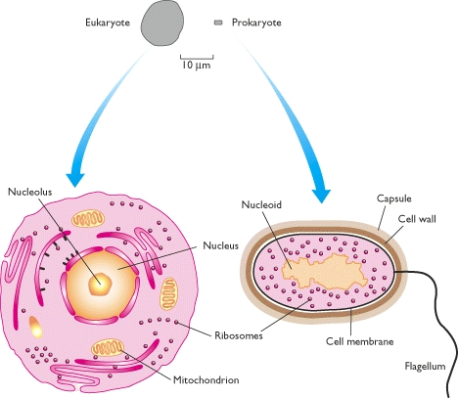
The division between prokaryotes and eukaryotes is usually considered the most important distinction or difference among organisms. The distinction is that eukaryotic cells have a "true" nucleus containing their DNA, whereas prokaryotic cells do not have a nucleus.
Both eukaryotes and prokaryotes contain large RNA/protein structures called ribosomes, which produce protein, but the ribosomes of prokaryotes are smaller than those of eukaryotes. Mitochondria and chloroplasts, two organelles found in many eukaryotic cells, contain ribosomes similar in size and makeup to those found in prokaryotes. This is one of many pieces of evidence that mitochondria and chloroplasts are descended from free-living bacteria. The endosymbiotic theory holds that early eukaryotic cells took in primitive prokaryotic cells by phagocytosis and adapted themselves to incorporate their structures, leading to the mitochondria and chloroplasts.
The genome in a prokaryote is held within a DNA/protein complex in the cytosol called the nucleoid, which lacks a nuclear envelope. The complex contains a single, cyclic, double-stranded molecule of stable chromosomal DNA, in contrast to the multiple linear, compact, highly organized chromosomes found in eukaryotic cells. In addition, many important genes of prokaryotes are stored in separate circular DNA structures called plasmids. Like Eukaryotes, prokaryotes may partially duplicate genetic material, and can have a haploid chromosomal composition that is partially replicated, a condition known as merodiploidy.
Prokaryotes lack mitochondria and chloroplasts. Instead, processes such as oxidative phosphorylation and photosynthesis take place across the prokaryotic cell membrane. However, prokaryotes do possess some internal structures, such as prokaryotic cytoskeletons.[47][48] It has been suggested that the bacterial order Planctomycetes have a membrane around their nucleoid and contain other membrane-bound cellular structures. However, further investigation revealed that Planctomycetes cells are not compartmentalized or nucleated and like the other bacterial membrane systems are all interconnected.
Prokaryotic cells are usually much smaller than eukaryotic cells. Therefore, prokaryotes have a larger surface-area-to-volume ratio, giving them a higher metabolic rate, a higher growth rate, and as a consequence, a shorter generation time than eukaryotes.
There is increasing evidence that the roots of the eukaryotes are to be found in (or at least next by) the Archaean asgard group, perhaps Heimdallarchaeota (an idea which is a modern version of the 1984 eocyte hypothesis, eocytes being an old synonym for crenarchaeota, a taxon to be found nearby the then unknown asgard group) For example, histones usually packaging DNA in eukaryotic nuclei, have also been found in several Archaean groups, giving evidence for homology. This idea might clarify the mysterious predecessor of eukaryotic cells (eucytes) which engulfed an alpha proteobacterium forming the first eucyte (LECA, last eukaryotic common ancestor) according to endosymbiotic theory. There might have been some additional support by viruses, called viral eukaryogenesis. The non-bacterial group comprising archaea and eukaryota has been called Neomura by Thomas Cavalier-Smith in 2002. However, in a cladistic view eukaryota are archaea in the same sense as birds are dinosaurs because they evolved from the maniraptora dinosaur group. In contrast, archaea without eukaryota appear to be a paraphyletic group, just like dinosaurs without birds.

Eukaryotic cell
“Eukaryotes are organisms whose cells have a nucleus enclosed within membranes, unlike prokaryotes (Bacteria and Archaea), which have no membrane-bound organelles”
Introduction:
Eukaryotes belong to the domain Eukaryota or Eukarya. Their name comes from the Greek (eu, "well" or "true") and (karyon, "nut" or "kernel"). Eukaryotic cells typically contain other membrane-bound organelles such as mitochondria and the Golgi apparatus, and in addition, some cells of plants and algae contain chloroplasts.
Unlike unicellular archaea and bacteria, eukaryotes may also be multicellular and include organisms consisting of many cell types forming different kinds of tissue. Animals and plants are the most familiar eukaryotes.
Eukaryotes can reproduce both asexually through mitosis and sexually through meiosis and gamete fusion. In mitosis, one cell divides to produce two genetically identical cells. In meiosis, DNA replication is followed by two rounds of cell division to produce four haploid daughter cells. These act as sex cells (gametes). Each gamete has just one set of chromosomes, each a unique mix of the corresponding pair of parental chromosomes resulting from genetic recombination during meiosis.
The domain Eukaryota is monophyletic and makes up one of the domains of life in the three-domain system. The two other domains, Bacteria and Archaea, are prokaryotes] and have none of the above features. Eukaryotes represent a tiny minority of all living things. However, due to their generally much larger size, their collective worldwide biomass is estimated to be about equal to that of prokaryotes.
Eukaryotes evolved approximately 1.6–2.1 billion years ago, during the Proterozoic eon.

History:
- The concept of the eukaryote has been attributed to the French biologist Edouard Chatton (1883–1947). The terms prokaryote and eukaryote were more definitively reintroduced by the Canadian microbiologist Roger Stanier and the Dutch-American microbiologist C. B. van Niel in 1962.
- In his 1937 work Titres et Travaux Scientifiques,Chatton had proposed the two terms, calling the bacteria prokaryotes and organisms with nuclei in their cells eukaryotes. However he mentioned this in only one paragraph, and the idea was effectively ignored until Chatton's statement was rediscovered by Stanier and van Niel.
- In 1905 and 1910, the Russian biologist Konstantin Mereschkowski (1855–1921) argued that plastids were reduced cyanobacteria in a symbiosis with a non-photosynthetic (heterotrophic) host that was itself formed by symbiosis between an amoeba-like host and a bacterium-like cell that formed the nucleus. Plants had thus inherited photosynthesis from cyanobacteria.
- In 1967, Lynn Margulis provided microbiological evidence for endosymbiosis as the origin of chloroplasts and mitochondria in eukaryotic cells in her paper, On the origin of mitosing cells. In the 1970s, Carl Woese explored microbial phylogenetics, studying variations in 16S ribosomal RNA. This helped to uncover the origin of the eukaryotes and the symbiogenesis of two important eukaryote organelles, mitochondria and chloroplasts. In 1977, Woese and George Fox introduced a "third form of life", which they called the Archaebacteria; in 1990, Woese, Otto Kandler and Mark L. Wheelis renamed this the Archaea.
- In 1979, G. W. Gould and G. J. Dring suggested that the eukaryotic cell's nucleus came from the ability of Gram-positive bacteria to form endospores. In 1987 and later papers, Thomas Cavalier-Smith proposed instead that the membranes of the nucleus and endoplasmic reticulum first formed by infolding a prokaryote's plasma membrane. In the 1990s, several other biologists proposed endosymbiotic origins for the nucleus, effectively reviving Mereschkowski's theory.

Cell features:
Eukaryotic cells are typically much larger than those of prokaryotes, having a volume of around 10,000 times greater than the prokaryotic cell.
They have a variety of internal membrane-bound structures, called organelles, and a cytoskeleton composed of microtubules, microfilaments, and intermediate filaments, which play an important role in defining the cell's organization and shape.
Eukaryotic DNA is divided into several linear bundles called chromosomes, which are separated by a microtubular spindle during nuclear division.
Internal membrane
Eukaryote cells include a variety of membrane-bound structures, collectively referred to as the endomembrane system. Simple compartments, called vesicles and vacuoles, can form by budding off other membranes.
Many cells ingest food and other materials through a process of endocytosis, where the outer membrane invaginates and then pinches off to form a vesicle. It is probable that most other membrane-bound organelles are ultimately derived from such vesicles. Alternatively some products produced by the cell can leave in a vesicle through exocytosis.
The nucleus is surrounded by a double membrane (commonly referred to as a nuclear membrane or nuclear envelope), with pores that allow material to move in and out. Various tube- and sheet-like extensions of the nuclear membrane form the endoplasmic reticulum, which is involved in protein transport and maturation. It includes the rough endoplasmic reticulum where ribosomes are attached to synthesize proteins, which enter the interior space or lumen. Subsequently, they generally enter vesicles, which bud off from the smooth endoplasmic reticulum. In most eukaryotes, these protein-carrying vesicles are released and further modified in stacks of flattened vesicles (cisternae), the Golgi apparatus.
Vesicles may be specialized for various purposes. For instance, lysosomes contain digestive enzymes that break down most biomolecules in the cytoplasm.
Peroxisomes are used to break down peroxide, which is otherwise toxic. Many protozoans have contractile vacuoles, which collect and expel excess water, and extrusomes, which expel material used to deflect predators or capture prey.
In higher plants, most of a cell's volume is taken up by a central vacuole, which mostly contains water and primarily maintains its osmotic pressure.
(The endomembrane system and its components)

Eukaryotic Cell Structure
Like a prokaryotic cell, a eukaryotic cell has a plasma membrane, cytoplasm, and ribosomes. However, unlike prokaryotic cells, eukaryotic cells have:
- a membrane-bound nucleus
- numerous membrane-bound organelles (including the endoplasmic reticulum, Golgi apparatus, chloroplasts, and mitochondria)
- several rod-shaped chromosomes
Because a eukaryotic cell’s nucleus is surrounded by a membrane, it is often said to have a “true nucleus. ” Organelles (meaning “little organ”) have specialized cellular roles, just as the organs of your body have specialized roles. They allow different functions to be compartmentalized in different areas of the cell.
Mitochondria and plastids:
Mitochondria are organelles found in all but one] eukaryote. Mitochondria provide energy to the eukaryote cell by converting sugars into ATP. They have two surrounding membranes, each a phospholipids bi-layer; the inner of which is folded into invaginations called cristae where aerobic respiration takes place.
The outer mitochondrial membrane is freely permeable and allows almost anything to enter into the intermembrane space while the inner mitochondrial membrane is semi permeable so allows only some required things into the mitochondrial matrix.
Mitochondria contain their own DNA, which has close structural similarities to bacterial DNA, and which encodes rRNA and tRNA genes that produce RNA which is closer in structure to bacterial RNA than to eukaryote RNA. They are now generally held to have developed from endosymbiotic prokaryotes, probably proteobacteria.
Some eukaryotes, such as the metamonads such as Giardia and Trichomonas, and the amoebozoan Pelomyxa, appear to lack mitochondria, but all have been found to contain mitochondrion-derived organelles, such as hydrogenosomes and mitosomes, and thus have lost their mitochondria secondarily. They obtain energy by enzymatic action on nutrients absorbed from the environment.
The metamonad Monocercomonoides has also acquired, by lateral gene transfer, a cytosolic sulfur mobilization system which provides the clusters of iron and sulfur required for protein synthesis. The normal mitochondrial iron-sulfur cluster pathway has been lost secondarily.
Plants and various groups of algae also have plastids. Plastids also have their own DNA and are developed from endosymbionts, in this case cyanobacteria. They usually take the form of chloroplasts which, like cyanobacteria, contain chlorophyll and produce organic compounds (such as glucose) through photosynthesis. Others are involved in storing food.
Although plastids probably had a single origin, not all plastid-containing groups are closely related. Instead, some eukaryotes have obtained them from others through secondary endosymbiosis or ingestion. The capture and sequestering of photosynthetic cells and chloroplasts occurs in many types of modern eukaryotic organisms and is known as kleptoplasty.
Endosymbiotic origins have also been proposed for the nucleus, and for eukaryotic flagella.

Simplified structure of a mitochondrion

Cytoskeletal structures:
Many eukaryotes have long slender motile cytoplasmic projections, called flagella, or similar structures called cilia. Flagella and cilia are sometimes referred to as undulipodia, and are variously involved in movement, feeding, and sensation.
They are composed mainly of tubulin. These are entirely distinct from prokaryotic flagella. They are supported by a bundle of microtubules arising from a centriole, characteristically arranged as nine doublets surrounding two sing lets.
Flagella also may have hairs, or mastigonemes, and scales connecting membranes and internal rods. Their interior is continuous with the cell's cytoplasm.
Microfilamental structures composed of actin and actin binding proteins, e.g., α-actinin, fimbrin, filamin are present in submembraneous cortical layers and bundles, as well.
Motor proteins of microtubules, e.g., dynein or kinesin and actin, e.g., myosins provide dynamic character of the network.
Centrioles are often present even in cells and groups that do not have flagella, but conifers and flowering plants have neither. They generally occur in groups that give rise to various microtubular roots.
These form a primary component of the cytoskeletal structure, and are often assembled over the course of several cell divisions, with one flagellum retained from the parent and the other derived from it. Centrioles produce the spindle during nuclear division.
Longitudinal section through the flagellum of Chlamydomonas reinhardtii

The significance of cytoskeletal structures is underlined in the determination of shape of the cells, as well as their being essential components of migratory responses like chemotaxis and chemokinesis. Some protists have various other microtubule-supported organelles.
These include the radiolaria and heliozoa, which produce axopodia used in flotation or to capture prey, and the haptophytes, which have a peculiar flagellum-like organelle called the haptonema.

Cell wall:
The cells of plants and algae, fungi and most chromalveolates have a cell wall, a layer outside the cell membrane, providing the cell with structural support, protection, and a filtering mechanism. The cell wall also prevents over-expansion when water enters the cell.
The major polysaccharides making up the primary cell wall of land plants are cellulose, hemicellulose, and pectin.
The cellulose microfibrils are linked via hemicellulosic tethers to form the cellulose-hemicellulose network, which is embedded in the pectin matrix. The most common hemicellulose in the primary cell wall is xyloglucan.

Cellulose: Cellulose is a long chain of β-glucose molecules connected by a 1-4 linkage. The dashed lines at each end of the figure indicate a series of many more glucose units. The size of the page makes it impossible to portray an entire cellulose molecule

Differences among eukaryotic cells
There are many different types of eukaryotic cells, though animals and plants are the most familiar eukaryotes, and thus provide an excellent starting point for understanding eukaryotic structure. Fungi and many protists have some substantial differences, however.

Animal cell:
All animals are eukaryotic. Animal cells are distinct from those of other eukaryotes, most notably plants, as they lack cell walls and chloroplasts and have smaller vacuoles. Due to the lack of a cell wall, animal cells can transform into a variety of shapes. A phagocytic cell can even engulf other structures.

.
Animal Cells: Despite their fundamental similarities, there are some striking differences between animal and plant cells. Animal cells have centrioles, centrosomes, and lysosomes, whereas plant cells do not.
Plant cell:
Plant cells are quite different from the cells of the other eukaryotic organisms. Their distinctive features are:
- A large central vacuole (enclosed by a membrane, the tonoplast), which maintains the cell's turgor and controls movement of molecules between the cytosol and sap^{[32]}
- A primary cell wall containing cellulose, hemicellulose and pectin, deposited by the protoplast on the outside of the cell membrane; this contrasts with the cell walls of fungi, which contain chitin, and the cell envelopes of prokaryotes, in which peptidoglycans are the main structural molecules
- The plasmodesmata, pores in the cell wall that link adjacent cells and allow plant cells to communicate with adjacent cells.^{[33]} Animals have a different but functionally analogous system of gap junctions between adjacent cells.
- Plastids, especially chloroplasts, organelles that contain chlorophyll, the pigment that gives plants their green color and allows them to perform photosynthesis
- Bryophytes and seedless vascular plants only have flagella and centrioles in the sperm cells.^{[34]} Sperm of cycads and Ginkgo are large, complex cells that swim with hundreds to thousands of flagella.^{[35]}
- Conifers (Pinophyta) and flowering plants (Angiospermae) lack the flagella and centrioles that are present in animal cells.

Plant Cells: Plant cells have a cell wall, chloroplasts, plasmodesmata, and plastids used for storage, and a large central vacuole, whereas animal cells do not.

Fungal cell:
Fungal Hyphae cells: 1 – hyphal wall, 2 – septum, 3 – mitochondrion, 4 – vacuole, 5 – ergosterol crystal, 6 – ribosome, 7 – nucleus, 8 – endoplasmic reticulum, 9 – lipid body, 10 – plasma membrane, 11 – spitzenkörper, 12 – Golgi apparatus
The cells of fungi are most similar to animal cells, with the following exceptions:
- A cell wall that contains chitin
- Less compartmentation between cells; the hyphae of higher fungi have porous partitions called septa, which allow the passage of cytoplasm, organelles, and, sometimes, nuclei; so each organism is essentially a giant multinucleate supercell — these fungi are described as coenocytic. Primitive fungi have few or no septa.
- Only the most primitive fungi, chytrids, have flagella.

Other eukaryotic cells:
Some groups of eukaryotes have unique organelles, such as the cyanelles (unusual chloroplasts) of the glaucophytes, the haptonema of the haptophytes, or the ejectosomes of the cryptomonads. Other structures, such as pseudopodia, are found in various eukaryote groups in different forms, such as the lobose amoebozoans or the reticulose foraminiferans.
Classification
In antiquity, the two lineages of animals and plants were recognized. They were given the taxonomic rank of Kingdom by Linnaeus. Though he included the fungi with plants with some reservations, it was later realized that they are quite distinct and warrant a separate kingdom, the composition of which was not entirely clear until the 1980s. The various single-cell eukaryotes were originally placed with plants or animals when they became known. In 1818, the German biologist Georg A. Goldfuss coined the word protozoa to refer to organisms such as ciliates, and this group was expanded until it encompassed all single-celled eukaryotes, and given their own kingdom, the Protista, by Ernst Haeckel in 1866. The eukaryotes thus came to be composed of four kingdoms:
- Kingdom Protista
- Kingdom Plantae
- Kingdom Fungi
- Kingdom Animalia
The protists were understood to be "primitive forms", and thus an evolutionary grade, united by their primitive unicellular nature.] The disentanglement of the deep splits in the tree of life only really started with DNA sequencing, leading to a system of domains rather than kingdoms as top level rank being put forward by Carl Woese, uniting all the eukaryote kingdoms under the eukaryote domain.] At the same time, work on the protist tree intensified, and is still actively going on today. Several alternative classifications have been forwarded, though there is no consensus in the field.

Phylogenetic and symbiogenetic tree of living organisms, showing a view of the origins of eukaryotes & prokaryotes
Eukaryotes are a clade usually assessed to be sister to Heimdallarchaeota in the Asgard grouping in the Archaea. The basal groupings are the Opimoda, Diphoda, the Discoba, and the Loukozoa. The Eukaryote root is usually assessed to be near or even in Discoba.
A classification produced in 2005 for the International Society of Protistologists, which reflected the consensus of the time, divided the eukaryotes into six supposedly monophyletic 'supergroups'. However, in the same year (2005), doubts were expressed as to whether some of these supergroups were monophyletic, particularly the Chromalveolata, and a review in 2006 noted the lack of evidence for several of the supposed six supergroups. A revised classification in 2012 recognizes five supergroups.
Archaeplastida (or Primoplantae) | Land plants, green algae, red algae, and glaucophytes
SAR supergroup | Stramenopiles (brown algae, diatoms, etc.), Alveolata, and Rhizaria (Foraminifera, Radiolaria, and various other amoeboid protozoa)
Excavata | Various flagellate protozoa
Amoebozoa | Most lobose amoeboids and slime molds
Opisthokonta | Animals, fungi, choanoflagellates, etc.

There are also smaller groups of eukaryotes whose position is uncertain or seems to fall outside the major groups– in particular, Haptophyta, Cryptophyta, Centrohelida, Telonemia, Picozoa, Apusomonadida, Ancyromonadida, Breviatea, and the genus Collodictyon.Overall, it seems that, although progress has been made, there are still very significant uncertainties in the evolutionary history and classification of eukaryotes. As Roger & Simpson said in 2009 "with the current pace of change in our understanding of the eukaryote tree of life, we should proceed with caution."[
In an article published in Nature Microbiology in April 2016 the authors, "reinforced once again that the life we see around us – plants, animals, humans and other so-called eukaryotes – represent a tiny percentage of the world's biodiversity."They classified eukaryote "based on the inheritance of their information systems as opposed to lipid or other cellular structures." Jillian F. Banfield of the University of California, Berkeley and fellow scientists used a super computer to generate a diagram of a new tree of life based on DNA from 3000 species including 2,072 known species and 1,011 newly reported microbial organisms, whose DNA they had gathered from diverse environments. As the capacity to sequence DNA became easier, Banfield and team were able to do metagenomic sequencing – "sequencing whole communities of organisms at once and picking out the individual groups based on their genes alone."
One hypothesis of eukaryotic relationships - the Opisthokonta group includes both animals (Metazoa) and fungi, plants (Plantae) are placed in Archaeplastida.
Reproduction
Cell division generally takes place asexually by mitosis, a process that allows each daughter nucleus to receive one copy of each chromosome. Most eukaryotes also have a life cycle that involves sexual reproduction, alternating between a haploid phase, where only one copy of each chromosome is present in each cell and a diploid phase, wherein two copies of each chromosome are present in each cell.
The diploid phase is formed by fusion of two haploid gametes to form a zygote, which may divide by mitosis or undergo chromosome reduction by meiosis. There is considerable variation in this pattern.
Animals have no multicellular haploid phase, but each plant generation can consist of haploid and diploid multicellular phases.
Eukaryotes have a smaller surface area to volume ratio than prokaryotes, and thus have lower metabolic rates and longer generation times.
The evolution of sexual reproduction may be a primordial and fundamental characteristic of eukaryotes. Based on a phylogenetic analysis, Dacks and Roger proposed that facultative sex was present in the common ancestor of all eukaryotes.
A core set of genes that function in meiosis is present in both Trichomonas vaginalis and Giardia intestinalis, two organisms previously thought to be asexual. Since these two species are descendants of lineages that diverged early from the eukaryotic evolutionary tree, it was inferred that core meiotic genes, and hence sex, were likely present in a common ancestor of all eukaryotes.
Eukaryotic species once thought to be asexual, such as parasitic protozoa of the genus Leishmania, have been shown to have a sexual cycle.] Also, evidence now indicates that amoebae, previously regarded as asexual, are anciently sexual and that the majority of present-day asexual groups likely arose recently and independently.

This diagram illustrates the twofold cost of sex. If each individual were to contribute to the same number of offspring (two), (a) the sexual population remains the same size each generation, where the (b) asexual population doubles in size each generation.

