Practical 1 _ Continued

Introduction to Microsoft Project

- Use your mouse to select the two tasks below the ”Requirements Analysis” entry and then click on the “indent” (green arrow pointing to the right) icon in the schedule group on the Task ribbon.
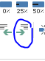

- Repeat this procedure to achieve the following project WBS structure:
Requirements Analysis
Information gathering
Define Requirements
Disk Storage Upgrade
Purchase
Install
Software Modifications
Database Changes
Design DB Changes
Modify DB
Programs
Design Programs
Program A
Code program A
Unit test A
Program B
Code program B
Unit test B
Program C
Code program C
Unit test C
Program D
Code program D
Unit test D
Program R1
Code program R1
Unit test R1
Integration
Integrate
Test
Advertising Brochure
Design
Print
Mail Out

Notice that the entries with subtasks are in bold. This indicates that they are summary tasks. Their symbol on the Gantt chart also appears as a black line. The summary tasks also have a “collapse symbol” (-) on their left hand side.

- Click on one of the collapse symbols and observe how this hides the subtasks beneath it. When subtasks are hidden, an “expand symbol” (+) appears to the left of the summary task name.
- Click on the expand symbol and notice how it expands the summary task.

Add the numerical codes for the WBS.
- Select the “Outline Numbers” check box on the ribbon of the Format tab. You should now see the numerical codes on your WBS. If you have indented the hierarchical structure correctly, you should see the following result.
Task Number | WBS Number | Task names
1 | 1 | Requirements Analysis
2 | 1.1 | Information gathering
3 | 1.2 | Define Requirements
4 | 2 | Disk Storage Upgrade
5 | 2.1 | Purchase
6 | 2.2 | Install
7 | 3 | Software Modifications
8 | 3.1 | Database
9 | 3.1.1 | Design DB Changes
10 | 3.1.2 | Modify DB
11 | 3.2 | Programs
12 | 3.2.1 | Design Programs
13 | 3.2.2 | Program A
14 | 3.2.2.1 | Code program A
15 | 3.2.2.2 | Unit test A
16 | 3.2.3 | Program B
17 | 3.2.3.1 | Code program B
18 | 3.2.3.2 | Unit test B
19 | 3.2.4 | Program C
20 | 3.2.4.1 | Code program C
21 | 3.2.4.2 | Unit test C
22 | 3.2.5 | Program D
23 | 3.2.5.1 | Code program D
24 | 3.2.5.2 | Unit test D
25 | 3.2.6 | Program R1
26 | 3.2.6.1 | Code program R1
27 | 3.2.6.2 | Unit test R1
28 | 4 | Integration
29 | 4.1 | Integrate
30 | 4.2 | Integration testing
31 | 5 | Advertising Brochures
32 | 5.1 | Design
33 | 5.2 | print
34 | 5.3 | Mail out

- Note that an alternative is to create a separate WBS column. If you scroll through the list of available columns in the column with the heading “Add a New Column” which should appear after the “Resource Names” column, you will find the WBS option. Columns can be rearranged, so this could be positioned before the “Task Name” column if required. Add the WBS column now and position it before the “task name column”.
- The task mode is manually scheduled by default. We will see the difference between manual and automatic scheduling later in the practicals, so for now we will leave the task modes as manually scheduled. If you cannot already view a “task mode column” add the “task mode” column to allow you to view whether tasks are automatically or manually scheduled. Position it just before the WBS column.
- The top of your project should now appear similar to the following screenshot.

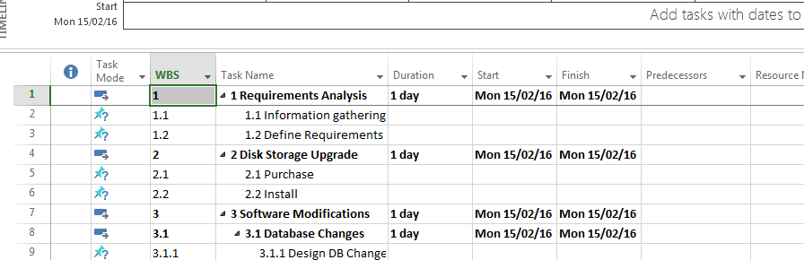

Adding the Project Title as a Project Summary Task

- Click the Format ribbon and select the “Project summary Task tick box.
- The file title should now appear as number 0 at the top of the task list (WBS 0) and the summary task should display the total duration of the project (which is only one at this stage as we have not entered task durations or predecessor information).
- The top of your project should now appear similar to the following screenshot.

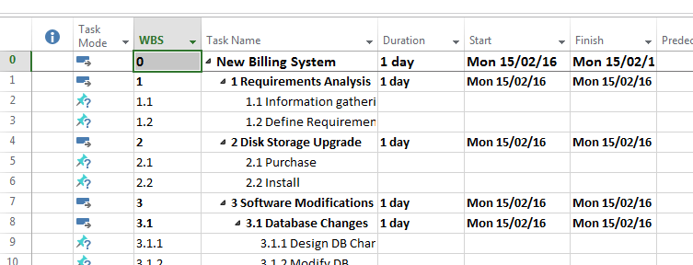

Saving Project Files
- Microsoft Project files can be saved with or without a baseline. The baseline allows you to track performance. However, as we are still developing our project file, we are not yet ready to save with a baseline. The default is to save the file without a baseline.
- Save your file (without a baseline) by selecting “Save As” from the File menu and saving your file as practical1 in the folder you created earlier called ProjectPracticals. Double click on the “computer” option to browse to the ProjectPracticals folder to save your file. (Note that one of the other options such as a “recent folder” may be appropriate in future.)

- 