Chapter 21
Cotton (Gossypiumhirsutum L.)Breeding Strategies

Saeed Rauf, Muhammad Shahzad, ShahidNazir, Jameel M. Al-Khayri, Hafiz Muhammad Imran and IjazRasoolNoorka

AbstractThis chapteris focused on the achievements and future prospects of cotton breeding and biotechnology. Traditionalplant breeding has been utilized for the development of pure line selectionfor high yielding cotton genotypes in segregating generations through the pedigree method. Selection criteria include boll number plant⁻¹, boll mass, sympodial branches, ginning outturn percentage. Plant breeder efforts have been fruitful in releasing the cotton varieties with high yield potential and superior lint quality traits.Traditional breeding efforts resulted in the increase of seed cotton yield and fiber length. The calculated increase in the yield potential was 1.34 kg ha⁻¹ year⁻¹.However, further genetic gains due to selection for high yield potential had reached a plateau since last two decades and the increase in yield was due to better cotton husbandry techniques in few years. Cotton ideotypes specifically for various agronomic and environmental conditions may be developed. Moreover, utilization of wild relatives for the introgression of disease resistance and abiotic stress tolerance is proposed through traditional plant breeding along with molecular markers to reduce linkage drags due to wild relatives. These high yielding varieties with superior agronomic and adaptability traits may be further used for the development of transgenics. Genome editing technique such as CRISPR/Cas (clustered regularly interspaced short palindomic repeats: associated protein) is one of the emerging technologies to knock out genes or SNP (single nucleotide polymorphism) substitution at specific site with future prospects for the development of disease resistant crop varieties.

Keywords CRISPR • Genetic gains •Ideotype • Introgression • Transgenic • Wild relatives

- Introduction

Cotton is an important cash crop,grown in more than 90 countries for its vegetable fiber which is processed by the textile industry. Globally cotton was cultivated on an area of 34.74 million ha which was app. 3% of the total world arable land (FAO 2014). Among the countries, India china, USA and Pakistan are the largest producer of raw cotton. The cotton seed is also consumed by oilseed industry for vegetable fat and cooking oil production while seed cake is consumed by animal and poultry farming. The quality of cotton seed products is influenced by the fatty acid content and chemical composition,which is known to vary among cotton genotypes (Al-Bahrany and Al-Khayri 2000).One important health concern is the gossypol contents and related sesquiterpenealdehydes in cotton seed meal, which function as natural phytoalexins against pathogens and pests (Tian et al. 2018).
Average global cotton production was 73.44 million tons during 2011–2016 (FAO 2016) which was 12% higher than the average world cotton production during 2001–2010, (65.23 million tons) and 36% higher than the average world cotton production during 1991-2000 (54 million tons). There was an increase of 21% in world cotton production when 1990–2000 and 2001-10 were compared while an increase of 13% in global cotton production was seen in present decade (FAO 2016). The world production grew by 1.5% year⁻¹ in last three decades.The global trade of cotton lint was only 21.30 million USD showing that most of the cotton was consumed and processed within cotton producing countries (FAO 2016). The cotton world map of production is shown in Fig. (1).
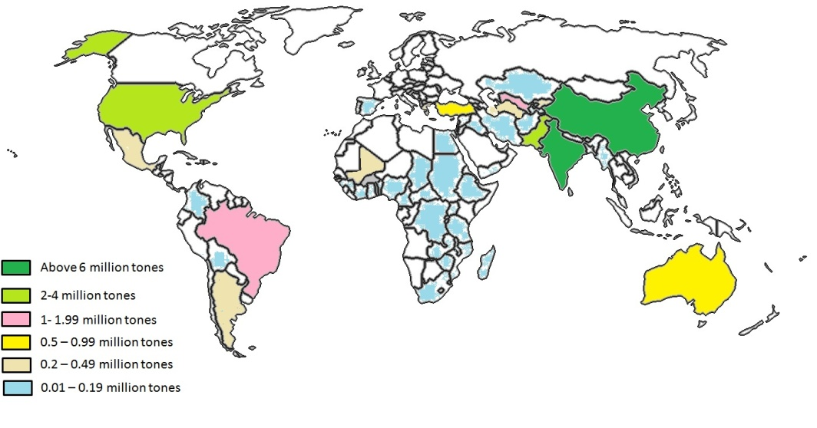
Fig 1. The world map of cotton production. The map prepared as per Food and agriculture statistics, 2016 (www.fao.org)
The yield gains in cotton has been attributed due to traditional plant breeding which developed cotton varieties having high yield potential, superior lint qualities, and tolerance to abiotic and biotic stresses along with early maturity to convert this crop from biannual to an annual growth habit. Cotton breeding is based on the exploitation of genetic variation within cotton germplasm and to select the transgressive plants with superior yield and lint quality. However, breeder selection efficiency was known to dependent on the heritability of the traits. Since most of economical traits were polygenic and are affected by the environment, therefore, the variation among the traits was often masked by the environment. The development of molecular marker system and whole genome sequences analysis has led to the identification of genes and genomic regions associated with traits of interest by which selecting cotton varieties is facilitated inbreeding programs (Fig. 2).
Cotton is among the first crop in which transgenic varieties have been successfully commercialized for large- scale cultivation during mid of 1990s (Zhang 2013). Transgenic cotton provided resistance against the boll worm complex which reduced the pesticide spray by nearly 50% (Traxler et al. 2001;Traxler and Godoy-Avila 2004). It is transformed with Cry genes encoding crystal protein δ-endotoxin (Bt toxin) obtained from Bacillus thuringenesis which is activated in the insect gut causing the death of the organism. Herbicide resistant genes reduced the yield losses due to weed competition for nutrients, light and soil moisture. The success of transgenic cotton in combating boll worms brought tremendous investment of private sector for the research and development of transgenic cotton in various countries (Qiao 2015). Experimentation and evaluation of other transgenic genes have been carried out with a hope to commercialize them in future for sustainable cotton production. Details are present in Section 5. Moreover, cotton regeneration system has been optimized and several methods for development of transgenic cotton have been devised.

Fig.2 Summary of integrated efforts for the improvement of cotton species through breeding and biotechnology

Establishment of functional genomic database in cotton is another milestone for cotton breeding and biotechnology that could help to develop molecular markers related to traits having importance in cotton breeding programs, mining of valuable genes from genome analyses and helped to understand the key metabolic pathways of commercial importance such as fiber development and oil contents (Arpatet al. 2004).
This chapter reviews theachievements and future prospects of cotton breeding and biotechnology. It covers breeding and biotechnology aspects of cotton for high and sustainable production.
- Cotton Sustainable Production

Cotton yield and production is an outcome of harvested bolls from a unit of population over multiple picks (Constable and Bange 2015). However, production is threatened by various social, economic, environmental, agronomic and biological factors (Gutierrez et al. 2015). Sustained cotton production strategies aim to improve these factors such as limiting degradation of environment, loss of bio-diversity, soil erosion, exhaust and leaching of soil nutrients, evolution of new pathogens and bio-type insectsdue to various practices of agriculture in cotton zone (Gutierrez et al. 2015). A precision agriculture may be implemented to precisely carry out various cultural activities from sowing to harvesting for continues success of the cotton crop with optimum use of farm resources, without affecting the environment and maximization of cotton farm income and profits (Roberts et al. 2002; Torbett et al. 2007).
The biological factors include the genotype performance “the ability to respondsuccessfully to a particular environment”. Varietal performance depends upon its genetic potential, stability over the range of environment and resistance to various yield-limiting factors of a particular area. Cotton yield potential is defined as the harvested yield through current cultivars and crop husbandry practices under ideal conditions in the absence of yield limiting factors (Constable and Bange 2015). Conventional cotton breeding tools such as selection and hybridization have been used to widen the genetic potential of cotton and biotechnological tools such as recombinant DNA technology have been employed to induce resistance against various biological and environmental yield-limiting factors. Better crop stand also play an important role in fully exploiting the benefits of the farm inputs and soil. Good crop stand depends on the optimum plant population per unit area, which is contributed by the percentage of seed germination, speed of germination (equals the sum of n1/d1+n2/d2+n3/d3+…;where, n = number of germinated seeds and d= number of days) and seedling vigor (Gairola et al. 2011). Optimization of these parameters is improved through seed technologies.

- Cotton Genetic Resources and Conservation

3.1 Cytogenetics and Evolution

Cotton has narrow genetic base due to bottleneck after evolving into allo-polyploidy species, domestication of few high yielding genotypes and intense pure line selection (pedigree selection method) by the breeders (Rauf et al. 2010; Kuraparthy and Bowman 2013). The upland (hirustum) or pima cotton (barbadense) evolved from two highly divergent species native to Africa (herbaceum like) carrying A genome and raimondii like species carrying D genome which is native to South America (Paterson et al. 2012). Parental species intercrossed about 1-2 million year ago, when species carrier of A genome spread in Mexican region through trans-oceanic dispersal (Paterson et al. 2012). Mating between the species lead to the evolution of several tetraploid species, out of which Gossypiumhirsutum and barbadense are widely cultivated throughout the tropical and subtropical regions of the world. A number of studies using molecular marker or phenotypic based studies have confirmed the presence of low genetic diversity in cotton elite germplasm (Raufet al. 2010). Therefore, there was a need to broaden genetic diversity within cotton germplasm and to use the wild germplasm resources for the improvement of cultivated species (Shaheenet al. 2012). The genus Gossypium comprises more than 50 species, out of which four are cultivated (Fig 3). These cultivated species have2 diploid and 2 tetraploid species. Among 50 species, 7 species areallo-tetraploid and 43 are diploid (Paterson et al. 2012). The A genome is native to the Africa while A1 and A2 genomes are native to Afghanistan, China and Burma. C and G genome evolved in Australia, D native to the America and E genome evolved in Arabian Peninsula(Wendel 2000).

3.2 World Cotton Collections

Cotton world collections has been classified into eight major sites including India, Brazil, France (CIRAD), USA, Australia, Uzbekistan, Russia, China (Campbell et al. 2010). Uzbekistan had the highest germplasm collection of G. hirsutum L. (13,241 accessions) followed by China (7712 accessions), India (7633 accessions), USA (6302 accessions), Russia (4503 accessions), France (2103 accessions), Brazil (1660 accessions) and Australia (1518 accessions) (Campbell et al. 2010). Uzbekistan (3019 accessions) also hold the world largest collection of G. barbadense followed by USA (1584 accessions), Brazil (1509 accessions), Russia (1057 accessions), China (633 accessions), India (534 accessions), France (483 accessions) and Australia (104 accessions) (Campbell 2010).
Germplasm from various sources has been collected and maintained at the Central Cotton Research Institute, Multan, Pakistan (Imran, 2018, Personal Communication). The collection includes 4243 accessions of G. hirsutum, 1025 accessions of G. arboretum, 556 accessions of G.herbaceum, and 109 accessions of G. barbadense. Several of classified Gossypium species were not maintained in their native sites and cotton germplasm was venerable to diseases and insect infestation and many cotton species were at the verge of extinction (Campbell 2010). A survey was carried out in Mexico during the year 2002-03 to determine the current status of the various diploid species of genus Gossypium. Increased population, rapid urbanization and pollution have threatened the local land races of diploid species of cotton (Ulloa et al. 2006). The populations of seven diploid species were collected from door yards, garden plots and as feral plants (Ulloa et al. 2006).Insitu preservation of all 11 diploid Mexican species was under threat.Therefore, collaborative efforts are required to be undertaken to preserve the cotton germplasm resources.The conventional method of in situ conservation was not applicable and exsitu conservation including seed bank for conservation of wild population should be considered (Almeida et al. 2009).
In order to preserve cotton germplasm in situ techniques such as nodal cultures, cryopreservation has been recommended (Altman 1990).

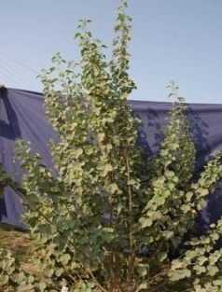  C  B  A | 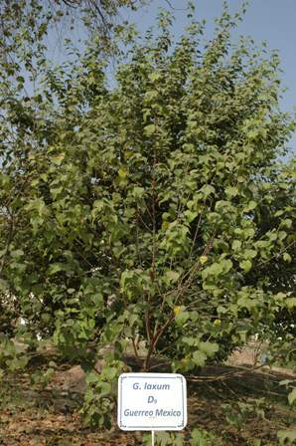 | 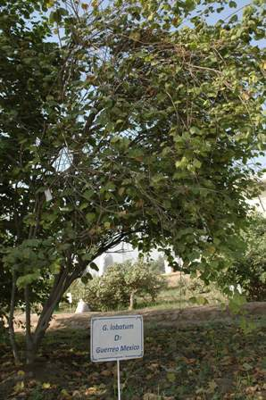
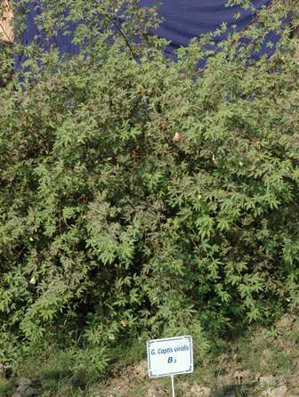  F  E  D | 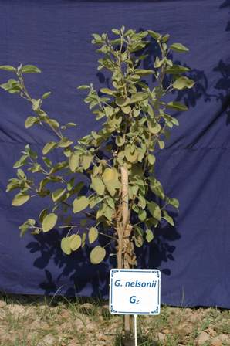 | 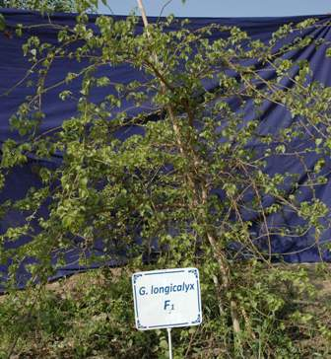
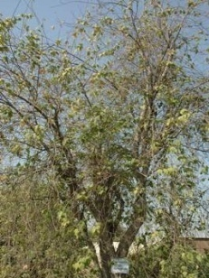  G | 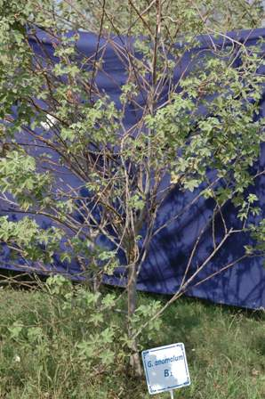  H | 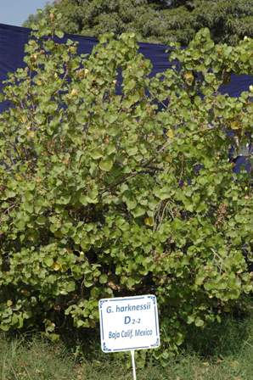  I
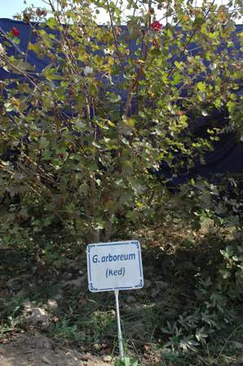  J | K  A

Fig. 3Ex situ wild germplasm collection at Central Cotton Research Institute, Multan, Pakistan. aG. somalense, b G. laxum, c G. lobatum, d G. capitiverdis, e G. nelsoni, f G. longicalyx, g G. gossypioides, h G. anomolum, I G. herkensii, j G. arboreum red, k G. arboreum (Photos by H.M. Imran)

3.3 Utilization of Wild Germplasm

The wild germplasm could be utilized for introgression of cytoplasmic male sterility, diseases and abiotic stress resistance, and to widen the genetic diversity of the cultivated species (Shaheenet al.2012; Table 1). Synthetic species can be reconstituted from donor species i.e. herbaceum and raimondii. Linkage drag from wild types i.e. introgression of undesirable alleles along with gene of interest is major limitation for use of wild species in cotton improvement breeding program. The deterioration of yield and quality, divergent gene regulatory system, chromosome structural differences, hybrid break down and genome assortment without introgression were the major limitation in utilization of wild germplasm for cotton breeding (Dioufet al.2014; Zhang et al. 2014). Molecular markers were used to reduce the linkage drags in back cross and transgressive breeding populations or development of substitution lines (Wang et al. 2011). Introgression of useful genes such as diseases or insect resistance especially from the wild relative also introduced non-targeted orundesirable genes (such as photoperiod sensitivity, late maturity,poor fiber and yield traits) which reduce the overall performance of introgessed populations and thus these breeding lines were not directly commercialized. Use of molecular markers in foreground and background selection could help to minimize the introgression of non-targeted loci and maximize the genome of recipient species along with gene of interest. This could also help to reduce the number of back crosses require to achieve the degree of homozygosity.
Chromosome substitution lines from wide crossing between barbadense × hirsutum were developed with the objective to combine the high yield, lint percentage with better lint quality traits (Sahaet al. 2010). The chromosome by chromosome approach was exploited to narrow down the search for the genotypes with high yield and premium quality fiber (Sahaet al. 2010). Breeding potential of introgression lines (barbadense × hirsutum) showed that some of the breeding lines had predominance of additive variance and were positive contributors of alleles related to yield and quality (Zhang et al. 2016). Developed introgression lines may be used for the development of hybrids and transgressive lines (Zhang et al. 2016).

Table 1 Development of breeding material from wild species of cotton
Interspecific crosses | Breeding material | Reference
hirsutum Cultivar 86-1× G. armourianum | Resistant to sucking pest such as jassid, white fly due to intense hairiness | Junqiet al. (1995)
hirsutum × arboreum | Sterile triploid hybrids which may be amphiploid to transfer cotton leaf curl virus resistance | Tahir et al. (2002)
hirsutum × arboreum and | Eight varieties were developed after introgression with lint yield. High yielding cotton variety Shiyuan 321 (Jimian 24) occupied the highest area in yellow river valley | Zhenglanet al. (2002)
longicalyx × amourianum × hirsutum  longicalyx × herbaceum × hirsutum | Tri species hybrids were resistant to nematodes infestation | Bell and Robinson (2004)
hirsutumAcala 44 × barbadensePima S-7 | Three QTL CM12, STS1, 314-7 had large effect over verticillium wilt resistance | Boleket al. (2005)
G. barbadense,  G. arboreum and  G. thurberi | Developed breeding lines after introgression with hirsutum had superior fiber quality, expanding genetic diversity and resistant to Fusarium wilt and Verticilium wilt | Pang et al. (2006)
G. anamolum | Genes for fiber fineness and strength and resistance to insect and disease | Mehetreet al. (2010)
hirsutum× barbadense | Salt tolerant back cross inbred lines surpassing both parents due to transgressive breeding | Tiwariet al. (2013)
G. gossypioides | Resistant to cotton leaf curl virus disease and may be exploited for introgression | Azharet al. (2013)
hirsutum× arboretum (followed by back crossing to hirsutum | Interspecific F1 hybrid was completely resistant to cotton leaf curl virus, resistance break down with back crossing scheme due to lack of introgression from arborem | Nazeeret al. (2014)
Synthetic amphiploidhirsutum× arboreum (AADDAA) | Amphiploid was resistant to verticillium and drought resistance | Chen et al. (2015)
Gossypiumcapitis-viridis×(G. hirsutum× G. australe) | Tri-species hybrid was intermediate in canopy characteristics and resistant to insect | Chen et al. (2015)
herbaceum (A1) × raimondii (D5) | Sterile hybrid with characteristics intermediate between the species. Synthetic species was used to understand speciation, genome interaction and evolution of tetraploid species | Wu et al. (2017)

  - Colored Cotton

Cotton produces white lint color. However, there is great variability within tetraploid cotton for the lint color. The lint is available from various shades of brown color to the light green (Fig 4). Colored cotton provide great potential for the textile industry to produce cloth without use of synthetic dyes and chemicals which causes allergies to the consumers and their effluent are toxic for the environment. It is also major component of the organic cotton, i.e. cotton produced with less damage to the environment without use of synthetic chemicals. However, colored cotton fiber qualities (fiber length, strength and micronaire) are inferior to the white cotton and cotton color is affected by the environment upon maturity. Therefore, there is need for the selections of colored cotton with stabilize the pigmentation and superior fiber quality for its acceptability in the textile industry.

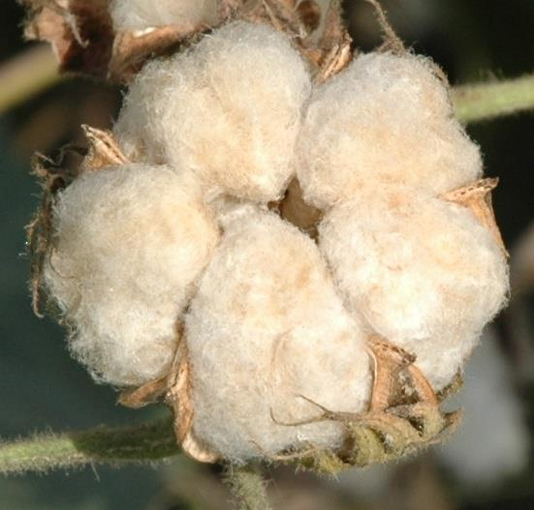  A | 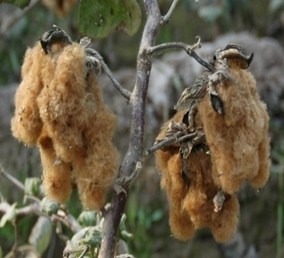  B | 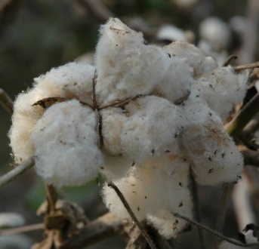  C
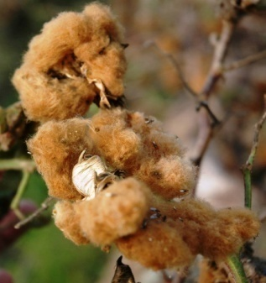  D | E

Fig. 4 Genetic diversity in cotton lint color. a Light brown,b Khaki, c Light green, d Dark brown, e White (Photos by H.M. Imran)

Colored lint develops as a result of accumulation of natural pigmentation in the fiber after exposure to the natural sunlight. All colors are genetically controlled having monogenic inheritance. The green color lint is controlled by the allele Lg (de Carvalho et al. 2014). There were about six alleles (Lc₁-Lc₆) for the brown color (Kohel 1985). Lc₁-Lc₂ produced brown color, Lc₃ produce dark brown color and Lc₄₋ Lc₆ produces light brown pigmentation in lint (Kohel1985). Lc₁ was assigned to chromosome 7 and Lc₂ on chromosome 6 (Wang et al. 2014).

- Traditional Cotton Breeding Programs

Traditional breeding based on basic principles and selection methods has been successfully employed in selecting cotton varieties with greater yield potential along with acceptable fiber quality traits. It involves developing crosses between good × good, or good × poor, which were selected through pedigree or recurrent selection in segregating population to establish pure lines. The selection pressure for early type varieties resulted in improvement of harvest index per unit area, and switching the cultivars from perennial to annual growth habit reduction in the monopodial branches with subsequent increase in the direct fruiting branches. A positive impact of breeding has been noted over the fiber quality traits and genetic gains for fiber quality traits (Kuraparthy and Bowman 2013). However, it is known that cotton yield has reached a plateau and further genetic gain in lint yield was not possible due to drain of genetic variation within elite cotton germplasm (Raufet al. 2012). Several types of cotton ideotypes have been proposed to develop cotton varieties with high yield potential or sustainable yield under various agro-ecological conditions, biotic and abiotic stresses (Table 2).

Table 2 Various ideotype of cotton to full fill ambitious breeding objectives of cotton
Breeding objective | Plant ideotypes | References
High yield potential | Compact canopy, high number of boll per meter², multiple bolls per fruiting point (boll borne in cluster), medium size boll, good boll opening, earlier anthesis, long reproductive duration, increase photosynthetic rate | Seklokaet al. (2008);  Loisonet al. (2017)
Mechanized farming | Uniform opening, small to medium compact canopy, direct fruiting branches, early maturing, good boll opening, normal broad shaped leaf at the base and okra leaf at the canopy | Karathikeyanet al. (2015)
Early maturity | Effective flowering time, plant height at harvest, length of fruiting branch, height to node ratio, average boll retention at first fruiting branch | Seklokaet al. (2008)
Insect resistant | Long frego bract, okra leaves, hairiness, small leaf area, red colored leaves, glandless leaves, nectariless | Taggar and Arora (2017)
Drought resistance | Small leaf area, early maturing, intense hairiness, high cuticular waxes, longer root length, greater stem reserve mobilization | Raufet al. (2016)
Heat resistance | Cell membrane stability, ability to bear flower and retain boll at lower nodes, leaf and stem angle, lower leaf senescence, canopy architecture, leaf thickness, leaf angle | Loison et al (2017)  Pauli et al.(2017)

Rapid genetic gain in the seed cotton yield potential of Pakistani cultivar was noted until 1980s (Fig 5). The yield potential expanded from 600 kg ha⁻¹ to 3500 kg ha⁻¹ from 1916 to 1988; afterward there was no change in the yield potential of the released cultivars. The increase in the yield potential was about 4.4% per year which was about 1.34 kg ha⁻¹ year⁻¹. There was also steady increase in the ginning out turn and staple length of the Pakistani cultivar; both traits increased by 0.5% and 0.6 per year respectively (Figs.5‒6).

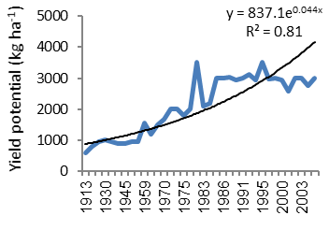 | 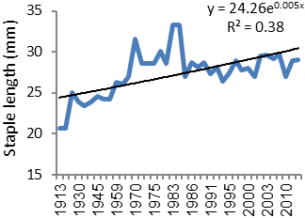

Fig. 5 Change in yield potential and staple length of cotton cultivars release in various periodicals

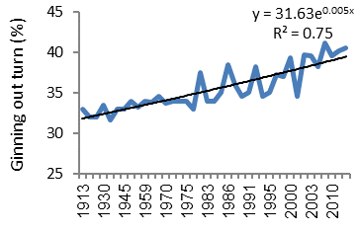 | 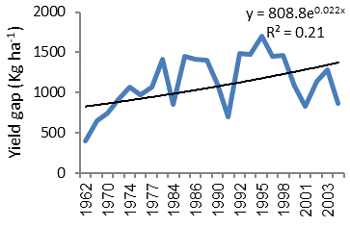

Fig. 6 Change in ginning out turn and yield gaps yield potential and staple length of cotton cultivars release in various periodicals

Correlation analyses showed that there was high significant (P ≤ 0.05) and positive relationship between the actual and potential yield, showing that release of high yielding cultivars had profound effects over the actual cotton seed yield in Pakistan (Table 3). Correlation between the potential seed cotton yield of cultivars with ginning out turn and staple length was also positive and significant (P ≤ 0.05) showing that high yielding cultivar also had superior fiber quality and increase in yield potential was not at the expense of fiber quality (Table 3). There was no improvement in yield potential later in 1990s – 2005. However, there was some increase in actual yield which may due to better crop husbandry managements, early sowing and management of insect infestation. Studies have also shownthat increase in lint yield occurred at the expense of seed yield (Loisonet al. 2017). Estimated genetic gain in lint yield at Cameroon was about 3.3 kg ha⁻¹ year⁻¹ due to increased ginning out turn. However, no genetic gains were noted for physiological traits such as radiation use efficiency, aerial biomass, harvest index, leaf area index and seed cotton yield (Loisonet al. 2017).

Table 3 Correlation coefficients between yield and quality traits
Traits | Yield potential | Actual yield | Yield gap | G.O.T.
Actual yield (Kg ha⁻¹) | 0.72*
Yield gap (kg ha⁻¹) | 0.66* | -0.06^{NS}
Ginning out turn (%) | 0.76* | 0.61* | 0.22^{NS}
Staple length (mm) | 0.62* | -0.21^{NS} | -0.02^{NS} | 0.47*
* Significant at P ≤ 0.05; * ginning out turn

Plant breeders also developed the hybrid cotton with significant economical heterosis for fiber yield and quality traits (Lian-gen 2011). It is principally grown in India, China and Vietnam, while India pioneered the hybrid cotton. In India 40% of the cotton cultivation was done through hybrid seed while in Vietnam about 70% of the cotton area was occupied by the hybrids. Development of high yielding hybrids could expand the yield potential of the varieties. The yield advantage of hybrid cotton in China was more than 20% over the open pollinated varieties (Dong et al. 2004). Bthybrid cotton was considered as an example of successful integration of traditional cotton breeding with biotechnology, as hybrid Bt cotton was based on the manifestation ofheterosis between non-Bt and Bt breeding lines (Dong et al. 2004). Recently several cotton hybrid varieties with high yield, lint percentage, multiple resistance and wide adaptability has been released for general cultivation in various parts of the world (Table 4). New technologies such as molecular markers have been employed to study the genetic purity of hybrids (Dongreet al. 2011). Hybrid varieties also exploited the heterosis for the development of long or extra-longstaple cotton through interspecific hybridization between the hirsutum × barbadense species.

Table 4 Cotton hybrid performance under various agro-environment conditions
Crosses | Heterosis | Reference
Hybrid transplantation technology | Transplanting BT hybrid could help to escape the chilling stress under controlled condition and provided additional one week growth period. | Dong et al. (2005)
Hybrid performance over organic vs. conventional cultivation | 37–71 % more bolls under organic condition and superior fiber traits | Blaiseet al. (2008)
Hybrid Ji-FRH3018  CMS-3096 × Ref 866 | High resistance to bollworm, Fusarium wilt and Verticillium wilt and high yield and lint quality | Guoet al. (2010)
Cytoplasmic male sterility source from Gossypiumharknsii | Negative impact of CMS source over number of bolls per plant and fiber quality traits | Tutejaet al. (2011)
Cotton hybrids CRI-28, CRI-29, XZM 2 and Jimian18. | Gene differential expression in hybrids when compared to parents which changed over various phonological stages. | Zhu et al. (2011)
Commercial Hybrid Xiangzamian 3 | Hybrid had better canopy cooling ability. Maximum heterosis for net photo synthesis rate was observed during post noon when temperature exceeded 45⁰C | Zenget al. (2012)
hirsutum × barbadensechromosome segment introgression lines | Stable heterotic loci (hLP-A4-3) was detected in all three years | Guoet al. (2013)
Okra leaf hybrid F1s, Crossed two sterile near isolines and three restorer near isolines | Lint percent 7–12%, boll weight (6–11%), Canopy light intensity (2–147%), 1–10% in net photosynthetic rate (Pn), and −3 to 3% in lint yield over check hybrid (Zhongza 29) | Zhu et al. (2013)
Recombinant inbred lines | 29 QTLs were linked to mid parent heterosis. Genetic basis of heterosis in cotton was due to dominance, partial dominance or epistasis | Shang et al. (2016)

- Genomic Database

The presence of large amount of sequence data set of cotton has led to have an integrated cotton functional data set (Zhu et al. 2017). Cotton functional data set (CottonFGD, https://cottonfgd.org) has been established which allow the easy, quick and user friendly access for the cotton functional genomic data set including all theGossypium speciesgenome data published. Cotton FGD was exploited to access genes for leaf shape and arginase (Zhu et al. 2017). The comparison of data sets from various upland and sea-island identified various polymorphic sites for the development of molecular markers for these traits. These sequences were used for marker- assisted -selection (MAS) within F2 population to identify the genomic regions associated with these traits. Marker- assisted- selection along with Cotton FGD tools narrowed down the genomic region associated with traits of interest resulting in the identification of 81 genes. Among the identified genes, ATHB-51 (Gh_D01G2042), a homeobox-leucine zipper protein was homologue to leaf shape gene in Arabidopsis thaliana. The draft genome sequence of raimondii species has been published (Wang et al. 2012) which showed that raimondii genome contained more than 40,976 protein-coding genes. However, species genome had under tremendous recombination with more than 40% gene synteny (Wang et al. 2012). Some key genes related to the fiber elongation were explored through expressed sequence tags (Arpatet al. 2014). More than 80 genes related to various developmental stages of fiber development were identified (Arpatet al. 2014). Several fiber related genes such asGhTTG1-GhTTG4, GhGa20ox1-3, iaaM,GbPDF1, GhJAZ2 (fiber initiation), GhSusA1, PHYA1 (fiber length)GbPDF1, E6, GhExp1,RLK (fiber strength), GbTCP, WLIM1a, PAG1,GhCaM7, ACO,GhHOX3, PIP2s (fiber elongation) has been reviewed and were considered as primary genes expressed at various stages of fiber development (Ashraf et al. 2018).The genes were unknown to regulate the fiber development pathways. Susy gene was found to be positively involved while GhPRP5 was negatively involved in the same fiber elongation pathways. The list of biotic and abiotic resistant genes and their putative function has been described in Table5andTable 6.

Table 5 Development of transgenic for protection against various types of biotic stresses
Trans-genes | Resistance | Reference
Hen egg white lysozyme, GAFP4, FreB gene (VDAG_06616)  Gastrodia antifungal proteins | Resistant to Verticilium wilt | Wang et al. (2016);  Wenfang et al. (2017);  Rehman et al. (2018)
GR79 EPSPS and N-acetyltransferase (GAT) genes | Resistant to glyphosate | Liang et al. (2017)
cry1Ac | BT toxin induction in hirsutum | Anayol et al. (2016)
Galanthusnivali agglutinin (GNA) and Amaranthuscaudatusagglutinin | Genes with anti aphid function having 75% control over the pest. | Yang et al. (2017)
Pyramiding RNAi and BT technology | PyramdingRNAi and BT technology was effective to control resistant Helicoverpaarmigera types | Ni et al. (2017)

Table 6 Characterization of various trans-genes under abiotic stresses
Trans-genes | Tolerance | Reference
Isopentenyltransferase gene | Increased salt tolerance due to higher chlorophyll and cytokinin contents which delayed leaf senescence | Liu et al. (2012)
LOS5/ABA3 (LOS5) encodes a molybdenum co-factor | Drought resistance due to lower transpiration losses and over accumulation abscisicacid | Yueet al. (2012)
Annexin gene, GhAnn1 | Enhance drought and salt tolerance | Zhang et al. (2015)
PeDREB2a and HhERF2 from eighty-six AP2/ERF | Transgenic plants containing PeDREB2a and KcERF showed tolerance to salt and drought stresses | Bo Li et al. 2017

6 Mutation Breeding

Mutation breeding program has been initiated for the improvement of cotton in various parts of the world during 19060s. High fruiting, diseases resistance, early maturity, lower monopodial growth habits were the main targets of these breeding programs (Saeed Iqbal 1994; Muthusamy et al. 2005).The mutants were generated with exposure of plant tissues such as seed (30KR), pollen (10 gyGy gamma rays), shoot tip (5-50 Gy gamma rays) ovule (50 Gy gamma rays) or with chemical mutagen 1-5 mM of ethyl methanesulfonate(Saeed Iqbal, 1994;Muthusamy et al. 2005; Muthusamy and Jayabalan 2011;Muthusamy and Jayabalan 2014; Aslam et al. 2018). Lower doses and concentration generated higher genetic variation for traits such as early flowering, plant height, number of bolls, yield of seed cotton, ginning percent, seed index, harvest index and fiber traits (Muthusamy and Jayabalan 2011; Muthusamy and Jayabalan 2014).Cell lines of varieties (Acala SJ2 and B1654) were developed by exposure of 2.13 µmol to sulfonyl urea. The embryogenic resistant cell had L₅₀ several 100 times greater than unselected lines (Rajeskaran et al. 1996). Regenerated plants were resistant to primsulfuron (0.06 to 0.21 μM), and were cross tolerant to two imidazolinone herbicides, imazethapyr and imazaquin (Rajeskaran et al. 1996). The Coker-2312 cell lines were exposed to the progressive higher doses of glyphosate (20 mM) (Tong et al. 2010). Regenerated calli line “R1098” can tolerate about 1.48 kg acid ha⁻¹ glyphosate (Tong et al. 2010).
A team at Nuclear Institute of Agriculture Biology, Faisalabad, Pakistan led by the lateRana Saeed IqbalKhan evolved a revolutionary cultivar NIAB-78 obtained by irradiating the F₁ cross of (Deltapine × AC-134). The Govt. of Pakistan awarded him the highest presidential award for the evolution of this cultivar and his services for the cotton community (Personal communication: Hafiz M. HassanMumtaz, 2019). The developed mutant was early maturing and high yield potential which increase the overall cotton production of Pakistan to several folds and was able to fit in double cropping system (Wheat-Cotton) of Pakistan. It occupied about 90% of the area during early 80s and total Pakistan cotton production increased from 3 million bales to about12.8 million bales (www.niab.org.pk). The cultivar was abounded due to its susceptibility to CLCuVD during mid 1990s(Personal communication: Hafiz M. HassanMumtaz, 2019). A high yielding mutant NIAB-92 was developed by irradiating seed of Stoneville-231 with gamma rays at 30KR from ⁶⁰CO. It has semi hairy, compact canopy wih 0-2 monopodial branches as compared to its parental cultivar (Saeed Iqbal, 1994). Later on, two new mutants (NIAB-999, NIAB-111) were released for cultivation which were high yielding, heat tolerant and CLCuVD resistant. NIAB-777 was developed by crossing the NIAB-78 with REBA-288. The pollen of REBA-288 were irradiated with 10 Gray of gamma rays before pollinating NIAB-78 (Aslam et al. 2018). Plants were selected for high yield, better fiber quality and disease resistance during segregating which resulted in the evolution of NIAB-777 cultivar (Aslam et al. 2018).Mutant with high fiber quality (fiber strength = 40.5) was isolated from segregating populations generated after exposure of “MD15” to 3.2% v/v ethylmethanesulfonate (Bechere et al. 2013).

7 In Vitro Plant Regeneration and Tissue Culture Applications

A prerequisite for genetic transformation is the development of a reliable in vitro regeneration system. Cotton is a recalcitrant species for tissue culture and regeneration via somatic embryogenesis is only confined to few varieties i.e. cocker lines (Trolinder and Goodin 1987). Cocker line such as 312 had high regenerable response and heart shaped globular embryo were cultured on semi solid media which germinated into plantlets (Trolinder and Goodin 1987). Research efforts were being carried out for the optimization of genotype independent protocols for regeneration and genetic transformation. Protocol for the invitro regeneration of cocker 312 is as follows: “Seeds of cotton genotype Coker-312 were surface sterilized with 0.1% SDS, 0.1% mercuric chloride and one drop of Tween-20 for 20 minutes in shaking. The seeds were then thoroughly washed three times with double distilled deionized autoclaved water and placed on ½ MS under dark conditions for germination. Hypocotyl portion of the germinated seedlings was aseptically excised and placed on callogenesis media having 4.33 gL⁻¹MS salts, B5 vitamins, 0.1 m gL⁻¹2,4-D, 0.5 mgL⁻¹kinetin, and 30 gL⁻¹glucose (Fig. 7, Kumar et al. 2004). The embryogenic calli was selected and further induced for somatic embryo genesis. Heart shaped embryos were selected for shoot regeneration and finally healthy shoot were rooted on growth media (Kumar et al. 2004).

Cotton regeneration protocol have been claimed to be optimized in several cultivars around the globe (Pathi and Tutega 2017). For instance, Chinese cultivar YZ-1 showed higher regeneration potential (81.9%) when compared with coker lines 312 and 212 (Jin et al. 2006). A selection toward regeneration potential in elite cultivar was carried out for two cycles and selected cell lines within elite cultivar were designated as “Max-R” (Mishra et al. 2003). The regeneration response was also known to be dependent over the explants, in addition to the growth media such as vitamins and plant growth regulators (Pathi and Tutega 2017). Explant such as embryo axis showed higher regeneration response due to direct regeneration in contrast to the leaf disc segments. Shoot tip explants have been used for transformation and transgenic mersitematic cell of Indian cotton cultivars were regenerated into plantlet (Satyavathi et al. 2002). Invitro regeneration in cotton was shown to be genetically controlled traits and showed moderate heritability when local genotypes were crossed with cocker lines (Rauf and ur Rahman 2005). Over dominance to additive type of gene action was involved in the expression of traits such as callus induction, embryogenic calli and germinating embryo (Rauf and ur Rahman 2005).
B.
C.
A.

Fig. 7 In-vitro culture of cotton genotype Coker-312 used for genetic transformation work. (A) Callus induction from hypocotyl portion (B) Inoculated callus on selective media (C) Organogenesis on regeneration media

8 Transgenic Cotton

Genetic transformation of cotton is categorized as Agrobacterium-mediated transformation, Biolistic transformation, in planta pollen tube pathway or pollen tube transformation. Agrobacterium mediated transformation is widely used and reliable method of transformation and is achieved by co-cultivation of explants with agrobacterium cultures. Recombinant DNA plasmid containing genes of interest along with reporter genes was first inserted in TDNA or other plasmids. The recombinant plasmid is than inserted in agrobacterium through various methods including elctroportation. Agrobacterium tumefacians have the capacity to transform the plant cells with recombinant T-DNA in cotton cell. Triple genes construct carrying cry1AC, cry2Ab and EPSPS was used to transform T-DNA to produce recombinant plasmid (Naqvi et al. 2017). The sequences were retrieved from the NCBI. The gene sequences were optimized according to upland cotton (Naqvi et al. 2017). 2X 35S promoters and terminator sequences were used to induce expression and terminationfor Cry1Ac gene. The 2x 35S promoter was first cloned in pBlue Script SK-zero using SwaI and BamHI restriction site while Cry1Ac was cloned in pBlue SK-35S using BaHI and HindIII restriction site. The terminator was cloned using HindIII and SalI restriction sites. Cry2Ab cassette comprise of figwort mosaic virus promoter, chloroplast signal peptide, partial Cry2Ab (270 bp) and G7 terminator (Naqvi et al. 2017). The cassava mosaic virus promoter (700bp) was used along EPSPS (1.9 kb) and E9 terminator to induce the expression of herbicide resistant gene. Gateway cloning technology was used to construct the cotton transformation vector with synthetic EPSPS gene (accession number KP212901). The plasmid vector pK2GW7,0, an Agrobacterium compatible plant expression vector was selected to clone the synthetic EPSPS and NPTII as selection marker gene (Fig.8) The final gene cassette was introduced into Agrobacterium strain LBA-4404 (Nazir, 2018 unpublished).

Fig. 8 Agrobacterium compatible plant expressing vector pK2GW7,0 with synthetic EPSPS and NPTII selection marker gene for cotton transformation

A method of transformation and regeneration was patent which involved the co-cultivation of cotton explants (hypocotyls from 8 days old seedling) with agrobacterium for two days on callus initiation media (Murashige and Skoog salts, glucose 30 g L⁻¹, myoinositol 100 mg L⁻¹, nicotinic acid 1mg L⁻¹, pyridoxine HCL 1mg L⁻¹, thiamine HCL 10 mg L⁻¹, magnesium chloride 1.87 g L⁻¹, potassium nitrate 1.90 g L⁻¹ and gelrite 4g L⁻¹) without exogenous plant growth regulators (Strickland 1998). The transformed tissues were screened over the 12.5 – 50 mg L⁻¹kenamycin and 150 mg L⁻¹cefotaxime.The survived cell were then continuously cultured on embryo genic calli inducing media and finally germinated over the shoot inducing media (Strickland 1998). The granular calli was inoculated with Agrobacterium culture with recombinant plasmid with gene of interest and screened on 50mgL⁻¹ of kanamycin media. Various stages of callogenesis, regeneration and selection are shown in Fig 7 (Nazir et al., unpublished). The cell suspension culture or embryo axis was also bombarded with highly density particles coated with plasmid using bolistic gun (Finer and McMullen 1990).The recombinant plasmid contained hygromycin resistant gene which was used to screen the transgenic cells over culture media (Finer and McMullen 1990).

In planta methods are devised toavoid the need for the complicated regeneration protocols (kalbande and Patil 2016). In planta pollen tube pathway is also a popular method of transformation. The principle of this method is to use the pollen tube formed by the pollen to insert the gene into embryo sac post pollination/fertilization. The steps are such as pollinating the flower, cutting the stylar tissue (10-12 hours post pollination), injecting the vector solution carrying the gene interest. The desired genes are directly inserted in pollen or injected into developing embryo via pollen tube pathways. In planta method of transformation in seedling include a vertical cut in 4- day- old seedlings at the junction of cotyledonary leaves to expose the apical meristem (kalbande and Patil 2016). The exposed apical meristem is then treated with Agrobacterium transformed with gene of interest. A transformation efficiency of 6.89% was obtained in variety LRK-516. The highest efficiency of transformation was obtained through Agrobacterium-mediated transformation as the gene of interest was inserted in the cells of L3 layers which produce germline tissues. Biolistic transformation produces chimeric tissues due to insertion in non-trageted layers.

Transgenic cotton is cultivated on more than 25 million hectare, which is about 70% of the total cotton area around the globe (Anderson and Rajasekaran 2016). 58 various events carrying insect and herbicide resistance with maximum of three genes (two insect resistance+ one herbicide resistance) along with marker genes have been released for general cultivation in various parts of the world. Transgenic cotton adaptation is increasing at rate of about 5% year⁻¹ containing either of cry genes or herbicide tolerant genes (Anderson and Rajasekaran 2016). Transgenic cotton is the second major commercial success of cry genes (cry1 Ac, cry2Ab2, cry2Ae, cry1 Ab, cry1A) along with herbicide resistant genes (bar,epsps, bxnanddmo) after soybean. Two transgenic varieties NuCOTN³³ and NuCOTN³⁵ with trademarkBollgardTM were released for general cultivation in 1996 through a joint venture between the Monsanto and Delta & Pine companies (Traxleret al. 2001). These varieties were also subsequently released in Argentina, China, Australia, South Africa and Mexico. Later on, several new companies introduced the Bt cotton (transgenic cotton transformed by various Cry genes which encode crystal protein δ-endotoxin to kill lepedoptera class of insect) varieties and local varieties in cotton growing countries were incorporated with various Cry genes through Agrobacterium-mediated transformation (Strickland 1998) or biolisticgenetic transformation (Finer and McMullen 1990), or backcrossed resulting in the wide spread of Bt cotton varieties containing cry genes encoding toxin which provided protection against bollworm complex (Wu et al. 2008).
In comparison to the non-Bt cotton, Bt cotton occupied 85% of the total of cotton cultivation area in USA, 90% in India and Pakistan, 65% China (Anderson and Rajasekaran 2016). Bt cotton had a great success in India which nearly doubled the cotton production due to reduction of yield losses and protection against boll worm. In Pakistan, farmers are still awaiting for the benefits of the Bt cotton due to several factors including weak expression of cry genes in local genotypes and their poor adaptation due to adverse climatic conditions, cotton leaf curl virus infestation and sucking pests. Bt technology has reduced the pesticide spray by 40%, reduced yield losses by 20% and farmer profitability was increased by 70%. In future, multiple Bt or Bt like genes will be staked together along with herbicide resistant genes to increase the efficacy, durability against the boll worm complex and to reduce the yield losses due to weeds by various multi or local companies in countries like USA, China, India and Pakistan (Naranjo 2010).The staking of RNAi genes in Btcottonwas used to interfere with the metabolism of juvenile hormone acid methyl transferease in Helicoverpaarmigera. The staking of genes increased the efficiacy of the Btcotton against the Bt resistant insects (Ni et al. 2017). Cry9C gene and Cry 2A or Cry 1Ac were pyramided (staked) in Bt cotton to increase the efficacy against the two lepidopetran insect i.e. Spodopteralitura and Heliothisarmigera (Li et al. 2014).
Gene pyramiding strategy (incorporation of diversified sources of resistance in a single genotype to reduce yield losses) has been adapted to kill insect due to host ability to produce various types of toxins which may delay the buildup of pest resistance (Brévaultet al. 2013). Initial selection exposure over cry1Ac increased the survival of Helicoverpaover two toxin cotton (Brévaultet al.2013). Some other events of transgenes are under trial or in developmental process with fascinating results (Table 5). However, biotechnological products are put under high watch list and heavy load of formalities which slows down the research from labs to the commercialization success.

- Improvement of Cotton against Abiotic Stresses

Cotton yield has been threatened by various abiotic and biotic stresses on lint yield. Heat and drought stress are the major threats for future cotton production due to rapid increase in the CO₂ which may increase the day and night temperature by 1–5ºC (Singh et al. 2007). It reduced the boll and flower retention on the plant and caused abscission of 40% bolls (Singh et al. 2007). Moreover, heat stress also had repressing effects over the boll size, number of seed per boll, oil and fiber quality traits (Pettigrew, 2008). High temperature also ameliorated the evapotranspiration losses, which increases the water requirement of the crop.
Breeders have made significant efforts to develop the heat or drought tolerant breeding material (Ur Rahman et al. 2004; Khan et al. 2008; Ullah et al. 2008). The efforts of plant breeders were generally aimed at improving seed cotton yield under targeted environment. However, seed cotton yield per se as selection criteria was complicated due to dependence over wide range of yield component in non-stress conditions and also dependenton the plant resistance under stress conditions. For instance, yield under non-stress condition is product of higher boll number, size of boll, no of fruiting points while under high temperature, yield was product of gametophtic fertility, canopy architecture (foliage position, hairiness), delayed leaf senescence, photosynthesis efficiency, less respiration rate, and harvest index (Kakaniet al. 2005; Jhaet al. 2014). A second approach was to screen the elite and wild germplasm and targeting the physiological or morphological traits which may be introgressed within advanced breeding lines. QTL mapping of the traits related to abiotic stress could further help to speed up the introgression and to decrease the linkage drags in the elite breeding material. Various transgenes have been identified which may further help to enhance the cotton crop tolerance to various abiotic stresses (Table 6). These transgenes were not negatively associated with yield, thus transformation did not induce any yield drags.

- Improvement of Cotton against Biotic Stresses

The cotton plant resistance is conventionally dependenton several morphological traits such as frego bract, nectariless, gossypol glands, red canopy color, leaf trichome, glabrous leaf, okra leaf shape and small leaf area. These morphological traits are linked with insect defense umbrella. However, their utilization in practical plant breeding for creating insect resistant cotton was limited due to their effect on plant morphology and yield. Plant biotechnology has been used to introduce transgenes against various abiotic factors. Bt transgenic cotton containing (Crygenes) having resistance to bollworms has gained popularity and replaced the conventional cotton varieties in many parts of the world. Research has been under progress to introduce the transgenic cotton for the diseases and sucking pest resistance. Hen egg white lysozyme, GAFP4, FreB gene (VDAG-06616) has been characterized as resistant to verticilium wilt upon introgression in cotton (Table 5). The gene Galanthus nivali agglutinin (GNA) and Amaranthus caudatus agglutinin was found resistant against aphid infestation (Yang et al. 2017).

- New Emerging Technologies

Genome editing technique such as CRISPR/Cas (clustered regularly interspaced short palindomic repeats: associated protein) is one of the emerging technologies to knock down the undesirable genes at specific site. This technique is used to edit genome through nuclease guided by the RNA to target a specific site in the genome provided that target site has known sequence. The CRISPR were found to be present in the bacteria, which was used to inactivate viral invasions (Razaet al. 2017). The CRISPR sequences are activated after the invasion by a virus utilizing its associated protein (Cas9). As a result of activation of CRISPR, it deactivates the viral genome and keeps small part of viral genome in its genome as spacer sequence (Razaet al. 2017). The guider RNA and spacer sequence in edited CRISPR/Cas9 system has been expected to be widely utilized for the modification of cotton genome. However, CRISPR/Cas9 genome modification technique requires protospacer adjacent motif. Cas9 proteins induces double stranded break at the target site which can be NHEJ (Non homologous end-joining) or HDR (homologous directed repair) by causing indels (insertion and deletions) in genome. This technique has been attempted to induce resistance against cotton leaf curl virus and verticilum wilt in cotton as replacement of RNAi technology (Iqbalet al. 2017). Optimization of CRISPR/Cas9 technique in cotton is in process (Long et al. 2018). A high CRISPR/Cas activity was observed in targeted genomic sites such as GhMYB25-like A and GhMYB25-like D. The targeted sites showed 50% editing through sgRNAof the transgenic allotetraploid cotton plants (Li et al. 2017).A mutation efficiency of 47.6–81.8% in two genes i.e. Cloroplastosalterados 1 (GhCLA1) and vacuolar H⁺-pyrophosphatase (GhVP) was induced through two guide RNAs (Chen et al. 2017).The promoter GHU6 was successfully cloned and provided 6-7 times more expression for sgRNA than AtU6-29 promoter (Long et al. 2018). Multi-site genome editing was done through two sgRNA in single vector which targeted two genes Discosoma red fluorescent protein2(DsRed2) and GhCLA1 in cotton. CRISPR/Cas9 successfully targeted both loci and transformation efficiency of 66.7 to 100% was observed (Wang et al. 2018). The albino expression of endogenous gene GhCLA1 was observed in 75% of the transgenic plants. It is difficult to target both loci in genome A and D controlling single traits due to polyploidy nature of cultivated cotton (Janga et al. 2017). The application of CRISP/Cas9 is severely handicapped due to absence of efficient genetic transformation (Long et al. 2018).The application of CRISPR/Cas9 in cotton genome editing is detailed in a separate chapter in this book.
Genome wide association (GWAS) mapping is also an emerging and an alternative method for detecting QTLs and dissection of quantitative traits in cotton such as plant canopy architecture (Su et al. 2018), agronomic traits i.e. yield and its components (Huang et al. 2017; Gapareet al. 2017), fiber quality traits (Gapareet al. 2017), diseases (Li et al. 2017). GWAS had several advantages over the biparental linkage mapping such as high density mapping covering whole genome, robust, time efficient, cost effective and there was no need of creating mapping populations for QTL mapping (Huang et al. 2017)

- Conclusions and Prospects

Cotton is an important fiber and oilseed crop of the world. It belongs to the genus Gossypium which has four cultivated species, two diploid and two tetraploid species. G. hirsutum is widely cultivated species for the spinablemedium length fiber in textile industry and occupies 90% of the world cotton primary located in America, Asia and Africa. Traditional plant breeding (based on basic principles and selection methods i.e. Pedigree, bulk and recurrent selection for cotton) led to the substantial increase in fiber yield and quality. However, cotton species especially hirustum and barbadense are affected by insects and diseases which increases the production cost. Therefore, Bollgard cotton was introduced to reduce the yield losses due to boll worm complex infestation. Introduction of Bt cotton has provided novel method for insect resistance in cotton and reduced yield losses due to lepedopteraninsects.On the other hand, viral diseases continue to challenge the sustainable cotton production in various parts of the world and introgression of resistance against diseases was difficult through traditional plant breeding due rapid emergence of new pathogens. It was hoped that anti-sense and RNAi technology will provide solution to combat cotton disease, howeverhave failedto develop disease resistant cotton. CRISPR/Cas is a new emerging technology that may be applied to correct or modify the genome region associated with susceptibility to indeterminate growth habit, boll losses, diseases and insects. Continues emergence of new viral strains could continue the battle between the pathogen and breeders. Climate changes due to environmental pollution and deposition of green house gases may threaten the key cotton production regions such as indo-Pak subcontinent. It has been observed that heat, salinity, mineral deficiencies and drought stress can pose serious threats to the cotton production. Breeding strategies such as incorporation ofresistant genes for the development of climate resilient cotton crop may be required to combat future climate changes.

References

Al-BahranyAM, Al-Khayri JM (2000) Genotype variability in fatty acid composition and chemical characteristics of cotton (Gossypiumhirsutum L.). Pak J BiolSci 3:1778–1780
Almeida VCD, Hoffmann LV, Yokomizo GKI et al (2009) In situ and genetic characterization of Gossypiumbarbadense populations from the states of Pará and Amapá, Brazil. PesquisaAgropecuáriaBrasileira 44(7):719–725
Altman DW, Fryxell PA, Koch SD, Howell CR (1990) Gossypiumgermplasm conservation augmented by tissue culture techniques for field collecting. Econ Bot 44(1):106–113
Anayol E, Bakhsh A, Karakoç ÖC et al (2016) Towards better insect management strategy: restriction of insecticidal gene expression to biting sites in transgenic cotton. Plant Biotech Rep 10(2):83–94
Anderson DM, Rajasekaran K (2016) The global importance of transgenic cotton. In: Ramawat KG, Ahuja MR (eds) Fiber plants, sustainable development and biodiversity, Springer International Publishing, Switzerland, pp 17–33
Arpat A, Waugh M, Sullivan JP et al(2004) Functional genomics of cell elongation in developing cotton fibers. Plant MolBiol 54(6):911–929
Ashraf J, Zuo D, Wang Q et al (2018) Recent insights into cotton functional genomics:progress and future perspectives. Plant Biotech J 16(3):699–713
Aslam M, Haq MA, Bandesha AA, Haidar S (2018) NIAB-777: an early maturing, high yielding and better quality cotton mutant developed through pollen irradiation technique - suitable for high density planting. J Anim Plant Sci 28(2):636-646
Azhar M, Anjum Z, Mansoor S (2013) Gossypiumgossypioides: a source of resistance against cotton leaf curl disease among D genome diploid cotton species. J Ani Plant Sci 23:1436–1440
Bechere E, Meredith WR, Boykin JC (2013) Registration of mutant population MD 15 M4 Gossypiumhirsutum L. with enhanced fiber quality. J Plant Reg 7(2):216–219
Bell A, Robinson AF (2004) Development and characteristics of triple species hybrids used to transfer reniform nematode resistance from Gossypiumlongicalyx to Gossypiumhirsutum. Proceedings of the Beltwide Cotton Conferences, New Orleans, USA, National Cotton Council of America, pp 422-426. https://naldc.nal.usda.gov/download/12353/PDF
Blaise D (2006) Yield, boll distribution and fibre quality of hybrid cotton (Gossypiumhirsutum L.) as influenced by organic and modern methods of cultivation. J Agron Crop Sci 192:248–256
Bo Li J, Ni Dong X, Lei Z et al (2016) Simultaneous overexpression of the HhERF2 and PeDREB2a genes enhanced tolerances to salt and drought in transgenic cotton. Prot Pep Let 23(5):450–458
Bolek Y, El-Zik KM, Pepper AE et al (2005) Mapping of Verticillium wilt resistance genes in cotton. Plant Sci 168:1581–1590
Brévault T, Heuberger S, Zhang M et al (2013) Potential shortfall of pyramided transgenic cotton for insect resistance management. Proceed Nat AcadSci 110(15):5806–5811
Campbell BT, Saha S, Percy R et al (2010) Status of the global cotton germplasm resources. Crop Sci 50(4):1161–1179
Carvalho LPD, Farias FJC, Lima MMDA, Rodrigues JIDS (2014) Inheritance of different fiber colors in cotton (Gossypiumbarbadense L.). Crop Breed Appl Biotech 14(4):256–260
Chen D, Wu Y, Zhang X, Li F(2015) Analysis of [Gossypiumcapitis-viridis×(G. hirsutum× G. australe)²] trispecific hybrid and selected characteristics. PloS One 10(6):e0127023. https://doi.org/10.1371/journal.pone.0127023
Chen X, Lu X, Shu N et al (2017) Targeted mutagenesis in cotton (Gossypiumhirsutum L.) using the CRISPR/Cas9 system. Sci Rep 7:44304. doi: 10.1038/srep44304
Chen Y, Wang Y, Zhao T et al (2015) A new synthetic amphiploid (AADDAA) between Gossypiumhirsutum and G. arboreum lays the foundation for transferring resistances to verticillium and drought. PloS One 10(6):e0128981
Constable GA, BangeMP(2015) The yield potential of cotton (Gossypiumhirsutum L.). Field Crops Res 182:98–106
Diouf FBH, Benbouza H, Nacoulima NL et al (2014) Segregation distortions in an interspecific cotton population issued from the [(Gossypiumhirsutum x G. raimondii) ² x G. sturtianum] Hybrid. Tropicultura 32:73–79

Dong H, Li W, Tang W, Zhang D(2004) Development of hybrid Bt cotton in China–a successful integration of transgenic technology and conventional techniques. CurrSci 86(6):778-782

Dong HZ, Li WJ, Tang Wet al(2005) Increased yield and revenue with a seedling transplanting system for hybrid seed production in Bt cotton. J Agron Crop Sci 191(2):116–124
Dongre AB, Raut MP, Bhandarkar MR, Meshram KJ (2011) Identification and genetic purity testing of cotton F 1 hybrid using molecular markers. Ind J Biotech 10:301–306
FAO (2014) Food and Agriculture data. Retrieved from http://www.fao.org/faostat/en/#home. Accessed 19 March 2016
FAO (2016) Food and Agriculture data. Retrieved from http://www.fao.org/faostat/en/#home. Accessed 20 February 2016
Finer JJ, McMullen MD (1990). Transformation of cotton (Gossypiumhirsutum L.) via particle bombardment. Plant Cell Rep 8(10): 586-589.
Gairola KC, Nautiyal AR, Dwivedi AK (2011) Effect of temperatures and germination media on seed germination of Jatrophacurcas Linn. AdvBiores 2(2):66–71
Gapare W, Conaty W, Zhu QH et al 2017) Genome-wide association study of yield components and fibre quality traits in a cotton germplasm diversity panel. Euphytica 213(3):66

Guo BS, Liu SE, Wang ZX et al (2010) Breeding of High Yield, High Quality Three Lines Hybrid Cotton Variety Ji-FRH3018 [J]. J HebeiAgricSci 7:025

Guo X, Guo Y, Ma J et al(2013) Mapping heterotic loci for yield and agronomic traits using chromosome segment introgression lines in cotton. J Integ Plant Biol 55(8):759–774
Gutierrez AP, Ponti L, Herren HR et al (2015) Deconstructing Indian cotton:weather, yields, and suicides. Environ SciEur 27(1):1–17
Huang C, Nie X, Shen C et al (2017) Population structure and genetic basis of the agronomic traits of upland cotton in China revealed by a genome‐wide association study using high density SNPs. Plant Biotech J 15(11):1374–1386
Iqbal Z, Sattar MN, Shafiq M (2016) CRISPR/Cas9: a tool to circumscribe cotton leaf curl disease. Front Plant Sci 7:475
Janga MR, Campbell LM, Rathore KS (2017) CRISPR/Cas9-mediated targeted mutagenesis in upland cotton (Gossypiumhirsutum L.). Plant Mol Bio 94(4–5):349–360
Jha UC, Bohra A, Singh NP(2014) Heat stress in crop plants:its nature, impacts and integrated breeding strategies to improve heat tolerance. Plant Breed 133(6):679–701
Jin S, Zhang X, Nie Y, Guo X, Liang S, Zhu H (2006). Identification of a novel elite genotype for in vitro culture and genetic transformation of cotton. BiologiaPlantarum 50(4): 519-524.
Junqi QS, Yingjun ZBH, XinlianS(1995) Studies on the interspecific hybrid of Gossypiumhirsutum Cultivar 86-1× G. armourianumand its use in breeding [J]. ActaAgronomicaSinica 5:013.
Kakani VG, Reddy KR, Koti S et al (2005) Differences in in vitro pollen germination and pollen tube growth of cotton cultivars in response to high temperature. Annals Bot 96(1):59–67
Kalbande BB, Patil AS (2016) Plant tissue culture independent Agrobacterium tumefaciens mediated In-planta transformation strategy for upland cotton (Gossypiumhirsutum). J Genet Eng and Biotech 14(1):9–18
Khan AI, Khan IA, Sadaqat HA (2008) Heat tolerance is variable in cotton (GossypiumhirsutumL.) and can be exploited for breeding of better yielding cultivars under high temperature regimes. Pak J Bot 40(5): 2053–2058
Kohel RJ (1985). Genetic analysis of fiber color variants in cotton. Crop Sci 25:793–797
Kuraparthy V, Bowman DT (2013) Gains in breeding Upland cotton for fiber quality. JCottonSci 17:157–162
Kumar S, Dhingra A, Daniell H (2004) stable transformation of the cotton plastid genome and maternal inheritance of transgenes. Plant Molecular Biology 56: 203-216.
Leelavathi S, Sunnichan VG, Kumria R, Vijaykanth GP, Bhatnagar RK, Reddy VS (2004). A simple and rapid Agrobacterium-mediated transformation protocol for cotton (Gossypiumhirsutum L.): embryogeniccalli as a source to generate large numbers of transgenic plants. Plant Cell Report 22(7): 465-470.
Li C, Unver T, Zhang B (2017) A high-efficiency CRISPR/Cas9 system for targeted mutagenesis in cotton (Gossypiumhirsutum L.). Sci Rep 7:43902. doi: 10.1038/srep43902
Li L, Zhu Y, Jin S, Zhang X (2014) Pyramiding Bt genes for increasing resistance of cotton to two major lepidopteran pests: Spodopteralitura and Heliothisarmigera. ActaPhysiol Plant 36(10): 2717–2727
Li T, Ma X, Li N et al (2017) Genome‐wide association study discovered candidate genes of Verticillium wilt resistance in upland cotton (Gossypiumhirsutum L.). Plant BiotechJ 15(12):1520–1532
Liang C, Sun B, Meng Z et al (2017) Co‐expression of GR79 EPSPS and GAT yields herbicide‐resistant cotton with low glyphosate residues. Plant Biotech J 15(12):1622–1629
Lian-gen FU(2011) Preliminary report of trial planting of hybrid cotton Tongza411 in Lanxi city and its cultivation technique. Hort Seed 3:121-129. http://en.cnki.com.cn/Article_en/CJFDTOTAL-GNZL201103036.htm
Liu YD, Yin ZJ, Yu JW et al (2012) Improved salt tolerance and delayed leaf senescence in transgenic cotton expressing the Agrobacterium IPT gene. BiolPlant 56(2):237–246
Loison R, Audebert A, Chopart JL et al (2017) Sixty years of breeding in Cameroon improved fibre but not seed cotton yield. ExpAgric 53(2):202–209
Loison R, Audebert A, Debaeke P et al (2017) Designing cotton ideotypes for the future:Reducing risk of crop failure for low input rainfed conditions in Northern Cameroon. Europ J Agron 90:162–173
Long L, Guo DD, Gao W et al (2018) Optimization of CRISPR/Cas9 genome editing in cotton by improved sgRNA expression. Plant Method 14:85.https://doi.org/10.1186/s13007-018-0353-0
Mehetre SS (2010) Wild Gossypiumanomalum:a unique source of fibre fineness and strength. CurrSci 7:58–71
Mishra R, Wang HY, Yadav NR, Wilkins TA (2003). Development of a highly regenerable elite Acala cotton (Gossypiumhirsutum cv. Maxxa)–a step towards genotype-independent regeneration. Plant Cell Tiss Org Cul 73(1): 21-35.
Muthusamy A, Jayabalan N (2011) In vitro induction of mutation in cotton (Gossypiumhirsutum L.) and isolation of mutants with improved yield and fiber characters. Actaphysiol Plant 33(5):1793–1801
Muthusamy A, Jayabalan N (2014) Radiation and chemical mutagen induced somaclonal variations through in vitro organogenesis of cotton (Gossypiumhirsutum L.). Int J Rad Biol 90(12):1229-1239
Muthusamy A, Vasanth K, Jayabalan N (2005) Induced high yielding mutants in cotton (Gossypiumhirsuthum L.). Mutat Breed News Lett 1:6–8
Naqvi RZ, Asif M, Saeed M, Asad S, Khatoon A, Amin I, Mansoor S (2017). Development of a Triple Gene Cry1Ac-Cry2Ab-EPSPS Construct and Its Expression in Nicotianabenthamiana for Insect Resistance and Herbicide Tolerance in Plants. Front Plant Sci 8:55.
Naranjo SE (2010) Impacts of Bt transgenic cotton on integrated pest management. J Agric Food Chem 59(11):5842–5851
Nazeer W, Tipu AL, Ahmad S et al (2014) Evaluation of cotton leaf curl virus resistance in BC1, BC2, and BC3 progenies from an interspecific cross between Gossypiumarboreum and Gossypiumhirsutum. PloS One 9(11):e111861

Ni M, Ma W, Wang et al (2017) Next generation transgenic cotton:pyramidingRNAi and Bt counters insect resistance. Plant Biotech J 15(9):1204–1213
Ni M, Ma W, Wang X et al (2017) Next‐generation transgenic cotton: pyramiding RNAi and Bt counters insect resistance. Plant Biotech J 15(9):1204–1213
Pang C, Du X, Ma Z(2006) Evaluation of the introgressed lines and screening for elite germplasm in Gossypium. Chinese Sci Bullet 51(3):304–312
Paterson AH, Wendel JF, Gundlach H et al (2012) Repeated polyploidization of Gossypiumgenomes and the evolution of spinnable cotton fibres. Nature 492(7429):423–427
Pathi K.M, Tuteja N (2013) High-frequency regeneration via multiple shoot induction of an elite recalcitrant cotton (Gossypiumhirsutum L. cvNarashima) by using embryo apex. Plant Signal Behav 8(1):e22763
Pauli D, White JW, Andrade-Sanchez P et al (2017) Investigation of the influence of leaf thickness on canopy reflectance and physiological traits in upland and Pima cotton populations. Front Plant Sci 8:1405
Pettigrew WT (2008). The effect of higher temperatures on cotton lint yield production and fiber quality. Crop Sci 48(1):278–285
Qiao F (2015) Fifteen years of Bt cotton in China:the economic impact and its dynamics. World Develop 70:177–185
Rajasekaran K, Grula JW, Anderson DM (1996) Selection and characterization of mutant cotton (Gossypiumhirsutum L.) cell lines resistant to sulfonylurea and imidazolinone herbicides. Plant Sci 119(1–2):115–124
Rauf S (2005). A study of in vitro regeneration in relation to doses of growth regulators in hybrids of upland cotton. Plant Cell Tiss Org Cul 83(2): 209-215.
Rehman L, Su X, Li X et al (2018). FreB is involved in the ferric metabolism and multiple pathogenicity-related traits of Verticilliumdahliae. Curr Genet 64(3):645–659
Roberts RK, English BC, Larson JA et al (2002) Precision farming by cotton producers in six southern states: Results from the 2001 southern precision farming survey. The University of Tennessee Agricultural Experiment Station, Department of Agricultural Economics, Research Series, 03–02
Saeed Iqbal RM, Chaudhry MB, Aslam M, Bandesha AA (1994) Development of a high yielding cotton mutant, NIAB-92 through the use of induced mutations. Pak J Bot 26: 99–99
Saha S, Wu J, Jenkins JN et al (2010) Genetic dissection of chromosome substitution lines of cotton to discover novel Gossypiumbarbadense L. alleles for improvement of agronomic traits. TheoretApplGenet 120(6):1193–1205
Satyavathi VV, Prasad V, Lakshmi BG, Sita GL (2002). High efficiency transformation protocol for three Indian cotton varieties via Agrobacterium tumefaciens. Plant Sci 162(2): 215-223.
Sekloka E, LanCOn J, Goze E et al (2008) Breeding new cotton varieties to fit the diversity of cropping conditions in Africa:effect of plant architecture, earliness and effective flowering time on late-planted cotton productivity. ExpAgric 44(2):197–207
Shaheen T, Tabbasam N, Iqbal MA et al (2012) Cotton genetic resources. A review. AgronSustDevelop 32:419–432

Shang L, Wang Y, Cai S et al (2016) Partial dominance, overdominance, epistasis and QTL by environment interactions contribute to heterosis in two upland cotton hybrids. G3:Genes Genomes Genetics 6(3):499–507
Singh RP, Prasad PV, Sunita K et al (2007) Influence of high temperature and breeding for heat tolerance in cotton:a review. AdvanAgron 93:313–385
Strickland SG (1998). U.S. Patent No. 5,846,797. Washington, DC: U.S. Patent and Trademark Office.
Su J, Li L, Zhang C et al (2018) Genome-wide association study identified genetic variations and candidate genes for plant architecture component traits in Chinese upland cotton. TheoAppl Genet 1–16
Taggar GK, Arora R(2017) Insect biotypes and host plant resistance.In: Arora R, Sandhu S (eds)Breeding insect resistant crops for sustainable agriculture. Springer, Singapore, pp 387–421
Tahir MS, Noor UIK(2011) Development of an interspecific hybrid (Triploid) by crossing Gossypiumhirsutum and G. arboreum. Cytologia 76(2):193–199
Tian X, Ruan J-X, Huang J-Q et al (2018) Characterization of gossypol biosynthetic pathway. PNAS 115(23) E5410-E5418. https://doi.org/10.1073/pnas.1805085115
Tiwari RS, Picchioni GA, Steiner RL et al (2013) Genetic variation in salt tolerance at the seedling stage in an interspecific backcross inbred line population of cultivated tetraploid cotton. Euphytica194:1–11
Tong XH, Daud MK, Zhu SJ (2010) Selection and characterization of a novel glyphosate‐tolerant upland cotton (Gossypiumhirsutum L.) mutant (R1098). Plant Breed 129(2):192–196
Torbett JC, Roberts RK, Larson JA, English BC (2007) Perceived importance of precision farming technologies in improving phosphorus and potassium efficiency in cotton production. PrecisAgric 8(3):127–137
Traxler G, Godoy-Avila S (2004) Transgenic cotton in Mexico. AgBioForum 7(1&2):57–62. http://www.agbioforum.org
Traxler G, Godoy-Avila S, Falck-Zepeda J, Espinoza-Arellano J (2001) Transgenic cotton in Mexico: economic and environmental impacts. Available atfile:///C:/Users/HP/Downloads/Transgenic_Cotton_in_Mexico_Economic_and_Environme.pdf
Trolinder NL, Goodin JR (1987). Somatic embryogenesis and plant regeneration in cotton (Gossypiumhirsutum L.). Plant Cell Rep 6(3): 231-234.

Tuteja OP, BangaM(2011) Effects of cytoplasm on heterosis for agronomic traits in upland cotton (Gossypiumhirsutum). IndJAgricSci 81(11):1001
Ullah I, Ashraf M, Zafar Y (2008) Genotypic variation for drought tolerance in cotton (Gossypiumhirsutum L.): leaf gas exchange and productivity. Flora 203(2):105–115
Ulloa M, Stewart JM, Garcia EAet al (2006) Cotton genetic resources in the western states of Mexico: in situ conservation status and germplasm collection for ex situ preservation. Genet Reso Crop Evol 53(4):653–668
ur Rahman H, Malik SA, Saleem M (2004) Heat tolerance of upland cotton during the fruiting stage evaluated using cellular membrane thermostability. Field Crop Res 85(2-3):149–158
Wang F, Gong Y, Zhang C et al (2011) Genetic effects of introgression genomic components from Sea Island cotton (Gossypiumbarbadense L.) on fiber related traits in upland cotton (G. hirsutum L.). Euphytica 181(1):41–53
Wang K, Wang Z, Li F et al (2012) The draft genome of a diploid cotton Gossypiumraimondii. Nat Genet 44:1098–1103
Wang L, Liu H, Li X et al (2014) Genetic mapping of fiber color genes on two brown cotton cultivars in Xinjiang. SpringerPlus 3(1):480
Wang P, Zhang J, Sun L et al (2018). High efficient multisites genome editing in allotetraploid cotton (Gossypiumhirsutum) using CRISPR/Cas9 system. Plant Biotech J 16(1):137–150
Wang Y, Liang C, Wu S et al (2016) Significant improvement of cotton Verticillium wilt resistance by manipulating the expression of gastrodia antifungal proteins. Mol Plant 9(10):1436–1439
Wendel JF (2000) Genome evolution in polyploids. In Plant molecular evolution (pp. 225-249). Springer, Dordrecht.
Wenfang G, Gangqiang Li, Wand NYC et al(2017) Transgenic cotton against Verticilliumwilt by over expression of hen egg white lysozyme. SINO-Pak International Conference on Innovation in Cotton Breeding & Biotechnology, 22–24 November, Multan, Pakistan, pp4
Wu KM, Lu YH, Feng HQ, Jiang YY, Zhao JZ (2008). Suppression of cotton bollworm in multiple crops in China in areas with Bt toxin–containing cotton. Science 321(5896): 1676-1678.
Wu Y, Chen D, Zhu S et al (2017) A new synthetic hybrid (A₁D₅) between Gossypiumherbaceum and G. raimondii and its morphological, cytogenetic, molecular characterization. PloS One 12(2):e0169833. doi: 10.1371/journal.pone.0169833
Yang C, Guo W, Li G et al(2017) Transgenic cotton against aphids by overexpression of snowdrop and amaranth lectin.SINO-Pak International Conference on Innovation in Cotton Breeding & Biotechnology, 22–24 November, Multan, Pakistan, pp 15
Yue Y, Zhang M, Zhang J et al (2012) Overexpression of the AtLOS5 gene increased abscisic acid level and drought tolerance in transgenic cotton. J Exp Bot 63:3741–3748

Zeng B, Xu X, Zhou S et al (2012) Effects of temperature and light on photosynthetic heterosis of an upland cotton hybrid cultivar. Crop Sci 52(1):282–291

Zhang B (2013) Transgenic cotton:from biotransformation methods to agricultural application. Methods MolBiol 958:3-15. doi: 10.1007/978-1-62703-212-4_1
Zhang F, Li S, Yang S et al (2015) Overexpression of a cotton annexin gene, GhAnn1, enhances drought and salt stress tolerance in transgenic cotton. Plant MolBiol 87:47–67
Zhang J, Percy RG, McCarty JC(2014) Introgression genetics and breeding between Upland and Pima cotton:a review. Euphytica 198(1):1–12
Zhang J, Wu M, Yu J et al (2016) Breeding potential of introgression lines developed from interspecific crossing between upland cotton (Gossypiumhirsutum) and Gossypiumbarbadense:heterosis, combining ability and genetic effects. PloS One 11(1):e0143646
Zhenglan L, Ruqin J, Wennan Z et al (2002) Creation of the technique of interspecific hybridization for breeding in cotton. Science in China Series C, Life Sci 45:331–336
Zhu T, Liang C, Meng Z et al (2017) CottonFGD: an integrated functional genomics database for cotton. BMC Plant Biol 17(1):101
Zhu T, Liang C, Meng Z et al(2017) Cotton FGD (Cotton Function Genomics Database) and two case studies in cotton genomics research. SINO-Pak International Conference on Innovation in Cotton Breeding & Biotechnology, 22–24 November, Multan Pakistan, pp 14
Zhu W, Liu K, Wang XD(2008) Heterosis in yield, fiber quality, and photosynthesis of okra leaf oriented hybrid cotton (Gossypiumhirsutum L.). Euphytica 164:283https://doi.org/10.1007/s10681-008-9732-3
Zhu X, Zhang Y, Guo W, Zhang TZ (2011) Relationships between differential gene expression and heterosis in cotton hybrids developed from the foundation parent CRI-12 and its pedigree-derived lines. PlantSci 180:221–227

Appendix I Research institutesrelevant to cotton breeding and biotechnology
Institution | Specialization and research activities | Contact information and website
Central cotton research institute, Multan, Pakistan | Varietal development, cotton yield management | http://www.ccri.gov.pk/
Cotton research Institute, Nanjing University China | Cotton genomics and genetics | http://mascotton.njau.edu.cn/
Central Institute for Cotton Research, India | Cotton varietal development, Integrated Pest Management | http://www.cicr.org.in/
Institute of Cotton Research, China | Genetic breeding, germplasm resources, farming cultivation, plant protection, molecular biology | http://www.caas.cn/en
Cotton Research Institute, Zimbabwe | Cotton varietal development, Integrated Pest Management | https://www.gfar.net/organizations/cotton-research-institute-1
Australian Cotton Research Institute, Narrabari, USA | Biopesticide, Insecticide Resistance, Cotton Nutrition and Irrigation, Cotton Pathology | https://www.dpi.nsw.gov.au/about-us/research-development/centres/narrabri
ACSA International Cotton Institute, USA | Basic education on all aspect of cotton | https://bf.memphis.edu/cotton/index.php/main/instructions
Cotton Research Institute, Egypt | Cotton breeding research, production and technology transfer | http://www.arc.sci.eg/InstsLabs/Default.aspx?OrgID=2
International Cotton Advisory Committee, USA | Cotton research and development policies formation | Icac.org
Cirad Agriculture Research Institute, France | Cotton germplasm, data bases | https://www.cirad.fr/en
Uzbekt Research Institute, Uzbekistan | Cotton germplasm resources | https://en.yellowpages.uz/company/uzbek-scientific-research-institute-of-cotton
Nazili Cotton Research Institute, Turkey | Cotton research and development | administrator@nazilli.tagem.gov.tr

Appendix IICotton genetic resources
Cultivar | Important traits | Cultivation location
NexGen 5711 B3XF | Bollgard3 XtendFlex Cotton Technology, Smooth leaf, bacterial blight tolerance, and fiber | AMERICOT, USA
ST 5517GLTP. | three-gene Bt technology of TwinLink Plus, bacterial blight resistance, and good storm tolerance | Stoneville, USA
FM 1953GLTP | - An early/medium maturity Glyphosate Tolerance LibertyLinkTwinLink Plus variety,Bacterial blight resistance, bollworm resistance and fall armyworm. | Bayer, USA
PHY 300 W3FE | Early maturing, moderate water stress resistant, superior fiber quality | Phytogen, USA
IUB-2013, FH-142, MNH-886 | High yield potential, Cry1A genes, heat resistance, increased boll retention under heat stress | South Punjab, Pakistan
Sicot 71 4B3F | High yield, fiber quality, wide regional adaptability, three transgenic trait Monsanto’s Bollgard II and RRFlex transgenic traits, providing both pest resistance and herbicide tolerance | CSIRO, Australia
GIZA 86 | High yield extra-long cotton having longest and thinnest fiber | Egypt
ICS-105 | High yield and adaptable varieties | Maharashtra, India
FM 1944GLB2 | Broadly adapted to all cotton-growing region, Liberty® and glyphosate herbicide tolerant, Lepidopteran resistant | USA
Gloria | High yield potential | Turkey

Index Keywords
Vol 4 Ch 21 Cotton
Abiotic stress
Bollworm complex
Bt cotton
Colored cotton
CRISPR/Cas
Crop wild relatives
Cry genes
Cultivar
Emasculation
Exsitu Conservation
Fiber length
Fiber strength
Ginning out turn
Hybrid cotton
Inplanta
Insitu Conservation
Introgression
Lint
Microniare
Organic cotton
Pathotypes
Pollen tube transformation
Regeneration
Somatic embryogenesis
Stability index
Sucking pest
Transformation
Varieties
Viral strains
Yield gap

