Strain Energy due to Direct Load
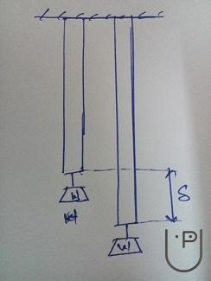
Let us assume a member with uniform cross section A and of length L, be subjected to external axial load W as shown in the figure.
As the load is gradually applied the load is increased from 0 to W, due to which the member is gradually extended by Δ.
Work done due to load is given by the product of average load and the displacement Δ.
Work done = 1/2 * W * Δ
Let the tension developed in the member be T, @ Equilibrium W = T
Tensile stress (ƒ) = T/A
Tensile strain (e) = ƒ/E = T/AE
Δ = eL = T/AE *L]
Strain Energy Stored = Work Done = 1/2*W*Δ = 1/2*T*TL/AE = T²L/2AE

