TOPIC: Cell wall
Cell wall:
content:
* Introduction
*Definition
*Function
*Plant cell wall
*Fungii cell wall
*bacteria cell walL
Cell:
The Cell is the basic structural, functional and biological unit of all Known organisms.
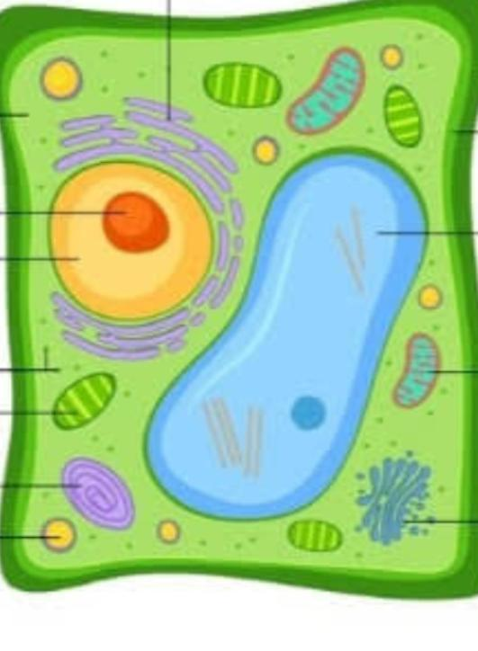
- A cell is the smallest unit of life. Cells are often called the "building blocks of life". The study of cells is called cell biology, cellular biology, or cytology.
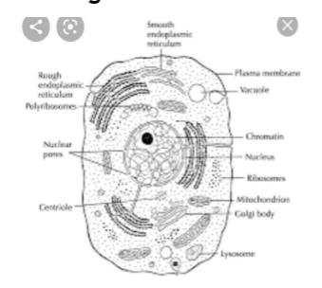
Cells were discovered by Robert Hooke in 1665, . Cell theory, first developed in 1839 by Matthias Jakob Schleiden and Theodor Schwann, states that all organisms are composed of one or more cells, that cells are the fundamental unit of structure and function in all living organisms, and that all cells come from pre-existing cells. Cells emerged on Earth at least 3.5 billion years ago.

Introduction:
- Cell wall Was first observed and named as simply “wall”by Robert hooke in 1965.
- In 1804, Karl Rudolphii and J.H.F link proved That cells have independent cell wall.
- Cell wall is a structural layer That surroundes all types of cells, Situated outhside the cell membrane.
It can be tough, flexible and rigid Which provides cells with both structural protection and support.
Definition:
The outermost non living layer of cells in plants, bacteria, fungi, and many algae that gives shape to the cell and protects it from infection,is called cell wall.
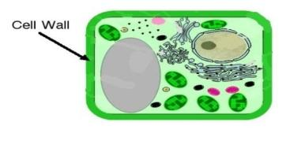
Explanation:
The cell wall is a protective layer outside the cell membrane that also provides support for the cell’s structure. It is the outermost layer of cells in plants, bacteria, fungi, and many algae that gives shape to the cell and protects it from infection. In plants, the cell wall is made up mostly of cellulose, determines tissue texture, and often is crucial to cell function. All living things are composed of cells. They are the building blocks of all life. Cells come in many different shapes and have different functions. Plant and animal cells are different too. The main difference between plant and animal cells is that plant cells have a cell wall on the outer layer, whereas animal cells only have a cell membrane. All cells have cell membranes, but generally only plants, fungi, algae, most bacteria, and archaea have cells with cell walls. The cell wall provides strength and structural support to the cell, and can control to some extent what types and concentrations of molecules enter and leave the cell. The materials that make up the cell wall differ depending on the type of organism. The cell wall has evolved many different times among different groups of organisms.
Composition of cell wall:
- It is the outer most layer of plant cell wall .It is made of pectin ,lignin,Chitin, glycolipids, Sugar and cellulose.
- Plant cell wall:
- Plant cell wall is made of cellulose .It is composed of three layers named as:
- * Middle lamella
- * Primary cell wall
- * Secondary cell wall
Middle Lamella:
- The cementing layer between two adjacent cells is known as middle lamella. Chemically it is made of Calcium and Magnesium pectates
- Composition:.
- Middle lamella of cell wall is composed of calcium and magnesium pectate. It joins the adjoining cells together and thus acts as a cementing layer.
The middle lamella is a layer which cements the cell walls of two adjoining plant cells together. The cell plate that is formed during cell division itself develops into middle lamella or lamellum. The middle lamella is made up of calcium and magnesium pectates.^{[2]} In a mature plant cell it is the outermost layer of cell wall.
Function:
- The main function of the middle lamella is to keep the adjacent cells together. The middle lamella is made up of pectin which acts as a gelling agent or glue that hold the plant together. In simple terms, the function of the middle lamella is adhesion of adjacent cells.
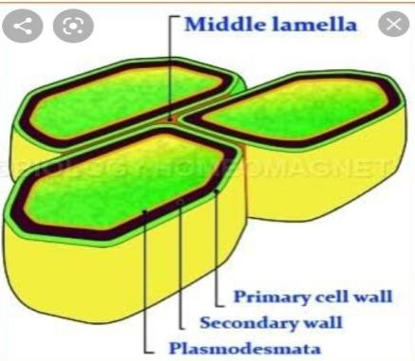

Primary cell wall:
- Definition:
- “The primary wall is the cellulose-containing layer laid down by cells that are dividing and growing.
- Composition:
- *cellulose. * Pectin * hemicellulose * polysaccharides
- Function:
- It has ability to growth and divide.
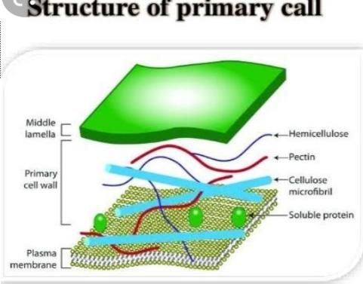
Primary walls surround growing and dividing plant cells. These walls provide mechanical strength but must also expand to allow the cell to grow and divide.

Secondary cell wall:
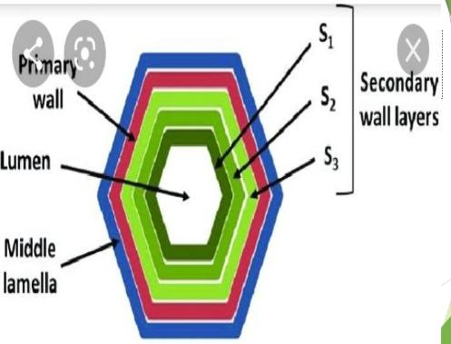
This layer is formed between the primary cell wall and plasma membrane in some plant cells. Once the primary cell wall has stopped dividing and growing, it may thicken to form a secondary cell wall. This rigid layer strengthens and supports the cell. In addition to cellulose and hemicellulose, some secondary cell walls contain lignin. Lignin strengthens the cell wall and aids in water conductivity in plant vascular tissue cells.
Plasmodesmata:
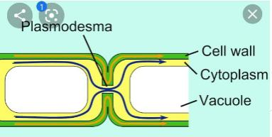
Plasmodesmata are narrow channels that act as intercellular cytoplasmic bridges to facilitate communication and transport of materials between plant cells.
Plasmolysis:
Definition:
“Plasmolysis is the process in which cells lose water (by the process of osmosis) in a hypertonic solution, the cell shrinks away from the cell wall (leaving a gap between them). Plasmolysis occurs only in plant cells and not in animal cells because animals cells do not have cell wall.”
Process of Plasmolysis:
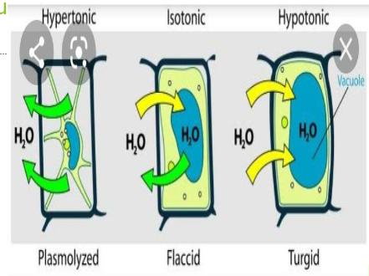
- The process of plasmolysis can be easily explained in the laboratory by placing a living cell in a strong salt solution. When the plant cells are placed in the concentrated salt solution, because of osmosis, water from the cell sap moves out. Therefore, the water travels through the cell membrane into the neighbouring medium. Finally, the protoplasm separates from the cell and assumes a spherical shape.
- Deplasmolysis
- When the plasmolysed cell is placed in a hypotonic solution, (the solution in which solute concentration is less than the cell sap), the water travels into the cell, due to the higher concentration of water outside the cell. Then the cell swells and becomes turgid. This is known as deplasmolysis.
When the living cells are placed in isotonic solution(both solutions have an equal amount of solute particles), the water does not flow within or outside. Here, the water passes in and out of the cell and in an equilibrium state, and Therefore, the cells are called as fflaccid.
Algae Cell Wall:
Algae are a diverse group, and the diversity in their cell walls reflects this. Some algae, such as green algae, have cell walls that are similar in structure to those of plants. Other algae, such as brown algae and red algae, have cellulose along with other polysaccharides or fibrils. Diatoms have cell walls that are made from silicic acid.
Fungi Cell Walls
The cell walls of fungi contain chitin, which is a glucose derivative that is similar in structure to cellulose. Layers of chitin are very tough; chitin is the same molecule found in the rigid exoskeletons of animals such as insects and crustaceans. Glucans, which are other glucose polymers, are also found in the fungal cell wall along with lipids and proteins. Fungi have proteins called hydrophobins in their cell walls. Found only in fungi, hydrophobins give the cells strength, help them adhere to surfaces, and help control the movement of water into the cells. In fungi, the cell wall is the most external layer, and surrounds the cell membrane.
Bacterial cell wall:
The cell walls of bacteria usually contain the polysaccharide peptidoglycan.
Function of cell wall:
- Gives the cell a definite shape and structure.
- Provides structural support.
- Protection against infection and mechanical stress.
- Separates interior of the cell from the outer environment.
- It enables transport of substances and information from the cell insides to the exterior and vice versa.
- Also helps in osmotic-regulation. Prevents water loss.
- The physiological and biochemical activity of the cell wall helps in cell-cell communication.
- It prevents the cell from rupturing due to tugor pressure.
Aids in diffusion of gases in and out of the cell.
Also provides mechanical protection from insects and pathogens. Support: The cell wall provides mechanical strength and support. It also controls the direction of cell growth.​
- Withstand turgor pressure: Turgor pressure is the force exerted against the cell wall as the contents of the cell push the plasma membrane against the cell wall. This pressure helps a plant to remain rigid and erect, but can also cause a cell to rupture.​
- Regulate growth: The cell wall sends signals for the cell to enter the cell cycle in order to divide and grow.
- Regulate diffusion: The cell wall is porous allowing some substances, including proteins, to pass into the cell while keeping other substances out.​
- Communication: Cells communicate with one another via plasmodesmata (pores or channels between plant cell walls that allow molecules and communication signals to pass between individual plant cells).​
- Protection: The cell wall provides a barrier to protect against plant viruses and other pathogens. It also helps to prevent water loss.​
- Storage: The cell wall stores carbohydrates for use in plant growth, especially in seeds.

Self made mcqs:
(1):The basic structural and functional unit of life:
(A) cell. (B)organ (C) stomach (D) none of these
(2): Major function of cell wall is:
(A) storage (B) protection (C) support (D) all of these
(3):cell is discovered by :
(A) Robert hooke (B) Schwartz (C) all of these (D) none of these
(4); plant cell wall is made of :
(A) cellulose (B) Chitin. (C) lignin. ( D) peptides
(5): Which layer perform the function of cement:
(A): primary cell wall (B) secondary cell wall (c) middle Lamella (D) All of these
(6):younger plants do not have:
(A) primary wall (B) secondary wall. (c) middle Lamella (D) None of these
(7) narrow channels in plant cell is called :
(A) plasmodesmata (B) plasmolysis (C) pores (D) all if these
(8): lignin is present in:
(A) secondary cell wall. (B) primary cell. Wall (c) middle Lamella (D) none of these
(9): cell wall is not present in:
(A) plant cell (B) animal cell. (c) fungi. (D) algae
(10): shrinkage of cell is called :
(A) plasmolysis (B) deplasmolysis ( c) both of these (D) none of these

