CHAPTER 1

Introduction to Nitrogenase

1.1 - Nitrogen fixation

The most abundant nitrogen source on earth is found in the atmosphere as N2, yet reduced nitrogen in the form of ammonia (NH3) is required to sustain life on earth. Nitrogen fixation is the conversion of N2 to NH3, and this process can occur by lightning, by an industrial process (Haber-Bosch) or by nitrogen fixing bacteria. Biological
nitrogen fixation plays a crucial role in supplying nitrogen for other forms of life in earth, since it contributes approximately 60% of the total N2 fixed in the biogeochemical nitrogen cycle (Burns et al., 1975; Kim et al., 1994).

Diazotrophs (“nitrogen eaters”) are organisms that are able to reduce N2 to NH3, whereas all other organisms, including plants and animals must rely on a fixed form of nitrogen for survival. Diazotrophs are widely distributed in the bacterial and archeal kingdoms. Bacterial examples include the well-studied species: Klebsiella pneumoniae,
Clostridium pasteurianum, and Azotobacter vinellandii.

Nitrogen fixation also has agronomic importance because fixed nitrogen sources usually limit crop production. This problem is circumvented by enriching the soil with nitrogen fertilizer. However, this solution is problematic for at least three reasons: (i) industrial synthesis of NH3 is expensive, (ii) transportation and distribution of fertilizer is
labor intensive, (iii) application of nitrogen on the soil usually causes contamination of

adjacent water sources. An alternative solution to supplementing soil with a nitrogen source would be the improvement of NH3 production by diazotrophs.

1.2 – Nitrogenase and its metalloclusters

Diazotrophic organisms can fix N2 because they produce an enzyme called nitrogenase. Most N2 fixing organisms studied so far produce a Molybdenum-containing

nitrogenase. In addition, some organisms have “alternative” systems that produce a vanadium-containing nitrogenase and/or an iron-only nitrogenase (Eady, 1996). Among these three classes of nitrogenase, the Mo-containing nitrogenase is the most prevalent and the best characterized.

Mo-containing nitrogenases are composed of two oxygen-sensitive components designated the MoFe protein and the Fe protein. Together, under ideal conditions, they
catalyze the following reaction:

N + 8H+
2
+ 8e-
+ 16MgATP  2NH3 + H2 + 16MgADP + 16Pi

The Fe protein, or component II, is a ~70 kDa homodimer that contains two ATP binding sites and a single [4Fe-4S] cluster bridged between each monomer through cysteine ligands. One of the functions of the Fe protein is to serve as an electron donor to the MoFe protein during catalysis. No other protein or artificial electron donor is able to replace this function. During catalysis, binding of ATP to the reduced Fe protein induces a conformational change that allows docking to the MoFe protein. Docking subsequently triggers the hydrolysis of ATP coupled with the transfer of one electron to the MoFe protein. One of the complexities of the nitrogenase system is that, although the MoFe protein receives one electron at a time from the Fe protein, it requires 2, 4, or 6 electrons to reduce various substrates. Catalysis therefore relies on multiple rounds of association/dissociation between the MoFe protein and the Fe protein (Christiansen et al.,
2001c).

The MoFe protein, or component I, is a ~240kDa heterotetramer (α2β2) and it contains two types of clusters, the P cluster and FeMo cofactor. The [8Fe-7S] P cluster is located at each α/β interface. The P cluster is believed to serve as an intermediate electron carrier during electron transfer from the Fe protein to the FeMo cofactor. In the crystal structure of the MoFe protein and Fe protein complex, the P cluster is located equidistant between the [4Fe-4S] cluster of the Fe protein and the FeMo-cofactor of the MoFe protein.

The FeMo-cofactor is located within the MoFe protein α-subunit and it has a unique structure not identified in any other metalloprotein. This cofactor is a [7Fe-9S- Mo-X-homocitrate] cluster, where X is likely to be a non-exchangeable nitrogen atom. A high-resolution crystal structure of the MoFe protein has recently revealed the presence of this atom in the central cavity of the cofactor, previously thought to be unoccupied (Einsle et al., 2002). The FeMo-cofactor is covalently attached to the protein by two amino acids residues, α-Cys275 and α-His442, and is tightly held within the protein through non-covalent interactions with the side chain of a variety of other residues.

2.1 - Introduction to Nitrogenase

The nitrogenases represent a class of complex metalloenzymes that catalyze the key reductive step in the global biological nitrogen cycle – nucleotide-dependent reduction of dinitrogen to ammonia. The best-studied member of this group is the Mo- dependent nitrogenase, which is composed of two component proteins usually designated the Fe protein and the MoFe protein (Figure 1), names that were derived from the compositions of their respective metallocluster complements (Burris, 1991). The Fe protein is an agent of electron transfer that sequentially delivers single electrons to the MoFe protein in a process coupled to MgATP hydrolysis. During the catalytic cycle, nucleotide binding to the Fe protein elicits a conformational change that primes the Fe protein for complex formation with the MoFe protein. Such nucleotide-induced interaction of the component proteins subsequently triggers nucleotide hydrolysis, electron transfer, and complex dissociation (Christiansen et al., 2001). A schematic representation of this process is shown in Figure 1. No artificial source of reducing equivalents has been shown capable of substituting for the function of the Fe protein in electron transfer necessary for substrate reduction (Burgess & Lowe, 1996). This feature is generally believed to reflect obligate reciprocal conformational signaling between the Fe protein and the MoFe protein as a way to accomplish the accumulation of the multiple electrons required for substrate reduction (Howard & Rees, 1994; Seefeldt & Dean,
1997). In this respect it is emphasized that during the catalytic cycle electrons are delivered to the MoFe protein one at-a-time but multiple electrons are required for substrate reduction. Nitrogenase catalysis is complicated and the exact mechanism has remained elusive for two important reasons. First, the MoFe protein does not bind substrate in the resting state, but must first accumulate two or more electrons to effect substrate binding. Second, in the absence of other substrates, all electrons accumulated within the MoFe protein become diverted to proton reduction, which returns the protein to the resting state. Thus, although attempts have been made to biophysically characterize the intractable semi-reduced forms of the MoFe proteins, with or without substrate or inhibitors bound (Lee et al., 2000; Ryle et al., 2000), intermediate states of

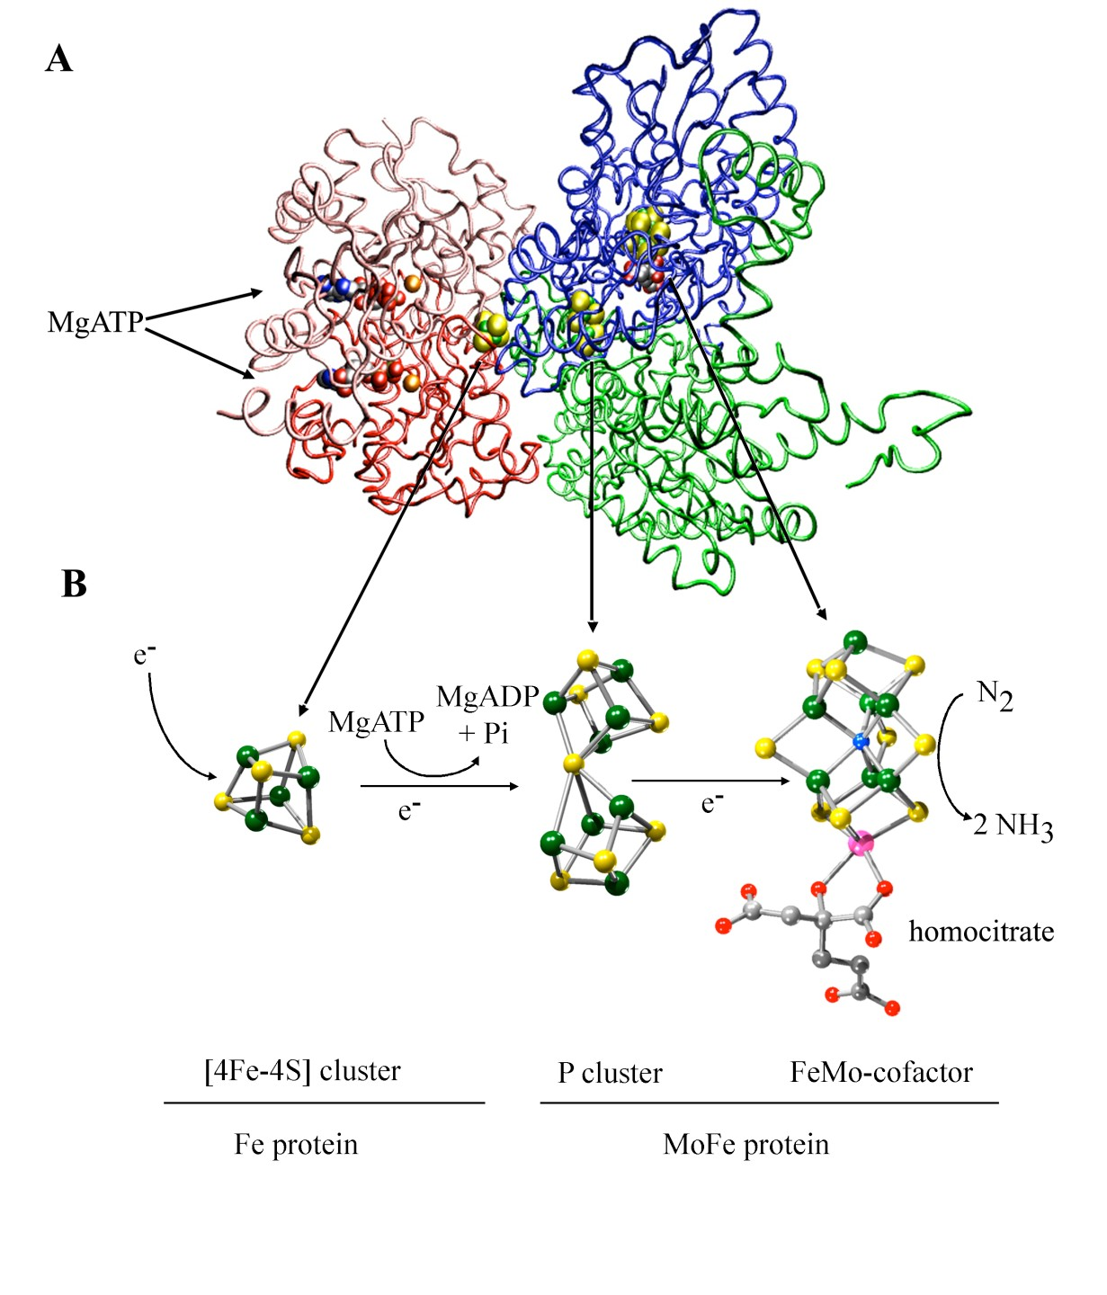Figure 1- Nitrogenase component proteins and their associated metal clusters. A- Fe protein is shown on the left (identical subunits in pink and red) and one catalytic αβ- dimer of the MoFe protein is shown on the right (α-subunit in blue and β-subunit in green). The associated metal clusters and MgATP located within the nitrogenase complex are shown as space filling models. Note that the nitrogenase complex structure was
solved in presence of MgADP-AlF4-, which is analogous to MgATP binding. B- The

structures of nitrogenase metal clusters are shown in ball-and-stick models. The direction of electron flow and the associated reactions are indicated by arrows. Electrons flow in an ATP-dependent reaction from the [4Fe-4S] cluster of Fe-protein to the P-cluster and FeMo-cofactor of the MoFe protein where the reduction of N2 to ammonia occurs. Figures were generated in VMD (Humphrey et al., 1996)(A) and SWISS PDB VIEWER (Guex & Peitsch, 1997)/POVRAY (B) using 1N2C and 1M1N PDB coordinates. Atom colors: carbon in gray, nitrogen in blue, oxygen in red, phosphorus in dark green, sulfur in yellow, magnesium in orange, iron in green and molybdenum in pink.

the protein have not been clearly defined so far. The reader is referred to comprehensive reviews on the structure and catalytic mechanism of nitrogenase (Burgess, 1985; Burgess
& Lowe, 1996; Christiansen et al., 2001; Howard & Rees, 1996; Mayer et al., 2002a; Rees & Howard, 2000).

2.2 - The Nitrogenase Associated Metalloclusters

The metalloclusters contained within the Mo-dependent nitrogenase include a typical [4Fe-4S] cluster bridged between the identical subunits of the Fe protein, and two novel clusters contained within the MoFe protein, designated the P cluster and FeMo- cofactor. Electron transfer is believed to proceed from the Fe protein [4Fe-4S] cluster, to the P cluster, and then to FeMo-cofactor, which provides the substrate reduction site (Figure 1). Isolated MoFe protein is an α2β2 tetramer but individually paired αβ units are usually considered as separate catalytic entities, and each of these contains one P cluster and one FeMo-cofactor. The P cluster is located at the pseudosymmetric αβ interface and is positioned near the surface that interacts with the Fe protein during complex formation. In the as isolated, “reduced” form of the MoFe protein, the [8Fe-7S] P cluster
(referred to as PN in this state) comprises two fused [4Fe-4S] subclusters that share a µ6-

sulfide. These subclusters are further linked, and are connected to the MoFe protein subunits, by two µ2-cysteinate bridges, one each provided by an individual α- and β- subunit. There are four other typical cysteinate ligands, two provided by each subunit, that also attach the P cluster to the MoFe protein. Upon treatment of the as-isolated MoFe protein with chemical oxidants, the P cluster rearranges to give an open, asymmetrical structure – referred to as POX - that has alterations in amino acid coordination including an oxygen- and a nitrogen-ligand, respectively provided by a serine side-chain alkoxide and a backbone cysteine amide (Mayer et al., 1999; Peters et al., 1997). The POX form of the P cluster is oxidized by two electrons with respect to the
PN state. Although there is good evidence that the P cluster undergoes changes in redox

state during turnover (Chan et al., 1999), it is not yet known whether or not POX represents a catalytically relevant state. Nevertheless, such significant redox-dependent rearrangements highlight the plasticity of [Fe-S] clusters, even when they are anchored

within a polypeptide matrix, a feature that is relevant to structural rearrangements that are likely to occur during complex metallocluster assembly.

Like the P cluster, FeMo-cofactor has an unusual structure not recognized so far in other biological systems. The metal-sulfur core of FeMo-cofactor is constructed from [4Fe-3S] and [3Fe-Mo-3S] substructures linked by three µ2 sulfide bridges (Figures 1 and
2). A recent high-resolution crystal structure of the MoFe protein revealed that the central cavity of FeMo-cofactor, previously thought to be unoccupied, contains an interstitial atom, presumably µ6, whose identity is not yet known (Einsle et al., 2002). In addition to its metal-sulfur core FeMo-cofactor contains an organic constituent, homocitrate, which is attached to the Mo atom through its 2-hydroxy and 2-carboxyl groups. FeMo-cofactor is covalently attached to the MoFe protein through a cysteinate
ligand (provided by α-Cys275) to an Fe atom at one end and by a side-chain nitrogen atom

(provided by α-His442) to the Mo atom, located at the opposite end (Figure 2)*. In addition to covalent ligands, FeMo-cofactor is tightly held within the MoFe protein through a variety of direct and water-bridged hydrogen bonds.

There is compelling genetic and biochemical evidence that FeMo-cofactor provides the substrate reduction site. First, certain mutant strains unable to synthesize FeMo-cofactor produce an “apo” MoFe protein** that contains a normal complement of P clusters but does not contain FeMo-cofactor (Christiansen et al., 1998; Shah & Brill,
1977). Such apo-MoFe proteins can be activated by the addition of FeMo-cofactor extracted from the intact MoFe protein by using a chaotropic solvent such as N- methylformamide. Second, FeMo-cofactor produced in a mutant strain defective in the
gene required for homocitrate biosynthesis contains citrate rather than homocitrate

* The numbering of amino acids in this article corresponds to positions within the relevant proteins from A. vinelandii.
** The term "apo-MoFe protein" has historically been used to designate MoFe proteins produced
by nifE, nifN, nifB, or nifH mutants that do not contain FeMo-cofactor. However, the term "apo" is a misnomer because these proteins still retain some form of P cluster. It has previously been shown that the properties of apo-MoFe proteins produced by nifE, nifN, or nifB mutants are not the same as the properties of apo-MoFe protein produced by a nifH mutant. In this review, apo- MoFe protein refers to the form produced by a nifB-deficient strain and the form produced by a nifH-deficient strain is designated ΔnifH-apo-MoFe protein

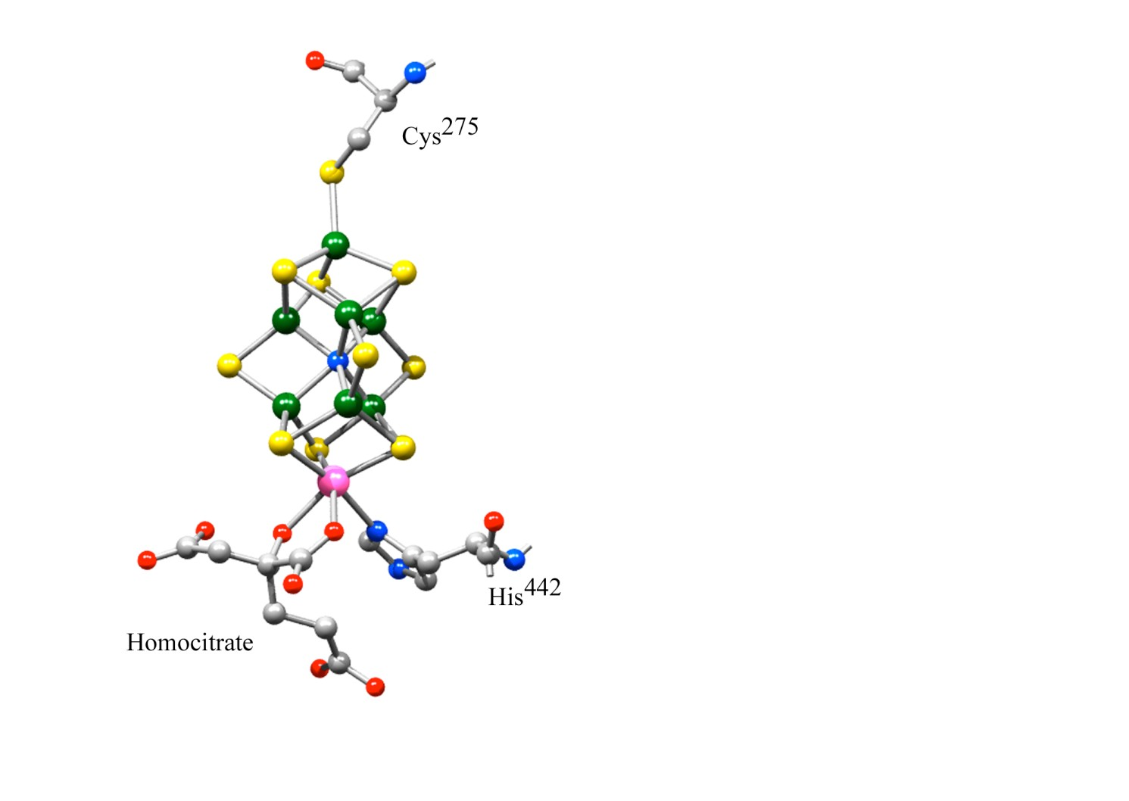

Figure 2- FeMo-cofactor and α-subunit ligands. FeMo-cofactor is attached to MoFe protein by α-Cys275 and α-His442. This figure was generated in SWISS PDB VIEWER (Guex & Peitsch, 1997)/POVRAY using 1M1N PDB coordinates. Atoms colors: carbon in gray, nitrogen in blue, oxygen in red, sulfur in yellow, iron in green and molybdenum in pink.

(Liang et al., 1990; Mayer et al., 2002c). This form of the MoFe protein has altered catalytic activities, for example, it remains capable of relatively efficient proton reduction, but is not capable of efficient dinitrogen reduction (McLean et al., 1983). If citrate-substituted FeMo-cofactor is used to activate apo-MoFe protein, then the reconstituted protein is also capable of efficient proton reduction but reduces dinitrogen very poorly (Hawkes et al., 1984). Third, certain mutant strains having substitutions for those amino acids providing the first shell of non-covalent interactions with the FeMo- cofactor, exhibit dramatic alterations in substrate reduction (Mayer et al., 2002b; Scott et
al., 1990). One recent example is substitution of the α- Gly69 residue by Ser, which

results in an altered MoFe protein that retains an ability to effectively reduce dinitrogen but is severely altered in its ability to reduce the alternative substrate acetylene (Christiansen et al., 2000a; Christiansen et al., 2000b). Moreover, substitution of the MoFe protein α-Val70 residue by Ala or Gly expands the ability of nitrogenase to reduce
small chain alkynes, propyne and butyne, which are not effectively reduced by the wild type enzyme (Mayer et al., 2002a). Thus, not only is it proven that FeMo-cofactor provides the substrate reduction site, but the available evidence now points to initial substrate binding, at least, occurring at a specific location within FeMo-cofactor.

The recent identification of an atom within the central Fe-S cage of FeMo- cofactor has led to speculation that this atom is a mechanistically relevant monoatomic nitrogen atom (nitride) that might become inserted into the metal-sulfur cage as an initial step in the activation of dinitrogen. Although the central atom could well be a nitride, and there are now theoretical calculations that support this possibility (Dance, 2003; Hinnemann & Norskov, 2003), it is very unlikely that it becomes inserted within the inner core as a consequence of MoFe protein dependent dinitrogen reduction. One reason for this is that FeMo-cofactor is separately synthesized and then inserted into the apo- MoFe protein (Ugalde et al., 1984). Namely, FeMo-cofactor can be synthesized in mutant strains that produce no MoFe protein (Robinson et al., 1986). Also, there are a number of mutant strains that are completely defective in their ability to reduce dinitrogen due to a defective Fe protein, for example a nifM deletion strain (Jacobson et al., 1989b), yet these mutant strains produce a fully active MoFe protein that contains a

complete complement of FeMo-cofactor. Thus, if insertion of the interstitial atom requires nitrogenase catalysis it would not seem possible that intact FeMo-cofactor could be assembled in mutants incapable of catalysis. Finally, arguments that the occurrence of six coordinately unsaturated Fe atoms present in the original FeMo-cofactor structure do not make chemical sense (Lee & Holm, 2003), would also apply to the structure of any precursor molecule. Even if the central atom is a nitride, recent spectroscopic experiments have demonstrated that it is not exchangeable by substrate nitrogen as the enzyme turns over (Lee et al., 2003). Thus, there are three important questions with respect to the central atom within FeMo-cofactor that remain to be answered – what is it, how does it get there, and what does it do?

