Found Object sculpture
Found object sculpture is basically about observation the things whether ordinary or extra ordinary which we didn’t notice in our daily routine . So in this assignment I try to open the mind of the students to find those things which sudden fascinate you and make a sculpture of it it can be any thing . And tell us why you choose this object , what you see in it how you display where you display.’
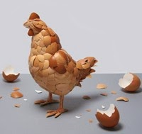
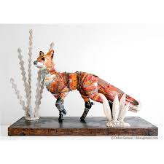
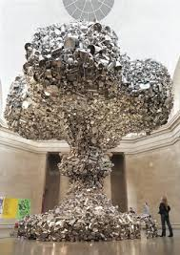
A very famous sculpture by Indian artist Subudh Gupta

