Cell Signaling
In order to respond to changes in their immediate environment, cells must be able to receive and process signals that originate outside their borders. Individual cells often receive many signals simultaneously, and they then integrate the information they receive into a unified action plan. Cells typically receive signals in chemical form via various signaling molecules. When a signaling molecule joins with an appropriate receptor on a cell surface, this binding triggers a chain of events that not only carries the signal to the cell interior, but amplifies it as well. Cells can also send signaling molecules to other cells. Some of these chemical signals, including neurotransmitters, travel only a short distance, but others go much farther to reach their targets.

Kind of Signals that Cells receive
Most cell signals are chemical in nature. For example, prokaryotic organisms have sensors that detect nutrients and help them navigate toward food sources. In multicellular organisms, growth factors, hormones, neurotransmitters, and extracellular matrix components are some of the many types of chemical signals cells use. These substances can exert their effects locally, or they might travel over long distances. For instance, neurotransmitters are a class of short-range signaling molecules that travel across the tiny spaces between adjacent neurons or between neurons and muscle cells. Other signaling molecules must move much farther to reach their targets. One example is follicle-stimulating hormone, which travels from the mammalian brain to the ovary, where it triggers egg release.
Some cells also respond to mechanical stimuli. For example, sensory cells in the skin respond to the pressure of touch, whereas similar cells in the ear react to the movement of sound waves. In addition, specialized cells in the human vascular system detect changes in blood pressure — information that the body uses to maintain a consistent cardiac load.

How Do Cells Recognize Signals?
Cells have proteins called receptors that bind to signaling molecules and initiate a physiological response. Different receptors are specific for different molecules. Dopamine receptors bind dopamine, insulin receptors bind insulin, nerve growth factor receptors bind nerve growth factor, and so on. In fact, there are hundreds of receptor types found in cells, and varying cell types have different populations of receptors. Receptors can also respond directly to light or pressure, which makes cells sensitive to events in the atmosphere.
Receptors are generally transmembrane proteins, which bind to signaling molecules outside the cell and subsequently transmit the signal through a sequence of molecular switches to internal signaling pathways. Membrane receptors fall into three major classes: G-protein-coupled receptors, ion channel receptors, and enzyme-linked receptors. The names of these receptor classes refer to the mechanism by which the receptors transform external signals into internal ones — via protein action, ion channel opening, or enzyme activation, respectively. Because membrane receptors interact with both extracellular signals and molecules within the cell, they permit signaling molecules to affect cell function without actually entering the cell. This is important because most signaling molecules are either too big or too charged to cross a cell's plasma membrane (Figure 1).
Not all receptors exist on the exterior of the cell. Some exist deep inside the cell, or even in the nucleus. These receptors typically bind to molecules that can pass through the plasma membrane, such as gases like nitrous oxide and steroid hormones like estrogen.
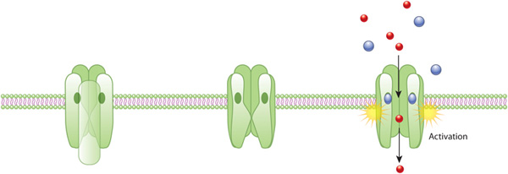
Figure 1: An example of ion channel activation
An acetylcholine receptor (green) forms a gated ion channel in the plasma membrane. This receptor is a membrane protein with an aqueous pore, meaning it allows soluble materials to travel across the plasma membrane when open. When no external signal is present, the pore is closed (center). When acetylcholine molecules (blue) bind to receptor, this triggers a conformational change that opens the aqueous pore and allows ions (red) to flow into cell.

How Do Cells Respond to Signals?
Once a receptor protein receives a signal, it undergoes a conformational change, which in turn launches a series of biochemical reactions within the cell. These intracellular signaling pathways, also called signal transduction cascades, typically amplify the message, producing multiple intracellular signals for every one receptor that is bound.
Activation of receptors can trigger the synthesis of small molecules called second messengers, which initiate and coordinate intracellular signaling pathways. For example, cyclic AMP (cAMP) is a common second messenger involved in signal transduction cascades (In fact, it was the first second messenger ever discovered). cAMP is synthesized from ATP by the enzyme adenylyl cyclase, which resides in the cell membrane. The activation of adenylyl cyclase can result in the manufacture of hundreds or even thousands of cAMP molecules. These cAMP molecules activate the enzyme, protein kinase A (PKA), which phosphorylates multiple protein substrates by attaching phosphate groups to them. Each step in the cascade further amplifies the initial signal, and the phosphorylation reactions mediate both short- and long-term responses in the cell (Figure 2). The cAMP stop signaling after it is degraded by the enzyme phosphodiesterase.
Other examples of second messengers include diacylglycerol (DAG) and inositol 1,4,5-triphosphate (IP3), which are both produced by the enzyme phospholipase, also a membrane protein. IP3 causes the release of Ca²⁺ — yet another second messenger — from intracellular stores. Together, DAG and Ca²⁺ activate another enzyme called protein kinase C (PKC).
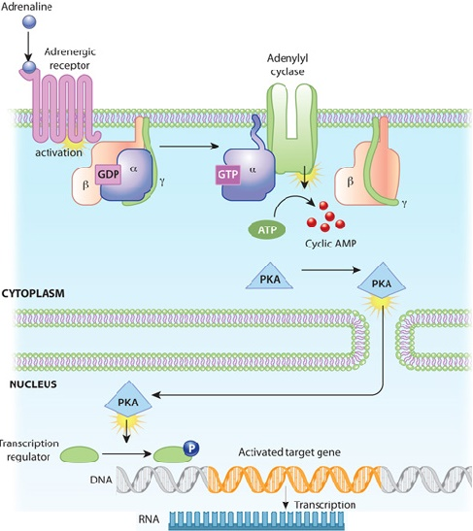
Figure 2: An example of a signal transduction cascade involving cyclic AMP
The binding of adrenaline to an adrenergic receptor initiates a cascade of reactions inside the cell. The signal transduction cascade begins when adenylyl cyclase, a membrane- bound enzyme, is activated by G-protein molecules associated with the adrenergic receptor. Adenylyl cyclase creates multiple cyclic AMP molecules, which fan out and activate protein kinases (PKA, in this example). Protein kinases can enter the nucleus and affect transcription.

How Do Signals Affect Cell Function?
Protein kinases such as PKA and PKC catalyze the transfer of phosphate groups from ATP molecules to protein molecules. Within proteins, Serine, Threonine, and Tyrosine are especially common sites for phosphorylation. These phosphorylation reactions control the activity of many enzymes involved in intracellular signaling pathways. Specifically, the addition of phosphate groups causes a conformational change in the enzymes, which can either activate or inhibit the enzyme activity. Then, when appropriate, protein phosphatases remove the phosphate groups from the enzymes, thereby reversing the effect on enzymatic activity. Phosphorylation allows for intricate control of protein function. Phosphate groups can be added to multiple sites in a single protein, and a single protein may in turn be the substrate for multiple kinases and phosphatases.
At any one time, a cell is receiving and responding to numerous signals, and multiple signal transduction pathways are operating in its cytoplasm. Many points of intersection exist among these pathways. For instance, a single second messenger or protein kinase might play a role in more than one pathway. Through this network of signaling pathways, the cell is constantly integrating all the information it receives from its external environment.

G-protein-coupled receptors (GPCRs) are the largest and most diverse group of membrane receptors in eukaryotes that play many different roles in eukaryotic cell signaling. These cell surface receptors act like an inbox for messages in the form of light energy, peptides, lipids, sugars, and proteins. Such messages inform cells about the presence or absence of life-sustaining light or nutrients in their environment, or they convey information sent by other cells. GPCRs play a role in an incredible array of functions in the human body, and increased understanding of these receptors has greatly affected modern medicine. In fact, researchers estimate that between one-third and one-half of all marketed drugs act by binding to GPCRs.

What Do GPCRs Look Like?
GPCRs bind a tremendous variety of signaling molecules, yet they share a common architecture that has been conserved over the course of evolution. Many present-day eukaryotes — including animals, plants, fungi, and protozoa — rely on these receptors to receive information from their environment. For example, simple eukaryotes such as yeast have GPCRs that sense glucose and mating factors. Not surprisingly, GPCRs are involved in considerably more functions in multicellular organisms. Humans alone have nearly 1,000 different GPCRs, and each one is highly specific to a particular signal.
GPCRs consist of a single polypeptide that is folded into a globular shape and embedded in a cell's plasma membrane. Seven segments of this molecule span the entire width of the membrane — explaining why GPCRs are sometimes called seven-transmembrane receptors — and the intervening portions loop both inside and outside the cell. The extracellular loops form part of the pockets at which signaling molecules bind to the GPCR.

What Do GPCRs Do?
As their name implies, GPCRs interact with G proteins in the plasma membrane. When an external signaling molecule binds to a GPCR, it causes a conformational change in the GPCR. This change then triggers the interaction between the GPCR and a nearby G protein.
G proteins are specialized proteins with the ability to bind the nucleotides guanosine triphosphate (GTP) and guanosine diphosphate (GDP). Some G proteins, such as the signaling protein Ras, are small proteins with a single subunit. However, the G proteins that associate with GPCRs are heterotrimeric, meaning they have three different subunits: an alpha subunit, a beta subunit, and a gamma subunit. Two of these subunits — alpha and gamma — are attached to the plasma membrane by lipid anchors (Figure 1).
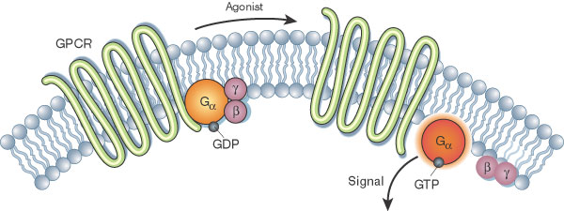
Figure: Activation of the G alpha subunit of a G-protein-coupled receptor
In unstimulated cells, the state of G alpha (orange circles) is defined by its interaction with GDP, G beta-gamma (purple circles), and a G-protein-coupled receptor (GPCR; light green loops). Upon receptor stimulation by a ligand called an agonist, the state of the receptor changes. G alpha dissociates from the receptor and G beta-gamma, and GTP is exchanged for the bound GDP, which leads to G alpha activation. G alpha then goes on to activate other molecules in the cell.
A G protein alpha subunit binds either GTP or GDP depending on whether the protein is active (GTP) or inactive (GDP). In the absence of a signal, GDP attaches to the alpha subunit, and the entire G protein-GDP complex binds to a nearby GPCR. This arrangement persists until a signaling molecule joins with the GPCR. At this point, a change in the conformation of the GPCR activates the G protein, and GTP physically replaces the GDP bound to the alpha subunit. As a result, the G protein subunits dissociate into two parts: the GTP-bound alpha subunit and a beta-gamma dimer. Both parts remain anchored to the plasma membrane, but they are no longer bound to the GPCR, so they can now diffuse laterally to interact with other membrane proteins. G proteins remain active as long as their alpha subunits are joined with GTP. However, when this GTP is hydrolyzed back to GDP, the subunits assume the form of an inactive heterotrimer again, and the entire G protein reassociates with the now-inactive GPCR. In this way, G proteins work like a switch — turned on or off by signal-receptor interactions on the cell's surface.
Whenever a G protein is active, both its GTP-bound α subunit and its β-γ dimer can relay messages in the cell by interacting with other membrane proteins involved in signal transduction. Specific targets for activated G proteins include various enzymes that produce second messengers, as well as certain ion channels that allow ions to act as second messengers. Some G proteins stimulate the activity of these targets, whereas others are inhibitory. Vertebrate genomes contain multiple genes that encode the alpha, beta, and gamma subunits of G proteins. Many different subunits encoded by these genes combine in multiple ways to produce a diverse family of G proteins.
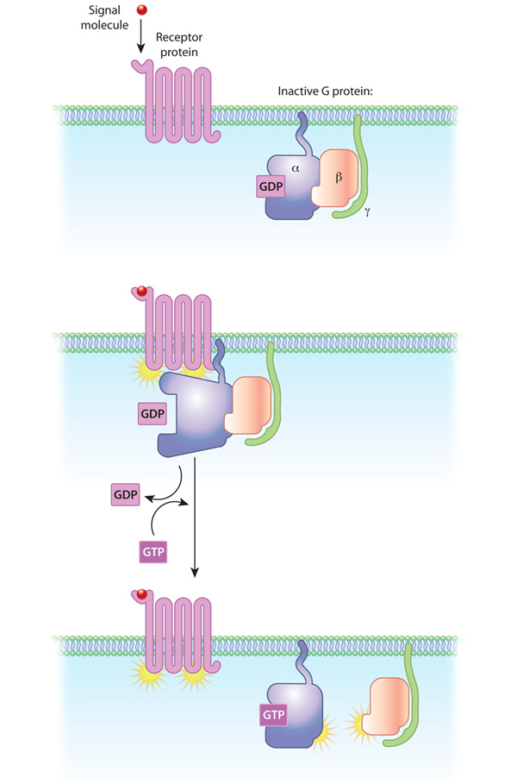
Figure 2: The relationships of G proteins to the plasma membrane
In this diagram of G-protein-coupled receptor activation, the alpha, beta, and gamma subunits are shown with distinct relationships to the plasma membrane. After exchange of GDP with GTP on the alpha subunit, both the alpha subunit and the beta-gamma complex may interact with other molecules to promote signaling cascades. Note that both the alpha subunit and the beta-gamma complex remain tethered to the plasma membrane while they are activated. These activated subunits can act on ion channels in the cell membrane, as well as cellular enzymes and second messenger molecules that travel around the cell.
© 2010 Nature Education All rights reserved.
Figure Detail

What Second Messengers Do GPCR Signals Trigger in Cells?
Activation of a single G protein can affect the production of hundreds or even thousands of second messenger molecules (Figure 3). (Recall that second messengers — such as cyclic AMP [cAMP], diacylglycerol [DAG], and inositol 1, 4, 5-triphosphate [IP3] — are small molecules that initiate and coordinate intracellular signaling pathways.) One especially common target of activated G proteins is adenylyl cyclase, a membrane-associated enzyme that, when activated by the GTP-bound alpha subunit, catalyzes synthesis of the second messenger cAMP from molecules of ATP. In humans, cAMP is involved in responses to sensory input, hormones, and nerve transmission, among others.
Phospholipase C is another common target of activated G proteins. This membrane-associated enzyme catalyzes the synthesis of not one, but two second messengers — DAG and IP3 — from the membrane lipid phosphatidyl inositol. This particular pathway is critical to a wide variety of human bodily processes. For instance, thrombin receptors in platelets use this pathway to promote blood clotting.
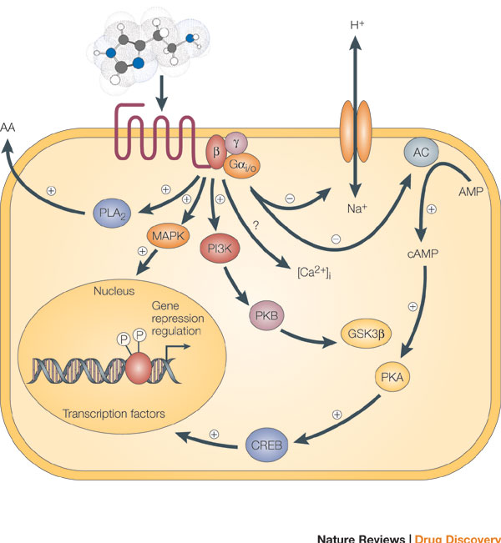
Figure 3: Signaling cascades within a cell can interact to affect multiple molecules in the cell, leading to secretion of substances from the cell, ion channel opening, and transcription.
Binding of an agonist to the seven-transmembrane G-protein-coupled receptor in the plasma membrane activates a pathway that involves G proteins as well as cAMP-related pathways that modulate cellular signaling. In this example, the activated G alpha (Gαi/0) proteins inhibit (-) adenylyl cyclase (AC, on the right), the enzyme that induces formation of cAMP, which in turn results in the activation of protein kinase A (PKA). This in turn activates a molecule called cAMP-responsive element-binding protein (CREB), which modulates gene transcription. The activated G alpha proteins can also have a variety of other effects, shown at the left. These effects include activating the mitogen-activated protein kinase (MAPK) and phosphatidylinositol 3-kinase (PI3K) pathways. Activation of the enzyme phospholipase A2 (PLA2) may also occur, which induces the release of arachidonic acid (AA), as well as inhibition of the Na+/H+ exchanger in the plasma membrane, and the lowering of intracellular Ca2+ levels (exact mechanism unknown, ?). Subsequent activation of the MAPK and PI3K pathways results in the phosphorylation of extracellular signal-regulated kinases (ERKs) and protein kinase B (PKB), respectively. Activated PKB will subsequently phosphorylate and thereby inhibit the action of glycogen synthase kinase 3beta (GSK3beta), a major kinase in the brain.
© 2005 Nature Publishing Group Leurs, R. et al. The histamine H3 receptor: from gene cloning to H3 receptor drugs. Nature Reviews Drug Discovery 4, 107-120 (2005). All rights reserved.
Figure Detail

Conclusion
GPCRs are a large family of cell surface receptors that respond to a variety of external signals. Binding of a signaling molecule to a GPCR results in G protein activation, which in turn triggers the production of any number of second messengers. Through this sequence of events, GPCRs help regulate an incredible range of bodily functions, from sensation to growth to hormone responses.

4.3 Ion Channel Receptors Generate Electrical Signals in Response to Chemical Signals
PREV PAGE
NEXT PAGE
Certain cells, commonly called excitable cells, are unique because of their ability to generate electrical signals. Although several types of excitable cells exist — including neurons, muscle cells, and touch receptor cells — all of them use ion channel receptors to convert chemical or mechanical messages into electrical signals.
Like all cells, an excitable cell maintains a different concentration of ions in its cytoplasm than exists in its extracellular environment. Together, these concentration differences create a small electrical potential across the plasma membrane. Then, when conditions are right, specialized channels in the plasma membrane open and allow rapid ion movement into or out of the cell, and this movement creates an electrical signal. But what do these channels look like, and how do they function? Also, how do the electrical signals generated by excitable cells differ from the other types of signals involved in cellular communication?

What Are Ion Channel Receptors?
Ion channel receptors are usually multimeric proteins located in the plasma membrane. Each of these proteins arranges itself so that it forms a passageway or pore extending from one side of the membrane to the other. These passageways, or ion channels, have the ability to open and close in response to chemical or mechanical signals. When an ion channel is open, ions move into or out of the cell in single-file fashion. Individual ion channels are specific to particular ions, meaning that they usually allow only a single type of ion to pass through them. Both the amino acids that line a channel and the physical width of the channel determine which ions are able to wiggle through from the cell exterior to its interior, and vice versa. The opening of an ion channel is a fleeting event. Within a few milliseconds of opening, most ion channels close and enter a resting state, where they are unresponsive to signals for a short period of time (Figure 1).
Figure 1: An example of ion channel receptor activation
An acetylcholine receptor (green) forms a gated ion channel in the plasma membrane. This receptor is a membrane protein with an aqueous pore, meaning it allows soluble materials to travel across the plasma membrane when open. When no external signal is present, the pore is closed (center). When acetylcholine molecules (blue) bind to the receptor, this triggers a conformational change that opens the aqueous pore and allows ions (red) to flow into the cell.
© 2010 Nature Education All rights reserved.

How Are Electrical Signals Propagated?
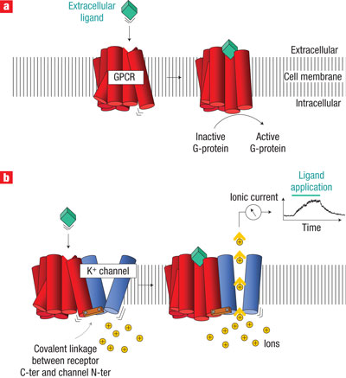
Figure 2: Comparing the activation of an ion channel receptor with that of a G-protein-coupled receptor
Activation of both a G-protein-coupled receptor (a) and an ion channel receptor (b) cause a conformational change in the receptor protein. G protein activation can lead to multiple intracellular events through a variety of intracellular proteins, and this signaling can take seconds to minutes. When a G protein activates transcription, this can take up to 20 minutes. In contrast, ion channel receptors open pores in the cell membrane, causing the formation of electrical current. This receptor activation therefore causes a much faster response within the cell, on the order of milliseconds.
© 2008 Nature Publishing Group Moreau, C. J. et al. Coupling ion channels to receptors for biomolecule sensing. Nature Nanotechnology3, 620-625 (2008) doi:10.1038/nnano.2008.242. All rights reserved.
Figure Detail
The opening of ion channels alters the charge distribution across the plasma membrane. Recall that the ionic composition of the cytoplasm is quite different from that of the extracellular environment. For instance, the concentration of sodium ions in the cytoplasm is far lower than that in the cell's exterior environment. Conversely, potassium ions exist at higher concentrations within a cell than outside it. Such differences create a so-called electrochemical gradient, which is a combination of a chemical gradient and a chargegradient. The opening of ion channels permits the ions on either side of the plasma membrane to flow down this dual gradient. The exact direction of flow varies by ion type, and it depends on both the concentration difference and the voltage difference for each variety of ion. This ion flow results in the production of an electrical signal. The actual number of ions required to change the voltage across the membrane is quite small. During the short times that an ion channel is open, the concentration of a particular ion in the cytoplasm as a whole does not change significantly, only the concentration in the immediate vicinity of the channel. In excitable cells, the electrical signal initiated by ion channel receptor activity travels rapidly over the surface of the cell due to the opening of other ion channels that are sensitive to the voltage change caused by the initial channel opening.
Electrical signals travel much more rapidly than chemical signals, which depend on the process of molecular diffusion. As a consequence, excitable cells respond to signals much more rapidly than cells that rely solely on chemical signals (Figure 2). In fact, an electrical signal can traverse the entire length of a human nerve cell — a distance of as much as one meter — within only milliseconds.

How Do Different Types of Excitable Cells Work?
Neurons, muscle cells, and touch receptor cells are all excitable cells — which means they all have the capacity to transmit electrical signals. Each of these cells also has ion channel receptors clustered on a particular part of its surface. For example, the receptors that respond to chemical signals are generally located at synapses — or points of near contact between adjacent cells.
Of the various types of excitable cells that respond to chemical signals, neurons are perhaps the most familiar. When electrical signals reach the end of neurons, they trigger the release of chemical messengers called neurotransmitters. Each neurotransmitter then diffuses from its point of release on one side of the synapse to the cell on the other side of the synapse. If the neurotransmitter binds to an ion channel receptor on the target cell, the related ion channel opens, and an electrical signal propagates itself along the length of the target cell.
Neurons have ion channel receptors specific to many kinds of neurotransmitters. Some of these neurotransmitters act in an excitatory capacity, bringing their target cells ever closer to signal propagation. Other neurotransmitters exert an inhibitory effect, counteracting any excitatory input and lessening the chance that the target cell will fire.
Skeletal muscle cells also rely on chemical signals in order to generate electrical signals. These cells have synapses that are packed with receptors for acetylcholine, which is the primary neurotransmitter released by motor neurons. When acetylcholine binds to the receptors on a skeletal muscle cell, ion channels in that cell open, and this launches a sequence of events that results in contraction of the cell.
In contrast to neurons and skeletal muscle cells, some excitable cells have ion channels that open in response to mechanical stimuli rather than chemical signals. These include the hair cells of the mammalian inner ear and the touch receptor cells of both human finger pads and Venus fly traps. Cells that respond to touch have their ion channel receptors clustered at the position where contact usually occurs.

Conclusion
Excitable cells, such as fast-acting neurons and muscle cells, have specialized channels that open in response to a signal and permit rapid ion movement across the cell membrane. The opening of just a single ion channel alters the electrical charge on both sides of the membrane. The resulting charge differential then causes adjacent voltage-sensitive channels to open in chain-reaction fashion, creating a self-propagating electrical signal that travels down the entire length of the cell. Sometimes, this sequence of events is triggered when a chemical signal — such as a neurotransmitter — binds to an ion channel receptor on cell's surface. Other times, a cell's ion channels open in response to mechanical (rather than chemical) stimuli.

4.4 Receptor Tyrosine Kinases Regulate Cell Growth, Differentiation, and Survival
PREV PAGE
NEXT PAGE
Although all cell membrane receptors receive and transmit signals from the environment, some of these receptors also double as enzymes. In such cases, the binding of a signaling molecule to the membrane receptor activates the receptor's inherent enzymatic activity. Of the various receptors that exhibit this capability, receptor tyrosine kinases (RTKs) make up the largest class. These cell surface receptors bind and respond to growth factors and other locally released proteins that are present at low concentrations. RTKs play important roles in the regulation of cell growth, differentiation, and survival.
When signaling molecules bind to RTKs, they cause neighboring RTKs to associate with each other, forming cross-linked dimers. Cross-linking activates the tyrosine kinase activity in these RTKs through phosphorylation — specifically, each RTK in the dimer phosphorylates multiple tyrosines on the other RTK. This process is called cross-phosphorylation.

What Do RTKs Look Like?
Once cross-phosphorylated, the cytoplasmic tails of RTKs serve as docking platforms for various intracellular proteins involved in signal transduction. These proteins have a particular domain — called SH2 — that binds to phosphorylated tyrosines in the cytoplasmic RTK receptor tails. More than one SH2-containing protein can bind at the same time to an activated RTK, allowing simultaneous activation of multiple intracellular signaling pathways. Ultimately, RTK activation brings about changes in gene transcription. Signaling becomes complex as signals travel from the membrane to the nucleus, due to crosstalk between intermediates in various signaling pathways in the cell (Figure 1).
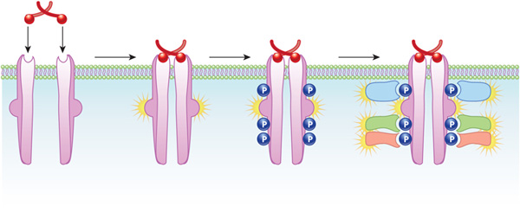
Figure 1: RTK activation involves the joining together and phosphorylation of proteins.
On the left, an unactivated RTK receptor (pink) encounters a ligand (red). Upon binding, the receptor forms a complex of proteins that phosphorylate each other. In turn, this phosphorylation affects other proteins in the cell that change gene transcription (not shown).
© 2010 Nature Education All rights reserved.
Figure Detail
One of the most common intracellular signaling pathways triggered by RTKs is known as the mitogen-activated protein (MAP) kinase cascade, because it involves three serine-threonine kinases. The pathway starts with the activation of Ras, a small G protein anchored to the plasma membrane. In its inactive state, Ras is bound to GDP. However, when SH2-containing proteins join with activated RTKs, they cause Ras to bind GTP in place of GDP and become active. Next, the GTP-bound Ras (which is not itself a kinase) activates the first serine-threonine kinase in the MAP kinase cascade. Each of the three kinases in this cascade then activates the next by phosphorylating it. Because all three kinases in this pathway phosphorylate multiple substrates, the initial signal is amplified at each step. Then, the final enzyme in the pathway phosphorylates transcription regulators, leading to a change in gene transcription (Figure 2). Many growth factors, including nerve growth factor and platelet-derived growth factor, use this pathway.
Not all RTKs use the MAP kinase cascade to send information to the nucleus. For example, insulin-like growth factor receptors activate the enzyme phosphoinositide 3-kinase, which phosphorylates inositol phospholipids in the cell membrane, leading in turn to a protein kinase cascade (distinct from the MAP kinase cascade) that relays the signal to the nucleus. Other RTKs use a more direct route to the nucleus. Transcriptional regulators known as STAT proteins, an acronym for signal transducers and activators of transcription, bind to the phosphorylated tyrosines in the receptors for cytokines and some hormones. Once activated, STAT proteins move directly into the nucleus, causing changes in transcription.
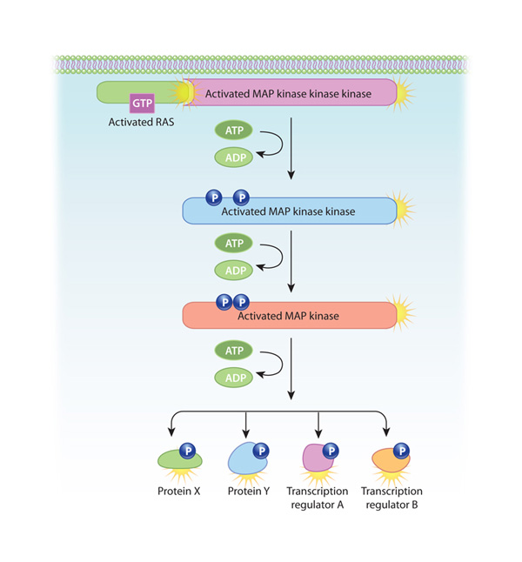
Figure 2: Ras MAP kinase activation: A common pathway activated by growth factors
RTKs can activate Ras, a protein that is tethered to the plasma membrane, by causing it to bind GTP. Once activated, Ras can do a variety of things. In this example, it activates an enzymatic cascade of MAP kinases. This results in potent changes in the cell, such as the alteration of key proteins and changes in gene transcription.
© 2010 Nature Education All rights reserved.
Figure Detail

How Do RTK Signals Regulate Cells?
Cells possess many different RTKs that bind to a diverse set of extracellular signaling molecules, many of which are locally produced and present in low concentrations. These local cell-to-cell interactions are important for developing and maintaining the spatial orientation of tissues, which is crucial for higher-level functioning.
Growth factors and hormones are two especially important categories of signaling molecules that bind to RTKs. These molecules direct cell differentiation by determining patterns of gene transcription. Extracellular matrix proteins and certain surface proteins on neighboring cells can also bind to and activate RTKs. For example, upon binding to RTKs, surface proteins called ephrins help guide developmental processes involved in tissue architecture, final placement of nerve endings, and blood vessel maturation.
When RTKs don't function properly, cell growth and differentiation go awry. For instance, many cancers appear to involve mutations in RTKs. For this reason, RTKs are the targets of various drugs used in cancer chemotherapy. For example, the breast cancer drug Herceptin is an antibody that binds to and inhibits ErbB-2 — an RTK that is overexpressed in many metastatic breast cancers.

Conclusion
RTKs are transmembrane protein receptors that help cells interact with their neighbors in a tissue. RTKs differ from other cell surface receptors in that they contain intrinsic enzyme activity. In particular, the binding of a signaling molecule with an RTK activates tyrosine kinase in the cytoplasmic tail of the receptor. This activity then launches a series of enzymatic reactions that carry the signal to the nucleus, where it alters patterns of protein transcription.

4.5 Cells Sense the Presence of Other Cells and Their Environment
All cells rely on cell signaling to detect and respond to cues in their environment. This process not only promotes the proper functioning of individual cells, but it also allows communication and coordination among groups of cells — including the cells that make up organized communities called tissues. Because of cell signaling, tissues have the ability to carry out tasks no single cell could accomplish on its own.
Different types of tissues, such as bone, brain, and the lining of the gut, have characteristic features related to the number and types of cells they contain. Cell spacing is also critical to tissue function, so this geometry is precisely regulated. To preserve proper tissue architecture, adhesive molecules help maintain contact between nearby cells and structures, and tiny tunnel-like junctions allow the passage of ions and small molecules between adjacent cells. Meanwhile, signaling molecules relay positional information among the cells in a tissue, as well as between these cells and the extracellular matrix. These signaling pathways are critical to maintaining the state of equilibrium known as homeostasis within a tissue. For example, the processes involved in wound healing depend on positional information in order for normal tissue architecture to be restored. Such positional signals are also crucial for the development of adult structures in multicellular organisms. As tissues develop, clumps of unorganized cells grow and sort themselves according to signals they send and receive.

How Do Integrins Promote Tissue Structure and Function?
Within tissues, adhesive molecules allow cells to maintain contact with one another and with structures in the extracellular matrix. One especially important class of adhesive molecules is the integrins. Integrins are more than just mechanical links, however: They also relay signals both to and from cells. In this way, integrins play an important role in sensing the environment and controlling cell shape and motility.
Integrins are a diverse family of transmembrane proteins found in all animal cells. Even simple animals like sponges have these proteins. Each individual integrin consists of two main parts: an alpha subunit and a beta subunit. Variation in the alpha and beta subunits accounts for the wide variety of integrins observed throughout the animal kingdom. For example, humans alone have over 20 different kinds of integrins.
Integrins link the actin cytoskeleton of a cell to various external structures. The cytoplasmic portion of each integrin molecule binds to adaptor proteins that connect to the actin filaments inside the cell. The extracellular portion of the integrin then binds to molecules in the extracellular matrix or on the surface of other cells. Integrin attachments to neighboring cells can break and reform as a cell moves (Figure 1).
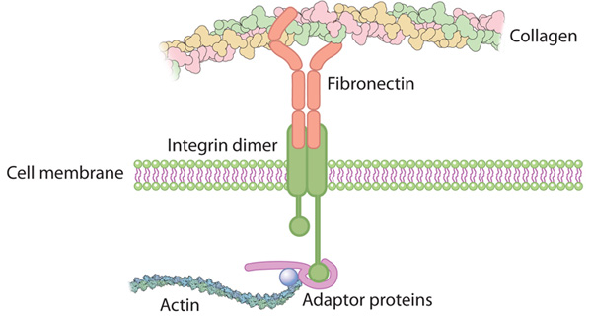
Figure 1: Integrin connects the extracellular matrix with the actin cytoskeleton inside the cell.
© 2010 Nature Education All rights reserved.
Figure Detail

How Else Do the Cells within a Tissue Stay in Contact?
Beyond integrins, cells rely on several other adhesive proteins to maintain physical contact. As an example, consider the epithelial cells that line the inner and outer surfaces of the human body — including the skin, intestines, airway, and reproductive tract. These cells provide a dramatic example of the different kinds of cell-to-cell junctions, but the same junctions also exist in a wide range of other tissues.
The side surfaces of epithelial cells are tightly linked to those of neighboring cells, forming a sheet that acts as a barrier. Within this sheet, each individual cell has a set orientation. Through integrins, the basal end of each cell connects to a specialized layer of extracellular matrix called the basal lamina. In contrast, the apical end of each cell faces out into the environment — such as the inner cavity or lumen of the gut.
The side-to-side junctions that link epithelial cells are diverse in their protein makeup and function. The adhesive transmembrane proteins anchoring these junctions have extracellular portions that interact with similar proteins on adjacent cells. Protein complexes within each cell further connect the transmembrane adhesive proteins to the cytoskeleton. In particular, adaptor complexes bind adherens junctions to cytoskeletal actin, and other adaptor complexes bind desmosomes to intermediate filaments. Both of these types of junctional complexes provide cells and tissues with mechanical support, and they additionally recruit intracellular signaling molecules to relay positional information to the nucleus.
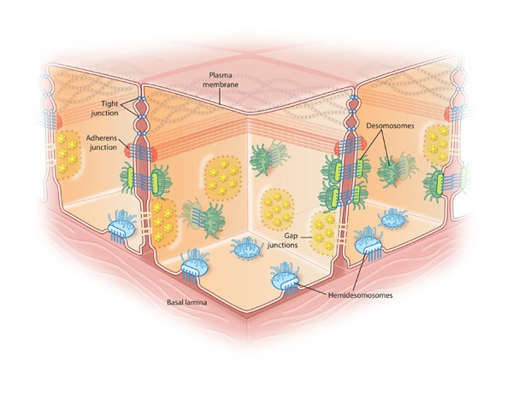
Figure 2: The different types of cell junctions
Tight junctions (blue dots) between cells are connected areas of the plasma membrane that stitch cells together. Adherens junctions (red dots) join the actin filaments of neighboring cells together. Desmosomes are even stronger connections that join the intermediate filaments of neighboring cells. Hemidesmosomes (light blue) connect intermediate filaments of a cell to the basal lamina, a combination of extracellular molecules on other cell surfaces. Gap junctions (yellow) are clusters of channels that form tunnels of aqueous connectivity between cells.
© 2010 Nature Education All rights reserved.
Figure Detail

The lateral surfaces of epithelial cells also contain several other types of specialized junctions. Tight junctions form a seal between cells that is so strong that not even ions can pass across it. Gap junctions are involved in cellular communication — not just in epithelial tissue, but in other tissue types as well. Gap junctions are specialized connections that form a narrow pore between adjacent cells. These pores permit small molecules and ions to move from one cell to another. In this way, gap junctions provide metabolic and electrical coupling between cells. For example, cardiac tissue has extensive gap junctions, and the rapid movement of ions through these junctions helps the tissue beat in rhythm. Gap junctions may also open and close in response to metabolic signals (Figure 2, Figure 3).
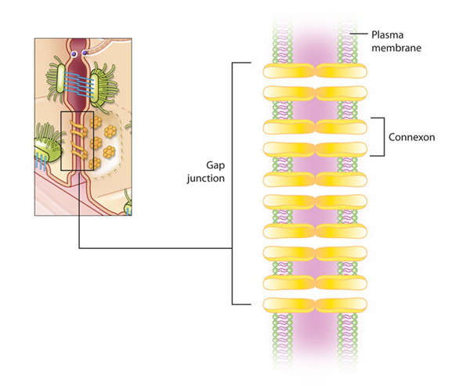
Figure 3: A gap junction
In a gap junction, the lipid bilayer of adjacent cells is pierced through by proteins called connexons. These proteins group together and effectively form a group of communication tunnels between adjacent cells.
© 2010 Nature Education All rights reserved.
Figure Detail

Cell Death Can Be Prompted by a Signal
Cell signaling isn't just central to tissue architecture and function: It also plays an important role in the balance between cell growth and death. Although it sounds like a bad thing, apoptosis — or the process of programmed cell death — is an essential aspect of development. Without it, repair and replenishment processes would overrun tissues with new cells. The orderly demise of a certain proportion of cells is therefore necessary for normal tissue turnover and maintenance of homeostasis. Apoptosis is distinct from necrosis, a messier form of cell death that causes cells to literally swell and burst. Necrotic cell death is not programmed; rather, it occurs in response to trauma or injury.
A range of extracellular and intracellular signals can trigger either cell growth or apoptosis. When cells receive these signals from their neighbors or from other aspects of the external environment, they carefully weigh them against each other before choosing a course of action. For instance, signals that indicate a lack of nutrients or the presence of toxins would likely stall cell growth and promote apoptosis. Within the cell, damage to the DNA or loss of mitochondrial integrity might also result in programmed cell death.
Cells self-destruct cleanly and quickly during apoptosis, thanks to the activation of a variety of enzymes — proteases and nucleases — that break down proteins and nucleic acids, respectively. In fact, scientists look for a characteristic pattern of fragmentation and nuclear condensation within tissues as evidence that apoptosis has occurred.

Conclusion
Some cell signaling occurs on a local level, such as when cells interact with the surrounding extracellular matrix or with their immediate neighbors. This type of signaling is especially important to the structure and function of tissues. Various signaling molecules allow the cells within a tissue to share information about internal and external conditions. This information helps the cells arrange themselves, coordinate their functions, and even know when to grow and when to die. Some of these signaling molecules also function in an adhesive capacity — not just relaying messages between the cells in a tissue, but physically joining these cells to one another.

Homeostasis is the tendency of an organism or cell to maintain a constant internal environment within tolerance limits
Internal equilibrium is maintained by adjusting physiological processes, including:
- Body temperature (normally 36 - 38°C)
- Blood pH (normally 7.35 - 7.45)
- Carbon dioxide concentration (normally 35 - 45 mmHg)
- Blood glucose concentration (normally 75 - 95 mg / dL)
- Water balance (varies with individual body size)

Negative Feedback
- Most homeostatic control mechanisms operate through a negative feedback loop
- When specialised receptors detect a change in an internal condition, the response generated will be the opposite of the change that occurred
- When levels have returned to equilibrium, the effector ceases to generate a response
- If levels go too far in the opposite direction, antagonistic pathways will be activated to restore the internal balance

Negative Feedback Loop
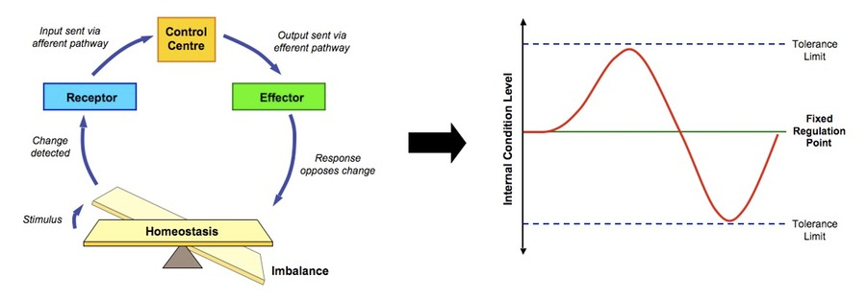

Positive Feedback

Homeostatic Control Systems
- Homeostasis is maintained by the concerted effort of body systems communicating via both electrical (nervous) and chemical (hormonal) systems
- Both nerves and hormones are specific in their actions - nerves terminate in specific parts of the organism, while hormones only produce activity in specific target cells
- The actions of both nerves and hormones involve chemical substances - hormones are chemicals themselves, while nerves use chemicals called neurotransmitters to facilitate electrical signalling
- Nerves tend to bring about a response very rapidly, while hormonal responses are much slower but tend to be longer lasting
- The initiation of homeostatic responses results from an external or internal stimulus, which is detected by a specific type of receptor

Types of Receptors
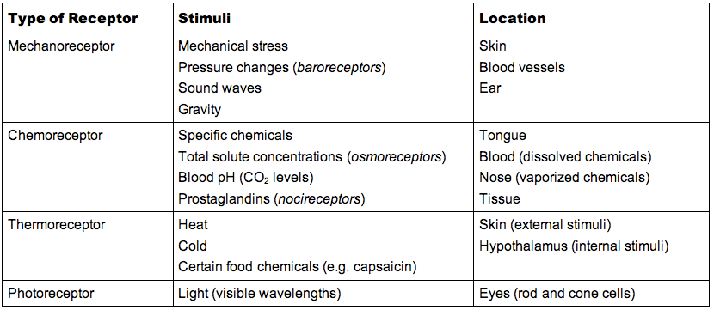

Homeostatic Control via the Nervous System
Thermoregulation
Animals capable of temperature regulation within a given range are called homeotherms and maintain a constant body temperature through a negative feedback loop
- The hypothalalmus acts as a control centre in thermoregulation by detecting fluctuations in body temperature
- The skin also possesses thermoreceptors and relays this information to the hypothalamus, which coordinates corrective measures

When body temperature rises, the following cooling mechanisms may occur:
- Vasodilation: The skin arterioles dilate, bringing blood into closer proximity to the body surface and allowing for heat transfer (convective cooling)
- Sweating: Sweat glands release sweat, which which is evaporated at the cost of latent heat in the air, thus cooling the body (evaporative cooling)

When body temperature falls, the following heating mechanisms may occur:
- Vasoconstriction: The skin arterioles constrict, moving blood away from the surface of the body, thus retaining the heat carried within the blood
- Shivering: Muscles begin to shake in small movements, expending energy through cell respiration (which produces heat as a by-product)

Other mechanisms through which homeotherms may regulate their body temperature include:
- Piloerection: Animals with furry coats can make their hair stand on end (piloerection), trapping pockets of warm air close to the body surface
- Behavioural responses: Animals may physically respond to environmental conditions in a bid to regulate temperature (e.g. bathing, burrowing, etc.)

Thermoregulation by the Nervous System
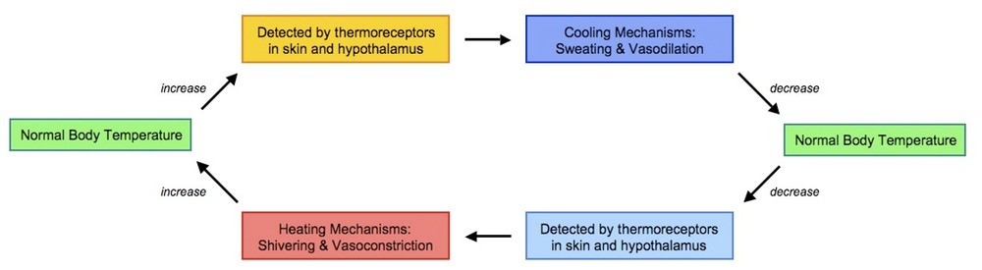

Homeostatic Control by the Endocrine System
Blood Glucose Regulation
The body requires volumes of glucose in order to make ATP, however the amount of ATP demand will fluctuate according to need and thus the body regulates its release of glucose into the bloodstream as high levels of glucose in the bloodstream can damage cells (creates hypertonicity)
- Two hormones, insulin and glucagon, are responsible for controlling blood glucose concentration (they have antagonistic functions)
- These hormones are released from different groups of cells with pancreatic pits (called the islets of Langerhans) and act principally on the liver

When blood glucose levels are high (e.g. after feeding):
- Insulin is released from beta cells in the pancreas and causes a decrease in blood glucose concentration
- This may involve stimulating glycogen synthesis in the liver (glycogenesis), promoting glucose uptake into the liver and adipose tissue or increasing the rate of glucose breakdown (increase cell respiration)

When blood glucose levels are low (e.g. after strenuous exercise):
- Glucagon is released from alpha cells in the pancreas and cause an increase in blood glucose concentration
- This may involve stimulating glycogen breakdown in the liver (glycogenolysis), promoting glucose release from the liver and adipose tissue or decreasing the rate of glucose breakdown (decrease cell respiration)

Blood Glucose Regulation by the Endocrine System
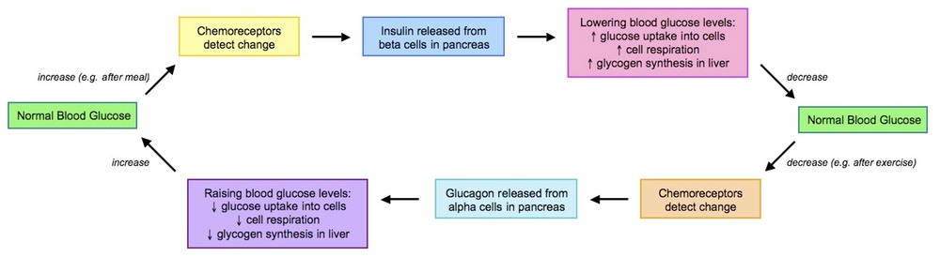

Homeostatic Control by Nervous and Endocrine Systems
Osmoregulation
All terrestrial animals regulate their body fluid levels by controlling the amount of water released from the body as urine
- The medullary region of the kidneys is hypertonic and will draw water out of the collecting ducts and back into the circulating blood
- Osmoreceptors in the hypothalamus detect water levels in the blood and coordinate the release of the neurohormone, anti-diuretic hormone (ADH)
- Neurohormones are hormones released from nerve cells that target distant cells (as opposed to neurotransmitters which target nearby neurons)

When blood water levels are low (e.g. dehydration):
- More ADH is released from the posterior pituitary
- ADH stimulates the production of aquaporins in the collecting ducts of the kidneys, making them more permeable to water
- More water is reabsorbed into the bloodstream and less water is lost in urine

When blood water levels are high:
- Less ADH is released from the posterior pituitary
- Less aquaporins are produced in the collecting ducts of the kidneys, making them less permeable to water
- Less water is reabsorbed into the bloodstream and more water is lost in urine

Osmoregulation by the Nervous and Endocrine Systems
