Topic: CHROMOSOMES: ABERRATIONS, MUTATIONS AND MAP
Chromosomes
Chromosomes are small thread like structures present in the nucleus of most living cells, carrying genetic information in the form of genes.
Discovery of chromosome
They were first observed by the German embryologist Walther Fleming in 1882. He discovered the chromosome by examining the rapidly dividing cells of salamander larvae. Since their discovery, chromosome have been found in the cells of all eukaryotes.
Components of a chromosome
Typically a chromosome is made of
- Two chromatids
- A centromere (primary constriction)
- Secondary constriction
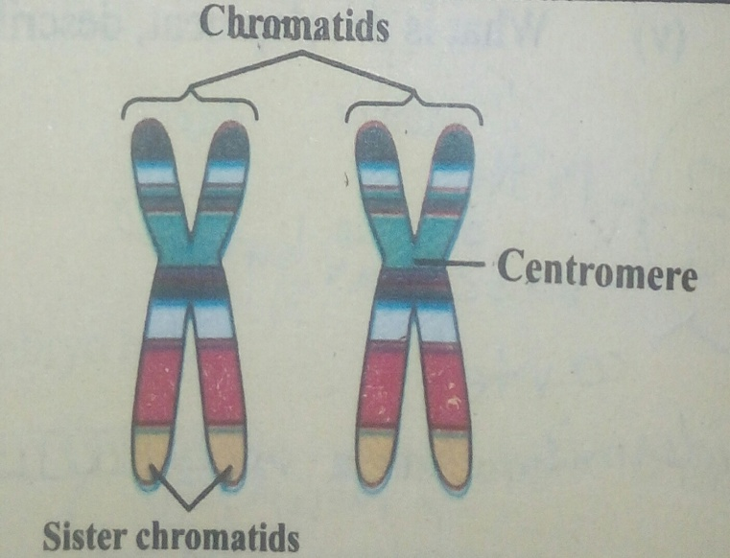
Chemical composition of chromosome
Chromosomes are made up of DNA and histone protein. A typical chromosome has following composition.
DNA : 40% Protein : 60%
RNA: A significant amount of RNA is also associated with chromosomes. Because these are sites of RNA synthesis.
Chromosomal aberrations
Chromosomal aberrations include changes in the structure and number of chromosomes. Generally, the chance of chromosomal abnormalities is 5- 6persons/ 1000. Many children with a chromosomal abnormality have mental or physical birth disorders. Abnormalities can be in the form of extra material which may be adhere to a chromosome or where part or a whole chromosome is missing.
Classification of chromosomal aberrations
There are two main types of chromosomal aberrations.
- Structural aberrations.
- Numerical aberrations.
1.Structural aberrations
Structural abnormalities occur when part of an individual chromosome is missing, extra, switched to another chromosome or turned upside down.
Structural chromosomal aberrations can result in genetic disorder due to trisomy and/or monosomy of chromosomal segments. Structural abnormalities are produced by chromosomal breakage or unequal crossingover which result in deletions, ring chromosomes, duplications, translocations, insertions and inversions. A single breakage in one chromosome will produce a terminal deletion, whereas two breaks in a single chromosome can produce an interstitial deletion, a ring chromosome or an inversion. Two breaks in two different chromosomes can result in structural changes including reciprocal and Robertsonian translocations. Unequal crossing-over can result in duplications or deletions.
Chromosome rearrangements are balanced if disomy is maintained for all of the autosomes and a normal complement of sex chromatin is present, even if the positions of the homologous segments on the chromosomes have been altered .on the other hand, when chromatin is lost or gained in the process the rearrangement is said to be unbalanced. Unbalanced constitutional rearrangements are usually associated with developmental delay or intellectual impairment, birth defects and poor growth, whereas balanced rearrangements often have no effect on physical or intellectual development. Structural chromosome rearrangements that are present at conception affect every cell and are referred to as constitutional. Rearrangements that takeplace later in development affect only a portion of the cells and result in mosaicism. Structural abnormalities that occur after birth are referred to as acquired and may cause tumours or leukaemia by altering cell cycle regulation.
Chromosomal abnormalities due to structural aberrations make up a significant portion of chromosomal genetic disease. Jacobs (1977) summarized data from seven separate newborn series of 48 650 infants in Europe and North America that were carried out before the development of banding techniques. Balanced structural rearrangements included Robertsonian translocations, with a frequency of approximately 1 in 1100, reciprocal translocations (about 1 in 1300) and inversions (1 in 7 000). Unbalanced structural rearrangements were less common and included Robertsonian and reciprocal translocations (1 in 16 000), inversions and deletions (1 in 8100) and other unbalanced karyotypes (1 in 3200). At birth, then, structural rearrangements, both balanced and unbalanced, were found in approximately one of every 400 infants.
TYPES OF STRUCTURAL ABERRATIONS
Structural aberrations include:
- Deletion
- Duplication
- Inversion
- Translocation
- Ring structure
- Insertion
i.Deletions
Abnormalities in which a portion of chromatin from one chromosome is lost are called deletions.
Deletions result in a partial monosomy and are, therefore, unbalanced rearrangements. Single breaks cause terminal deletions with a subsequent loss of the chromosome end. When two breaks take place in the same arm of a chromosome, interstitial deletions are produced by a loss of the chromatin between the breaks and a rejoining of the remaining segments. Deletions that are huge enough to be visible to the eye by light microscopy represent the loss of many genes that are physically located in the same band or region of the chromosome, and result in monosomy for that portion of the genome. For many loci, it represents a haplo-insufficiency in function and is mostly severe enough to cause death of the embryo. Deletions that survive to birth are connected with a very high risk of birth defects and intellectual impairment. Those that involve tumour suppressor genes confer a high risk of cancer and/or leukaemia.
One of the earliest described and best delineated syndromes due to deletion is the cri-du-chat syndrome with loss of part of the short arm of chromosome 5. This may be due to a very small deletion involving a break at band 5p15.2 or one that includes virtually the entire short arm. The cat-like cry at birth gives the syndrome its name, using the French terminology. The infant has a round face with wide-set eyes, but the older child and adult develops an elongated asymmetrical face. There is rigorous intellectual impairment.
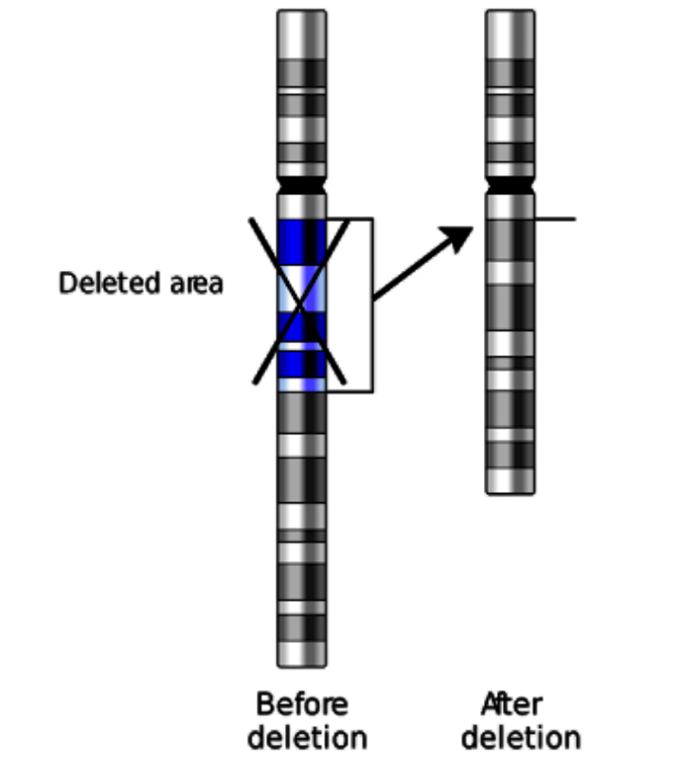
ii.Duplications:
An event in which the large piece of chromosome is repeated resulting in extra genetic material.
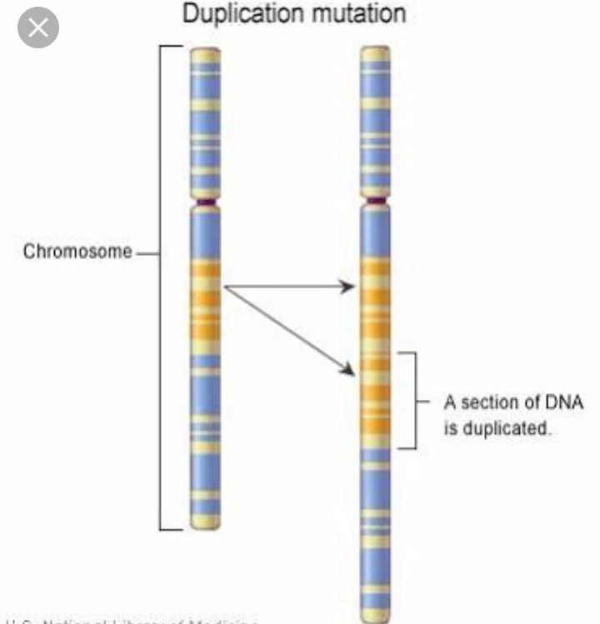
Compared with deletions, duplications tend to be somewhat less dangerous in effect, but they share many of the same clinical features. Duplications are believed to result primarily from unequal crossing over especially in regions of the genome where repeat DNA sequences are found.. One example of chromosome duplication is duplication of a segment of the long arm of chromosome 15, which is generally observed as an extra dicentric chromosome. Duplication of the proximal long arm of chromosome 22 as an extra dicentric chromosome (cat eye syndrome) is also relatively common and is connectsd with coloboma of the eye, intellectual impairment and anal atresia.
iii.Inversions
Inversions are produced by two breaks in the same chromosome with exchange of the two ends. Inversions are therefore essentially formed in the same manner as translocations except that the breaks and exchange occur in the same chromosome. Two different types of inversion are found. One is a pericentric and second is paracentric.
Pericentric and paracentric inversions .
The major difference between pericentric and paracentric inversions involves the position of the centromere in the recombinant products. Since the region within the inversion loop remains balanced, the recombination products of the pericentric inversion each retain a single copy of the centromere and can, therefore, disjoin normally during mitosis.on the other hand, because the region outside the inversion loop is either duplicated or deleted, the recombination products from the paracentric inversion receive either two copies or no copies of the centromere, neither of which is compatible with long-term survival. On rare occasions, recombination products with a single active centromere have been reported from paracentric inversions, which allow the embryo to survive.
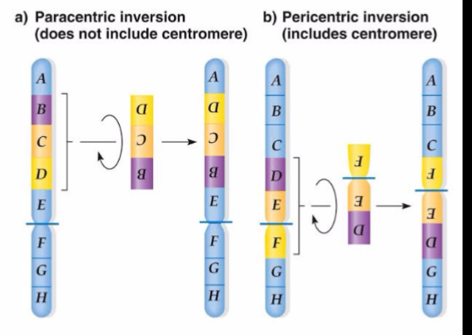
iv.Translocations
It contains breaks in two different chromosomes with an exchange of segments.
In humans, there are two major types of translocation: reciprocal translocations and Robertsonian .
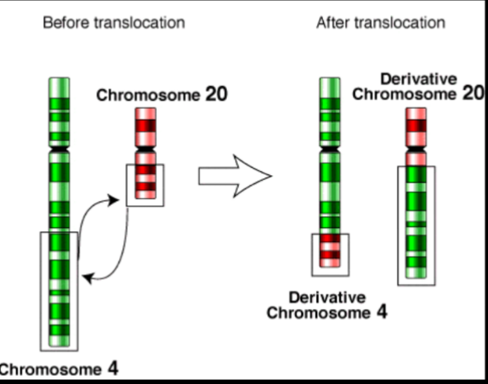
Reciprocal translocations
Reciprocal translocations are characterized by an exchange of chromatin between different chromosomes. A single break takes place in each chromosome, and the noncentric segments are exchanged without the visible loss of any chromatin .However, the two new derivative chromosomes may contain very different morphology depending on the breakpoints. The carrier of a reciprocal translocation usually has no phenotypic effects due to the rearrangement except for possible reproductive abnormalities including infertility, spontaneous abortions and abnormal offspring. Translocations that reposition proto-oncogenes can result in disregulation of the cell cycle and the development of tumours or leukaemia.
Robertsonian translocations
Robertsonian translocations are unique types of whole arm translocations that are from due to ‘centric fusion’ of the long arms of two acrocentric chromosomes with loss of the short arms, thus reducing the number of chromosomes by one. They are named for W. R. B. Robertson, who was an insect cytogeneticist and studied numerical chromosome changes in several orthopteran populations (Robertson, 1916). The formation of a Robertsonian translocation may actually result from breaks in the short arm, in the long arm or within the centromere of the chromosomes that make the ‘fusion’ product. Depending on the position of the breaks and exchange of chromatin segments, the resulting derivative chromosome may be either monocentric or dicentric. Robertsonian chromosomes formed of two homologous long arms (e.g. a chromosome composed of two chromosome 14 long arms) may be the result of a U-type exchange between sister chromatids or two homologous chromosomes, or may actually be an isochromosome with identical arms produced by a misdivision of the centromere.
v.Ring chromosomes
A ring chromosome is produced from two terminal deletions (Figure 1b). There is a break in both the short arm and the long arm, with fusion of the ends of the centromeric segment and loss of the two terminal segments. Ring chromosomes represent a form of terminal deletion with the added characters of being mitotically unstable due to mechanical problems during replication. Individuals with ring chromosomes contain many of the features of patients with terminal deletions as well as growth retardation. Three types of ring chromosome are relatively common: large rings with minimal loss from the terminal segments of the short and long arms, very small rings as extra chromosomes in the karyotype, and rings formed from the X-chromosome, which are usually present in females with features of Turner syndrome.
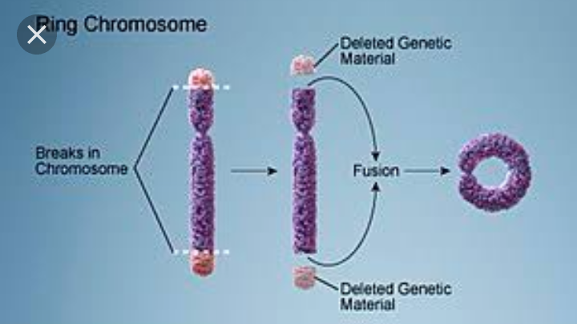
vi.Insertion
An event in which a piece of the chromosome is removed and inserted in to a different or another chromosome.
It result in loss of genetic material from one chromosome.
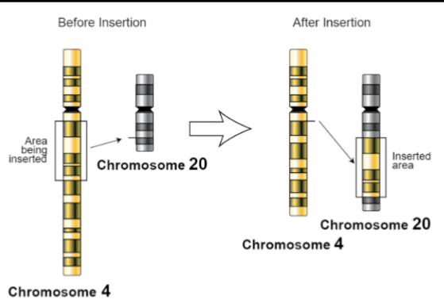
2.Ploidy/Numerical aberrations
- Genomatic mutation is a chromosomal mutation in which the numerical changes in chromosomes or variation in chromosomal numbers takes place, known as numerical chromosomal aberration. The change in chromosome numbers is due to error in meiosis and mitosis. The measure of number of chromosome in a cell is called ploidy.
- The minimum number of chromosome which function as a harmonious and integrated unit is called basic chromosomal number.
- The chromosome number present in gamete produced by diploid cell is called haploid (n). The chromosome occurs in pair in somatic cell called diploid (2n). For eg. In Human 23 pairs of chromosome is present, which is the basic chromosomal number.
- The chromosomal number is maintained from generation to generation in a species, but, certain mutation causes change in chromosomal number in somatic cell. This condition is called ploidy.
- The alterations in chromosome number involves addition or deletion of individual chromosome or of a complete set of chromosome.
Types of ploidy:
Changes in chromosome number are of two basic types: changes in one or more chromosome number in a set, resulting in a condition called aneuploidy and changes in whole chromosome sets, resulting in a condition called aberrant euploidy.
1.Aneuploidy
2.Euploidy
i.Aneuploidy:
It is the condition in which one or more chromosome is added or deleted from basic chromosomal number in a diploid cell.
In aneuploidy, the chromosome number is not multiple of basic chromosomal number.The organism with such abnormal conditions are called aneuploids or heteroploids.
There are two class of aneuploidy
Hyperploid: addition of one or more chromosome to a diploid set.
Hypoploid: deletion of one or more chromosome from a diploid set.
Causes of aneuploidy
i). Non-disjunction:
It is the condition in which one or more pairs of chromosome (bivalent chromosome) fails to separate during anaphase of meiosis-I. Due to irregular distribution of chromosome at poles, one daughter cell receives one or more extra chromosome whereas other daughter cell lacks one or more chromosome and they form respective gametes.When the gametes having extra chromosome fuse with normal haploid gametes, it result in hyperploids.And when the gamete lacking one or more chromosome fuse with normal gamete, it result in hypoploids.
ii). Non orientation of one or more bivalent at metaphase-I of meiosis-I
iii). Loss of individual chromosome in meiosis or mitosis
iv). Irregularities in segregation of chromosome during meiosis in polyploidy condition also results in aneuploidy
v). Multipolar mitosis with irregular distribution of chromosome to daughter cell
Types of aneuploidy
a. Monosomics: 2n-1
It is loss of one copy of chromosome from a diploid complement set. It’s chromosome number is represented by 2n-1.A diploid cell missing a single chromosome is monosomic. And if a cell misses two non-homologous chromosomes, it is called double monosomic. In most diploid organisms, loss of one chromosome copy from a pair is deleterious.In humans, monosomics condition in any autosomes are fatal. And also, monosomic in X-chromosome are fatal, but few viable cases are present. Eg. Turner syndrome
Example: Turner’s syndrome: (44+X)
It takes place when an abnormal egg (O) fuse with normal sperm (X). The individuals have 45 chromosome (44 autosome and one X).
The affected individual is sterile female with under-developed breasts, reduced ovaries, short stature, and often have a web of skin extending between the neck and shoulders lacks menstrual cycle and few male like characters.
b. Nullisomic: 2n-2
It is loss of a pair of chromosome from diploid set.In this case, a diploid organism lacks a pair of homologous chromosome. It’s chromosomal number is represented by 2n-2.It is usually lethal in an organism.
Example: In wheat, they can tolerate a nullisomic mutation
c. Trisomic: 2n+1
An organism comprising one extra chromosome in addition to diploid set.
In normal meiosis-I, chromosome pair of bivalent separates and goes to each of the daughter nuclei. But very rarely, one pair of chromosome fails to disjoin and finally it moves to one pole, so half of the daughter cell receive extra chromosome and other half of daughter cell lose one. Such that (n+1) and (n-1) gametes are formed.When n+1 gamete fuse with normal gamete, it gives trisomic organism.
Example: Down syndrome; trisomy 21
It is because of an extra chromosome number 21.
The individual with Down syndrome have 47 chromosome.
Its symptoms are mental retardation, short body stature, swollen tongue, eyelid folds resembling Mongolian race.
Example: Klinefelter’s syndrome:
It is characterized by 2n+1 (44+XXY) genotype.It ohappens when an abnormal egg (XX) fuse with normal sperm (Y).The affected individual is sterile male and is represented by unusually long body, obese and female like characteristics.
d. Tetrasomic: 2n+2
An organism having one extra pair of chromosome in addition to its diploid set.It is represented as 2n+2.
Examples: tetrasomy 9p, tetrasomy 18p, tetrasomy 12p (Pallister-Killian syndrome), tetrasomy 22 (Cat eye syndrome)
ii.Euploidy:
It is the condition of addition or loss of complete one set or more than one set of chromosome in diploid organism.
Types of euploidy:
1.Monoploidy or Haploidy
2.Diploidy
3.Polyploidy
a.Monoploidy or haploidy:
The total amount of genetic material in a haploid cell or in prokaryotic organism is called genome.
Monoploidy or haploidy includes loss of complete one set of chromosome from a diploid cell. Monoploid or haploid organism comprises of single genome (n) in their cell. They have one member of each kind of chromosome. Haploid cell is formed during gametogenesis is diploid organism. Viruses and bacteria have single genome and are haploid. Majority of lower plants mostly thallophyta and bryophyte exists in monoploid form. In higher plants, haploidy develops due to parthenogenesis. In some animals, like honey bees and wasps, male drone are haploid.
Characteristics of haploids
- Haploid plants are generally weaker and smaller than diploid, but in pepper the haploid are as healthy as normal diploid plant.
- Leaves of haploid plants are generally small and plants have low viability.In monoploid male honey bees, during spermatogenesis the meiosis is bypassed by mitosis. As a result, their sperms are haploid and viable.
b.Diploidy:
Normally all higher plants and animals occurs in diploid form.
They contains two copy of each chromosome.
c.Polyploidy:
Polyploidy is a condition of addition of one or more complete set of chromosome in diploid cell.
Polyploidy results because of failure of separation of chromosomal sets during mitosis or meiosis such that more than two chromosomal sets are present in a cell. Polyploidy is more common and sometimes resulting in evolution of new plant species with better yield. Many of agriculturally important crops, such as wheat, oats, cotton, potatoes, and sugar cane are polyploids .Generally, Organism contain two sets of chromosome (2n) called diploid. The organism with three sets of chromosome called triploid, 4 sets; tetrapolid, 5 sets; pentaploid and so on. These all are polyploids and the condition is known as polyploidy.
Types of polyploidy
1.Autopolyploidy
2.Allopolyploidy
1.Autopolyploidy:
It is the condition in which an individual organism comprises of more than two sets of same genome (homologous chromosome).
For examples: if an organism has two set of chromosome (homologous chromosome ie AA) then the autotriploid (an autopolyploidy condition) will have similar three chromosome AAA. Autopolyploidy condition is multiplication of same basic set of chromosome within same species.
Examples:
Autotriploid plants (3n); developed by fertilization of diploid (2n) and haploid (n) gametes
Autotetraploid (4n); developed by fertilization of two diploid gametes.
Significance of Autopolyploidy:
1.U sually , Autopolyploidy leads to increase in size, vigour and strength and mostly larger than their diploid counterparts. In some cases autopolyploids are smaller and weaker then diploid
2.Pollen grains, stomatal guard cell and xylem parenchyma arehuge in size in autoployploids than diploids
3.Autopolyploids generally show reduced fertility because of high irregularities during meiosis which causes genotypic imbalance leading to physiological disturbances.
4.Generally autopolyploids reproduce by vegetative propagation.
5.The flower and fruits per plant in autopolyploids are usually less in number than diploids
6.Autopolyploidy is much successful in species with low chromosome number and in cross pollinated species.
7.Autopolyploidy is used in horticulture for ornamental plants like roses, dahlias and also in production of seedless plants. Examples; apples, pears, banana, grapes, orange etc
2.Allopolyploidy:
Allopolyploidy is a condition developed by hybridization between two genetically different species followed by doubling of chromosomes.
For examples; hybridization between species X with AA set of chromosomes and species Y with BB set of chromosomes results in hybrid species XY with AB set of chromosomes. On doubling the hybrid chromosomes set, resulting individuals have AABB set of chromosome, condition known as Allopolyploidy
Generally the hybrid with AB set of chromosome are sterile but when the chromosomes is doubled (AABB), then resulting allopolyploids (amphidiploids) are fertile as they can produce gametes.
Significance of Allopolyploidy:
1.Used in crop breeding
2.Used as a bridge species in transfer of desired characters from one species to another. For eg. Modern wheat
3.For production of new crop species; Raphanabrassica
4.Played vital role in evolution of species: 1/3 rd of flowering plants are polyploids and most are allopolyploids.
Mutations
The changes to the genetic material are called mutations.
Causes of mutation
Mutations can be caused by
- Copying errors in the genetic material during cell division.
- By exposure to radiations, chemicals (mutagens).
- Viruses may cause mutations
- Mutations can occur under cellular control during processes such as meiosis or hypermutation.
Types of mutations
In multicellular organisms, mutations can be subdivided in to two types.
- Germline mutation :
These mutations can be passed on to descendants.
- Somatic mutations :
These cannot be transmitted to descendants in animals. Plants sometimes can transmit somatic mutations to their descendants asexually or sexually.
Classification of mutations
Classification by effect on structure
The DNA sequence of a gene can be altered in a number of ways. Gene mutations have varying effects on health. It depends on where they occur and whether they after the function of essential proteins. Structurally, mutations can be classified as
i.Small scale mutations
These mutations effect one or a few nucleotides. These are
a.Point mutations
Mutations caused by exchange of single nucleotide are called point mutations. They are often caused by Chemicals or malfunction of DNA replication. Most common is the transition that exchanges a purine for a purine (A G) or a pyrimidine to a pyrimidine (C T). A transition can be caused by nitrous acid, base mispairing or mutagenic base analogs such as 5-bromo-2-deoxyuridine. Less common is a transversion, which exchange a purine for a pyrimidine or a pyrimidine for a purine (C/T A/G). A point mutation can be reversed by another point mutation in which the nucleotide is changed back to its original state or by second- site version. Point mutations that occur within the protein coding region of a gene are classified into three kinds.
- Silent mutations : which code for the same amino acid.
- Missense mutations : which code for a different amino acid.
- Nonsense mutations : which code for stop codons.
b.Insertion
The mutations in which one or more extra nucleotides are added into the DNA is called insertion. They are usually caused by transposable elements or errors during replication of repeating elements. It has two types.
- Splice site mutations: In this case, the coding region of a gene may alter splicing of the Messenger RNA.
- Frameshift mutations : These mutations cause a shift in the reading frame. It significantly alter the gene product.
c.Deletion
The removal of one or more nucleotides from the DNA is called deletion. Like insertion, these mutations can alter the reading frame of the gene. They are irreversible.
ii.Large scale mutations
These mutations causes change in chromosomal structure including
a. Amplification
Leading to multiple copies of chromosomal regions. It increases the dosage of the genes located within them.
b.Deletion
Deletion of large chromosomal regions leading to loss of the genes within those regions. Mutations whose effect is to juxtapose previously separate pieces of DNA. It brings together separate genes to form functionally distinct fusion genes.
- Chromosomal translocation: Interchange of genetic material from non homologous chromosomes.
- Interstitial deletion : Removing regions of DNA from a single chromosome, thereby apposing previously distant genes.
- chromosomal inversions: reversing the orientation of a chromosomal segment.
c. Lost of heterozygosity: loss of one allele either by a deletion or recombination event in organisms which previously had two.
Classification by effect on function
i.Amorphic mutations
These are the result of gene product having less or no function. When the allele has a complete loss of function it is often called an amorphic mutation. Phenotypes associated with such mutations are most often recessive.
ii. Neomorphic mutations
This mutations alter the gene product such that it gains a new and abnormal function. This mutations generally have dominant phenotype.
iii.Lethal mutations
These are mutations that lead to a phenotype in capable of effective reproduction
iv.Actinomorphic mutations
These have an altered gene product that acts antagonistically to the wild-type allele. This mutations generally result in an altered molecular function. They are characterized by a dominant or semi dominant phenotype.
Classification on the basis of causing agents
Two classes of mutations are spontaneous mutations and induced mutations caused by mutagens.
i.Spontaneous mutations
Mutations caused by molecular decay are called spontaneous mutations. These include
- Tautomerism a base is altered by the repositioning of a hydrogen atom
- Depurination loss of a purine base.
- Deamination changes a normal base to an atypical base
- Transition a purine changes to another purine or a pyramidine into another pyrimidine.
- Transversion a purine becomes a pyrimidine or vice versa
ii.Induced mutations
The mutations caused by mutagens are called induced mutations. Induced mutations may be caused by chemicals like nitrosoguanidine or by radiation like ultraviolet radiations.
Effects of mutations
- Changes in DNA caused by mutations can cause errors in protein sequence creating partially or completely non functional proteins.
- If a mutation is present in a germ cell this can give rise to a offspring that carries the mutations in all of its cells. This is the case in heriditary diseases.
- Open gene mutations that could cause a genetic disorder are repaired by the DNA repair system of the cell. Each cell has a number of Pathways through which enzymes recognise and repair mistakes
- A very small percentage of all mutations actually have a positive effect. These mutations lead to new version of proteins. These proteins help an organism and its future generations better adopt to changes in their environment.
Gene mapping
Gene mapping describes the methods used to identify the locus of a gene and the distances between genes. Gene mapping can also describe the distances between different sites within a gene.
The essence of all genome mapping is to place a collection of molecular markers onto their respective positions on the genome. Molecular markers come in all forms. Genes can be viewed as one special type of genetic markers in the construction of genome maps, and mapped the same way as any other markers.
How do researchers create a genetic map?
To produce a genetic map, researchers collect blood or tissue samples from members of families in which a certain disease or trait is prevalent. Using various laboratory techniques, the scientists isolate DNA from these samples and examine it for unique patterns that are seen only in family members who have the disease or trait. These characteristic patterns in the chemical bases that make up DNA are referred to as markers.
DNA markers don't, by themselves, identify the gene responsible for the disease or trait; but they can tell researchers roughly where the gene is on the chromosome.
This is why: when eggs or sperm develop, the paired chromosomes that make up a person's genome exchange stretches of DNA. Think of it as a shuffling process, called recombination. The single chromosome in a reproductive cell contains some stretches of DNA inherited from the person's mother and some from his or her father.
If a particular gene is close to a DNA marker, the gene and marker will likely stay together during the recombination process, and they will likely be passed on together from parent to child. If each family member with a particular disease or trait also inherits a particular DNA marker, it is very likely that the gene responsible for the disease lies near that marker.
The more DNA markers there are on a genetic map, the more likely it is that at least one marker will be located close to a disease gene-and the easier it will be for researchers to zero in on that gene. One of the first major achievements of the HGP was to develop dense maps of markers spaced evenly across the entire human genome.
Use
Identification of genes is usually the first step in understanding a genome of a species; mapping of the gene is usually the first step of identification of the gene. Gene mapping is usually the starting point of many important downstream studies.
Disease association
The process to identify a genetic element that is responsible for a disease is also referred to as "mapping". If the locus in which the search is performed is already considerably constrained, the search is called the fine mapping of a gene. This information is derived from the investigation of disease manifestations in large families (genetic linkage) or from populations-based genetic association studies.
Mcq’s
- A condition in which the organisms have more than two complete sets of chromosomes is called:
- Polyploidy b. euploidy c. aneuploidy d. none
- X0 is:
- Trisomic b. monosomic c. tetrasomic d. nullisomics
- The interchange of parts between non-homologous chromosomes is called:
- Duplication b. translocation c. inversion d. deletion
- Frameshift mutation is caused due to:
- Duplication b. translocation c. inversion d. deletion
- Which of the following chemical mutagen affects only replicating DNA?
- Acridine dye b. alkylating agent c. deaminating agent d. base analogs
- Addition or deletion of bases causes which kind of mutation ?
- Transversion b. frameshift c. transition d. transcription
- The mutations caused by mutagens are called :
- Induced b. spontaneous c. point mutations d. lethal
- Methods used to identify the locus of a gene and the distances between genes.
- Gene expression b. genome sequencing c. gene mapping
- Genetic markers are identifiable portions of a whose inheritance patterns can be followed.
- Genes b. chromosomes c. chromatids d. DNA
- What is the unit of a genetic map?
- Centimeter b. Nanometer c. angstrom d. centimorgan

