TOPIC: GENETICS (Introduction, brief history, scope)

Introduction:

Genetics is the study of heredity. Heredity is a biological process whereby a parent passes certain genes onto their children or offspring.
Since the dawn of civilization, humankind has recognized the influence of heredity and applied its principles to the improvement of cultivated crops and domestic animals. A Babylonian tablet more than 6,000 years old, for example, shows pedigrees of horses and indicates possible inherited characteristics. Other old carvings show cross-pollination of date palm trees. Most of the mechanisms of heredity, however, remained a mystery until the 19th century, when genetics as a systematic science began.
Genetics arose out of the identification of genes, the fundamental units responsible for heredity. Genetics may be defined as the study of genes at all levels, including the ways in which they act in the cell and the ways in which they are transmitted from parents to offspring. Modern genetics focuses on the chemical substance that genes are made of, called deoxyribonucleic acid, or DNA, and the ways in which it affects the chemical reactions that constitute the living processes within the cell. Gene action depends on interaction with the environment. Green plants, for example, have genes containing the information necessary to synthesize the photosynthetic pigment chlorophyll that gives them their green colour. Chlorophyll is synthesized in an environment containing light because the gene for chlorophyll is expressed only when it interacts with light. If a plant is placed in a dark environment, chlorophyll synthesis stops because the gene is no longer expressed.

DNA
DNA is the cornerstone of genetics and is the perfect place to start for an introduction to genetics. DNA stands for deoxyribonucleic acid and it is the molecule that holds the genetic information for a cell and an organism.
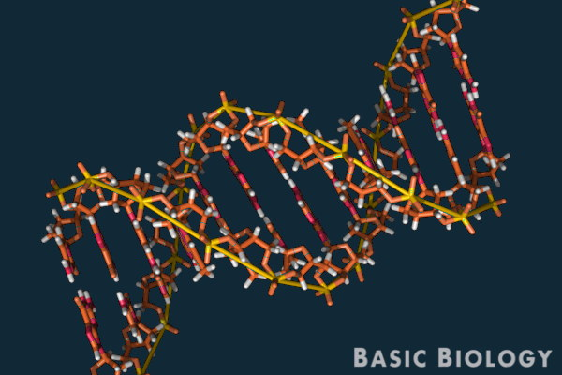
A DNA molecule contains a code that can be used by a cell to express certain genes. Specific sections of a DNA molecule provide the information to build specific proteins which can then be used by a cell to express the desired gene.
GENES
A gene is a specific segment of a DNA molecule that holds the information for one specific protein. DNA molecules have a unique code for each gene which codes for their specific protein. Some organisms can have more than 100,000 different genes so they will have 100,000 unique sequences of DNA ‘code’.
Genes are the basic unit of heredity. The genes of an individual are determined by their parent or parents. Bacteria that is born by one parent cell splitting into two cells and has the exact same genes as their one parent cell.
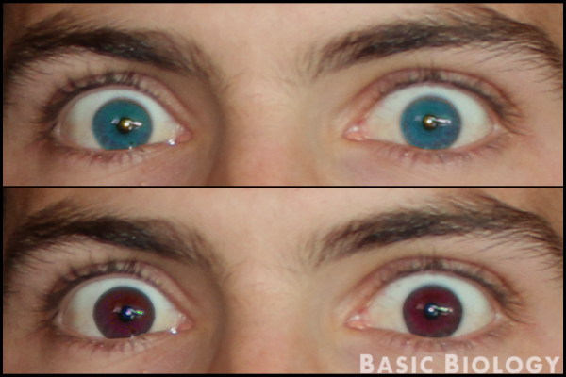
Physical traits such as eye color or height are often determined by the combination of multiple genes. The environment an individual lives in also impacts how genes are expressed.

CHROMOSOMES
A chromosome is a structure made from tightly packed strands of DNA and proteins called histones. Strands of DNA are tightly wrapped around the histone proteins and form into long worm-shaped structures called ‘chromatids’. Two chromatids join together to form a chromosome.
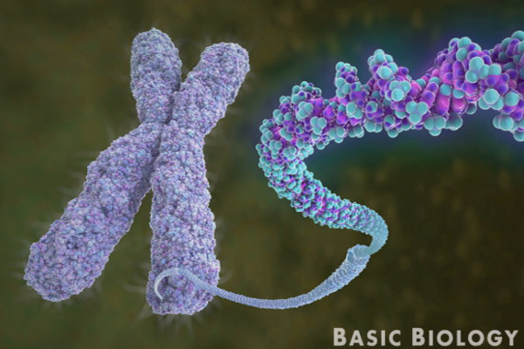
Chromosomes are formed in the nucleus of a cell when a cell is dividing. It is possible to see chromosomes under an ordinary light microscope if the cell is in the right stage of cell division.

GENETIC INHERITANCE
Inheritance is the backbone of genetics and is an important topic to cover in an introduction to genetics. Long before DNA had been discovered and the word ‘genetics’ had been invented, people were studying the inheritance of traits from one generation to the next.
Genetic inheritance occurs both in sexual reproduction and asexual reproduction. In sexual reproduction, two organisms contribute DNA to produce a new organism. In asexual reproduction, one organism provides all the DNA and produces a clone of themselves. In either, genetic material is passed from one generation to the next.
Areas of genetics:
Following are the main areas of genetics;
Classical genetics: The study of techniques and methodologies of genetics. It gives rise to molecular biology. Then genetic codes and tools of cloning and restriction enzymes were discovered. Thus following are branches of classical genetics;
Behavioral genetics: The study of influence of genetics on animal behavior. It studies the effects of human disorders and its causes.
Clinical genetics: Training of genesists to diagnose, treat and counsel patients with genetic disorders.
Molecular genetics: Deals with the structure of genes at molecular level. It employs the methods of both classical genetics and molecular biology.
Population, quantitative and ecological genetics: Sub branches of classical genetics.
Genomics: Study of large scale genetic patterns.
Genetic Engineering: The manipulation of genes. It is also a sub field of classical genetics.
Mendelian genetics: The genetics which governs the transmission of characteristics from parents to off springs. The genetics were initially derived from the works of Gregor Mendel. This work was re-discovered. Thomas Hunt Morgan integrated the chromosomal theory of inheritance which became the core of classical genetics.

HISTORY
Timeline:
Mid to Late 19th Century: Evolution, Natural Selection, Particulate Inheritance and Nuclein 1858
- Darwin and Wallace - Role of natural variation and natural selection in evolution
- 1865 - Gregor Mendel - Particulate inheritance
- 1866 - Ernst Haeckel; Heredity materials was in the nucleus
- 1871 - Friedrich Miescher; Material in the nucleus was a nucleic acid
Early 20th Century: Mendelian Principles are extended and the Chromosomal Theory of Inheritance solidifies
- 1900 - Correns, de Vries, von Tschermak - Mendel’s work is rediscovered;The age of genetics begins
- 1902 - Walter Sutton and Theodor Boveri - Chromosomal Theory of Inheritance; The heredity material resides in chromosomes
- 1905-1923
  - Linkage
  - Sex linkage
  - Genetic mapping
  - Number of linkage groups - number of chromosomes
  - Lethal genes
  - Maternal inheritance
- 1908 - Hardy and Weinberg - Hardy-Weinberg principle of genetic equilibrium
- 1909 - Nilsson-Ehle - Theory of quantitative traits and quantitative genetics
Mid 20th Century: DNA is the stuff of life; the preeminence of the Darwinian theory of evolution via natural selection is confirmed
- 1928 - Griffith - Transformation experiments
- 1944 - Avery, MacLeod, McCarty - Definitive proof that DNA is the genetic material
- 1953 - Watson and Crick - DNA structure is defined
- 1954-1961
  - DNA code is determined
  - Transcription is described
  - Replication is described
  - Translation is described
  - Operons are discovered
- 1932-1953
  - Fisher and Dobzhansky - The Modern Synthesis is formulated
  - Links Darwinian evolutionary theory and Mendelian genetics
- 1968
  - Kimura
  - Neutral Theory of Molecular Evolution is introduced
Mid-late 20th Century and the Early 21st Century: The Age of Molecular Genetics; Phylogenetics Studies Intensive; The Information Age; The Emergence of Genomics Science
- 1969 - ARPANET - Internet comes on line
- 1970 - Arber and Smith - First restriction enzyme, Hind II, is isolated
- 1970 - Baltimore and Temin - Discovery of reverse transcriptase
- 1972 - Berg - First recombinant DNA molecule is constructed
- 1973 - Boyer and Cohen - First functional recombinant E. coli cell produced
- 1977 - Sanger and Gilbert - DNA sequencing techniques are described
- 1977 - Sharp and Roberts - Introns discovered
- 1978 - Botstein - RFLPs launch the era of molecular mapping of linkage groups
- 1980 - Sanger Group - First genome is sequenced, the bacteriophage ΦX174 of E. coli
- 1983 - Mullis - PCR technique is discovered
- 1986 - Hood, Smith, Hunkapiller and Hunkapiller - First automated DNA sequencer
- 1990 - US Government - Human Genome Project launched
- 1995 - Celera - First bacterial genome (H. influenza) is sequenced
- 1996
  - Yeast Genome Consortium
  - First eukaryotic genome (yeast) sequenced
- 2000 - Arabidopsis Genome Initiative - First flowering plant genome (Arabidopsis thaliana) is sequenced
- 2001 - The human genome sequence is published.

Scope
Genetics as basis of biological science:
Genetics provides a foundation for biological studies. Law of inheritance helps us to understand principles of embryology, evolution and ecology. Thus it provides mechanism of transfer of genes from parents to off springs. Genetics also has a close relationship with evolution. Evolutionary principles cannot be studied without genetics. Similarly the study of ecological principles also requires genetics. Biotechnology has direct link with genetics and thus it has a great role as basis of biology.

Role of genetics in food production:
The scientists use the principles of genetics for better food production. It has improved the existing varieties of crops, livestock, wheat, rice, corn, chicken and sheep. New varieties of whea are developed with the help of genetics which help in giving high yields. Transgenic plants can also be made with genetic engineering, these are the plants which have foreign DNA in their cells. Genetic engineering has also helped improve production of milk and meat. Thus genetics plays a very important role in food production.
Role of genetics in disease control:
Many diseases are discovered and caused by genetics. These include Haemophilia, Thalasemia, Colour blindness, Arthritis, Cancer, Sickle cell anemia and Phenylketonuria. Most of these diseases are fatal and efforts are being made to cure these diseases with the help of gene therapy. Gene therapy is used to treat these diseases with the help of genetics. Some diseases are completely incurable and thus the genetics provide counseling before marriage. These diseases are more common in certain families. Thus genetic counseling helps to prevent these diseases by cross marriages.
Role of genetics in conservation of wild life:
Wildlife has great ecological significance for the humans. Extinction of many animals has upset the environment. Many governments are trying to conserve animals by launching conservation programmes but it is impossible without gene conservation. Genetic conservation means the conservation of many genes of the endangered species. Genetic laws are being applied for genetic conservation.
Role of genetics in genetic engineering:
Manipulation of genes for the benefit of mankind is called genetic engineering. It has a direct link with genetics yet some scientists disagree with this fact. They include classical genetics and Mendelian genetics as the only branches of genetics. Some applications of genetics on genetic engineering are given below;
- Control of genetic diseases
- Gene therapy
- Improvement in production of food
- Development of transgenic crops
Role of genetics in Biotechnology:
Genes are located with the help of gene mapping. Gene mapping is done through genetics. The gene of interest is found and transferred with the help of plasmids into bacteria. These bacteria produce desired products like insulin, vaccines, growth hormone with the help of biotechnology.
Behavioral genetics:
It studies the effect of genetics on animal behavior. It has helped diagnose and cure a lot of genetic diseases and has solved some very interesting questions about animals behavioral evolution.
Clinical genetics:
Trains physicians in genetics so they be able to diagnose, treat and counsel the patients with genetic disorders. They study family history for diseases and find a solution for them.
Molecular genetics:
It focuses on the structure and function of genes at molecular level. It uses the studies of classical genetics such as hybridization and molecular biology. An important use of molecular genetics is to determine the exact patterns of descent and then t provide an accurate classification. This is called molecular systematics.
Population, quantitative and ecological genetics:
It is a sub branch of classical genetics. It usually deals with distribution and change in allele frequency of genes. These changes occur under the influence of four forces;
Natural selection, genetic drift, mutation and migration.
Genomics:
A more recent development is that of genomics. It attempts the study of large scale genetic patterns across the genome for a given species. Genomics depend upon the availability of whole genome sequences and computer tools for analysis of large set of genomic data.

Finished.

