What Is a Conjunction?
A conjunction is the glue that holds words, phrases and clauses (both dependent and independent) together. There are three different kinds of conjunctions -- coordinating, subordinating, and correlative -- each serving its own, distinct purpose, but all working to bring words together.
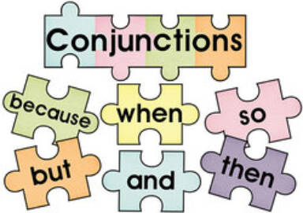
Thanks to conjunctions, we don't have to write short, choppy sentences. We can extend our lines with simple words like "and" or "but" and perhaps a comma or two. What is a conjunction? It's a joiner and so much more. Review the examples below and then download the handy chart as a reminder of each type of conjunction, its definition, and examples.

What Is a Coordinating Conjunction?
Coordinating conjunctions are what come to most people's minds when they hear the word "conjunction." They join together words, phrases, and independent clauses. With them, short and choppy sentences can be joined into fuller lines. There are seven of them, and they're easy to remember if you can just think of the acronym "FANBOYS."
- For - Explains reason or purpose (just like "because")
- And - Adds one thing to another
- Nor - Used to present an alternative negative idea to an already stated negative idea
- But - Shows contrast
- Or - Presents an alternative or a choice
- Yet - Introduces a contrasting idea that follows the preceding idea logically
- So - Indicates effect, result or consequence

Coordinating Conjunctions Used in Sentences
Here are some example sentences using the seven coordinating conjunctions:
- I go to the park every Sunday, for I love to watch the ducks on the lake.
- I watch the ducks on the lake and the shirtless men playing soccer.
- I don't go for the fresh air nor for the ducks; I just like soccer.
- Soccer is entertaining in winter, but it's better in the heat of summer.
- The men play on two teams: shirts or skins.
- I always take a book to read, yet I never seem to turn a single page.
- I'm dating one of the players, so I was

What Is a Subordinating Conjunction?
A subordinating conjunction always introduces a dependent clause, tying it to an independent clause. A dependent clause is a group of words that cannot stand alone as a complete sentence. An independent clause, by contrast, can stand alone as a complete sentence.
Unlike coordinating conjunctions, subordinate conjunctions can often come first in a sentence. This is because of the nature of the relationship between the dependent and the independent clause.
In English, there are lots of subordinating conjunctions. Here are the most common examples:
although | as | because
before | how | if
once | since | than
that | though | until
when | whenever | where
whether | while | why

Examples of Subordinating Conjunctions in a Sentence
Here are some example sentences utilizing several subordinating conjunctions:
- Because of him, I learned how to start my own business.
- Everything will fall into place if you start at the beginning,
- Until you try, you'll never know.
- I add a new entry to my gratitude journal when I wake in the morning,
- As I write this letter, I know I must say goodbye.
- Life's been so happy since I moved to Chile.

What Are Correlative Conjunctions?
Correlative conjunctions are tag-team conjunctions. They come in pairs, and you have to use both of them in different places in a sentence to make them work. These conjunctions work together (co-) and relate one sentence to another. Correlative conjunctions connect two equal grammatical terms. So, if a noun follows "both," then a noun should also follow "and."
Common pairs include:
- both/and
- whether/or
- either/or
- neither/nor
- not/but
- not only/but also

Example Sentences Using Correlative Conjunctions
To best understand how to use correlative conjunctions correctly, study these sentence examples:
- I want either the pink sofa or the purple one.
- I'll study both English literature and art history.
- I didn't know whether you'd want milk or cream, so I grabbed both.
- Why do you want to visit neither Ireland nor Scotland?
- I took not only the pink sofa but also the Tiffany lamp.
- Not the cheeseburger for me, but definitely the fries.
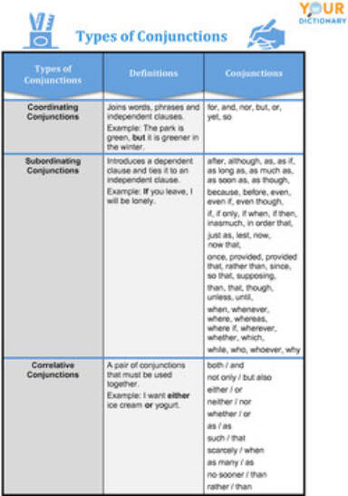

Correctly Connect with Conjunctions
Interesting, right? Perhaps correlative conjunctions are the most noteworthy. Many people forget that, if they use "not only," they must also include "but also" later in the line. For a deeper dive into these clause connectors, read Types of Conjunctions. It provides an even deeper dive into these short but mighty words. And, when you're ready to practice your skills, give these Conjunction Exercises your best shot!

