“Respiratory System of Insects”

Dr. Muhammad Asam Riaz
Assistant Professor, Entomology

University College of Agriculture,
University of Sargodha

Respiratory System of Insects
All insects are aerobic organisms and get oxygen directly from their surroundings to stay alive. They utilize oxygen to covert nutrients into the chemical energy by metabolic reactions as ATP. At the end, oxygen and hydrogen react to make H₂O and release energy that is apprehended in a phosphate bond i.e., ATP. The respiratory system transports sufficient oxygen to all parts of the body, each cell and for eliminates CO₂ that is created as a waste product of cellular respiration.
In the gigantic diversity of insects, respiration held by means of internal air tubules known as trachea. This procedure occurred by means of organs of the body and its appendages, the finest branches being termed as tracheoles. The air mainly enters the trachea through paired openings known as spiracles that are arranged segmentally along the thorax and abdomen. In the immature stages of many aquatic insects, special respiratory organ present called gills or branchiae and these may or may not linked with open spiracles.
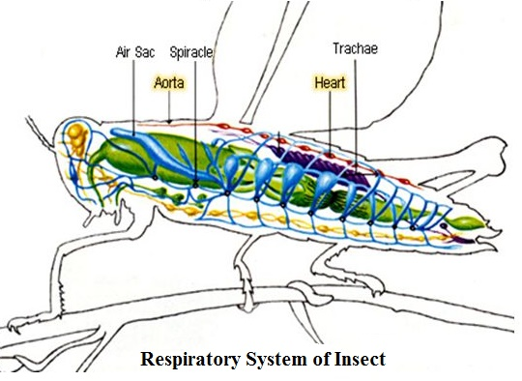
The respiratory organs of insects are developed from ectoderm: while trachea is derived from solid tubular invaginations of the layer and gills arise as hollow outgrowths. Both are composed of a layer of cuticle, the epidermis and more often a basement membrane, all directly permanent with similar layer outlining the general body wall. All or most of the cuticular lining of the trachea-spiracle systemis usually shed at ecdysis.
Tracheal system is not present in some insects like Collembola, some Protura, some endoparasitic Hymenopteran and Dipteran larvae.
Number and Arrangement of Spiracles in Insects
Spiracles are developed from the opening of ectodermal invaginations which are used for respiration and give rise to tracheal system. They are present on the lateral sides of abdomen and thorax and normally they are present inter-segments of insect body. Sometimes their location is altered. In the developed embryo, it is said to be 12 pairs of spiracles are there on thorax and first nine abdominal segments but mostly spiracles found on two pairs on thorax and eight pairs on abdomen. They may be closed or visible as fine marks.
According to number and position of spiracles, respiratory system is classified as follow:
- Holopneustis Respiratory System
This system is most ancient arrangement found in many insects. In this system 8 pairs of spiracle are found on first 8 abdominal segments while remaining 2 pairs found on metathorax and pro or mesothorax. This system is characteristics of Dipterans and some Hymenopterans.
- Hemipneustic Respiratory System:
This system is common of insect larva and in this system, out of 10 pairs of spiracle; one or two pairs are non-functional.
- Peripneustic Respiratory System:
This system is found in many terrestrial larvae of orders Neuroptera, Lepidoptera, Coleoptera, Mecoptera, and Hymenoptera in which spiracles are present in a row on each side of body. In this spiracles on abdomen are open while on metathorax are close.
- Amphipneustic Respiratory System:
Only 2 pairs of spiracles are open, one of prothorax and other spiracle is of posterior abdominal segment. Example is Dipteran’s larva.
- Propneustic Respiratory System:
Only one pair of prothoracic spiracle is functional. It is most rare and found in some pupae of Diptera family.
- Metapneustic Respiratory System:
Only last abdominal spiracles pair is functional. It is most common in 1st larval instars of aquatic Coleopetra, Family Culicidae, Tipulidae and Oestridae.
- Apneustic Respiratory System:
All spiracles are closed (closed tracheal system). In this respiration takes place by means of diffusion through gills and general body surface. It can be seen in aquatic insects like naiad of Mayfly, nymph of Ephemeroptera, Odonata and many endoparasites (Hymenoptera) that submerged in liquid substances.
In all above types of respiratory systems are classified on the bases of open and closed spiracles while other term, i.e, Hyponeustic also used in which one or more pairs of spiracles completely disappeared. For example in Mallophaga and Siphunculata, total 7 spiracles are present and in Thysanoptera only 4 pairs of spiracles found.
Structure of Spiracles:
Generally, the spiracles not only use for respiration, it is also useful for ecdysis and water loss. Spiracles have a cavity called atrium or vestibule with a closing and opening apparatus called valve. This control air passage and reduce water loss. Each spiracle is surrounded with sclerotized cuticular plate called a peritreme. Tracheae are invaginations of the epidermis and thus their lining is incessant with the body cuticle. The circlelar look of the tracheae is due to the spiral sculptur called taenidia. This permits the tracheae to be stretchy but oppose compression. Cuticular linings of the tracheae are shed down when molting occur.
Tracheae and Tracheoles:
The tracheae are elastic in nature and cuticular pipe like apparatus. When it filled with air, it shows silvery appearance in dissection. The intima or cuticular lining spread throughout the external body surface and developed from epidermis. In tracheae, thick, helical and thread like layer present to resist tracheae to compressed. A fragile basement membrane makes the outermost layer of tracheae.

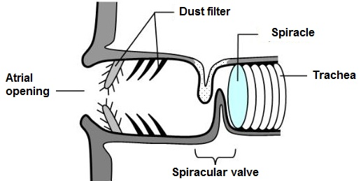
The network of tracheae is called tracheoles with a diameter less than 1µm (0.2-0.3µm). It also bears with helical thin walled taenidia that can be seen under electron microscope. Gaseous will exchange across tracheoles. There are 4 tracheal costumes i.e., lateral, ventral, dorsal and visceral, help in the passing of air.
Liquid or air present in it and anastomosis with each other and its lining not shed down on molting. Tracheoles are intracellular in structure, derived from large cells called tracheoblast. Tracheoblast independently developed from tracheal epithelium.
Air-Sacs:
In many pterous insects, the tracheae are expanded in many parts of the body to make thin walled, collapsible structure present called air sacs that act as air reservoir. The air sacs can be seen simply as shiny white vesicle when fill with air.
It affords enthusiasm to flying by lessening gravity of insects and space for growing organs. It also proceeds as sound resonator by free vibration of tympanic membrane and help in heat insulations. Moreover, it also decreases the mechanical clamming of wing actions by blood.
Physiology of Respiration:
The oxygen enters into the trachea by spiracles of terrestrial insects. By combination of ventilation movement of opening and closing of spiracle, air passes through the spiracles system. Exchange of air between tracheoles and tissues rely upon diffusion process. This progression is very slow if oxygen exceeds through fluid rather than gas phase.

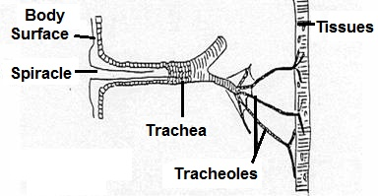
Eventually air diffuse into the tissues (each cell of the body) by concentration gradient in which air diffuse from high concentration to low concentration. As oxygen diffuse inwards of the body, likewise, carbon dioxide move outward. In respiration process, blood plays a minute role.

All respiration process is regulated by valves of spiracles that cause opening and closing of spiracles at specific frequency and intensity of air movement.
Respiration of Aquatic and Endoparasitic Insects:
Aquatic insects also need oxygen for survive. Mostly closed tracheal system is presenntThe tracheal system is varied according to the related ecosystem of the insects. In water insects, they adopted many modifications for respiration. Some are as follows:
- Cuticular Respiration
Several aquatic insects have a comparatively thin integument than terrestrial that permit diffusion of oxygen and carbon dioxide. Diffusion of oxygen may be enough to meet the metabolic activities in the body.
Larger insects, more active ones, or those living in less oxygenated water may need to rely on other adaptations (see below) to supplement cuticular respiration.
- Biological Gills
A biological gill is an appendage or outgrowth that permits liquefy oxygen from the water to insect body by the process of diffusion. In insects, gills are generally coated with layer of thin cuticle that is permeable for gasses both O₂ and CO₂.

For example, in larvae of mayflies and damselflies, gills are situated on lateral sides or posterior sides of abdomen that are leaf like in appearance. The insects are contact with water due to fanning actions of the gills.
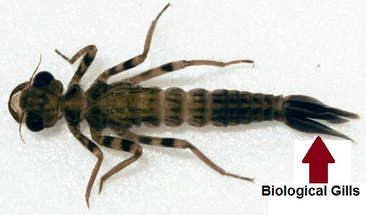

- Breathing Tubes
Several aquatic insects that submerged under the water take oxygen directly from surface by hollow tube that is called Siphon tube.

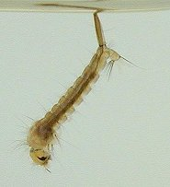

For example, in the larva of mosquito, siphon tube present on posterior side that work on the same principle as diver’s snorkel.

- Air Bubbles
Few aquatic insects have bubble of air with them when they swim under the water surface.

This bubble may cover one or more spiracle by which insects breathe from air bubble. In diving Beetles it is prominent. Air bubble gives short-term supply of oxygen.
