APA and MLA Documentation and Formatting

14.1 Formatting a Research Paper
In this chapter, you will learn how to use APA style, the documentation and formatting style followed by the American Psychological Association, as well as MLA style, from the Modern Language Association. There are a few major formatting styles used in academic texts, including AMA, Chicago, and Turabian:
- AMA (American Medical Association) for medicine, health, and biological sciences
- APA (American Psychological Association) for education, psychology, and the social sciences
- Chicago—a common style used in everyday publications like magazines, newspapers, and books
- MLA (Modern Language Association) for English, literature, arts, and humanities
- Turabian—another common style designed for its universal application across all subjects and disciplines
While all the formatting and citation styles have their own use and applications, in this chapter we focus our attention on the two styles you are most likely to use in your academic studies: APA and MLA.
If you find that the rules of proper source documentation are difficult to keep straight, you are not alone. Writing a good research paper is, in and of itself, a major intellectual challenge. Having to follow detailed citation and formatting guidelines as well may seem like just one more task to add to an already-too-long list of requirements.
Following these guidelines, however, serves several important purposes. First, it signals to your readers that your paper should be taken seriously as a student’s contribution to a given academic or professional field; it is the literary equivalent of wearing a tailored suit to a job interview. Second, it shows that you respect other people’s work enough to give them proper credit for it. Finally, it helps your reader find additional materials if he or she wishes to learn more about your topic.
Furthermore, producing a letter-perfect APA-style paper need not be burdensome. Yes, it requires careful attention to detail. However, you can simplify the process if you keep these broad guidelines in mind:
- Work ahead whenever you can.Chapter 10 "Writing Preparation" includes tips for keeping track of your sources early in the research process, which will save time later on.
- Get it right the first time. Apply APA guidelines as you write, so you will not have much to correct during the editing stage. Again, putting in a little extra time early on can save time later.
- Use the resources available to you. In addition to the guidelines provided in this chapter, you may wish to consult the APA website at http://www.apa.org or the Purdue University Online Writing lab at http://owl.english.purdue.edu, which regularly updates its online style guidelines.

General Formatting Guidelines
This chapter provides detailed guidelines for using the citation and formatting conventions developed by the American Psychological Association, or APA. Writers in disciplines as diverse as astrophysics, biology, psychology, and education follow APA style. The major components of a paper written in APA style are listed in the following box.
These are the major components of an APA-style paper:
- Title page
- Abstract
- Body, which includes the following:
  - Headings and, if necessary, subheadings to organize the content
  - In-text citations of research sources
- References page
All these components must be saved in one document, not as separate documents.

Title Page
The title page of your paper includes the following information:
- Title of the paper
- Author’s name
- Name of the institution with which the author is affiliated
- Header at the top of the page with the paper title (in capital letters) and the page number (If the title is lengthy, you may use a shortened form of it in the header.)
List the first three elements in the order given in the previous list, centered about one third of the way down from the top of the page. Use the headers and footers tool of your word-processing program to add the header, with the title text at the left and the page number in the upper-right corner. Your title page should look like the following example.
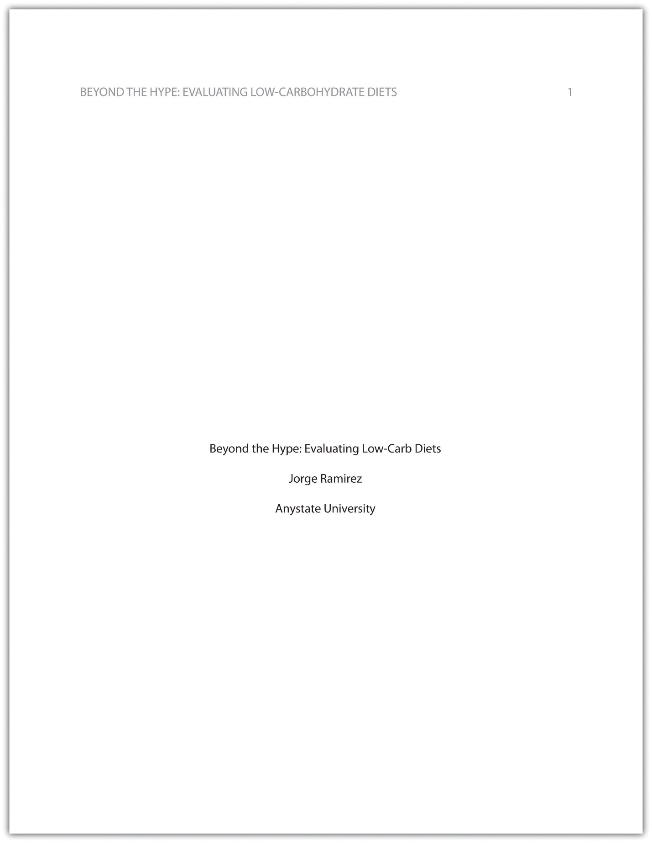

Abstract
The next page of your paper provides an abstract, or brief summary of your findings. An abstract does not need to be provided in every paper, but an abstract should be used in papers that include a hypothesis. A good abstract is concise—about one hundred to one hundred fifty words—and is written in an objective, impersonal style. Your writing voice will not be as apparent here as in the body of your paper. When writing the abstract, take a just-the-facts approach, and summarize your research question and your findings in a few sentences.
In Chapter 11 "Writing", you read a paper written by a student named Jorge, who researched the effectiveness of low-carbohydrate diets. Read Jorge’s abstract. Note how it sums up the major ideas in his paper without going into excessive detail.
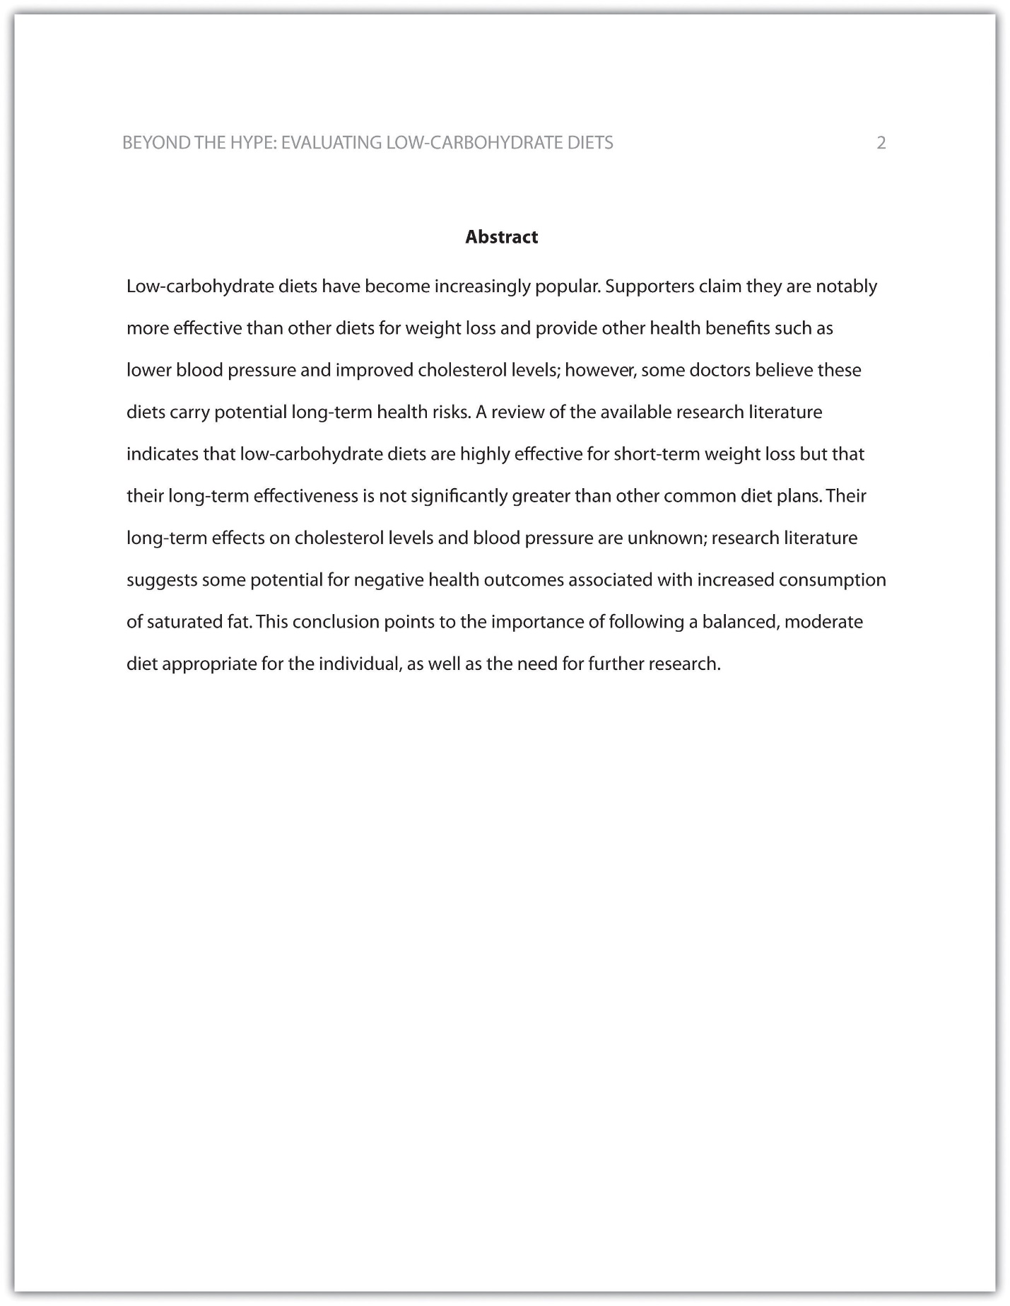

EXERCISE 1
Write an abstract summarizing your paper. Briefly introduce the topic, state your findings, and sum up what conclusions you can draw from your research. Use the word count feature of your word-processing program to make sure your abstract does not exceed one hundred fifty words.

Tip
Depending on your field of study, you may sometimes write research papers that present extensive primary research, such as your own experiment or survey. In your abstract, summarize your research question and your findings, and briefly indicate how your study relates to prior research in the field.

Margins, Pagination, and Headings
APA style requirements also address specific formatting concerns, such as margins, pagination, and heading styles, within the body of the paper. Review the following APA guidelines.
Use these general guidelines to format the paper:
- Set the top, bottom, and side margins of your paper at 1 inch.
- Use double-spaced text throughout your paper.
- Use a standard font, such as Times New Roman or Arial, in a legible size (10- to 12-point).
- Use continuous pagination throughout the paper, including the title page and the references section. Page numbers appear flush right within your header.
- Section headings and subsection headings within the body of your paper use different types of formatting depending on the level of information you are presenting. Additional details from Jorge’s paper are provided.
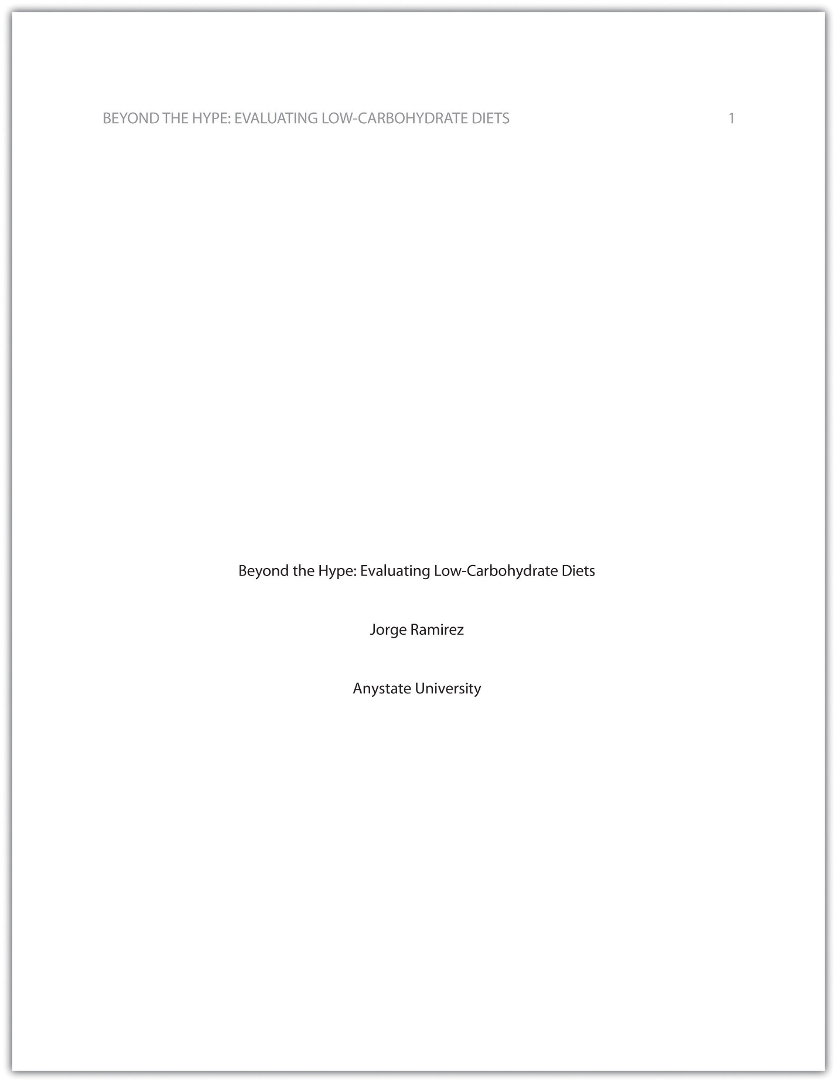
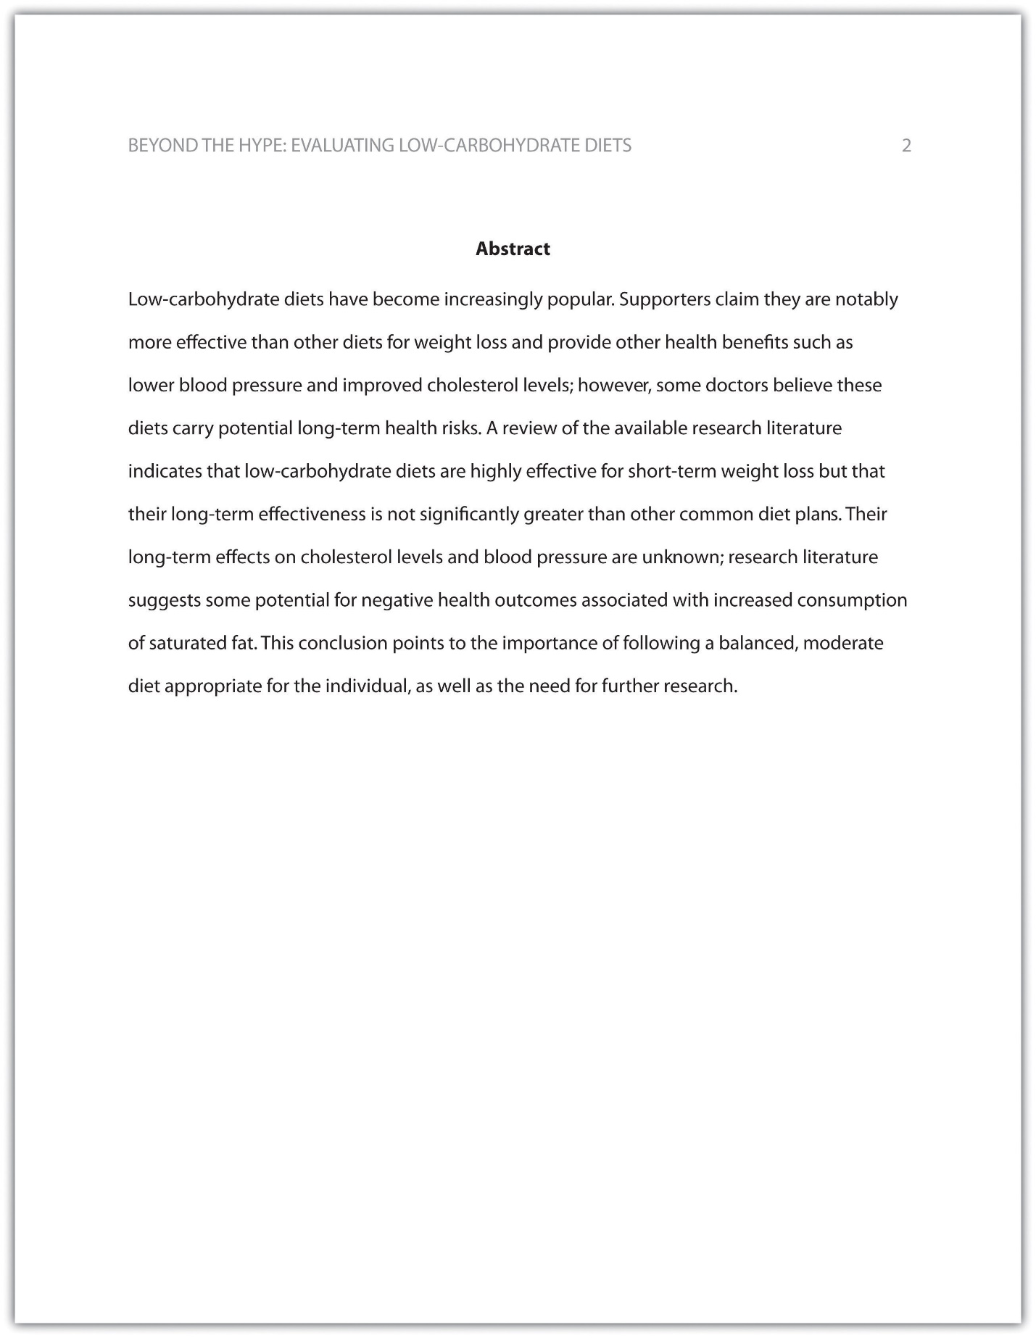

EXERCISE 2
Begin formatting the final draft of your paper according to APA guidelines. You may work with an existing document or set up a new document if you choose. Include the following:
- Your title page
- The abstract you created in Note 14.8 "Exercise 1"
- Correct headers and page numbers for your title page and abstract

Headings
APA style uses section headings to organize information, making it easy for the reader to follow the writer’s train of thought and to know immediately what major topics are covered. Depending on the length and complexity of the paper, its major sections may also be divided into subsections, sub-subsections, and so on. These smaller sections, in turn, use different heading styles to indicate different levels of information. In essence, you are using headings to create a hierarchy of information.
The following heading styles used in APA formatting are listed in order of greatest to least importance:
- Section headings use centered, boldface type. Headings use title case, with important words in the heading capitalized.
- Subsection headings use left-aligned, boldface type. Headings use title case.
- The third level uses left-aligned, indented, boldface type. Headings use a capital letter only for the first word, and they end in a period.
- The fourth level follows the same style used for the previous level, but the headings are boldfaced and italicized.
- The fifth level follows the same style used for the previous level, but the headings are italicized and not boldfaced.
Visually, the hierarchy of information is organized as indicated in Table 14.1 "Section Headings".

Table 14.1 Section Headings
Level of Information | Text Example
Level 1 | Heart Disease
Level 2 | Lifestyle Factors That Reduce Heart Disease Risk
Level 3 | Exercising regularly.
Level 4 | Aerobic exercise.
Level 5 | Country line dancing.
A college research paper may not use all the heading levels shown in Table 14.1 "Section Headings", but you are likely to encounter them in academic journal articles that use APA style. For a brief paper, you may find that level 1 headings suffice. Longer or more complex papers may need level 2 headings or other lower-level headings to organize information clearly. Use your outline to craft your major section headings and determine whether any subtopics are substantial enough to require additional levels of headings.

EXERCISE 3
Working with the document you developed in Note 14.11 "Exercise 2", begin setting up the heading structure of the final draft of your research paper according to APA guidelines. Include your title and at least two to three major section headings, and follow the formatting guidelines provided above. If your major sections should be broken into subsections, add those headings as well. Use your outline to help you.
Because Jorge used only level 1 headings, his Exercise 3 would look like the following:
Level of Information | Text Example
Level 1 | Purported Benefits of Low-Carbohydrate Diets
Level 1 | Research on Low-Carbohydrate Diets and Weight Loss
Level 1 | Other Long-Term Health Outcomes
Level 1 | Conclusion

Citation Guidelines

In-Text Citations
Throughout the body of your paper, include a citation whenever you quote or paraphrase material from your research sources. As you learned in Chapter 10 "Writing Preparation", the purpose of citations is twofold: to give credit to others for their ideas and to allow your reader to follow up and learn more about the topic if desired. Your in-text citations provide basic information about your source; each source you cite will have a longer entry in the references section that provides more detailed information.
In-text citations must provide the name of the author or authors and the year the source was published. (When a given source does not list an individual author, you may provide the source title or the name of the organization that published the material instead.) When directly quoting a source, it is also required that you include the page number where the quote appears in your citation.
This information may be included within the sentence or in a parenthetical reference at the end of the sentence, as in these examples.
Epstein (2010) points out that “junk food cannot be considered addictive in the same way that we think of psychoactive drugs as addictive” (p. 137).
Here, the writer names the source author when introducing the quote and provides the publication date in parentheses after the author’s name. The page number appears in parentheses after the closing quotation marks and before the period that ends the sentence.
Addiction researchers caution that “junk food cannot be considered addictive in the same way that we think of psychoactive drugs as addictive” (Epstein, 2010, p. 137).
Here, the writer provides a parenthetical citation at the end of the sentence that includes the author’s name, the year of publication, and the page number separated by commas. Again, the parenthetical citation is placed after the closing quotation marks and before the period at the end of the sentence.
As noted in the book Junk Food, Junk Science (Epstein, 2010, p. 137), “junk food cannot be considered addictive in the same way that we think of psychoactive drugs as addictive.”
Here, the writer chose to mention the source title in the sentence (an optional piece of information to include) and followed the title with a parenthetical citation. Note that the parenthetical citation is placed before the comma that signals the end of the introductory phrase.
David Epstein’s book Junk Food, Junk Science (2010) pointed out that “junk food cannot be considered addictive in the same way that we think of psychoactive drugs as addictive” (p. 137).
Another variation is to introduce the author and the source title in your sentence and include the publication date and page number in parentheses within the sentence or at the end of the sentence. As long as you have included the essential information, you can choose the option that works best for that particular sentence and source.
Citing a book with a single author is usually a straightforward task. Of course, your research may require that you cite many other types of sources, such as books or articles with more than one author or sources with no individual author listed. You may also need to cite sources available in both print and online and nonprint sources, such as websites and personal interviews. Chapter 14 "APA and MLA Documentation and Formatting", Section 14.2 "Citing and Referencing Techniques" and Section 14.3 "Creating a References Section" provide extensive guidelines for citing a variety of source types.

Writing at Work
APA is just one of several different styles with its own guidelines for documentation, formatting, and language usage. Depending on your field of interest, you may be exposed to additional styles, such as the following:
- MLA style. Determined by the Modern Languages Association and used for papers in literature, languages, and other disciplines in the humanities.
- Chicago style. Outlined in the Chicago Manual of Style and sometimes used for papers in the humanities and the sciences; many professional organizations use this style for publications as well.
- Associated Press (AP) style. Used by professional journalists.

References List
The brief citations included in the body of your paper correspond to the more detailed citations provided at the end of the paper in the references section. In-text citations provide basic information—the author’s name, the publication date, and the page number if necessary—while the references section provides more extensive bibliographical information. Again, this information allows your reader to follow up on the sources you cited and do additional reading about the topic if desired.
The specific format of entries in the list of references varies slightly for different source types, but the entries generally include the following information:
- The name(s) of the author(s) or institution that wrote the source
- The year of publication and, where applicable, the exact date of publication
- The full title of the source
- For books, the city of publication
- For articles or essays, the name of the periodical or book in which the article or essay appears
- For magazine and journal articles, the volume number, issue number, and pages where the article appears
- For sources on the web, the URL where the source is located
The references page is double spaced and lists entries in alphabetical order by the author’s last name. If an entry continues for more than one line, the second line and each subsequent line are indented five spaces. Review the following example. (Chapter 14 "APA and MLA Documentation and Formatting", Section 14.3 "Creating a References Section" provides extensive guidelines for formatting reference entries for different types of sources.)
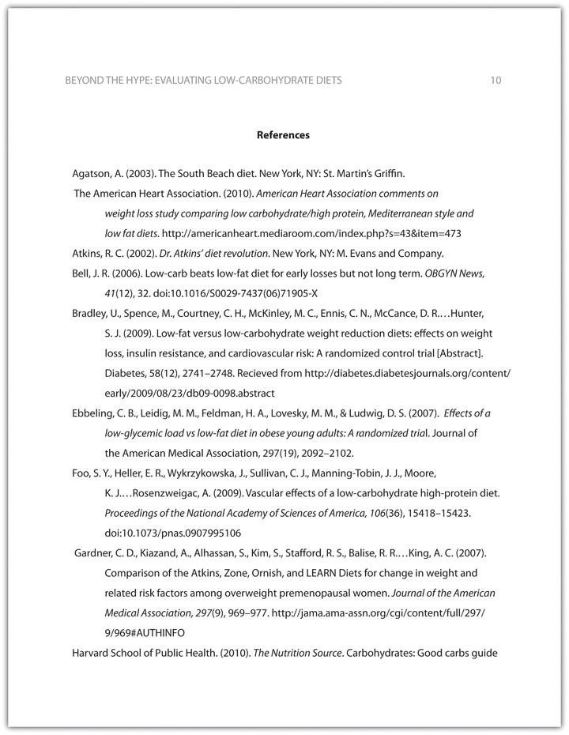
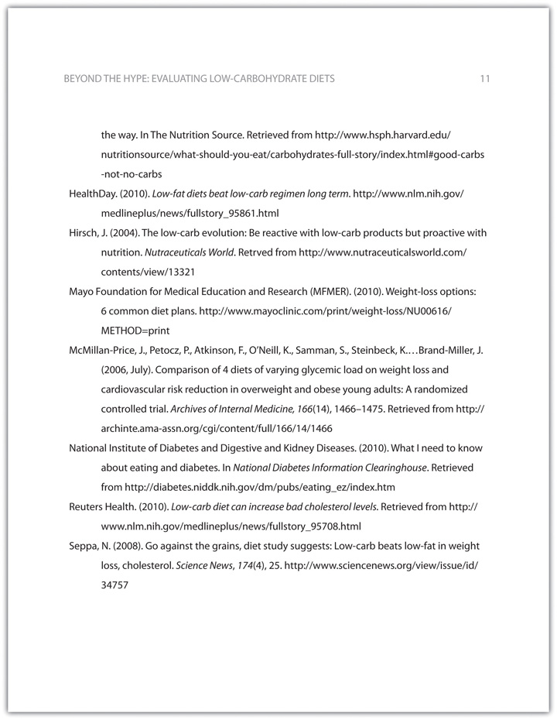
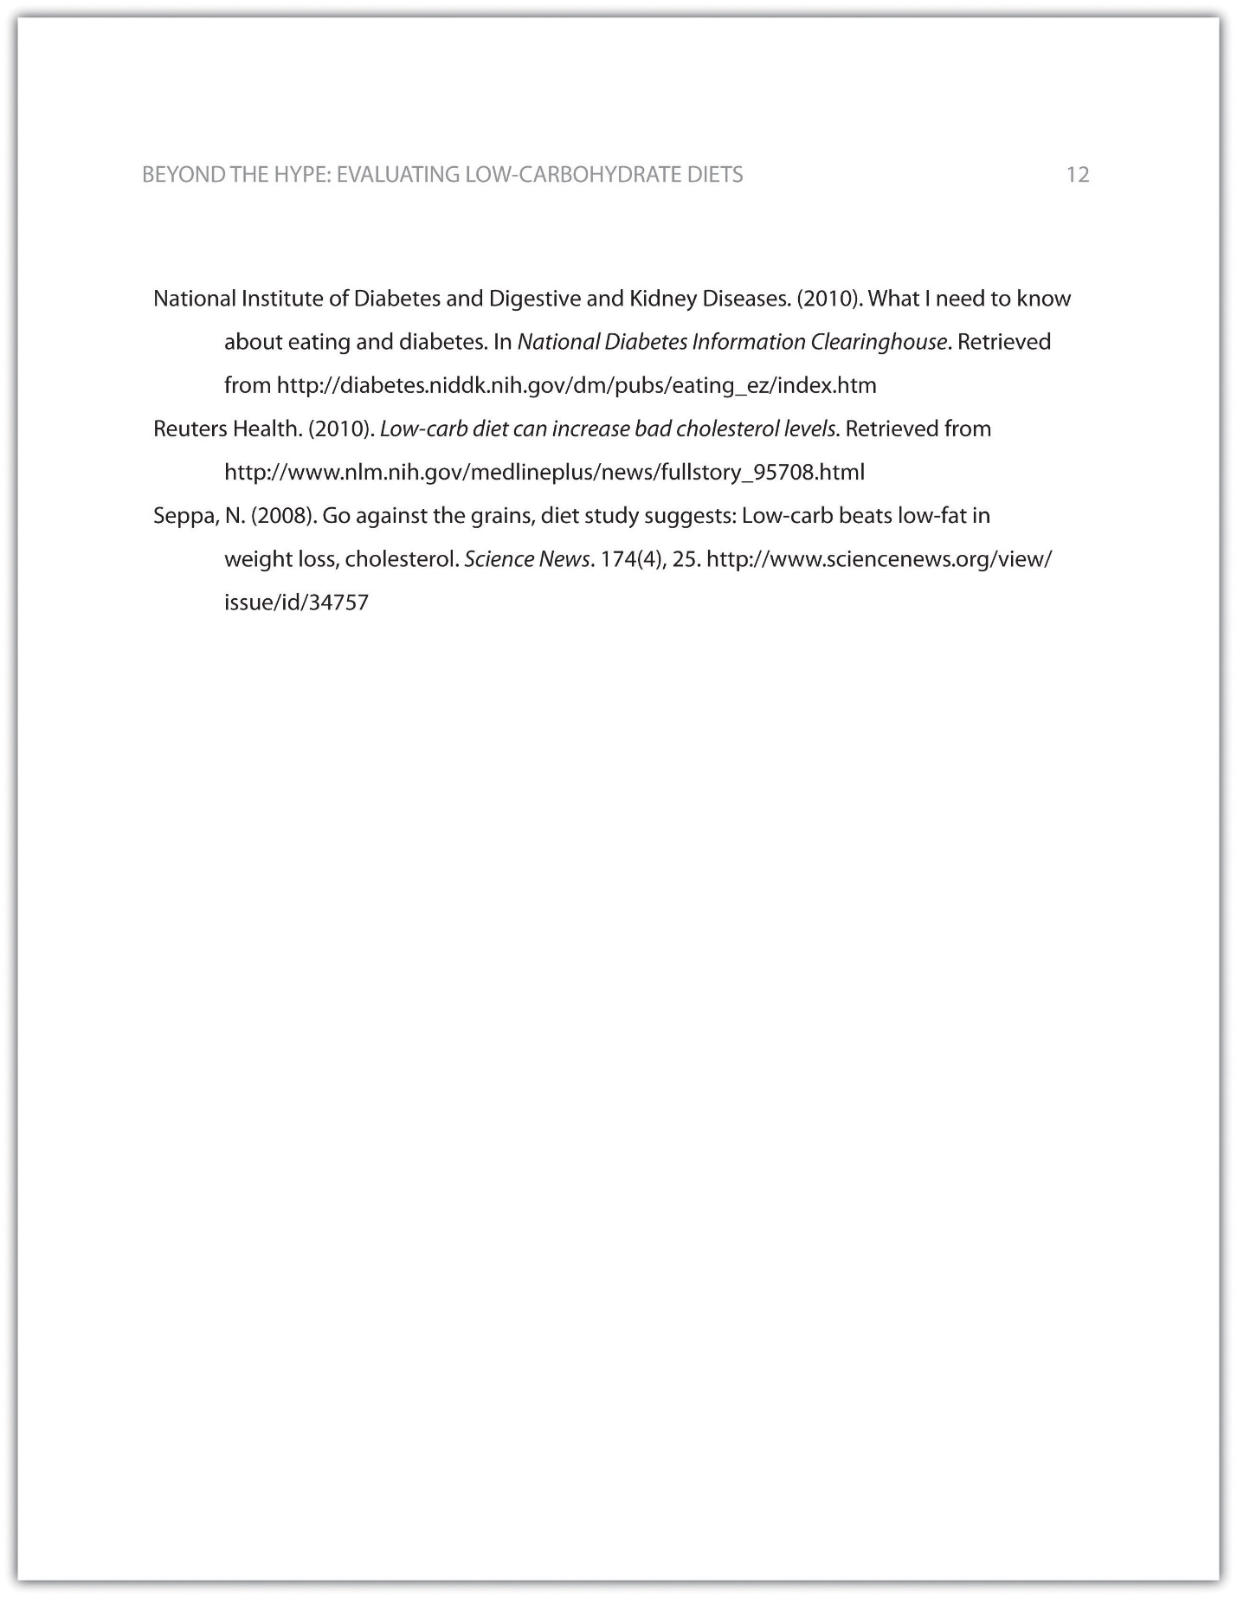

Tip
In APA style, book and article titles are formatted in sentence case, not title case. Sentence case means that only the first word is capitalized, along with any proper nouns.

KEY TAKEAWAYS
- Following proper citation and formatting guidelines helps writers ensure that their work will be taken seriously, give proper credit to other authors for their work, and provide valuable information to readers.
- Working ahead and taking care to cite sources correctly the first time are ways writers can save time during the editing stage of writing a research paper.
- APA papers usually include an abstract that concisely summarizes the paper.
- APA papers use a specific headings structure to provide a clear hierarchy of information.
- In APA papers, in-text citations usually include the name(s) of the author(s) and the year of publication.
- In-text citations correspond to entries in the references section, which provide detailed bibliographical information about a source.

14.2 Citing and Referencing Techniques

LEARNING OBJECTIVE
- Apply American Psychological Association (APA) style formatting guidelines for citations.
This section covers the nitty-gritty details of in-text citations. You will learn how to format citations for different types of source materials, whether you are citing brief quotations, paraphrasing ideas, or quoting longer passages. You will also learn techniques you can use to introduce quoted and paraphrased material effectively. Keep this section handy as a reference to consult while writing the body of your paper.

Formatting Cited Material: The Basics
As noted in previous sections of this book, in-text citations usually provide the name of the author(s) and the year the source was published. For direct quotations, the page number must also be included. Use past-tense verbs when introducing a quote—“Smith found…” and not “Smith finds.…”

Formatting Brief Quotations
For brief quotations—fewer than forty words—use quotation marks to indicate where the quoted material begins and ends, and cite the name of the author(s), the year of publication, and the page number where the quotation appears in your source. Remember to include commas to separate elements within the parenthetical citation. Also, avoid redundancy. If you name the author(s) in your sentence, do not repeat the name(s) in your parenthetical citation. Review following the examples of different ways to cite direct quotations.
Chang (2008) emphasized that “engaging in weight-bearing exercise consistently is one of the single best things women can do to maintain good health” (p. 49).
The author’s name can be included in the body of the sentence or in the parenthetical citation. Note that when a parenthetical citation appears at the end of the sentence, it comes after the closing quotation marks and before the period. The elements within parentheses are separated by commas.
Weight Training for Women (Chang, 2008) claimed that “engaging in weight-bearing exercise consistently is one of the single best things women can do to maintain good health” (p. 49).
Weight Training for Women claimed that “engaging in weight-bearing exercise consistently is one of the single best things women can do to maintain good health” (Chang, 2008, p. 49).
Including the title of a source is optional.
In Chang’s 2008 text Weight Training for Women, she asserts, “Engaging in weight-bearing exercise is one of the single best things women can do to maintain good health” (p. 49).
The author’s name, the date, and the title may appear in the body of the text. Include the page number in the parenthetical citation. Also, notice the use of the verb asserts to introduce the direct quotation.
“Engaging in weight-bearing exercise,” Chang asserts, “is one of the single best things women can do to maintain good health” (2008, p. 49).
You may begin a sentence with the direct quotation and add the author’s name and a strong verb before continuing the quotation.

Formatting Paraphrased and Summarized Material
When you paraphrase or summarize ideas from a source, you follow the same guidelines previously provided, except that you are not required to provide the page number where the ideas are located. If you are summing up the main findings of a research article, simply providing the author’s name and publication year may suffice, but if you are paraphrasing a more specific idea, consider including the page number.
Read the following examples.
Chang (2008) pointed out that weight-bearing exercise has many potential benefits for women.
Here, the writer is summarizing a major idea that recurs throughout the source material. No page reference is needed.
Chang (2008) found that weight-bearing exercise could help women maintain or even increase bone density through middle age and beyond, reducing the likelihood that they will develop osteoporosis in later life (p. 86).
Although the writer is not directly quoting the source, this passage paraphrases a specific detail, so the writer chose to include the page number where the information is located.

Tip
Although APA style guidelines do not require writers to provide page numbers for material that is not directly quoted, your instructor may wish you to do so when possible.
Check with your instructor about his or her preferences.

Formatting Longer Quotations
When you quote a longer passage from a source—forty words or more—use a different format to set off the quoted material. Instead of using quotation marks, create a block quotation by starting the quotation on a new line and indented five spaces from the margin. Note that in this case, the parenthetical citation comes after the period that ends the sentence. Here is an example:
In recent years, many writers within the fitness industry have emphasized the ways in which women can benefit from weight-bearing exercise, such as weightlifting, karate, dancing, stair climbing, hiking, and jogging. Chang (2008) found that engaging in weight-bearing exercise regularly significantly reduces women’s risk of developing osteoporosis. Additionally, these exercises help women maintain muscle mass and overall strength, and many common forms of weight-bearing exercise, such as brisk walking or stair climbing, also provide noticeable cardiovascular benefits. (p. 93)

