CALVIN CYCLE AND CAM CYCLE

- CALVIN CYCLE

- Calvin cycle is a light independent reaction of photosynthesis

Which take place in the absence of light

- Light directly does not effect it ,but uses the energy of light reactions product like ATP and NADPH

- it is also known as C3 cycle because the first product is a 3-carbon compound.

- It is a series of reaction in which carbon is fixed and reduced, and synthesis of sugar take place.

Process of Calvin cycle

• CO2 is absorbed bythe • Plant andreact with the
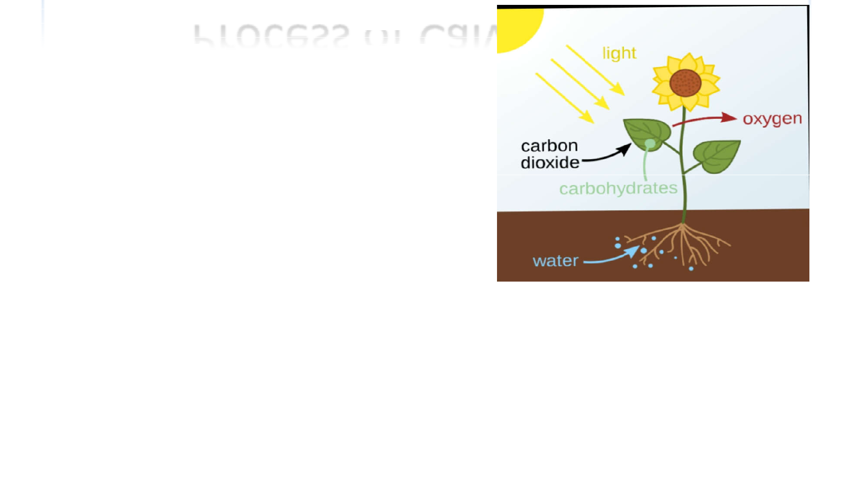
- 5-carbon compound called a

- (RUBP).

- This process is carried by the

- Enzyme called RUBISCO, and it

- catalyze the process.

- Then the intermediate obtained

- break into 3-carbon compound which is known as phosphoglycerate or PGA.

•

Reduction of carbon

- Now the carbon which is a part of carbon dioxide, now it become a part of an organic compound, so we can say that the carbon is fixed.

- Now the process of reduction take place.

- PGA molecule receive a ATP and after a process it convert into G3P molecule.
- It is the same molecule which is also produced during the first phase of respiration by breaking of glucose molecule.

- Only one molecule of G3P leaves the cycle and then produce a organic compound.

Regeneration of carbon dioxide

- From this series of reaction the other 5 molecules are rearranged and form a three molecules of 5-C ribose phosphate (RUP).

- By the addition of another phosphate group this convert into RUBP.

- This is the five-carbon acceptor of carbon dioxide from which the whole cycle started.

- This is produced again and the cycle continues.

- Three molecules of ATP from light reaction are again used in this process for the addition of phosphate.

- Thus the acceptor of CO2 is regenerated.

Representation of Calvin cycle

- The in put of this cycle Is a 3 molecules of CO2.

- The output of this process is Is a G3P molecule which produce a carbohydrate, Sucrose, glucose or starch.

- It is called a dark reaction Light independent reaction Of photosynthesis.
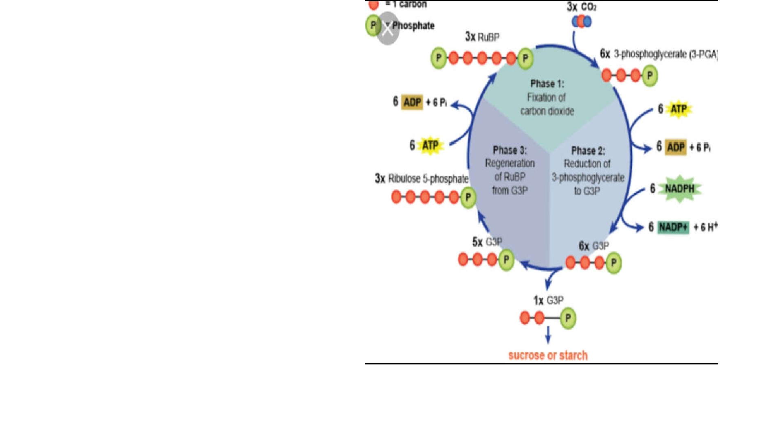

CAM CYCLE
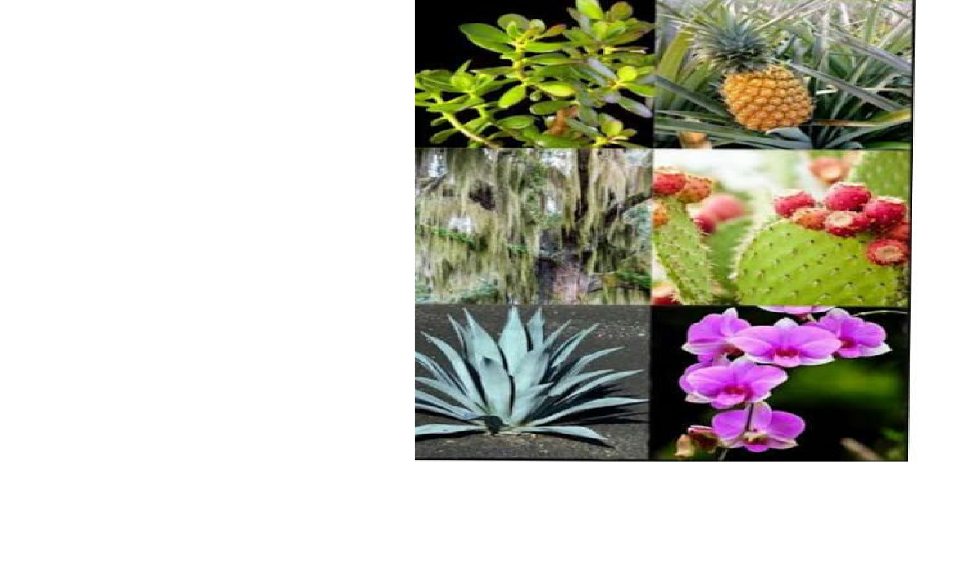

- CAM stand for

(CRASSULACEAN ACID METABOLISM) discovered in succulent plants of CRASSULACEAE family, including limited families.

- It is the changed Mechanism Of C4 photosynthesis, for the Assimilation of CO2.

Process of CAM Cycle

- Carbon dioxide is accepted by a compound which is called a PEP 3-Carbon Compound, during night period and create a 4-carbon compound called a Oxaloacetate.

- This 4- carbon compound is then converted into 4-carbon malate.

- This 4-carbon malate is converted into pyruvate molecule and carbon dioxide during the day time.

- And the CO2 produce is entered into a Calvin cycle and play role in the synthesis of sugars.

- Pyruvate molecule is again converted into PEP compound which acceptor the carbon dioxide.

Representation of CAM Cycle
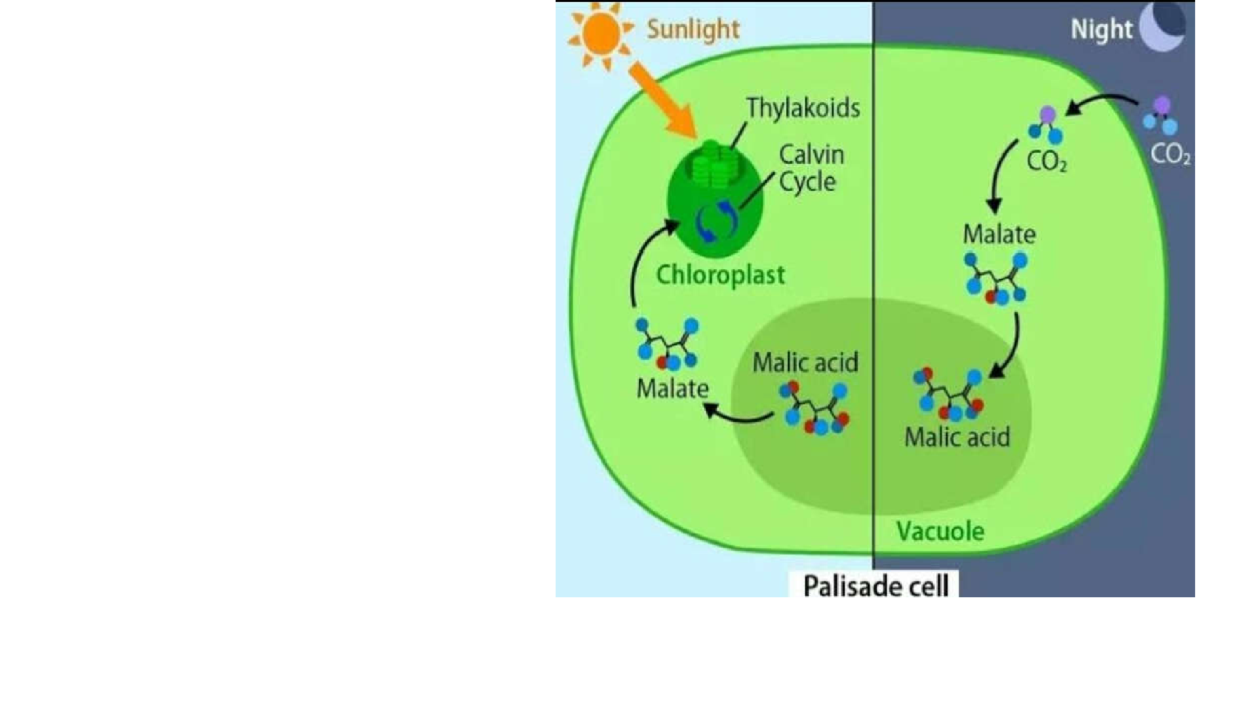

- The malate is produce , during the process is stored in the vacuole of plant, in form of malic acid.

- During the day time, acid is Covert into malate and then e Enter into chloroplast .

- Release carbon dioxide is Used in the Calvin cycle so, Related to the C3 cycle.

Adaptive Perspective

- it is consider that CAM photosynthesis is a adaptive method of photosynthesis in the succulent plants.

- In this process stomata are open during night and carbon dioxide is assimilated. And stomata remains close during the day time.

- This adaptive process to prevent water loss in xerophytes.

- It produce acid and store it in the vacuoles so called

CRASSULACEAN ACID MECHANISM.

- It is consider that CAM cycle of photosynthesis is derieved from C3 photosynthesis.

- It is also called a day-night cycle.

Difference between C3 and CAM cycle

C3 cycle CAM CYCLE

•CALVIN CYCLE is seen in all photosynthetic plants.

•Photorespiration is present in high rate

•CAM cycle is followed by semi-arid conditions plants.

•Photorespiration can be detected during afternoon.

•For glucose production 12 NADPH and 18 ATPS are required.

•Optimum temperature for photosynthesis is 15-35₀.

•RUBP is a enzyme which is used for this process.

•First stable product is 3-phosphoglycerate.

•12 NADPH and 39 ATP are required for glucose production.

•Optimum temperature for photosynthesis is greater than 40ₒ.

•In dark PEP CARBOXYLASE is used while in light RUBP CARBOXYLASE.

•First stable product is 4C.oxaloacetate in night and 3-PGA at day time.

Examples

- The C3 plants are;

- Sunflower

- Beans

- Cotton etc.

- The CAM plants are;

- Cacti

- Orchids

- Pineapple

- Wax plant etc.

