Practical 3

Adding Resources
- Open practical2.mpp file (if it is not already open) and save to a file called practical3.mpp. You now have a copy of your work to use in practica3.mpp. You will use practical3.mpp as the starting point for this week’s practical.

Create the resource pool
- If it is not already open, open practical3.mpp by double clicking on the file.
- Make sure you are using the Gantt chart view.
- Select the “Resource Sheet” option from the View ribbon. In the table that is displayed, you should see columns for the resource name, type, material label, initials, group, max units, std rate etc. If this is not the table you see displayed, select Entry from the Tables drop-down list in the Data group on the View ribbon.
- Add the information about the resources for the project. The resource could include both workers and materials such as equipment hire. In our example we only have to add the staff responsible for the tasks. The staff resources that are available for our example project are listed below. Enter them in the resource table now.
Resource Name | Type | Max Units | Std. Rate | Accrue At | Base calendar
Programmer | Work | 200% | $80,000/yr | Prorated | standard
Analyst | Work | 100% | $120,000/yr | Prorated | standard
Hardware engineer | Work | 100% | $110,000/yr | Prorated | standard
Marketing specialist | Work | 100% | $120,000/yr | Prorated | standard
Purchasing agent | Work | 100% | $75,000/yr | Prorated | standard
Tester | Work | 200% | $100,000/yr | Prorated | standard
Senior Programmer | Work | 50% | $120,000/yr | Prorated | standard
Graphic Designer | Work | 100% | $100,000/yr | Prorated | standard
Admin Assistant | Work | 100% | $50,000/yr | Prorated | standard
printer | Work | 100% | $60,000/yr | Prorated | standard

- Note that:
  - You enter the resource units into Microsoft Project as a percentage. The default percentage is 100%. 100% indicates that there is one of those resources available. If, as in the case of programmers, there are 2 available, you enter 200%. Similarly, if there was a full-time programmer and one part-time (or 0.5 time) programmer available, you would enter 150%. (This assumes that someone working 50% is there for half a day every day. If this was not the case you may have to “fine tune” this resource information and allocation.) When you group resources together in this way it means that they are interchangeable, i.e. all programmers can do the same work, have the same skill level and get the same salary. If you need to make a distinction then you should enter the details of the different resources separately.
  - It is easy to switch between hourly and annual pay rate. If you enter the numeric value/yr, the entry will be an annual pay rate.
  - If you entered an hourly rate, then that group could qualify for overtime rates which would then be entered in the “Ovt rate” column.
  - In the “Accrue at” column, there are various options available in the drop down list: start, prorated, end. Prorated means that the cost/payment is accrued on a day to day basis. Start means payment is required at the start. End means the payment is required when the work is complete.
  - The calendar can also be changed for each resource entry. This would allow you to take into account the differences in availability of work groups or individuals in the project.

Assigning resources
- Return to the Gantt chart view and click the Resource tab.
Note that there is an icon on the toolbar that is for assigning resources. (It has the appearance of the head and shoulders of two people.)
- Click the “Information Gathering” task in your project (in the task list). You are now going to assign resource to this information gathering task. Click on the “assign resources” icon on the toolbar. In the pop-up window that appears you will see all the resources available for the project.
- Select analyst and click on the assign button. The analyst is going to work with the marketing specialist on the information gathering task, so you must now select marketing specialists and click on the assign button again.
Notice that although the number of resources have increased, the duration of the task has not been reduced. This is because Microsoft Project 2010 (and 2013) sets automatically scheduled tasks to “fixed units” that are not “effort driven”. (In previous versions of Microsoft Project the default setting was different.)
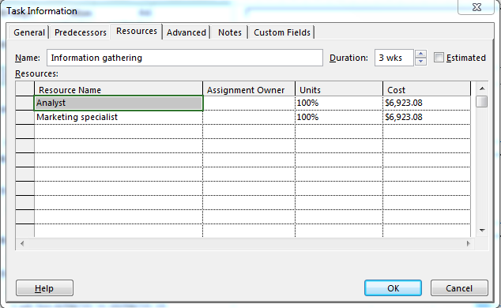

If the task was effort driven, then the additional resource would have reduced the duration for the task accordingly.
Microsoft Project uses resource and assignment information when calculating the schedule. It takes into account things such as:
- The amount of work or overtime a resource is allocated.
- The task type.
  - Fixed unit – “A task in which the assigned units [or resources] is a fixed value and any changes to the amount of work or the task's duration do not affect the task's units. This is calculated as follows: Duration x Units = Work” (Microsoft Help, 2010)
  - Fixed duration – “A task in which the duration is a fixed value and any changes to the work or the assigned units [that is, resources] don't affect the task's duration. This is calculated as follows: Duration x Units = Work.” (Microsoft Help, 2010)
  - Fixed work –“A task in which the amount of work is a fixed value and any changes to the task's duration or the number of assigned units [or resources] do not affect the task's work. This is calculated as follows: Duration x Units = Work.” (Microsoft Help, 2010)
- Whether or not the task is effort driven. “If a task is effort-driven, as resources are added or removed on the assignment, the work remains constant for the task and is redistributed among the resources. For fixed-unit tasks, for example, one result is that if more resources are assigned, a shorter duration is required to complete the task” (Microsoft Help, 2010)
- The resource calendar.
You may have read the details about “How do resource assignments drive the schedule?” when you read the “How scheduling works in Project” article in Microsoft Help that was referred to earlier in these practicals. If not, read this now and experiment with the various options to make sure that you understand them. (To modify a task type, double click on the task, Select the “Advanced” tab in the “Tasks Information” pop up window and select the task type from the drop down list. Note that there is also a check box to allow you to select whether or not you want the task to be “effort driven”.)
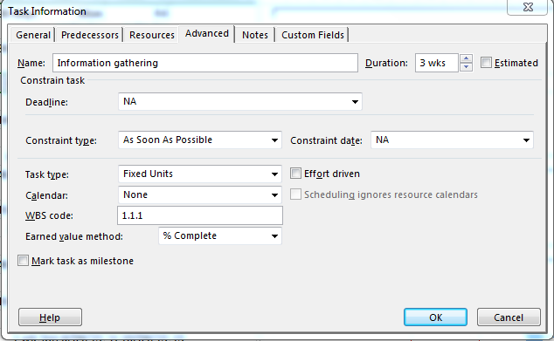

Try different combinations such as:
- Fixed unit, effort driven
  - Add a new resource – what happens to the duration?
  - Reduce one of the resources to 50% – what happens to the duration?
etc.
The various options are described in detail in the Microsoft Project “Help” on “How scheduling works in Project” article referred to earlier in the practicals.
Make sure that you understand the various options and the results of your experimentation. If you believe that Microsoft Project has modified your schedule in a way that does not correspond to the requirements for your project, you can override the duration etc. (Note that manually scheduled tasks cannot be set to effort-driven.)
- If necessary, reset the default for the task you have been experimenting with to automatically scheduled and “fixed units” that are not “effort driven”
- In our example, the information gathering task is to take 3 weeks (15 working days) with both the analyst and marketing specialist working on this together (and both allocated 100% to this task). Make sure that this is correct in your schedule.
Always take care when you modify resource assignments. Check that the result is the desired duration and resource allocation for your project. You should also check that resources are not over-allocated. This will be discussed further in the next section.
- Add the following resources to the project tasks. Note that the task durations are also given in the table. If necessary override the durations to correspond to the data in the table below. Also, note that there is an alternative method for adding a resource. You can select the resource from the drop down list of available resources that you observe when you click in the resource column for a particular task.
Task names | Durations | Resources
New Billing System
Requirements Analysis
Information gathering | 3 weeks | 1 analyst and 1 marketing specialist
Define Requirements | 3 weeks | 1 analyst and 1 marketing specialist
Disk Storage Upgrade
Purchase | 1 day (lag of 10 days for delivery introduced earlier) | I purchasing agent
Install | 3 days | 1 hardware engineer
Software Modifications
Database
Design DB Changes | 2 weeks | 1 analyst
Modify DB | 1 week | 0.5 senior programmer
Programs
Design Programs | 3 weeks | 1 analyst
Program A
Code program A | 2 weeks | 1 programmer
Unit test A | 1 week | 1 tester
Program B
Code program B | 4 weeks | 1 programmer
Unit test B | 2 weeks | 1 tester
Program C
Code program C | 3 weeks | 1 programmer
Unit test C | 2 weeks | 1 tester
Program D
Code program D | 3 weeks | 1 programmer
Unit test D | 2 weeks | 1 tester
Program R1
Code program R1 | 2 weeks | 1 programmer
Unit test R1 | 1 weeks | 1 tester
Integration
Integrate | 2 weeks | 0.5 Senior Programmer, 1 programmer
test | 1 week | 0.5 senior programmer, 1 tester
Advertising Brochures
Design | 2 weeks | 1 graphic designer, 1 marketing specialist
print | 1 day | 1 printer
Mail out | 1 day | 1 admin assistance

- If you do not wish to allocate 100% of a resource to a particular task (e.g. if you want the resource to work 50% on one task and 50% on another task for a particular period of time), it is possible to specify this.
- Double click on the “mail out” task. You will see a “Task Information” pop-up window.
- Click on the Resources tab. You can now adjust the units in the “Units” column. Try changing the units for the admin assistant now. Click ok and note any changes. Did anything happen to the duration and/or cost for this task? Explain.
___________________________________________________________________________
- Change the units for the admin assistant back to their original value.
Note that some of the tasks now have a red symbol in the “i” column to indicate that they use resources that are now over-allocated. You will learn about some techniques to help resolve those issues in the next section.

Adjusting Resource Allocation

Identification of resource over-allocation
- Select the View tab and click on “Resource Sheet” in the Resource Views group. You should now see a view of the resource sheet. In this view, you should see the over- allocated resources displayed in red. Are any of your resources over-allocated for this project?
(The programmers, analysts and testers should be displayed in red because they are over- allocated.)
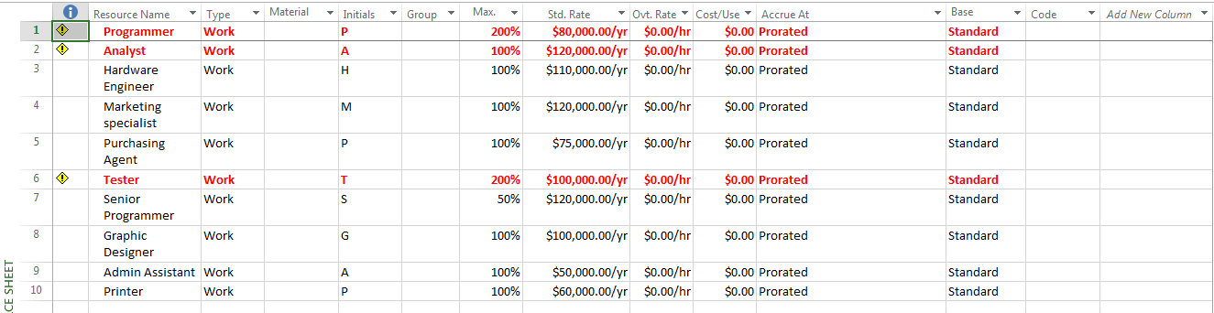
- To obtain more information about the over-allocation problem, select the “Resource Usage” option the Resource Views group. If you use the bottom scroll bar to view all the data (or zoom in/view entire project), you will be able to see where/when the various resources are over-allocated. Where/when does this project have problems with over-allocation of resources? [Tip: Check the information noted in red]
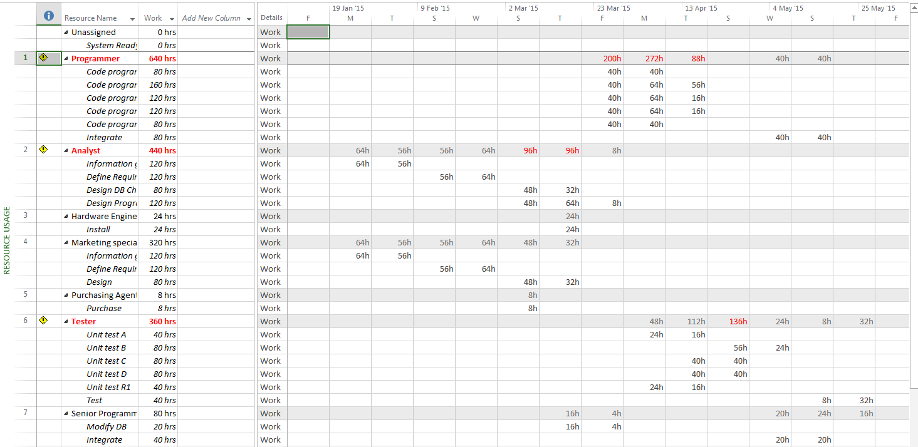

- An alternative view that can be very useful is the resource graph. You can view the resource graph by selecting the “Resource Graph” option from the “Other Views” drop-down list. Try that now. (You may need to select “entire project” from the zoom block on the View ribbon.)
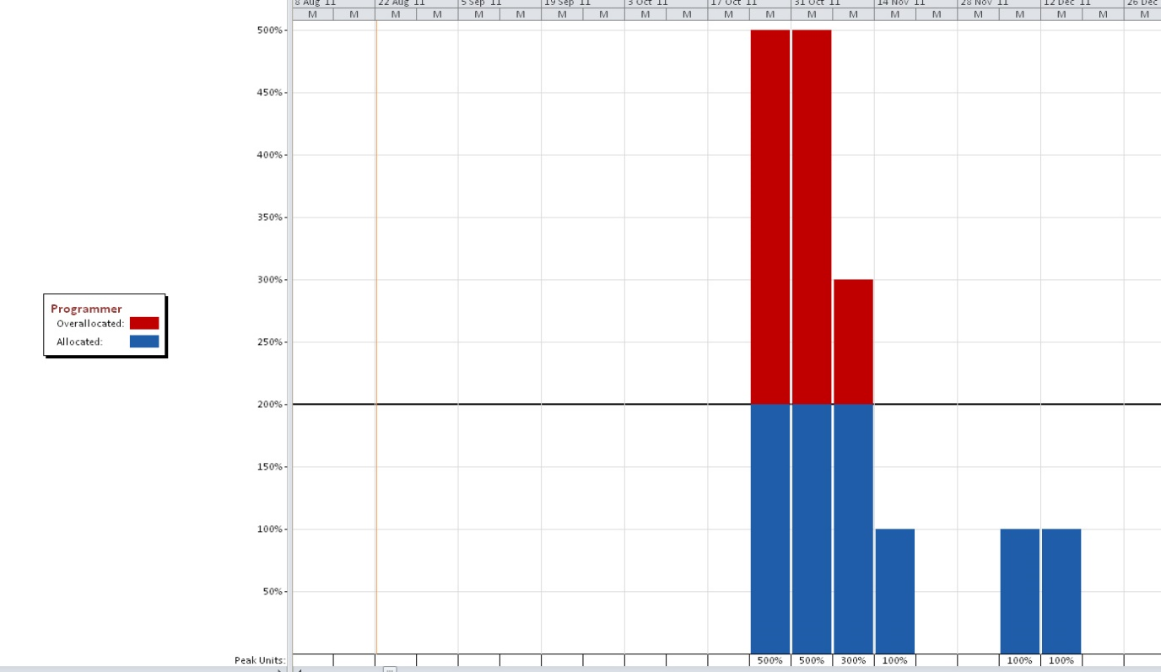

Clicking on the arrows at the bottom of the page allows you to move back and forward to view alternative resources.
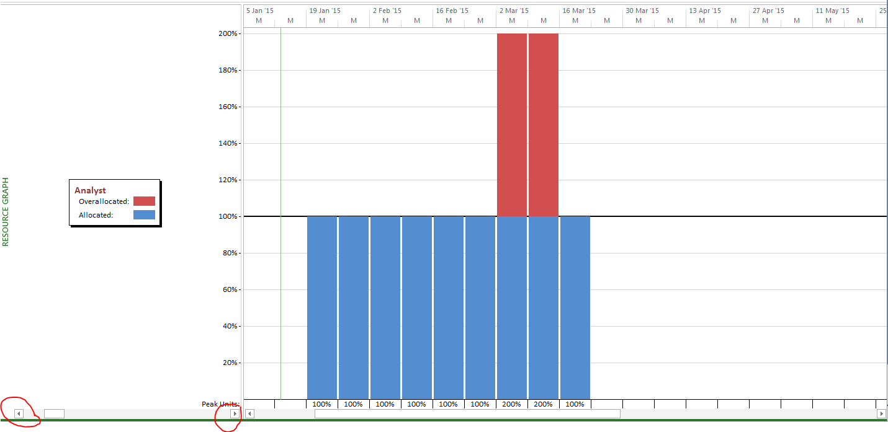

Dealing with over-allocation issues
There are various options for dealing with resource over-allocation:
- It may be possible to overcome the problems by levelling the resources within existing slack. This does not extend the project duration, but because you have absorbed some of the existing slack [i.e. pushed a task later in the timeline], it may make the network more sensitive.
- It may not be possible to overcome the over-allocation problem by using slack. In this situation, options include:
- extending the project duration;
- allocating additional resources to the project;
- making the existing resources work overtime.
In our example, the analyst is over-allocated when he/she has to design the database changes and the programming tasks.
- If you are not in the Gantt Chart view, return to the Gantt chart view.
- Click the arrow on Tables in the Data group on the View ribbon and select the “Schedule” table. This allows you to view the “schedule table”.
Observe that there are 6 weeks of slack for the “database design and changes” tasks, but 0 slack for the program designs.
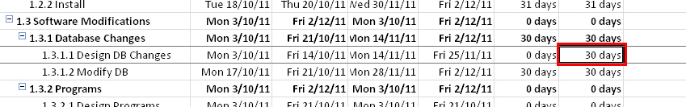
- Record the end date for your project here: _______________________
- Record the duration of the project (in days) here:
- Click the Resource tab and select “Levelling Options” from the Level group. In the Resource Levelling window that appears, select “Level only within available slack” in the “resolving over-allocations section”. Make the selections as shown below and click OK.
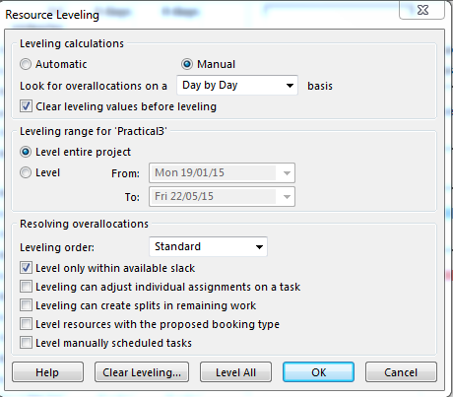
- This option will attempt to resolve the problems without adding extra resources or extending the duration. Click the “level all” button at the bottom of the pop-up window.
- After selecting the “level only within available slack” click the “level all” button at the bottom. You will find that you start to get warnings about the difficulties with the programmer and tester resources. (Remember that there was 0 slack for the programming tasks, so that you would not have expected to be able to resolve the issues by using available slack.) Select skip or skip all.
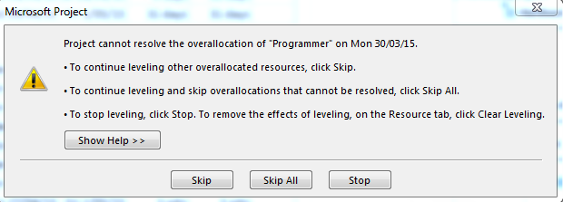
- What affect has this had? (View the result in the “Resource Sheet” and on the Gantt chart.)
How much slack is there for the “database design and changes” tasks now?
What tasks are now “critical”?

Note that this is now considered to be a “critical chain”. This term was coined by by Eliyahu Goldratt who recognised that that a project network may be constrained by both resource and technical dependencies as is the case in this example. The term critical path tends to be associated with just technical dependencies, not resource dependencies.
- Record the end date and duration (in days) of the project now:
Have they changed? (Explain.)

- You should find that the end date has not changed and that the over-allocation of the analyst has been resolved, but not the problem with the programmers and testers. We were able to resolve the over-allocation of the analyst using available slack, but not the problem with the programmers and testers.
To resolve the other resource over-allocation issues we either need to extend the duration of the project or add extra programming and testing resources. For the purposes of this exercise, we will assume that the addition of extra resources is not an option and that we need to extend the duration.
- Again Click the Resource tab and select “Levelling Options” from the Level group. The Resource Levelling window will appears. This time “untick” the “Level only within available slack” option.
- Click the “Level All” button. (Note that now we are not actually performing “ resource levelling” according to the text book definition because we are not levelling within available slack. According to the text book definitions, we are performing “resource constrained scheduling” where we are resolving resource over-allocation issues that arise because the number of resources are constrained. With resource constrained scheduling, we allow the duration of the project to be extended if that is necessary to resolve over-allocation when the number of resources are limited. In the text book definition of “resource levelling” we aim to achieve a “more even/more level” usage of resources without extending the duration of the project by only adjusting the scheduled time for a task “within the available slack”.)
- What has happened?
- Is there still a resource allocation problem?
- Check the resource sheet and resource graph (for the programmers, analyst and testers). Are they over-allocated?
- What has happened to the duration of the project now that you have performed resource levelling without the “level only within available slack restriction”?
- What has happened to the critical tasks?
- When does the project finish now? (Record the project end date now)
- What is the project start date?
Note that in this practical we have carried out resource “levelling” over the entire project. However, this is not the only option. For example, you can choose to level only a portion of the project or to perform levelling for selected resources that are in high demand. It is also possible to manually resolve “occasional resource over allocations” by introducing “levelling delays”. In addition, you will have noticed that there are various options that you can set when performing levelling (e.g. to allow tasks to be split). Discussion of these options is beyond the scope of these practicals.

Viewing the budget details

View the total cost
- Select the “Cost” table from the drop-down list of tables in the View ribbon.
TIP: Do this by first choosing the VIEW tab (AKA ribbon) – Go to the “Data” section, and select from the drop-down listing under “Tables”: Cost
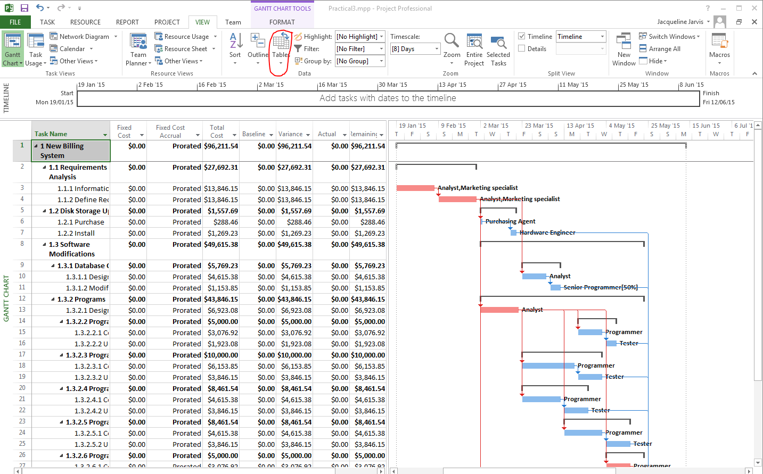
- What is the total cost estimate for this project?
- What is the most expensive task?
- To view the costs associated with each of the resources select “Resource Sheet” from the “Resource Views” group and select the “Cost” table from the drop-down list of tables in the Data group on the View ribbon. This should allow you to view the cost associated with each of the resources.
- What is the total amount estimated to be spent on programming staff in this project?
- 