Basic Principles of Freeze Drying

OVERVIEW
Freeze drying is the removal of ice or other frozen solvents from a material through the process of sublimation and the removal of bound water molecules through the process of desorption.
Lyophilization and freeze drying are terms that are used interchangeably depending on the industry and location where the drying is taking place. Controlled freeze drying keeps the product temperature low enough during the process to avoid changes in the dried product appearance and characteristics. It is an excellent method for preserving a wide variety of heat-sensitive materials such as proteins, microbes, pharmaceuticals, tissues & plasma.
SUBLIMATION
Sublimation is when a solid (ice) changes directly to a vapor without first going through a liquid (water) phase. Thoroughly understanding the concept of sublimation is a key building block to gaining knowledge of freeze drying.
As shown below on the phase diagram for water, low pressures are required for sublimation to take place.
Sublimation is a phase change and heat energy must be added to the frozen product for it to occur.
Sublimation in the freeze drying process can be described simply as:
- FREEZE - The product is completely frozen, usually in a vial, flask or tray.
- VACUUM - The product is then placed under a deep vacuum, well below the triple point of water.
- DRY – Heat energy is then added to the product causing the ice to sublime.

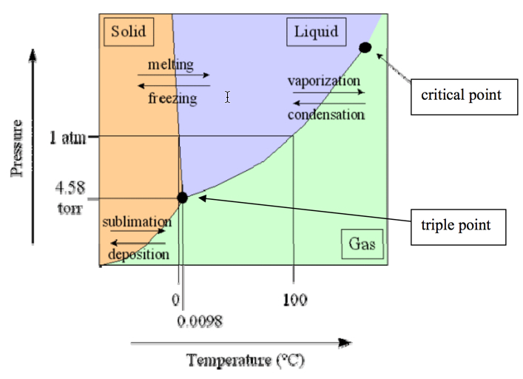

The steps required to lyophilize a product in a batch process can be summarized as follows:
- Pretreatment / Formulation
- Loading / Container (Bulk, Flask, Vials)
- Freezing (Thermal Treatment) at atmospheric pressure
- Primary Drying (Sublimation) under vacuum
- Secondary Drying (Desorption) under vacuum
- Backfill & Stoppering (for product in vials) under partial vacuum
- Removal of Dried Product from Freeze Dryer
In addition to providing an extended shelf-life, successful freeze-drying should yield a product that has a short reconstitution time with acceptable potency levels. The process should be repeatable with well defined temperature, pressure and time parameters for each step. Visual and functional characteristics of the dried product are also important for many applications.
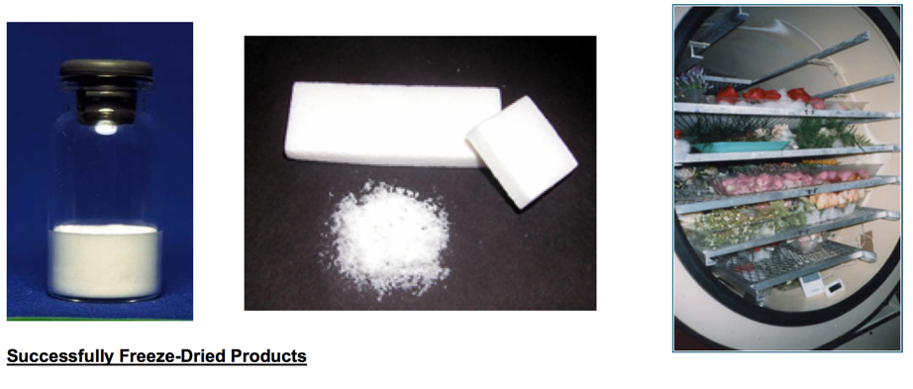

FREEZE DRYING EQUIPMENT
The main components of freeze drying equipment are:
- Refrigeration System
- Vacuum System
- Control System
- Product Chamber or Manifold
- Condenser
The refrigeration system cools the (ice) condenser located inside the freeze dryer. The refrigeration system can also be employed to cool shelves in the product chamber for the freezing of the product.
The vacuum system consists of a separate vacuum pump connected to an airtight condenser and attached product chamber.
Control systems vary in complexity and usually include temperature and pressure sensing ability. Advanced controllers will allow the programming of a complete “recipe” for freeze drying and will include options to monitor how the freeze drying process is progressing. Choosing a control system for the freeze dryer depends on the application and use (i.e. lab vs. production).
Product chambers are typically either a manifold with attached flasks, or, a larger chamber with a system of shelves on which to place the product.
The purpose of the condenser is to attract the vapors being sublimed off of the product. Because the condenser is maintained at a lower energy level relative to the product ice, the vapors condense and turn back into solid form (ice) in the condenser. The sublimated ice accumulates in the condenser and is manually removed at the end of the freeze drying cycle (defrost step). The condenser temperature required is dictated by the freezing point and collapse temperature of the product. The refrigeration system must be able to maintain the temperature of the condenser substantially below the temperature of the product.
In shelf freeze dryers, the condenser can be located inside the product chamber (internal condenser) or in a separate chamber (external condenser) connected to the product chamber by a vapor port.
Manifold freeze dryers rely on ambient conditions to provide the heat of sublimation to the product. This heat input does not melt the product because an equivalent amount of heat is removed by vaporization of the solvent. Advanced shelf freeze dryers can provide a heat source to control/expedite the drying process and they can also employ the refrigeration system to allow freezing of product inside the unit.
Freeze dryers can be informally classified by the type of product chamber: (1) Manifold dryers where the product is typically pre-frozen & in flasks (2) Shelf dryers where the product is placed in a tray or directly on a shelf (3) Combination units with both drying options.
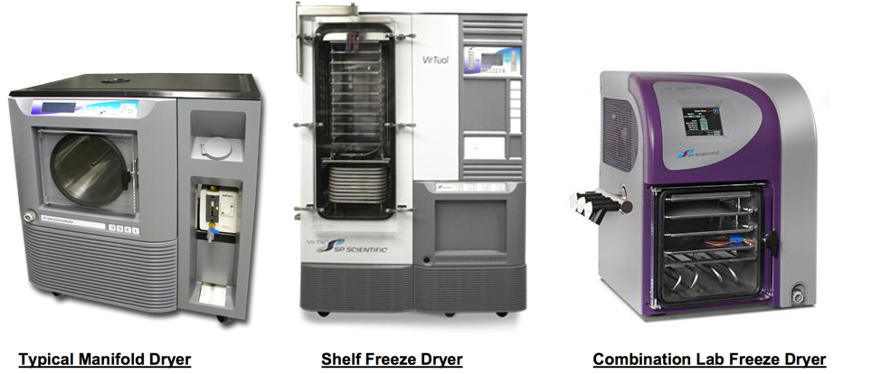
Freeze-dryers can also be grouped by size & use: (1) laboratory bench-top units for R&D (2) pilot units for process development and scale-up, and (3) larger production-sized units. It should be noted that in addition to process scale-up work, pilot-sized freeze dryers are often used for product R&D as well as small volume production applications.
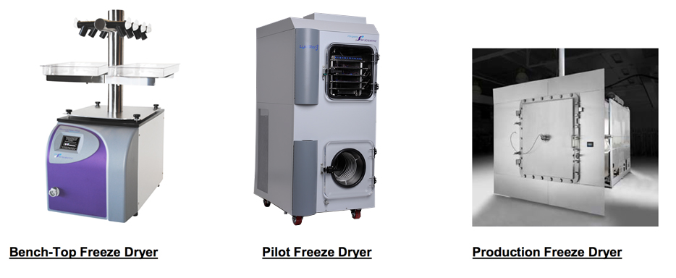
Choosing a freeze dryer depends on the product characteristics as well as many other application-based variables including the container that the product will be dried in, the shelf area or number of ports required to accommodate the quantity to be dried in each batch, the total volume of ice to be condensed and whether there are any organic solvents. The type and shape of product being dried and its end-use also need to be considered.

PRODUCT CONTAINERS AND CONTAINMENT SYSTEMS
A suitable container system must be chosen for the product. The most common product containers are flasks, vials and trays. If possible, it is advisable to pick a container that keeps the maximum thickness of the product to less than ¾” (2 cm). Special containers made of Gore-Tex® & Tyvek® are also available for specific applications where product contamination is a concern.
Product trays with removable-bottoms are available when working with vials. The tray is loaded with vials, placed on a shelf in the freeze dryer and then the bottom part of the tray is slid out. This allows the vials to rest directly on the shelf and increases the heat transfer to the product.
Special containment systems such as glove boxes are required for freeze drying certain products, especially when toxic materials are present.

PHYSICAL PROPERTIES OF MATERIALS AND FORMULATION
Understanding the physical properties of materials that are freeze-dried is a key part in developing a successful lyophilization process. Although a few products are simple crystalline materials, the vast majority of products that are lyophilized are amorphous and form glassy states when frozen.
Processing and formulation development are important steps often taken to make a product ready for freeze drying and usable for its specific application. The choice of excipients added to a formulation can severely affect the thermal characteristics of the product and its ability to be freeze dried in a reasonable amount of time.

RECIPE FOR FREEZE DRYING
Lyophilization in a shelf freeze dryer requires the design of a working process or cycle which is sometimes referred to as a “recipe”. Typically, there are multiple steps involved for both freezing and drying of the product. Individual temperature, pressure and time settings need to be determined for each step.
Each specific product or formulation that is lyophilized requires the development of a freeze drying process that is based on the unique characteristics of the product, the amount of product and the container used. There is no universal “safe” recipe that will work with every product.

FREEZING
It is extremely important that the sample be fully and completely frozen prior to pulling a vacuum and starting the drying process. Unfrozen product may expand outside of the container when placed under a vacuum.
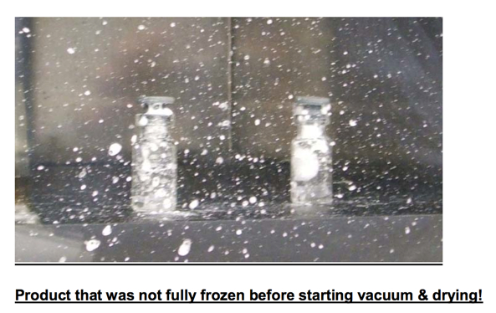
With simple manifold freeze dryers, the product is placed in a vial or flask depending on quantity, and then frozen in a separate piece of equipment. Options include standard laboratory freezers, shell baths, and direct immersion in liquid nitrogen.
Shell (bath) freezing involves rotating a flask containing the sample in a freezing bath so the sample freezes on the walls of the flask. This freezing method maximizes the product surface area and minimizes its thickness. It is best not to freeze a large block of sample in the bottom of a flask because the sample will be too thick for efficient water removal. Also, the flask might break due to uneven stress.
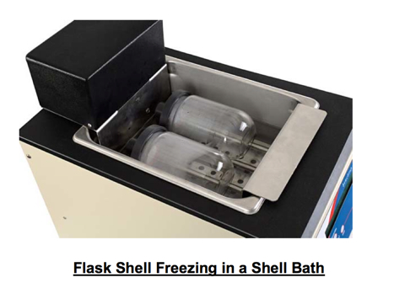
More advanced shelf freeze dryers have freezing capability built into the product shelf which allows the product freezing to be accomplished inside the freeze dryer. Product is either pre-loaded into vials which are then transferred to the shelf or it is loaded in bulk form directly onto a product tray.
Shelf freeze dryers allow the precise control of cooling rates which affects product freezing rates and crystal size. Larger ice crystals improve the speed of the freeze drying process because of the larger vapor pathways left behind in the dried portion of the product as the ice crystals are sublimated.
Slower shelf cooling rates do not necessarily yield larger ice crystals because of the effects of super-cooling. When the super-cooled liquid finally freezes, it happens extremely quickly resulting in smaller ice crystals. In a clean room environment with very few particulates for ice nucleation, there is a significantly greater amount of super-cooling.
Some biological products can not tolerate large ice crystals and they must be freeze dried with smaller ice crystal sizes.

EUTECTIC / COLLAPSE TEMPERATURE
Determination of the critical collapse temperature of a product is an important step in establishing and optimizing a freeze drying process. This critical temperature determines the maximum temperature that the product can withstand during primary drying without it melting or collapsing. Thermal analysis (Differential Scanning Calorimetry & Freeze Dry Microscopy) and Dielectric Resistance analysis and are common methods used to determine this critical temperature of the product.
Frozen products can be categorized as either crystalline or amorphous glass in structure. Crystalline products have a well defined “eutectic” freezing/melting point that is its collapse temperature. Amorphous products have a corresponding “glass transition” temperature and they are much more difficult to freeze dry. The collapse temperature of amorphous products is typically a few degrees warmer than its glass transition temperature. Although most materials that are freeze dried are actually amorphous, the term “eutectic” is often used (erroneously) to describe the freezing/melting point any product.
The US FDA Guide To Inspections Of Lyophilization Of Parenterals ( http://www.fda.gov/ora/inspect_ref/igs/lyophi.html ) states that the manufacturer should know the eutectic point (critical collapse temperature) of the product. It is good practice to characterize the collapse temperature for all new injectable or ingestible drug formulations to be freeze dried.
Without knowing the critical temperature of the product, a trial and error approach is required to determine appropriate primary drying temperatures. A slow conservative cycle with low temperatures & pressures can be used initially. The temperature & pressure can then be raised on subsequent cycles until evidence of collapse or melt-back is seen – indicating that the product was too warm.
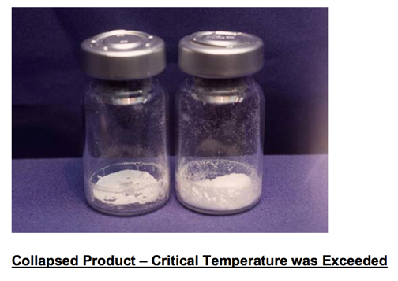

ANNEALING
Some amorphous products (such as mannitol or glycine) form a metastable glass with incomplete crystallization when first frozen. These products can benefit from a thermal treatment process, which is also called annealing. During annealing, the product temperature is cycled (for example: from -40C to -20C for a few hours and then back to -40C) to obtain more complete crystallization. Annealing has the added advantage of larger crystal growth and corresponding shorter drying times.

ORGANIC SOLVENTS
The use of organic solvents requires more attention in the freeze drying process. Lower temperatures are required to freeze and condense solvents and they can easily bypass the condenser and end up causing damage to the vacuum pump. Freeze dryer refrigeration designs are available to provide the lower shelf and condenser temperatures needed to freeze and then condense some organic solvents.
Special filter cartridges or liquid nitrogen (LN2) traps may be required to catch/condense certain solvents with very low freezing temperatures. Safety considerations must be made when handling volatile and/or potentially harmful materials.
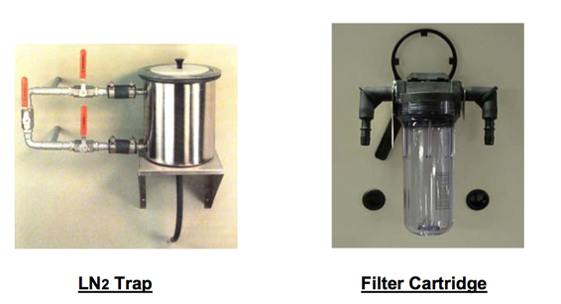

PRIMARY DRYING
The drying portion of freeze drying is actually a two part process consisting of Primary Drying and Secondary Drying. The bulk of water removed from the product during freeze drying is via sublimation of all of the free ice crystals during the primary drying step. Organic solvents are also removed during primary drying.
Primary drying (sublimation) is a slow process conducted at cooler temperatures, safely below the product’s critical collapse temperature. Sublimation requires heat energy to drive the phase change process from solid to gas. All three methods of heat transfer - conduction, convection and radiation, must be considered when freeze drying a product.
In a simple manifold dryer, heat is transferred to the flask/product primarily through convection and radiation from the surrounding environment. With little control over heat flow into the product, it is more difficult to control the process. When working with products with low collapse temperatures, it may be necessary to wrap or insulate the flask to slow down the rate of heat transfer and avoid collapse.
In a shelf freeze dryer, most of the heat is transferred into the product through conduction and it is important to maximize the surface contact of the product/container/tray with the shelf. However, the effects of radiation and convection also need to be considered for product uniformity and process control purposes.
Radiant heat from the inside walls of the product chamber will cause product/vials on the perimeter of the shelf to dry more quickly than product in the center of the shelf (known in freeze-drying as the “edge effect”). Radiation coming through the acrylic doors commonly used on pilot and R&D freeze dryers has an even greater effect and product located in the front of these dryers will typically dry the fastest of all. For this reason, production freeze dryers are designed with metal doors and small view ports. A piece of aluminum foil can be hung in front of the product on the inside of a pilot freeze dryer as a shield – of course this will block the view of the product and not allow observation during the process.
Because shelf contact is often inconsistent, convective heat transfer can help promote uniform product drying. System pressures in the 100 mTorr to 300 mTorr range will usually promote an adequate amount of convection. At ultra low system pressures less than 50 mTorr, there are fewer gas molecules present to provide convection and uneven / slower drying is likely.
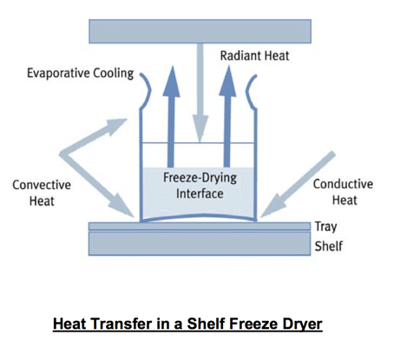
Primary drying is a top-down process with a well-defined sublimation front moving through the product as it dries. Above the ice surface interface is dried product, or “cake”; below the interface is product with ice crystals still remaining to be sublimed. At the end of primary drying when all of the free ice crystals have been sublimed, the product will appear to be dried. However, the moisture content can still be in the 5-10% range due to the presence of “sorbed” water molecules attached to the product.

PRESSURE & TEMPERATURE DURING PRIMARY DRYING
As mentioned earlier, each frozen product has a unique critical temperature. It is necessary to keep the product temperature safely below this critical temperature during primary drying to avoid collapse. The product temperature is dependant on the vapor pressure at the ice interface and in turn, this vapor pressure is dependant on both the rate of heat transfer into the product (which is controlled by adjusting the shelf temperature) and the system vacuum level set point.
Once a target product temperature is identified (typically several degrees colder than the critical temperature), the only two variables left to determine/control are the shelf temperature and system vacuum level. During primary drying, the system pressure and the shelf temperature are set and controlled in combination to yield the appropriate product temperature.
A recommended approach is to first set the system pressure using the vapor pressure of ice table. The product temperature is monitored using thermocouples and then the shelf temperature set point is slowly increased until the product reaches its target temperature. When the target product temperature is obtained, the shelf temperature is held constant for the balance of primary drying. Certain products with high resistance to vapor flow in the dried portion of the cake may require that the shelf temperature be reduced towards the end of primary drying to keep the product temperature at its target and to avoid collapse.
It is not recommended to arbitrarily and repetitively increase the shelf temperature during primary drying, as is seen on some older legacy cycles.
Using the vapor pressure of ice table is a scientific way to determine an appropriate pressure for freeze drying. A general guideline is to choose a system pressure that is 20% to 30% of the vapor pressure of ice at the target product temperature. When the vacuum level set point is deeper than the vapor pressure of ice at the current product temperature, sublimation can take place. Typically, vacuum levels for freeze drying are between 50mTorr and 300mTorr with 100mTorr to 200mTorr being the most common range.
With the temperature and pressure parameters set, primary drying is then continued for a length of time sufficient for all of the ice crystals to be sublimed.
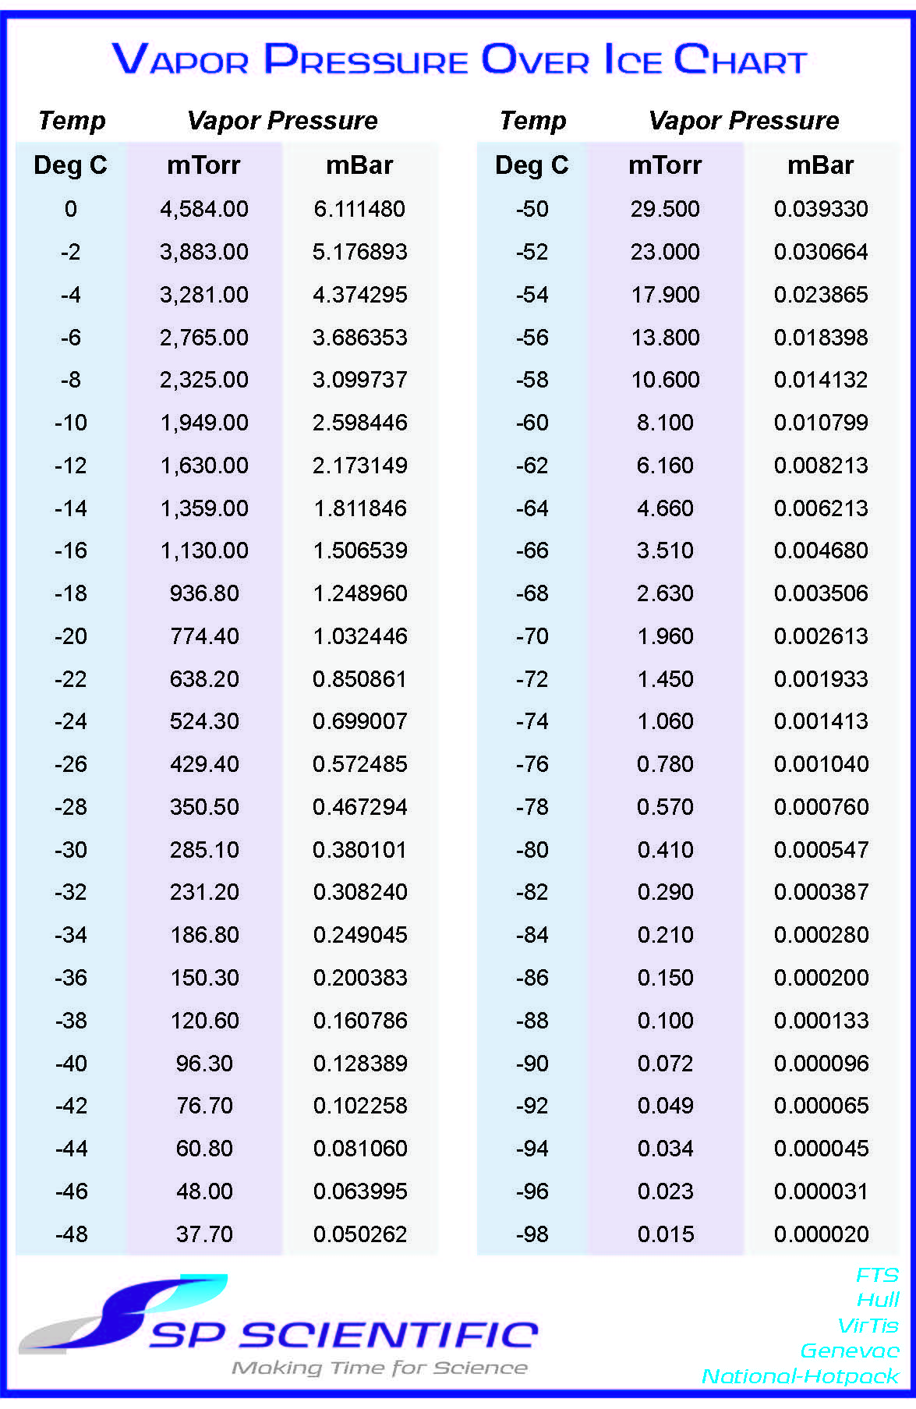
Because most commercial freeze dryers can not consistently control vacuum much below 30mTorr, at very cold product temperatures (less than -40ºC), it becomes impossible to have a system pressure set point that is 20% to 30% of the vapor pressure of ice. Freeze drying occurs extremely slowly at these cold product temperatures.
With manifold freeze drying, the process is driven by the system pressure set point and the ambient temperature in the room. Because of the lack of control over the rate of heat transfer into the product, most manifold dryers are operated conservatively at lower pressures to help keep the product temperature lower.

DETERMINATION OF THE END OF PRIMARY DRYING
Several analytical methods are available for determining that primary drying is complete. The most basic method is to monitor the product temperature with a thermocouple probe. The measured product temperature will be colder than the shelf temperature set point during active primary drying because the heat from the shelf is being used for the sublimation phase change. When sublimation of ice crystals is complete, the product temperature will increase and approach the shelf temperature. When the product temperature equals the shelf temperature, it can be inferred that primary drying is complete.
Note: the specific vial that contains the thermocouple wire will typically dry faster than the other vials on the shelf because the wire will conduct more heat into that specific vial. Similarly, if bulk drying, the area around the thermocouple wire will dry more quickly than other areas in the product tray. It is important to allow a modest amount of additional drying time (30 min to 2 hrs, depending on the product characteristics) after the product thermocouple temperature increases to ensure that all of the ice in the entire batch of product has been completely sublimated.
Because product will dry from the top down, the tip of the thermocouple should always be placed at the very bottom and center of the container. It is OK if the thermocouple touches the bottom of the container. If drying in vials, it is good practice to insert the thermocouple in a vial located in the middle of the shelf. Radiant heating effects will cause vials/product on the perimeter of the shelf to dry more quickly.
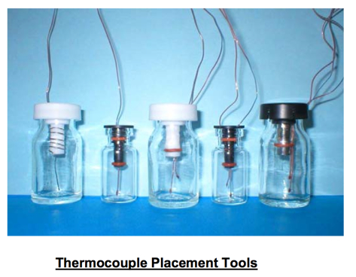
Additional primary drying endpoint determination tools are available on larger freeze dryers equipped with advanced process control systems. One such method entails comparison of parallel pressure readings between a Pirani gauge and a capacitance manometer. A capacitance manometer always gives a true pressure reading in the product chamber. The Pirani gauge, however, will give a false high reading in the presence of water vapor. When the Pirani pressure reading decreases and approaches the true pressure reading of the capacitance manometer, little or no water vapor is present and it can be concluded that primary drying is complete.
Another tool is available with freeze dryer designs that have external condensers. An isolation valve can be added to the vapor port that connects the product chamber to the condenser. This valve can be closed for a short period of time and the subsequent rise in pressure in the product chamber can be measured. When this pressure rise approaches zero, no more water vapor is being generated via sublimation.
SECONDARY DRYING
In addition to the free ice that is sublimed during primary drying, there remains a substantial amount of water molecules that are bound to the product. This is the water that is removed (desorbed) during secondary drying. Since all of the free ice has been removed in primary drying, the product temperature can now be increased considerably without fear of melting or collapse.
Secondary drying actually starts during the primary phase, but at elevated temperatures (typically in the 30ºC to 50ºC range), desorption proceeds much more quickly. Secondary drying rates are dependant on the product temperature. System vacuum may be continued at the same level used during primary drying; lower vacuum levels will not improve secondary drying times.
Amorphous products may require that the temperature increase from primary to secondary drying be controlled at a slow ramp rate to avoid collapse.
Secondary drying is continued until the product has acceptable moisture content for long term storage. Depending on the application, moisture content in fully dried products is typically between 0.5% and 3%. In most cases, the more dry the product, the longer its shelf life will be. However, certain complex biological products may actually become too dry for optimum storage results and the secondary drying process should be controlled accordingly.
During secondary drying, a “sample thief” mechanism may be used to periodically remove vials from the freeze dryer for residual moisture content determination.
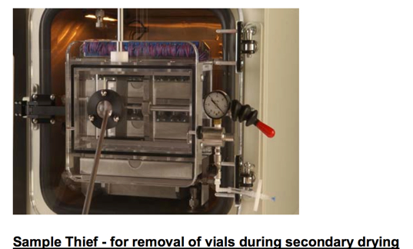

CYCLE OPTIMIZATION
In addition to designing a recipe that successfully dries a product, it is also extremely valuable to optimize (shorten) the length of the cycle, especially if there is potential for process repetition or scale-up for production. Freeze drying can be a multi-day process. The cycle time can often be substantially reduced by investigating several factors:
- Freezing and annealing – maximize crystal size and crystallization to increase drying rates.
- Thickness of product - water vapor molecules experience resistance as they exit from the dried portion of the product. Thinner samples yield less resistance to vapor flow and lead to faster drying. Shell freezing can help when drying bulk product in flasks.
- Critical Collapse Temperature – this is the most important piece of information for cycle optimization. The ability to run primary drying at higher product temperatures greatly reduces drying time by creating a larger pressure differential between the vapor pressure over ice in the product and the pressure at the condenser. Each 1oC increase in product temperature can decrease primary drying time by 13%.
Cycle optimization using eutectic/collapse temperature information requires an iterative approach of taking real-time measurements of the product temperature during primary drying and then making corresponding adjustments to the shelf temperature settings. This can be accomplished manually using product thermocouples or, if drying in vials, an automated SMART system can be used.

PROCESS SCALE-UP CONSIDERATIONS
Laboratory pilot-sized shelf freeze dryers are often used to develop a cycle to be used for process scale-up to a larger production sized unit. Similarity in heat transfer characteristics and shelf temperature uniformity is important to ensure that a lyophilization process developed in the lab can be successfully transferred to a production freeze dryer.
One of the most important factors to consider is the difference between the clean room environment typical of a production freeze dryer and the lab environment that most pilot units are operated in. The difference in particulates can greatly affect product freezing and ice crystal size.
Production freeze dryers are usually configured for operation in a clean room environment and can have the ability for clean-in-place (CIP) and steam sterilization (SIP). Another production consideration is process compliance to US FDA regulation 21 CFR 11, if required. This regulation requires certain standards of process control and security.
STORAGE OF DRIED PRODUCT
Lyophilized products are extremely hydroscopic and they must be sealed in air tight containers following freeze drying to prevent rehydration from atmospheric exposure. Freeze dryers can be configured with a “stoppering” capability to seal the product while it is still under partial vacuum inside the unit. Typically, stoppering is done on vials with partially inserted stoppers. The shelves are collapsed so that each shelf pushes down the vials/stoppers located on the adjacent shelf. It is also common to backfill with an inert gas such as dry nitrogen before sealing/stoppering the product.
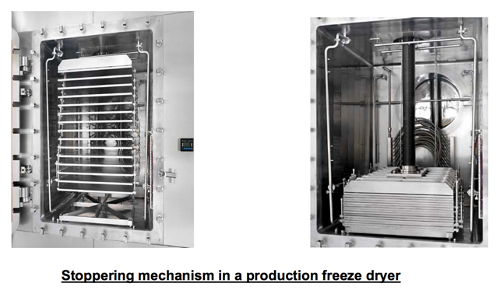

FREEZE DRYER CARE AND MAINTENANCE
In addition to defrosting the condenser and cleaning the system after each cycle, routine freeze dryer maintenance typically includes periodic changing of vacuum pump oil and visually checking all seals and gaskets. Advanced controllers offer the capability of running a periodic system test and/or leak test to ensure that the unit is performing to original factory specifications.

