ACTIVE & PASSIVE TRANSPORT OF NUTRIENT

Nutrients
Nutrients is the food or any substance that supplies the body with elements, necessary for metabolism.
Need of nutrients in plants is same as in animals because plants need nutrients to fight of diseases & pests, germinate, grow & reproduce. Plants needs nutrients & larger/smaller or may in trace amount to stay healthy.

Plants must obtain following number of nutrients for their growth,

-Macro Nutrients: Nitrogen (N), Phosphorus (P), potassium (K), Hydrogen (H), Calcium (CA), Carbon ©, Oxygen (O), Magnesium (Mg), Sulfur (S).
-The Micro Nutrients (Trace nutrients): Iron (fe), Manganese (Mn), Boron (B), Molybdenum (Mo), Copper (C), Zinc (Zn), Chlorine (Cl), Nickel (Ni), Cobalt (Co), Sodium (S), Silicon (Si).

These macronutrients contributes 95% of plants entire biomass on dry weight basis.
Nutrients are important to complete their life cycle.
Uptake of Mineral nutrients from the soil
Mostly plants are autotropic, and use photosynthesis to make their own food from inorganic raw material, such as carbon dioxide & water. (Some plants are heterotrophic: they are unable to synthesize their own food& draw all the nutrients from the host plant). As most of the plants are autotropic and can make their own sugar from CO2 & H2O but still need some ion & minerals from soil.
How plants require micronutrients from SOIL
This process carried out by root hair, which are extensions of root epidermal tissues that result in the increase of the surface area of the root, contribute to absorb water & mineral.
As the roots are deeply penetrated till the horizon of the soil & nutrients are presently in soil and are also dissolved in water so root hair absorb ion from it. However not all ions are equally present in soil water, depending on properties of soil.
The clay is negatively charged so any positive ion (cations) present in clay rich soil will remain bounded tightly to the particles if the clay, the tight association between cations & clay particles prevent cations from being washed away by heavy rains. But it also restrict the plan root here absorb the cation. So anions are easily dissolved in soil water and readily assessable to plant root here. However the rain water easily washed them away. It help to prevent leaching the off cations from soil by rain water.

How do plants overcome these issues?
The epidermal tissues of fruit hair having proton pumps (H+ ATPases) that use ATP as an energy source to pump the protons out of the cells and into the soil, against their electrochemical gradient. This result in formation of strong electrochemical gradient with high concentration of proton & strong positively charge outside the cell and low concentration of proton & relatively negatively changed inside the cell.

There are 2 outcomes in the result of the protons pumped into the soil by proton pumps.
- 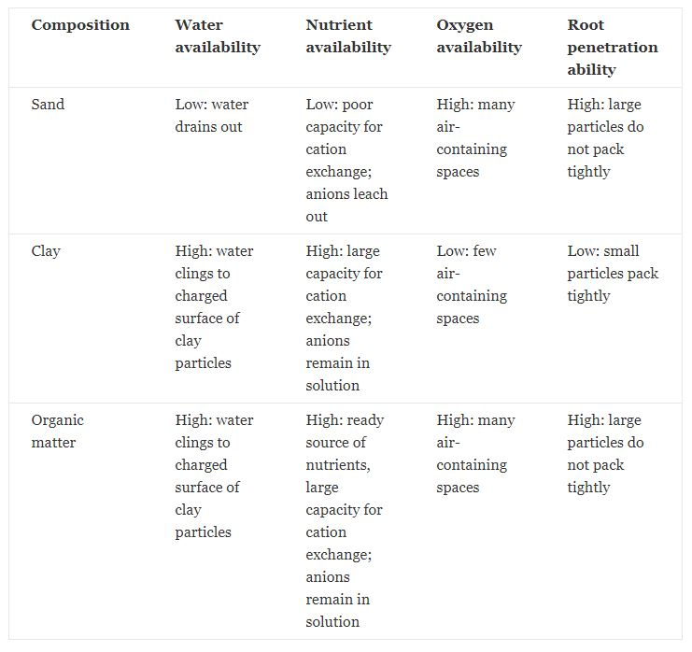Protons bind to the negatively charged particles, releasing the cations from the clay in a process called cation exchange. Then cations defuses down their electrochemical radiant & to the root hair. As the soil environment is highly positively charged so it favorable to cations to move into the root hair.
- High concentration of plant & the soil creates a strong electrochemical gradient that allows the transport of protons back into root hair so plants used co-transport of protons down their concertation radiant. As the energy source to move anions again their gradient into the root hair (as the soil environment is highly positively charged so it is unfavorable for anions to leave the soil, but highly favorable for the protons to leave the soil. Due to influence of PH, the composition & texture of soil greatly influences the ability of roots to penetrate the soil, as well as the availability of water nutrients and oxygen.
Transportation in Plants: 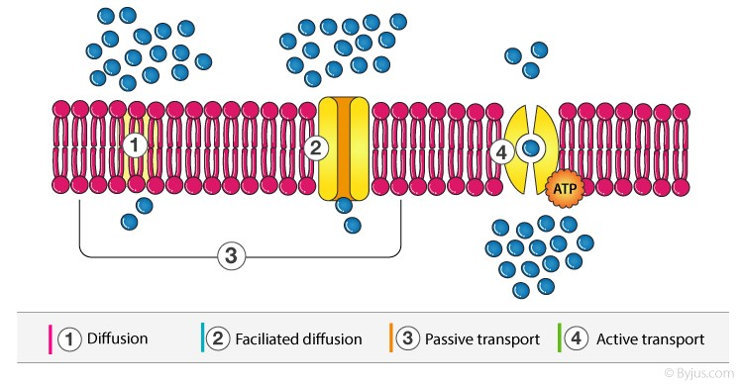Transportation is the process that involves the moment of water & necessary nutrients to all parts of the plants for its survival. There are 4 types of transportation in plants.
- Diffusion
- Facilitated diffusion
- Passive Transport
- Active Transport

Transportation is an important process in plant, the nutrients & the water are transported through the roots to the tips of the leaves for the survival of the trees & plants.

Water is the biggest factor in the growth of the plant as it is limited in quantity, to over overcome this problem the plants & the trees have system for the absorption & translocation of the water.

Plants contains biggest network of conduits which consist of xylem & phloem, this is like circulatory system that transport blood thought out the human body. These conducting tissues originated from roots & move up through the trunks of the trees. Later the branch off into the branches & then branching into further every leaf like spider web.

Transportation occur in 3 level in case of plant.
- Transportation of substance from 1 cell to another.
- Long distance transport of SAP with xylem & phloem.
- The release & update of solute and water by individual cells.
Diffusion
This is a process that involve passive moment of a substance from cell to cell or from 1 part of plant to the cell they don’t involve in the moment of molecules takes place in random fashion & expenditure of energy. It’s a slow process

In this process substance moves from higher concentration to the lower. Gases can transport in plants by diffusion. The rate of diffusion depends on the temperature, pressure & mainly on gradient of concentration.
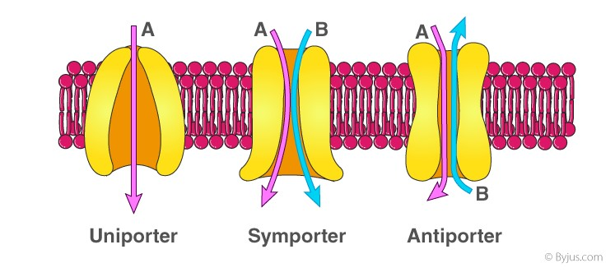
Facilitated diffusion
In facilitated diffusion gradient is important component for this product. Smaller substances has to be diffused faster as compared to larger ones. This is a passive process that comprises & anti port, uniport & symport.
Antiport proteins exchange the solute by transporting them IN/OUT of the cell.
The function of the uniport protein is to carry single solute across the membrane.
Symport transfer to different solute simultaneously in the same direction.

Passive Transport
Passive transport moves biochemical from area of higher concertation to the area of lower concentration, in order to maintain the equilibrium in the cells it doesn’t require energy. It maintains dynamic equilibrium of nutrients water gases nutrients wastes etc. It is between cells of extra cellular fluid.
No next diffusion / Osmosis occur after the establishment of equilibrium.
Example: Diffusion, osmosis & facilitated diffusion.
Passive transport is physical process, partially known selective & is comparatively slow process. And transpires by directly but there is no need of carrier proteins.

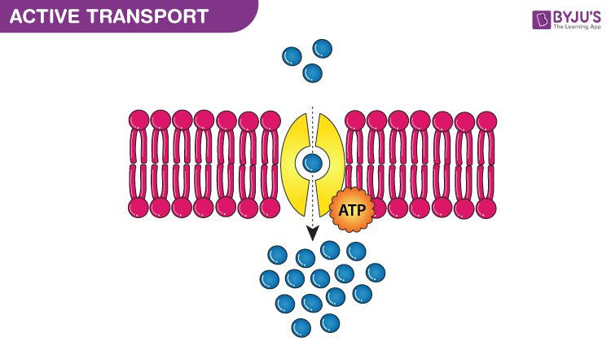Active Transprot
This is the movement of particles down the concentration gradients often substances have to be moved from low to high concertation gradients. This process require energy. Whenever plants are in need of mineral ions they are moved into root hairs from higher concertation to lower concentration, active transport always leads to the accumulation of molecules or ions towards one side of the membrane. This mode of transportation in plants is carried out by membrane protein & substances are transported from lower to high concentration. It uses stored energy to move the particles.
Ascent of SAP
The moment of water and dissolved mineral passed through the cortex and endodermis and reach xylem & roots in the water and dissolved minerals are carried or pulled upward towards the leaves through xylem tissue, this is called ascent of SAP.
This may involve following processes,
-Root Pressure Theory
-Transpiration Pull theory
1. Root Pressure
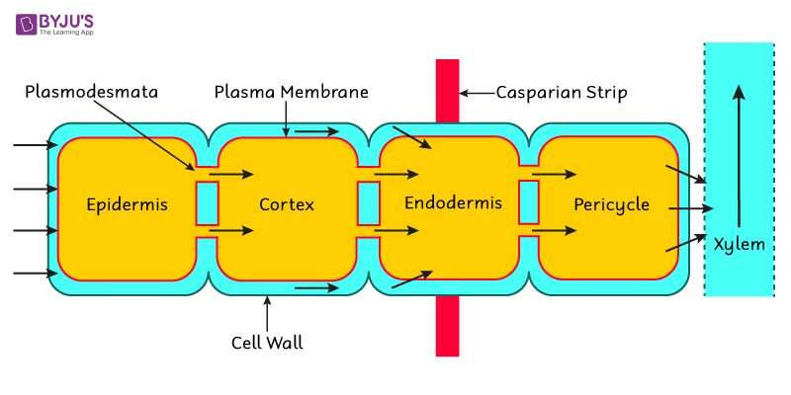Force is involved in the movement of water and dissolved minerals up in the xylem tissue is the root pressure.
Root pressure is created by active secretion of salutes & other salutes from the other cells into xylem SAP. This lowers the water potential of xylem SAP. Water enters the xylem cells by OSMOSIS, thus increasing the level of SAP in xylem cells.
Water entering the xylem cells may take,
-Apoplast way (Non Osmotic)
- Symplast way (Osmotic)
Limitations
- As a result of root pressure the SAP in xylem does not rise to the enough height in the most plants.
- Root pressure is also least during day when transpiration pull is active, force involve in pulling the SAP xylem upward.
- Root pressure is dominated during night time.
TRANSPIRATION PULL THOERY:
This theory was proposed by DIXON, it explains the flow of water and minerals upward from the root to the leaves, in bulk flow or mass flow.

- 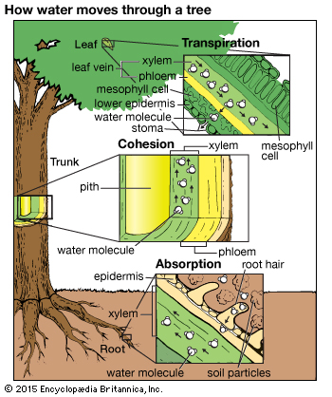 Cohesion Tension Theory
It is the attraction between similar molecules which hold molecules together forming a solid chain like column within the xylem tubes.
Tension:
It is provided when this water chain is pulled up in the xylem. Transpiration provides necessary energy or force. Tension is between molecules or water by hydrogen BOND.
Adhesion:
It may be added that the water molecules adhere to the cell wall of xylem cells, so that the column of water in xylem tissue does not break.
-Xylem Walls should have high tensile strength
-Total water pulled up in the leaves is transpired, except about 1% which is used by plant in various activities including photosynthesis.
MECHANISM of Transpiration Pull Theory
“Evaporation of water from Ariel parts of the plants especially through the stomata of leaves is a process called transpiration”.
As a leaf transpire water potential of its mesophyll cells drop. This drop, causes water to move by osmosis from the xylem cells of the leaves into the dehydrated mesophyll cells. Water molecules leaving the xylem or attached to other water molecules in the same xylem tube by hydrogen bond. Therefore, when water molecules moves up in the xylem, the process continuous all the way to the root. Where water is pulled from the xylem cells. This pull also causes water to move down its concertation gradient transversally from the root epidermis to cortex by endosmosis and to pericycle. This pulling force is called transpiration pull.

