NATURALISM
Topics to discuss in this lecture
- Naturalism; theme and major proponents
- Fundamental principles of Naturalism
- Principles and Aims of Education
- Shape of Curriculum
- Methods of teaching
- Teachers and student role
- Shape and role of school
- Discipline in class and school
Major proponents of Naturalism
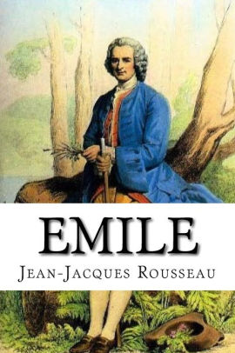
- Aristotle
- John Jacques Rousseau – Novel “Emile”
- Charles Darwin
- Montessori
- Rabindranath Tagore
- Bacon
- Bernard Shaw
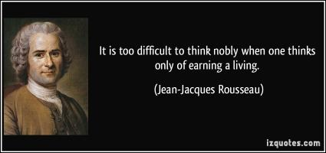
Naturalism and its Fundamental Principles

- Back to Nature and according to nature
- Started from the thoughts of Aristotle
- Nature is everything and nothing is beyond it
- Nature is eternal
- It believes in matter and material world
- Physical and Natural Principles are supreme and Universal
- There is no ideal or supreme value
Principles of Education in context of Naturalism
- Education is based on Psychology
- Emphasizes on basic instincts
- Child and his present life are the centers of education
- Only individual is considered and valued
- It is progressive and dynamic ideology
Aims of Education
- Development of individuality
- Self-expression
- Perfection of human as a perfect being for survival and existence
- Preparing the child for a happy life Now and in Future
- Adaptation to environment
- Natural Development
- Autonomous Development
Shape of Curriculum
- Curriculum is constructed according to basic instincts, aptitudes and tendencies of children
- Important area/ subject are Sports and Games
- Physical sciences and physiology as well as material and biological
- mathematics and language
- History and Social Sciences
- Curriculum of Agriculture and Vocational skills
- Moral Education
- Curriculum should be broad based
- Should include various Skills and activities
- Should be related to life
Methods of Teaching
- Learning by Doing
- Methods of direct experiences
- experimental method
- Observation / Demonstration method
- Discovery Methods
- Play way Method
- Montessori method
- Methods involving freedom for the children to learn
Role of Teacher
- Teacher’s role is Facilitator
- Stage Preparation and then set aside
- Observer
- Guide / Protector
Discipline
- Slogan of naturalism is freedom
- Emancipatory discipline based on consequences
- No Punishment
Shape and role of school
- According to Naturalism, natures Vast campus is the real school.
- School should be natural and spontaneous field of free activates.
- It should be flexible, based on liberal and free atmosphere
- Democratic
- Social environment based of principle of liberty, equality and Fraternity
- Students should be involved in governance
Summary
- Objects of physical world are considered as reality
- Gave expansion to new subjects e.g Mathematics, Psychology, Botany, Zoology,

