topic : Polysaccharides( a type of carbohydrate)

Polysaccharides(a type of carbohydrate)
Introduction: Carbohydrates represent a broad group of substances which include the sugars, starches, gums and celluloses. The common attributes of carbohydrates are that they contain only the elements carbon, hydrogen and oxygen, and that their combustion will yield carbon dioxide plus one or more molecules of Water. Carbohydrates are probably the most abundant and widespread organic substances in nature, and they are essential constituents of all living things. Carbohydrates are formed by green plants from carbon dioxide and water during the process of photosynthesis. Carbohydrates serve as energy sources and as essential structural components in organisms; in addition, part of the structure of nucleic acids, which contain genetic information, consists of carbohydrate.
Definition of carbohydrates: A carbohydrate) is a biomolecule consisting of carbon (C), hydrogen (H) and oxygen (O) atoms, usually with a hydrogen–oxygen atom ratio of 2:1 (as in water) and thus with the empirical formula C_{m}(H₂O)_{n} (where m may be different from n). However, not all carbohydrates conform to this precise stoichiometric definition (e.g., uranic acids, deoxy-sugars such as fucose), nor are all chemicals that do conform to this definition automatically classified as carbohydrates (e.g. formaldehyde).
- The carbohydrates are a group of naturally occurring carbonyl compounds (aldehydes or ketones) that also contain several hydroxyl groups.
- It may also include their derivatives which produce such compounds on hydrolysis.
- They are the most abundant organic molecules in nature and also referred to as “saccharides”.
- The carbohydrates which are soluble in water and sweet in taste are called as “sugars”.
STRUCTURE:
- Carbohydrates consist of carbon, hydrogen, and oxygen.
- The general empirical structure for carbohydrates is (CH₂O)_{n}.
- They are organic compounds organized in the form of aldehydes or ketones with multiple hydroxyl groups coming off the carbon chain.
- The building blocks of all carbohydrates are simple sugars called monosaccharides.
- A monosaccharide can be a polyhydroxy aldehyde (aldose) or a polyhydroxy ketone (ketose)
The carbohydrates can be structurally represented in any of the three forms:
- Open chain structure.
- Hemi-acetal structure.
- Haworth structure.
- Open chain structure: It is the long straight-chain form of carbohydrates.
- Hemi-acetal structure: Here the 1st carbon of the glucose condenses with the -OH group of the 5th carbon to form a ring structure.
- Haworth structure: It is the presence of the pyranose ring structure.
Properties of carbohydrates:
Physical Properties of Carbohydrates
- Stereoisomerism – Compound shaving the same structural formula but they differ in spatial configuration. Example: Glucose has two isomers with respect to the penultimate carbon atom. They are D-glucose and L-glucose.
- Optical Activity – It is the rotation of plane-polarized light forming (+) glucose and (-) glucose.
- Diastereo isomers – It the configurational changes with regard to C2, C3, or C4 in glucose. Example: Mannose, galactose.
- Annomerism – It is the spatial configuration with respect to the first carbon atom in aldoses and second carbon atom in ketoses.
Chemical Properties of Carbohydrates
- Osazone formation: Osazone are carbohydrate derivatives when sugars are reacted with an excess of phenyl hydrazine. eg. Glucosazone
- Benedict’s test: Reducing sugars when heated in the presence of an alkali gets converted to powerful reducing species known as enediols. When Benedict’s reagent solution and reducing sugars are heated together, the solution changes its color to orange-red/ brick red.
- Oxidation: Monosaccharides are reducing sugars if their carbonyl groups oxidize to give carboxylic acids. In Benedict’s test, D-glucose is oxidized to D-gluconic acid thus, glucose is considered a reducing sugar.
- Reduction to alcohols: The C=O groups in open-chain forms of carbohydrates can be reduced to alcohols by sodium borohydride, NaBH₄, or catalytic hydrogenation (H2, Ni, EtOH/H2O). The products are known as “aldols”.

Importance of Carbohydrates
Now as we previously discussed, carbohydrates are absolutely essential for life on the planet. Let us take a more detailed look at the importance of carbohydrates.
- Carbohydrates are responsible for storing chemical energy in living organisms. You must hear all the time when athletes carbo-load before a game. This is so they can provide themselves with extra energy. They are also an important constituent for supporting tissues in plants and even in some animals.
- As I am sure you are already aware of photosynthesis. It is the process by which plants utilize solar energy to generate energy for themselves and food for us. Through this process, plants fix CO2 and synthesize carbohydrate. Let us take a look at the chemical reaction occurring during photosynthesis.
_{x}(CO2) + _{y}(H2O) + Solar energy ⇒ C_{x} (H2O)_{y} + O₂
- So carbohydrates due to photosynthesis are the repository of solar energy in plants, Then when plants or animals metabolize the said carbohydrate this energy releases. The metabolizing equation is just the reverse of the photosynthesis equation
C_{x} (H2O)_{y} + O2 ⇒ _{x}(CO2) + _{y}(H2O) + Energy
Types of carbohydrates:
- Monosaccharides
- Disaccharides
- Polysaccharides.
Monosaccharides
- Simplest group of carbohydrates and often called simple sugars since they cannot be further hydrolyzed.
- Colorless, crystalline solid which are soluble in water and insoluble in a non-polar solvent.
- These are compound which possesses a free aldehyde or ketone group.
- The general formula is C_{n}(H2O)_{n}or C_{n}H_{2n}O_{n}.
- They are classified according to the number of carbon atoms they contain and also on the basis of the functional group present.
- The monosaccharides thus with 3,4,5,6,7… carbons are called trioses, tetroses, pentoses, hexoses, heptoses, etc., and also as aldoses or ketoses depending upon whether they contain aldehyde or ketone group.
- Examples: Glucose, Fructose, Erythrulose, Ribulose.
Oligosaccharides
- Oligosaccharides are compound sugars that yield 2 to 10 molecules of the same or different monosaccharides on hydrolysis.
- The monosaccharide units are joined by glycosidic linkage.
- Based on the number of monosaccharide units, it is further classified as disaccharide, trisaccharide, tetrasaccharide etc.
- Oligosaccharides yielding 2 molecules of monosaccharides on hydrolysis is known as a disaccharide, and the ones yielding 3 or 4 monosaccharides are known as trisaccharides and tetrasaccharide respectively and so on.
- The general formula of disaccharides is C_{n}(H2O)_{n-1}and that of trisaccharides is C_{n}(H2O)_{n-2} and so on.
- Examples: Disaccharides include sucrose, lactose, maltose, etc.
- Trisaccharides are Raffinose, Rabinose.

Polysaccharides:

Polysaccharides), or polycarbohydrates, are the most abundant carbohydrate found in food. They are long chain polymeric carbohydrates composed of monosaccharide units bound together by glycosidic linkages. This carbohydrate can react with water (hydrolysis) using amylase enzymes as catalyst, which produces constituent sugars (monosaccharides, or oligosaccharides). They range in structure from linear to highly branched. Examples include storage polysaccharides such as starch, glycogen and galactogen and structural polysaccharides such as cellulose and chitin.
Polysaccharides are often quite heterogeneous, containing slight modifications of the repeating unit. Depending on the structure, these macromolecules can have distinct properties from their monosaccharide building blocks. They may be amorphous or even insoluble in water.

Functions of a Polysaccharide:
Depending on their structure, polysaccharides can have a wide variety of functions in nature. Some polysaccharides are used for storing energy, some for sending cellular messages, and others for providing support to cells and tissues.

Storage of energy:
Many polysaccharides are used to store energy in organisms. While the enzymes that produce energy only work on the monosaccharides stored in a polysaccharide, polysaccharides typically fold together and can contain many monosaccharides in a dense area. Further, as the side chains of the monosaccharides form as many hydrogen bonds as possible with themselves, water cannot intrude the molecules, making them hydrophobic. This property allows the molecules to stay together and not dissolve into the cytosol. This lowers the sugar concentration in a cell, and more sugar can then be taken in. Not only do polysaccharides store the energy, but they allow for changes in the concentration gradient, which can influence cellular uptake of nutrients and water.

Cellular Communication:
Many polysaccharides become glycoconjugates when they become covalently bonded to proteins or lipids. Glycolipids and glycoproteins can be used to send signals between and within cells. Proteins headed for a specific organelle may be “tagged” by certain polysaccharides that help the cell move it to a specific organelle. The polysaccharides can be identified by special proteins, which then help bind the protein, vesicle, or other substance to a microtubule. The system of microtubules and associated proteins within cells can take any substance to its destined location once tagged by specific polysaccharides. Further, multi-cellular organisms have immune systems driven by the recognition of glycoproteins on the surface of cells. The cells of a single organisms will produce specific polysaccharides to adorn its cells with. When the immune system recognizes other polysaccharides and different glycoproteins, it is set into action, and destroys the invading cells.

Cellular Support:
By far one of the largest roles of polysaccharides is that of support. All plants on Earth are supported, in part, by the polysaccharide cellulose. Other organisms, like insects and fungi, use chitin to support the extracellular matrix around their cells. A polysaccharide can be mixed with any number of other components to create tissues that are more rigid, less rigid, or even materials with special properties. Between chitin and cellulose, both polysaccharides made of glucose monosaccharides, hundreds of billions of tons are created by living organisms every year. Everything from the wood in trees, to the shells of sea creatures is produced by some form of polysaccharide. Simply by rearranging the structure, polysaccharides can go from storage molecules to much stronger fibrous molecules.
Types of Polysaccharides: polysaccharides can be broadly classified into two classes:
- Homo-polysaccharides
- Hetero-polysaccharides
Homopolysaccharides are polysaccharides composed of a single type of sugar monomer. For example, cellulose is an unbranched homopolysaccharide made up of glucose monomers connected via beta-glycosidic linkages; glycogen is a branched form, where the glucose monomers are joined by alpha-glycosidic linkages.Starch,xylan etc.
Here we will discuss some examples of homopolysaccharide:

- Starch:
Introduction : Starch or amylum is a polymeric carbohydrate consisting of numerous glucose units joined by glycosidic bonds. This polysaccharide is produced by most green plants as energy storage. It is the most common carbohydrate in human diets and is contained in large amounts in staple foods like potatoes, maize (corn), rice, wheat and cassava.
Pure starch is a white, tasteless and odorless powder that is insoluble in cold water or alcohol.
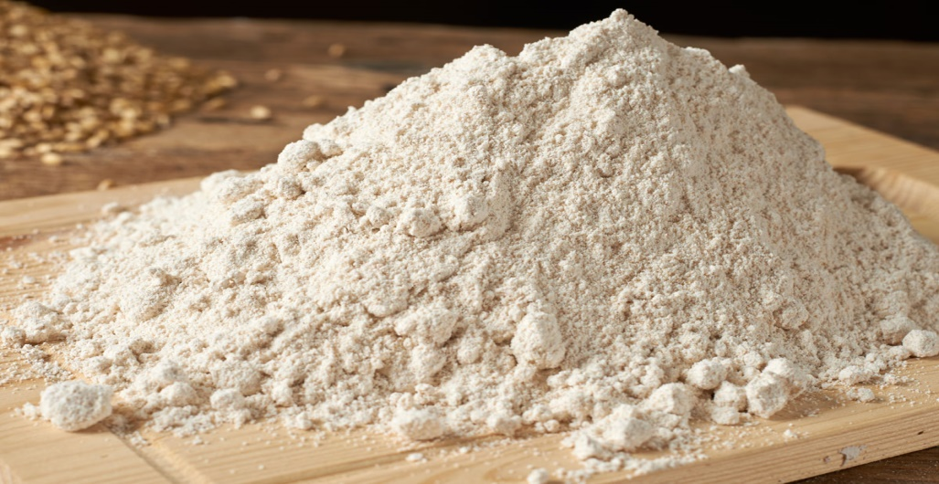
Definition:
Starch is a soft, white, tasteless powder that is insoluble in cold water, alcohol, or other solvents. The basic chemical formula of the starch molecule is (C₆H₁₀O₅)_{n}. Starch is a polysaccharide comprising glucose monomers joined in α 1,4 linkages.
It consists of two types of molecules:
- Amylose
- Amylopectin
Amylose: Amylose consists of a linear, helical chains of roughly 500 to 20,000 alpha-D-glucose monomers linked together through alpha (1-4) glycosidic bonds.
It is one of the two components of starch, making up approximately 20-30%. Because of its tightly packed helical structure, amylose is more resistant to digestion than other starch molecules and is therefore an important form of resistant starch.
Structure of amylose:
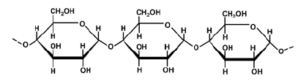
Amylopectin: Amylopectin is a much larger molecule than amylose, the mass of amylopectin is typically 4 to 5 times that of amylose in starch. It is made up of a polymer of alpha-glucose units and linked linearly with α(1→4) glycosidic bonds, as well as α(1→6) bonds occurring at intervals of 24 to 30 glucose subunits. This means that the 1-carbonof a glucose subunit is linked to the 4-carbon of the next glucose subunit via a glycosidic bond. It is one of the two major types of carbohydrates found in starch (the other is amylose
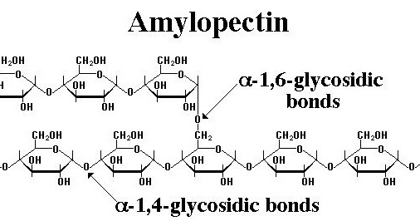
Uses of starch:
- In baking and brewing industry: Aside from their basic nutritional uses, starches are used in brewing and as thickening agents in baked goods and confections.
- Uses in paper industry: Starch is used in paper manufacturing to increase the strength of paper and is also used in the surface sizing of paper.
- Uses in food industry: As an additive for food processing, food starches are typically used as thickeners and stabilizers in foods such as puddings, custards, soups, sauces, gravies, pie fillings, and salad dressings, and to make noodles and pastas.
Cellulose:
It is defined as a polysaccharide (C₆H₁₀O₅)x of glucose units that constitutes the chief part of the cell walls of plants, occurs naturally in such fibrous products as cotton and kapok, and is the raw material of many manufactured goods (such as paper, rayon.
Cellulose is an organic compound with the formula (C₆H₁₀O₅)_{n}, a polysaccharide consisting of a linear chain of several hundred to many thousands of β(1→4) linked D-glucose units.^{[3][4]} Cellulose is an important structural component of the primary cell wall of green plants, many forms of algae and the oomycetes. Some species of bacteria secrete it to form biofilms.^{[5]} Cellulose is the most abundant organic polymer on Earth.^{[6]} The cellulose content of cotton fiber is 90%, that of wood is 40–50%, and that of dried hemp is approximately 57%.

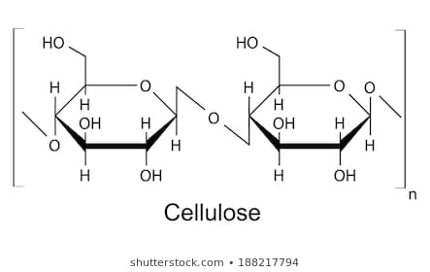
Example: cotton, wood ,flax and hemp

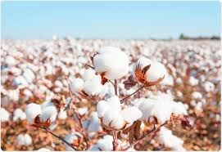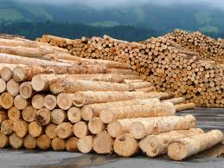

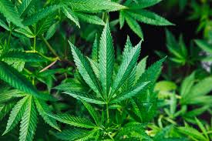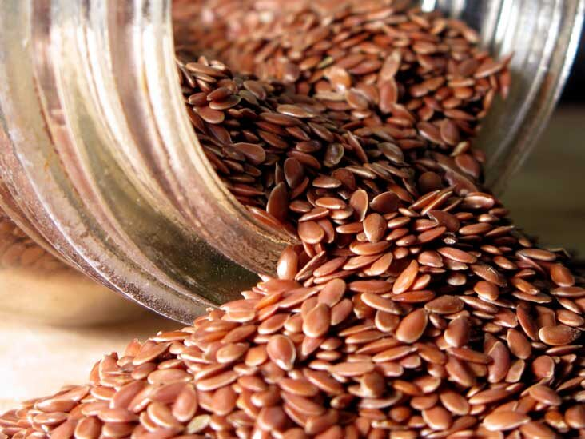
Physical properties of starch:
- It appears in form of hollow fibre which has characteristic appearance and shape.
- Cellulose is soluble in ammonical solution of cupric hydroxide and insoluble in all organic solvents.
Chemical properties:
- Hydration: on treatment with cellulose it is changed into hydrated cellulose called hydrocellulose.
- Treatment with alkali: when cellulose is treated with 15-20% caustic soda its reticulated fibrous wall swells to a cylindrical shape.
Cellulose industrial applications:
- Textile industry: cellulose is employed in the manufacture of cellulose.
- Explosives: gum, cotton which is cellulose tri-nitrate is used as blasting and propellant agen
- celluloid: synthetic plastic manufactured by mixing colloid on cotton and camphor in the presence of alcohol.
- Artificial silk: cellulose finds extensive use in the manufacture of artificial silk.
Heteropolysaccharides:
In general, heteropolysaccharides (heteroglycans) contain two or more different monosaccharide units. Although a few representatives contain three or more different monosaccharides, most naturally occurring heteroglycans contain only two different ones and are closely associated with lipid or protein.
In general, heteropolysaccharides (heteroglycans) contain two or more different monosaccharide units. Although a few representatives contain three or more different monosaccharides, most naturally occurring heteroglycans contain only two different ones and are closely associated with lipid or protein. The complex nature of these substances has made detailed structural studies extremely difficult. The major heteropolysaccharides include the connective-tissue polysaccharides, the blood group substances, glycoproteins (combinations of carbohydrates and proteins) such as gamma globulin, and glycolipids (combinations of carbohydrates and lipids), particularly those found in the central nervous system of animals and in a wide variety of plant gum.
Example: These heteropolysaccharides are commonly called as Glycosaminoglycan. They include chondroitin sulfate, hyaluronic acid and heparin. Chondroitin sulfate is an important component of cartilage. Hyaluronic acid is found in the fluid of joints and in vitreous humor of the eye. Hyaluronic acid, condroitin sulfates and dermatan sulfates are important heteropolysaccharides in the extracellular matrix. These heteropolysaccharides usually are formed by the repetition of a disaccharide unit of an amino sugar and an acid sugar.
Established specific functions of some glycosaminoglycan are:

Hyaluronic Acid (Hyaluronate): It is a lubricant in the synovial fluid of joints,
give consistency to vitreous humor, contributes to tensile strength and elasticity of cartilages and tendons

Chondroitin Sulfates: contributes to tensile strength and elasticity of cartilages, tendons, ligaments and walls of aorta.

Dermatan sulfate (former chondroitin sulfate B) is found mainly in skin, but also is in vessels, heart, lungs. It may be related to coagulation and vascular diseases and other conditions.

Keratin sulfate: Present in cornea, cartilage bone and a variety of other structures as nails and hair.
Heparin

It is a potent natural anticoagulant produced in the Mast Cells that causes antithrombin bind to thrombin and produce inhibition of blood coagulation.

Glycosaminoglycan are synthesized in the ER and Golgi. They are degraded by lysosomal hydrolases. A deficiency of one of the hydrolases results in a mucopolysaccharidosis. These are hereditary disorders in which glycosaminoglycan accumulate in tissues, causing symptoms such as skeletal and extracellular matrix deformities, and mental retardation.
Examples of these genetic diseases are Hunter and Hurler syndromes.
These diseases, caused by different enzyme deficits, are characterized by physical deformities, mental retardation and disturbances in the degradation of heparan sulfate and dermatan sulfate.

Functions of a Polysaccharide
Depending on their structure, polysaccharides can have a wide variety of functions in nature. Some polysaccharides are used for storing energy, some for sending cellular messages, and others for providing support to cells and tissues.

Storage of Energy
Many polysaccharides are used to store energy in organisms. While the enzymes that produce energy only work on the monosaccharides stored in a polysaccharide, polysaccharides typically fold together and can contain many monosaccharides in a dense area. Further, as the side chains of the monosaccharides form as many hydrogen bonds as possible with themselves, water cannot intrude the molecules, making them hydrophobic. This property allows the molecules to stay together and not dissolve into the cytosol. This lowers the sugar concentration in a cell, and more sugar can then be taken in. Not only do polysaccharides store the energy, but they allow for changes in the concentration gradient, which can influence cellular uptake of nutrients and water

Cellular Communication
Many polysaccharides become glycoconjugates when they become covalently bonded to proteins or lipids. Glycolipids and glycoproteins can be used to send signals between and within cells. Proteins headed for a specific organelle may be “tagged” by certain polysaccharides that help the cell move it to a specific organelle. The polysaccharides can be identified by special proteins, which then help bind the protein, vesicle, or other substance to a microtubule. The system of microtubules and associated proteins within cells can take any substance to its destined location once tagged by specific polysaccharides. Further, multi-cellular organisms have immune systems driven by the recognition of glycoproteins on the surface of cells. The cells of a single organisms will produce specific polysaccharides to adorn its cells with. When the immune system recognizes other polysaccharides and different glycoproteins, it is set into action, and destroys the invading cells.

Cellular Support
By far one of the largest roles of polysaccharides is that of support. All plants on Earth are supported, in part, by the polysaccharide cellulose. Other organisms, like insects and fungi, use chitin to support the extracellular matrix around their cells. A polysaccharide can be mixed with any number of other components to create tissues that are more rigid, less rigid, or even materials with special properties. Between chitin and cellulose, both polysaccharides made of glucose monosaccharides, hundreds of billions of tons are created by living organisms every year. Everything from the wood in trees, to the shells of sea creatures is produced by some form of polysaccharide. Simply by rearranging the structure, polysaccharides can go from storage molecules to much stronger fibrous molecules.
Multiple Choice Questions:
- Example of bacterial and yeast polysaccharides:
- Starch
- Glycogen
- Cellulose
- Dextrin
Answer :Dextrin
2.when all the monosaccharide in a polysaccharide are same it is:
- Homoglycan
- Heteroglycan
- Oligosaccharide
- Dipolysaccharide
Answer: homoglycan
3.In which form glucose is stored in plants :
- Starch
- Cellulose
- Glycogen
- Dextrin
Answer: starch
4.In which form glucose is stored in liver:
- Glycogen
- Starch
- Cellulose
- Dextrin
5.Which component of starch is present in greater amount:
- Amylose
- Amylopectin
- Both
- None of these
Answer: amylose
6.Gelatin is a:
- Disaccharide
- Monosaccharide
- Oligosaccharide
- Polysaccharide
Answer: polysaccharide
7.Which component of starch has both alpha 1,4 and 1,6 glycosidic linkage:
- Amylose
- Amylopectin
- Both
- None
Answer: amylopectin
8.Glycosidic bond is present in:
- Starch
- Cellulose
- Starch
- All
Answer: All
9.Beta glycosidic linkage id present in:
- Cellulose
- Starch
- Dextrin
- Pectin
Answer: cellulose
10. Keratin is present in:
- Nails
- Hair
- Both
- None
Answer: both

