Barrages and headwork’s in Pakistan.

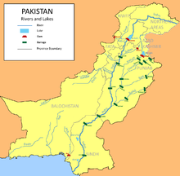
Khyber Pakhtunkhwa.
- Munda Headworks
Punjab.
- 1 Chashma Barrage
- 2 Head Balloki
- 3 Islam Barrage
- 4 Jinnah Barrage
- 5 Khanki Headworks
- 6 Marala Headworks
- 7 Panjnad Headworks
- 8 Qadirabad Headworks
- 9 Rasul Barrage
- 10 Sidhnai Headworks
- 11 Sulemanki Headworks
- 12 Mailsi Headworks
- 13 Taunsa Barrage
- 14 Trimmu Barrage
- 15 Mohammad wala Headwork
- 16 Ghazi Brotha Barrage
Sindh.
- Guddu Barrage
- Kotri Barrage
- Sukkur Barrage

