Cell cycle
- Cell cycle is the series of events from the time a cell is produced until it completes mitosis & produce new cells
Cell cycle consists of two major phases
- Interphase
- Mitotic phase
- Mitotic phase is a relatively short period of cell cycle
- It alternates with the much longer interphase, where cell prepares itself for division
- Interphase is the time when a cell’s metabolic activity is very high, as it perform its various function
It is divided into three phases:
- G1 (First phase)
- S phase (Synthesis)
- G2 (second gap)

G1 Phase
- After its production,a cell starts its cell cycle in G1 phase
- During this phase,cell increase its supply of proteins,increases the number of its organelles (such as mitochondria,ribosomes),and grows in size
- This phase is also marked by the synthesis of various enzymes that is required in next phase I.e S phase for the duplication of chromosomes
S Phase
- In this phase, cell duplicates its chromosomes
- As a result, each chromosome consists of two sister chromatids

G2 Phase
- In the G2 phase, cell prepares protein that are essential for mitosis, mainly for the production of spindle fiber
- After the G2 phase of interphase, cell enters the division phase i.e. M phase
- It is characterized by mitosis, in which cell divides into two daughter cells
- Cells that have temporarily or permanently stopped dividing are said to have entered a state of quiescence called G0 phase
G0 Phase
- In multicellular eukaryotes, cells entered G0 phase from G1 and stop dividing
- Some cells remaining G0 for indefinite period i.e. neurons
- Some cells entered G0 phase semi permanently i.e. some cells of liver and kidney
- Many cells do not enter G0 and continue to divide throughout an organism’s life i.e. epithelial cells

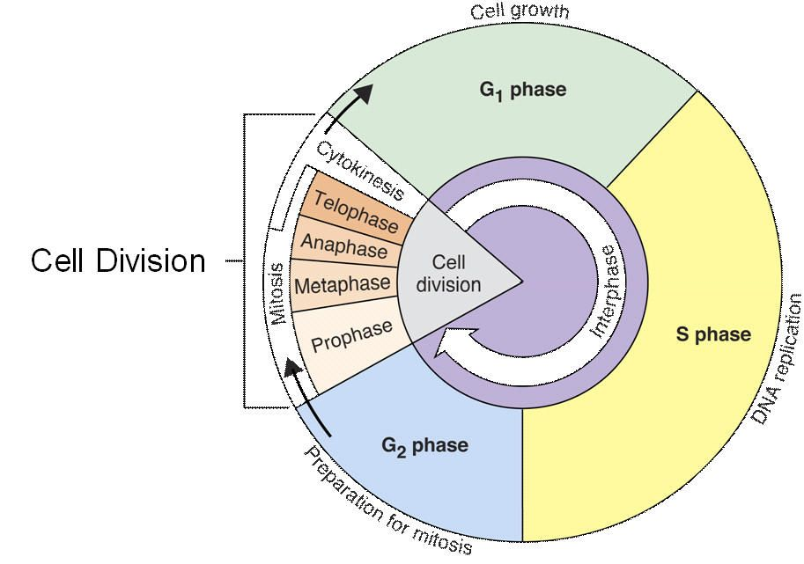
Mitosis
- In 1980, a German biologist Welter Flaming observed that in a dividing cell, nucleus passes through a series of changes which he called mitosis
- Mitosis is the type of cell division in which a cell divides into two daughter cells, each with the same number of chromosomes as were present in parent cell
- Mitosis occurs only in eukaryotic cells
- In multicellular organism, the somatic cells undergo mitosis
- Prokaryotic cells undergo a process similar to mitosis called binary fission
Phases of Mitosis
The process of mitosis is complex and regulated
There are two major phases i.e.
The division of nucleus known as karyoKinesis
The division of cytoplasm known as cytokinesis
- karyokinesis
The divion of nucleus is further divided into 4 phases
- Prophase
- Metaphase
- Anaphase
- Telophase

Prophase
- Normally the genetirorc material in nucleus is in a loose threadlike form called chromatin
- And the onset of prophase, chromatin condenses into highly ordered structure called chromosomes
- Since the genetic material has already been duplicated earlier in S phase, each chromosome is made of two sister chromatids, bound tighter at the same centromere
- Each chromosome also has kinetochore at centromere
- Kinetochore is a complex protein structure that is the point where spindle fibers attach
- There are two centrioles close to nucleus
- Each centriole duplicates and two daughter centrosomes are formed
- Both centrosomes migrate to the opposite pole of cell.
- The give rise to microtubules by joining tubulin proteins Preset in cytoplasm
- The microtubules, thus formed are called spindle fiber
- Complete set of spindle fiber is known as mitotic spindle
- By this time, nucleolus and nuclear envelope have degraded and spindle fibers have invaded the central space
In plants
- In highly vacuolated plant cell, nuecleus have to miagrte the centre of cell before prophase
- The cells of plants lack centrioles
- Spindle fibers are formed by aagregation of tubulin protein on the surface of nuclear envelope during prophase
Metaphase
- When spindle fibers have grown to sufficient length, some spindle fibers, known as kinetochore fibers, attach with the kinetochore of chromosomes
- Two kinetochore fibers from opposite poles attach with each chromosomes
- Chromosomes arrange themselves along the equator of cell forming a metaphase plate
- A number of other fibers non-kinetic, from the opposite centrosomes attach with each other
Anaphase
- When a kinetochore spindle fiber connects with the kinetochore of chromosome, it starts to pull towards the originating centrosomes
- The pulling force divides the chromosomes sister chromatids and they separate
- These sister chromatids are now sister chromosomes & they are pulled apart toward the respective centrosomes
- The other spindle fiber non kinetochore are elongate at the end of anaphase cell has succeeded in separating identical copies of chromosomes into two groups at the opposite pole
Telophase
- Telophase is the reversal of prophase
- A new nuclear envelope forms around each set of separated chromosomes
- Both set of chromosomes, now surrounded by nuclear envelopes, unfold back into chromatin
- Nuclear division is completed but cell division has yet one more set to complete
Cytokinesis
In animal cells
- Cytokinesis is the division of cytoplasm
- In animal cells cytokinesis occur by a process known as cleavage
- A cleavage furrow develops where the metaphase plate used to be
- The furrow deepens & eventually pinches the parent cell into two daughter cells
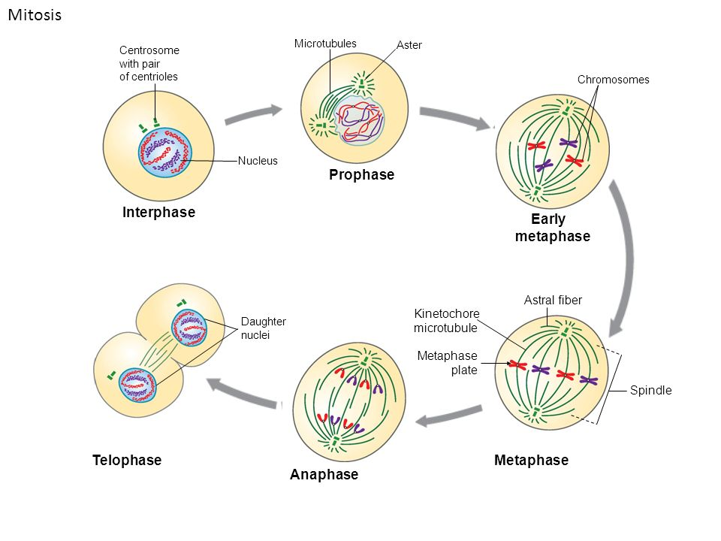Cytokinesis in plant cells
- Cytokinesis occurs in plant cells differently
- Vesicles derived from the Golgi apparatus move to the middle of cell & fuse to form a membrane bounded disc called cell plate of phragmoplast
- The plate grows outward & move vesicles fuse with it
- Finally, membrane of cell plate fuse with plasma membrane & its contents join the parental cell wall
- The result is two daughter cells, each bounded by its own plasma membrane & cell wall

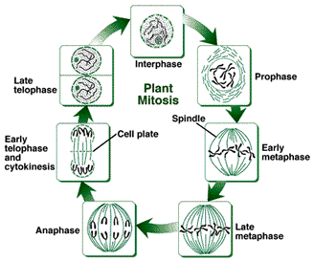

Significance of mitosis
- Importance of mitosis is the maintenance of chromosomal set e.g. each daughter cell receives chromosomes that are alike in composition & equal in number of chromosomes of parental cell
- Following are the occasions in the lives of organisms where mitosis happens
Development & growth
- The number of cells within an organism increase by mitosis
- This is the basis of mitosis of the development of a multicellular body from a single cell e.g. zygote & also the basis of the growth of multicellular body
Cell replacement
- In some parts of body e.g. skin & digestive tract, cells are constantly sloughed off and replaced by new ones
- New cells are formed by mitosis & so are exact copies of the cell being replaced
- Similarly red blood cells have short life span about four months & new red blood cells are formed by mitosis
- Regeneration
- Some organisms can regenerate parts of their bodies
- The production of new cells is achieved by mitosis e.g. sea star regenerate its lost arm through mitosis
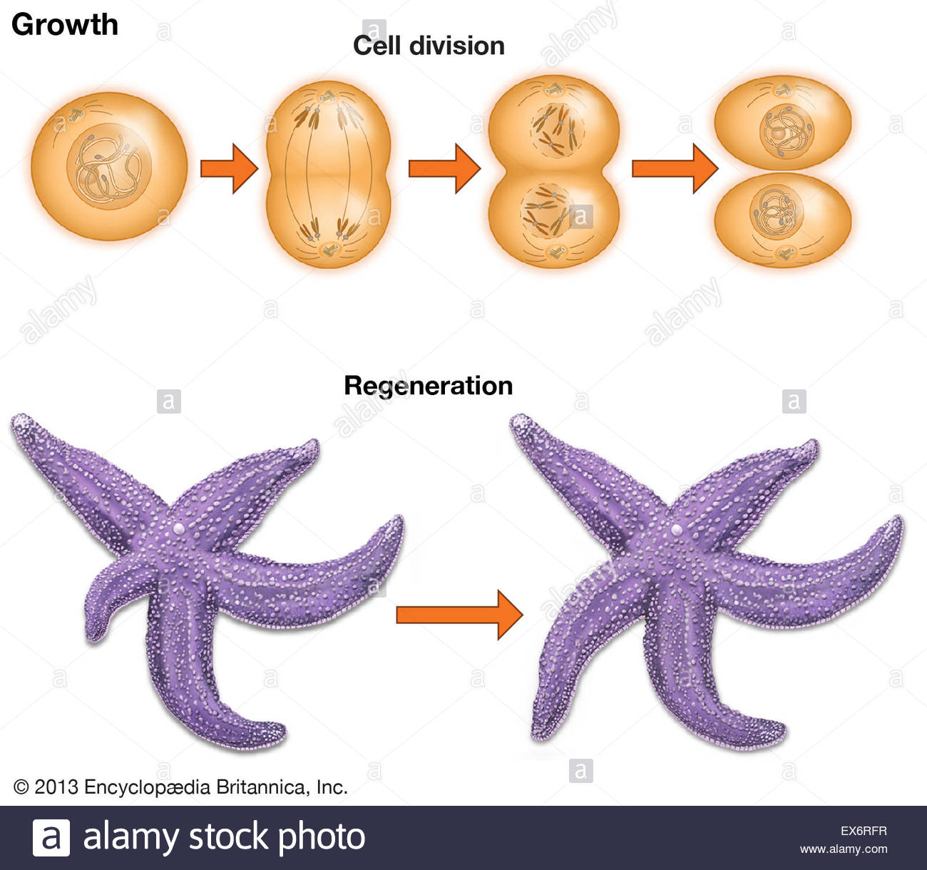
Asexual reproduction
- Some organisms produce genetically similar off spring to a sexual reproduction
- Mitosis is a means of a sexual reproduction i.e. hydra reproduces a sexually by buddying
- The cells at the surface of hydra undergo mitoses and from a mass called bud
- Mitosis continues in the cell of bud and it grows into a new individual. The same division happens during a sexual reproduction i.e. vegetative propagation in plants
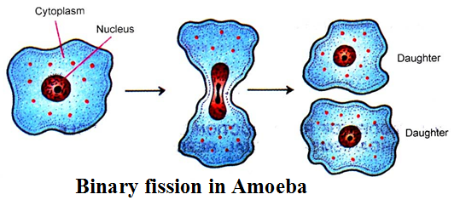

Errors in mitosis
- Errors in the control of mitosis may cause cancer.
- All cells have genes that control the timing and number of mitosis.
- Sometimes mutation occurs in such genes and cells continue to divide.
- It results in growth of abnormal cells tumors. As long as these tumors remain in their original location. There are called benign

- But if they invade other issues they are called malignant or cancerous tumors and they cells are called cancer cells
- Such tumors scan send cancer cells to other parts in body where new tumor may formed this phenomena is called metastasis (spreading of disease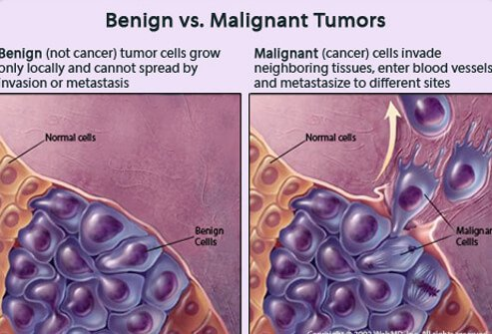se).

