Project Report (GroupNo#12,B’SBotany,IISemester
Course Name : BS Botany
Project Title : To provide awareness to people by placards and verbally.
Submission Date: 7,06,202o.
Group Members : Munazza.
Submitted To: Mam Mehlah Jabeen
Session : 2019-2020.
University : University of Sargodha,Sub Campus Bhakker.

Awareness About COVID 19 by using Play-Cards and Oral Communication
- Introduction
- Back ground of the Problem.

Basically novel coronavirus was originated from Wuhan city in China in December 2019. This virus has become the cause of a highly contagious named disease as COVID -19 by WHO on February 12,2020 . It's spread to 200 countries in the world. (https :// psychcentral. Com/coronavirus /background ) main place in Wuhan from where it originated is a wet-market of live animals where people sell and buy cats, dogs, rabbits etc. This virus transmitted from diseased to healthy one by droplets that comes out from infected person and attack the respiratory tract directly. (https ://medicine. Medscape.)
Present Situation
Present Situation of the world due to corona virus is much alarming. Few months ago it seems easy to cope with it but now it's almost seems impossible. This virus has taken the lives of the millions of people around the world, and don't seems to stopping. Due this virus life has become stationery and all industries and commercial units are closed. World is facing the sever problem of food shortage. Along with them several other issues are getting ready for the people to face.
- Justification of the Project.
- Importance of the Project.
Different awareness projects about corona virus are the great need of the hour. Now country, city or the area of the world is save for humans. We have to aware people about its spreation and also tell them about the preventive measurements. So may people adopt them can the save lives of their friends and family. (https ://www.who.int.com)
- Practical Implications.
It's very important point for any type of project. Task of my project was to aware people about destroying virus. So I worked upon my project keeping in mind the life style and their attitude about this virus. I told them how by adopting the safety precautions we can save ourselves and family from nonsense COVID 19 . For this purpose I made charts of safety precautions and displayed them on gate to gate and also on crowding places of our village. Infect I also urged them to a extant that they themselves began to essential to act upon safety precautions. (Munazza, BBTF19BMO38 (2020).Bs Botany II Semester, Department of Biological sciences. University of Sargodha, sub campus Bhakker. )
- Objectives of the Project.
The only objective of my project was to save the lives of our by some stop the spread of COVID 19 virus. And help them spiritually to told them how to face this problem. Not so more but some how play my part to save my be loving people and my country from the destruction of this virus. Munazza, BBTF19BMO38 (2020).Bs Botany II Semester, Department of Biological sciences. University of Sargodha, sub campus Bhakker. )

- Plan of Action.
- Plan to do this Job.
I have done this with help of my cousin and brother by not only by displaying play cards of preventive measurements but also give awareness to people orally. For this purpose we made charts and especially take lectures of awareness about COVID 19 for different social media sources. We have done this into parts number one bye making charts and placing them on crowding places and number 2 by giving people awareness orally. Munazza, BBTF19BMO38 (2020).Bs Botany II Semester, Department of Biological sciences. University of Sargodha, sub campus Bhakker. )

- Sources.
Charts and paly cards we write by hand.
And task is completed by me himself, my brother Noman and cousin Shahid.
- Duration of the Project.
We were sure that we will complete our task within 10 days and am happy to say Alhamdulillah we completed our task within this duration.
Evaluation of the Project.
As according to present situation we can't evaluate our project by gathering people, so we planed to communicate with people separately to know their point of view about this project and to know is our project is doing good for people or not? Alhamdulillah people have given positive feedback to my project and I can my self feel the changing behavior of people about this situation after our awareness compain. Munazza, BBTF19BMO38 (2020).Bs Botany II Semester, Department of Biological sciences. University of Sargodha, sub campus Bhakker. )
Out comes of Project.
I am feeling pleased to learn about the results of my project because now people are more conscious about safety precautions and dealing with coronavirus in the best way.
Proves.
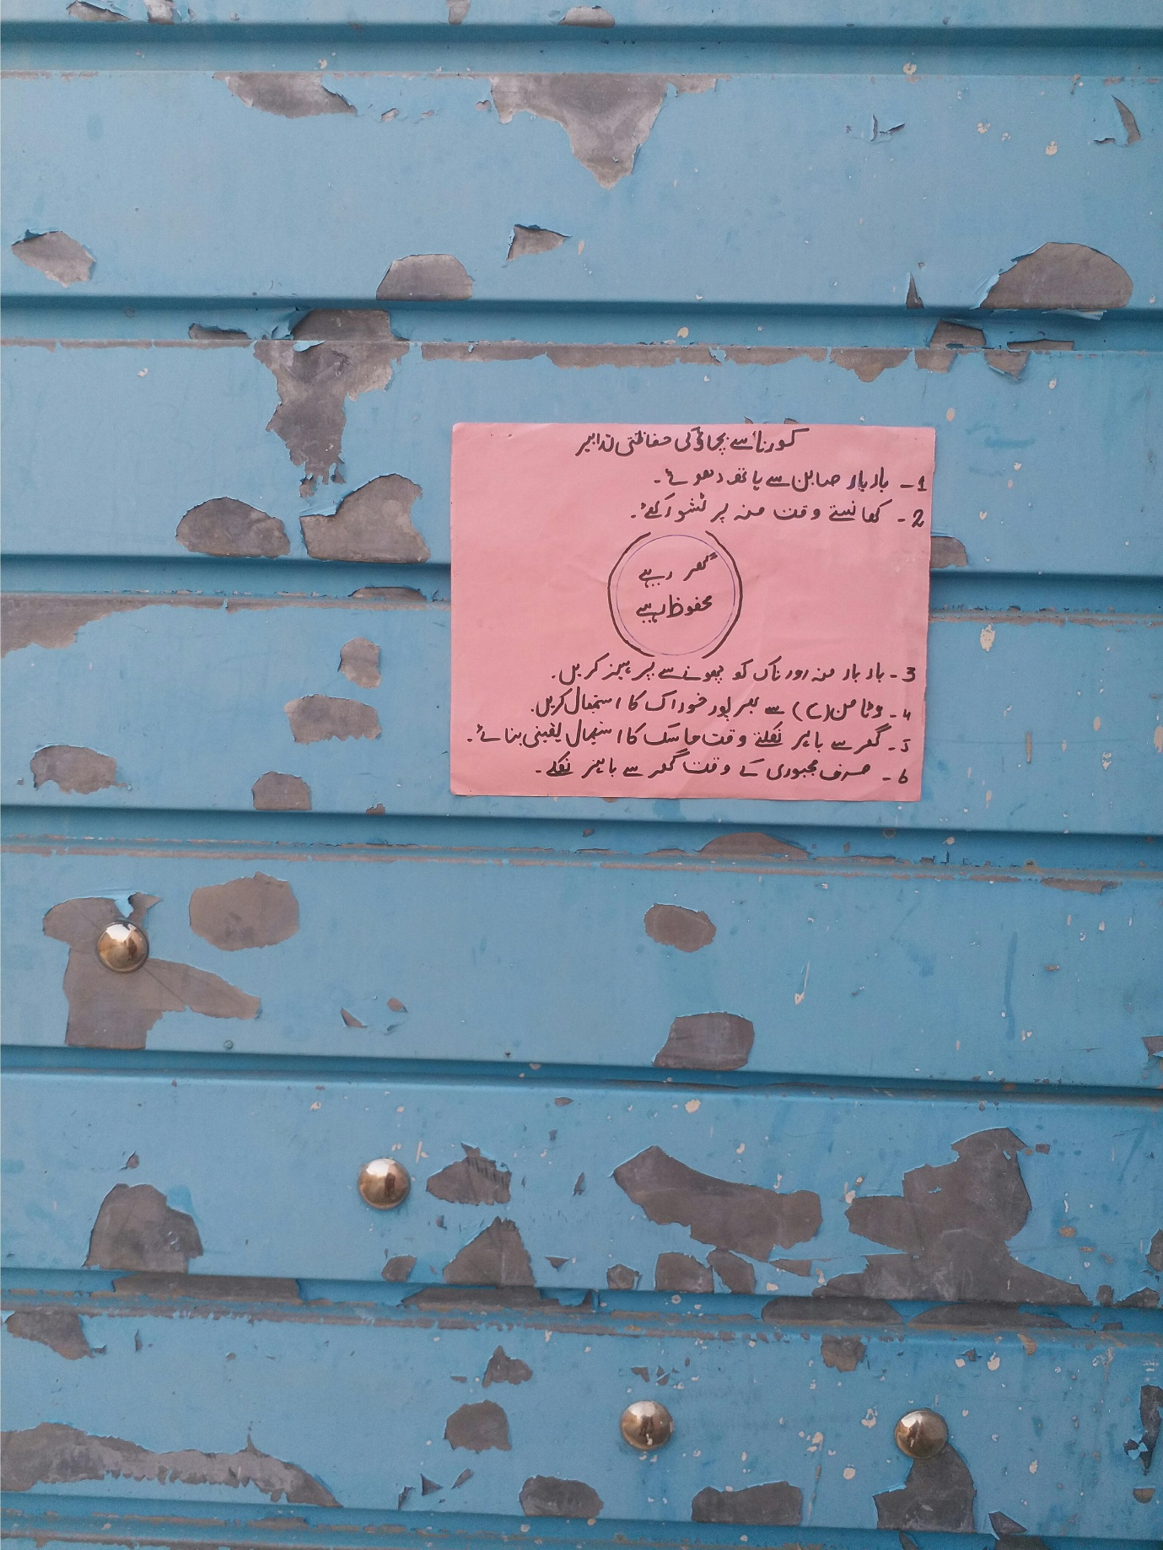
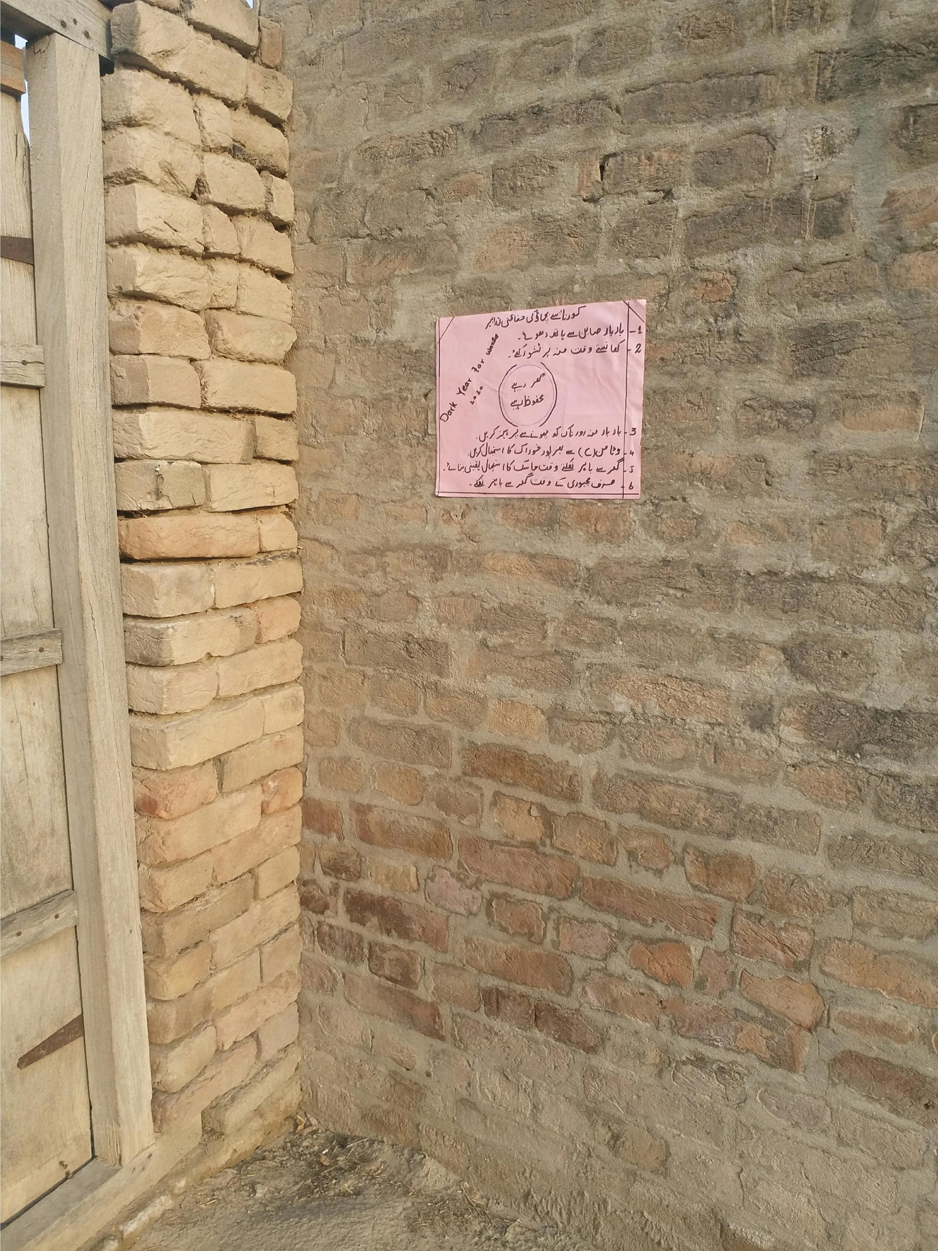
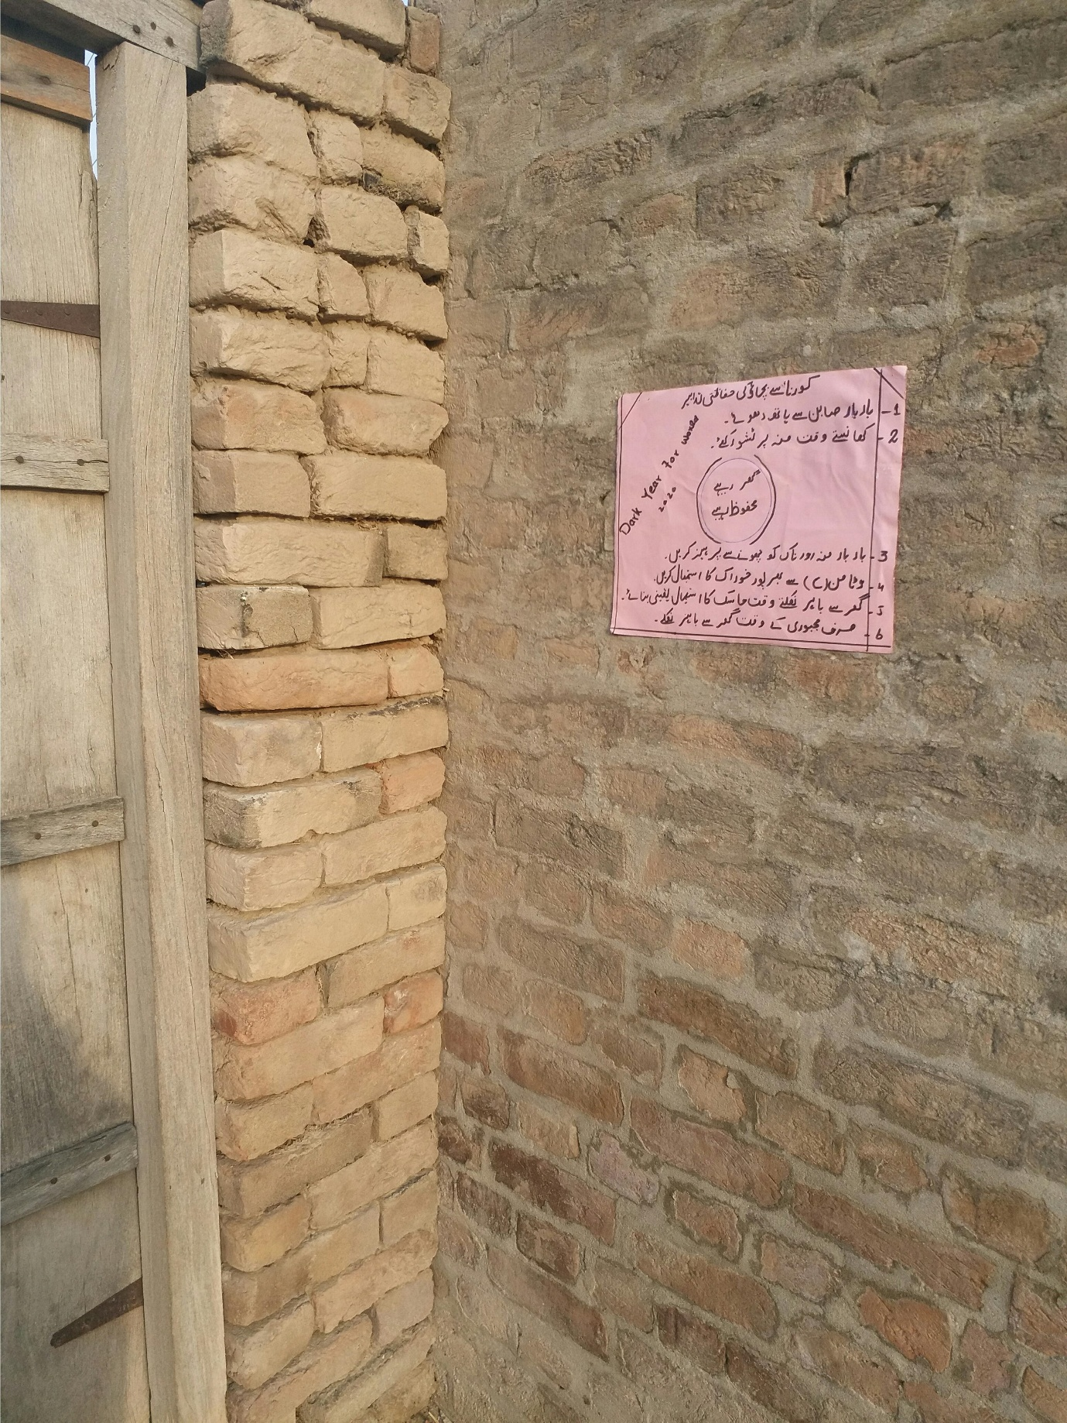

- References.
https ://psychcentral.com/coronavius /background.
https ://medicine. Medscape.com.
https ://www.who.int.
https ://www. Cbc.gov.
Munazza, BBTF19BMO38, (2020).Bs Botany II Semester, Department of Biological sciences. University of Sargodha, Sub Campus Bhakker.

