Defination.
Geography is the study of places and the relationships between people and their environments. Geographers explore both the physical properties of Earth’s surface and the human societies spread across it. They also examine how human culture interacts with the natural environment and the way that locations and places can have an impact on people. Geography seeks to understand where things are found, why they are there, and how they develop and change over time.

The highest mountains of the world known as “The Himalayas” Comprising of a series of ranges is situated in the north east of our country. The Himalayas stretches like a bow in the north of Indo-Pak Sub-continent having a length of about 1500 miles. The part of this mountain which came into our share , consists of four parallel ranges. Between these ranges lies some beautiful valleys. The slope of these goes decreasing from the north to south. Thus according to their altitudes, these ranges can be sub-divided as:
- The siwalik range
- The peer pinjal range
- Central or great hamaliya
- Karakoram range
THE SIWALIK RANGE:
These are the line of low altitude hills, situated adjacent to plain areas of Hazara district in NWFP and Attock, Rawalpindi, Jhelum, Gujarat and Sialkot district. Here these hills have a height of between 2000 to 3000 feet from the sea level.
THE PEER PINJAL RANGE:
These range lies further of the north and mostly run parallel to the Siwlik hills. Beside Murree and Hazara hills , Peer pinjal range is one of the famous ranges that lie in these areas, it has an average altitude of 14000 to 15000feet: most of the peaks remains snow covered during winter. These are also covered with natural vegetation; forests are also seen at some places.
THE CENTRAL OF GREAT HIMALAYA:
These mountains lie in between the Pir Pinjal range & Karakoram range. These ranges have an average height of 2000feet and most of the peaks remain snow-covered throughout the year. The heigst peak of this range known as Nanga Parbet lies in Kashmir has an height of about 26600 feet. The beautiful valley of Kashmir lies between the Pir Pinjal range and the great Himalaya.
THE KARAKORAM RANGE:
the famous Karakoram Range lies to the north of central Himalaya in northern Kashmir and Gilgit area. This range has an average height of about 20000 feet above sea level. The second highest peak of the world and highest peak of Pakistan, Godwin Austin (K-2) having a height of 28,250 feet or 8475 meters in this range near Gilgit. This peak was first conquered by an Italian expendition in 1954. The peak having a high altitude remain snow covered throughout the year.
The northeastern mountains of our country are quite high and it is difficult to cross them easily, but these mountains have a few passes, which are used for communication purpose. Some of the important passes are:
- THE BABUSAR PASS
- THE LAWARI PASS
- THE SHANDUR PASS
- THE MAZTAGH PASS

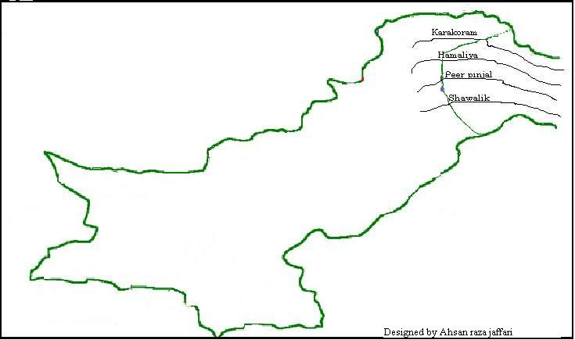

The north western ranges of our country are also known as western branches of the Himalayas Mountains. These mountains consist of series parallel ranges and are lower in altitude than the northeastern mountains. As most of these ranges lie outside the course of summer monsoons coming from Arabian Sea, and so there the rainfall is low and they are almost bare of natural vegetation. These mountains act as a boundary between Afghanistan, Iran and our country. These mountain ranges lie north to south, having some passes in river, beds in the valleys. So the northwestern mountains can be sub-divided into following divisions:
Hindu Kush range
Between the Indus and Kabul rivers lies the Hindu Kush range. The average height of this range is between 10,000 to 16,000 feet above sea level. The highest peak of this area is known as Torch Mir, having an altitude of 25230 feet. Most of the mountain remains snow-covered during winter months. The Kabul, Swat, Panjkora and Kunar flow through months. The minor ranges of this mountain. These entire rivers join the Indus from the western side. The famous Khyber Pass lies south of the Kabul river. This pass is a historical trade route between Peshawar and Kabul, the capital of Afghanistan.
Safed Koh range.
South of the Kabul River up to Kurram pass lies the Safed Koh range, which runs east and west. These mountains have an average height of 12,000 feet and are often covered with snow in winter. The rover Kurram lies to the south of this range. The Kurram pass, which provides an easy route in to Afghanistan, is situated near this range. Kohat is an important military base situated at the end of this pass.
Waziristan hills.
Between the Kurram and the Gomal rivers lies the Waziristan hills area. These hills have low altitude. The Tochi River joins the Kurram River from the west in North Waziristan. These rivers after passing through Tochi pass join the Indus. Similarly Gomal River coming from Afghanistan joins Indus near Dera Ismail Khan. Bannu at Tochi pass and Dera Ismail Khan at Gomal pass are the important towns and military centers.
Sulman mountain.
In the south of the Gomal river lies the Sulman mountain. It rims southward for a distance of about 300 miles. Its highest peak is known as Takhat-I-Sulaimani, whose height is 11,100 feet above sea level. At the southern end of the Sulaiman mountain, the Bugti and Mari hills run from the southeast to the northwest. The Bolan is the main river of this region. The Bolan river passes through the Bolan Pass, which provides communication facilities between Iran and Pakistan . Queta is and important base at the northern end of Bolan pass.
The Kerther hills.
In the west of lower Indus plain lies a hilly area known as “The Kerther hills”. These hills are not high enough, their average height being about 7000 feet. The Kerther hills are drained by the Hab and Layari stream join the water of the Arabian sea near Karachi.
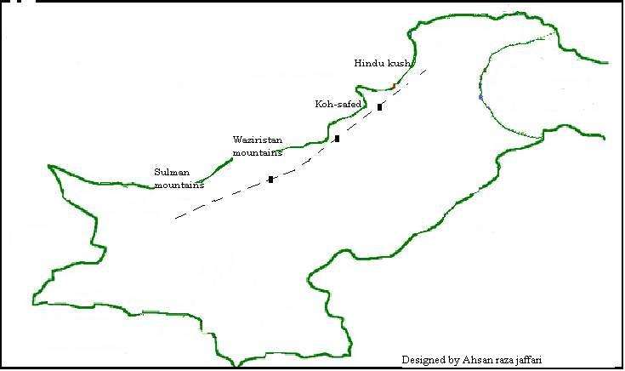
Deserts of Pakistan.

Deserts in Pakistan
Pakistan hosts five major deserts which were historic forests. These include Thar desert in Sindh, Kharan desert in Balochistan, Katpana desert in Skardu (Gilgit Baltistan), Thal desert in Bhakkar (Punjab) and Cholistan in Bahawalpur (Punjab).
1Kharan Desert
2Thal Desert
3Thar Desert
4Cholistan Desert
5Cold Desert, Skardu

Kharan Desert.
The Kharan Desert is located in Northwest Balochistan. It makes a nature boundary between Pakistan, Iran and Afghanistan. It is located in Kharan District. The Kharan Desert is a sandiest desert in Pakistan. It is distinct from the rest of the province's landscape due to its sandy nature and more even ter. The desert was used for nuclear testing by the Pakistan military, making it the most famous of the five deserts.
Thal Desert.

Thal Desert
The Thal Desert is located in Bhakkar District of Pakistan between the Indus and Jhelum rivers. A large canal-building project is currently underway to irrigate the land. Irrigation will make most of the desert suitable for farming. In the north of the Thal Desert there are salt ranges, in the east the Jhelum and Chenab rivers and to the west the Indus river.
Thar Desert.

That desert
The Thar Desert spans an area of 175,000 square kilometers and covers large areas of Pakistan and India. It is the largest desert of Pakistan and the only subtropical desert of Asia. It is the seventh largest desert on the planet and the third largest in Asia. It has also spread into India. The Thar Desert, also known as the Great Indian Desert, is a large, arid region in the northwestern part of the Indian subcontinent that forms a natural boundary between India and Pakistan. It is the world's 17th largest desert, and the world's 9th largest subtropical desert. 85% of the Thar Desert is in India, and the remaining 15% is in Pakistan. In India, it covers 320,000 km2 (120,000 sq mi), of which 90% is in Rajasthan and extends into Gujarat, Punjab, and Haryana. In Pakistan, it spreads over Punjab and Sindh starting from the Tharparkar District in the east. This desert consists of a very dry part, the Marusthali region, in the west, and a semi-desert region in the east with fewer sand dunes and slightly more precipitation.
Cholistan Desert.
Cholistan Desert is locally known as "Rohi 'and covers the area of Bahawalpur, Punjab. It adjoins the Thar Desert, extending over to Sindh and into India. Cholistan desert hosts an annual Jeep rally, known as Cholistan Desert Jeep Rally which is the biggest motor sports event in Pakistan.
Cold Desert, Skardu.

Katpana Desert
The Cold Desert is a high-altitude desert located near Skardu, in Pakistan's northern Gilgit-Baltistan region. The desert contains expanses of large sand dunes that are sometimes covered in snow during winter. Situated at an elevation of 2,226 metres (7,303 feet) above sea level, the Katpana Desert is one of the highest deserts in the world.
The desert technically stretches from the Khaplu Valley to Nubra in Ladakh, but the largest desert area is found in Skardu and Shigar Valley..

