Still Life in Painting: Definition, Medium Types & Examples

When artists paint still lifes, they take very special care to arrange the objects in a certain way. Sometimes this is done to create different visual effects, like shadows or color contrast. Still lifes can also be arranged to communicate a certain meaning to the viewer. For example, using flowers such as lilies symbolizes purity, while rotting fruit symbolizes mortality.

The Paints
Still life paintings can be done with a number of different mediums, most commonly oil, watercolor, and acrylic paints. Originally, still life paintings were done with oil paints; different colored pigments mix with oils to make up the paint. Oil paintings have rich colors and the paints can be layered for a textural effect. One downside of oil painting, however, is the length of time it takes for the paint to dry. Artists like Vincent Van Gogh and Claude Monet are renowned for their oil-on-canvas still life paintings.
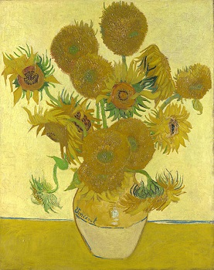
Vincent Van Gogh, Vase with Fifteen Sunflowers (oil on canvas)

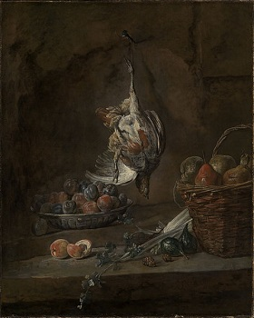
Jean Baptiste Simeon Chardin, Still Life with Dead Pheasant (oil on canvas)
Watercolors are another popular medium for still life painting. Watercolor paints are water-soluble, meaning they can be dissolved in water. When painting with watercolors, artists do not need to use the color white. Instead, they thin the paint with water to make it more transparent. Paul Cezanne's 'Three Pears' below is a mixture of watercolor paints with graphite (pencil).

