The earliest known drawings date from 30,000 to 10,000 B.C.. They were found on the walls of caves in France and Spain. Other examples of early drawing are designs that were scratched, carved, or painted on the surfaces of primitive tools
Elements of Arts

- Line
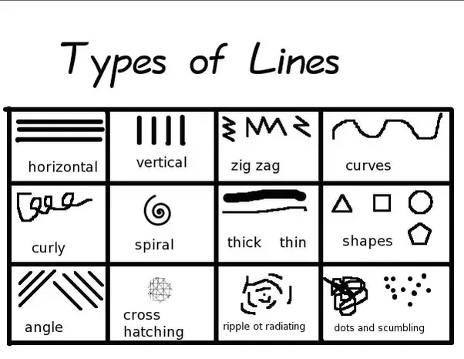

- Color

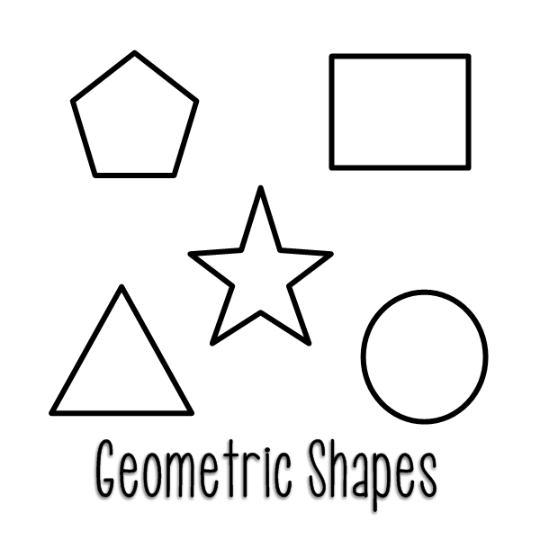
- Shape
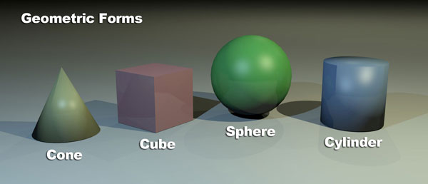
- Form

- Value
The relative lightness of darkness of color

- Space

- Texture

Shading Techniques



